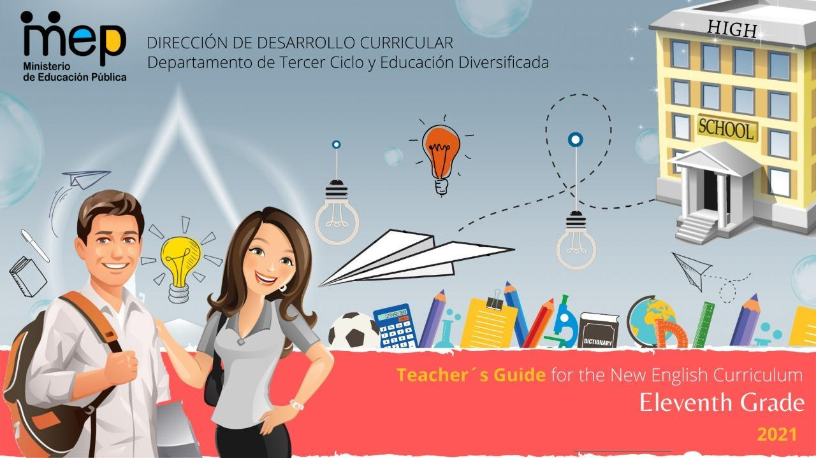
Autoridades

Giselle Cruz Maduro
Ministro de Educación Pública

Melania Brenes Monge
Viceministra Académica de Educación

María Alexandra Ulate Espinoza
Directora de la Dirección de Desarrollo Curricular

Rigoberto Corrales Zúñiga
Jefe del Departamento de Tercer Ciclo y Educación Diversificada

Comisión redactora

Mag. Marianella Granados Sirias,
Asesora Nacional de Inglés, Departamento de Tercer Ciclo y Educación Diversificada

Mag. Alfredo Ortega Cordero,
Asesor Nacional de Inglés, Departamento de Tercer Ciclo y Educación Diversificada

Unidad 2
Mag. Yasmín Mayorga Leal
Asesora Regional de Inglés, Dirección Regional de Santa Cruz

Docentes de Inglés de Tercer Ciclo y Educación Diversificada, DRE Santa Cruz
Willy Rivas Álvarez, Liceo de Villarreal
Giovanna Marcela Obando Barrantes, Liceo de Villarreal
Enni Cabalceta Leal, LEB de Santa Cruz

Colaboraciones especiales en validación de contenido y revisión filológica
Mag. Sandra Araya Acuña
Asesora Regional de Inglés, Dirección Regional de Guápiles
Kimberly Vindas Astúa, docente Liceo Rural Palacios-El Ceibo

Voluntarios
Revisión de la unidad
Kevin Hayes
Sylvia Anchía

Noelia González Cascante
Dirección de Regional de Educación Guápiles, Diseño de portada

Unit 2
From the Wheel to the Drone

SCOPE AND SEQUENCE
Level 11th Unit 2
CEF Level to be Reached B1 Basic User/Independent User
Scenario: From the Wheel to the Drone

Enduring Understanding |  | Technology requires responsible users for an effective ethical response.
Essential Question |  | How can technology make us closer or further apart?
General Competences

Responsible Citizenship ( )
Life Competences ( )
Competences for Employability ( )

Distribution of the Unit
Week 1  Goals  L.1.understand detailed oral instructions when supported by visuals such as textbook illustrations regarding technology.  R.1. follow simple instructions, for example for a video or computer game, using familiar type of technological devices, using social networks, and creating electronic accounts (e.g. Facebook, Twitter, Instagram, etc.).  SP.1. describe inventions, living in a tech world and the next wave of innovations, in a comprehensible and fairly fluent manner using a large number of different words and expressions, though there may be pauses for self-correction. | Week 1  Assessment  L.1.distinguishes detailed oral instructions when supported by visuals.  R.1. follows simple instructions.  SP.1. describes inventions, living in a tech world and the next wave of innovations in a comprehensible and fairly fluent manner | Week 2  Goals  L.2. understand the main points of stories and other text read aloud in the classroom related to inventions, living in a tech world, safety, and the next wave of innovations.  R.2. understand relations between main ideas and supporting ideas in topical articles and reports in which the authors are presenting and defending a particular point of view in regards to technological advance.  SI.2. express opinions and make suggestions about inventions, living in a tech world, safety, and the next wave of innovations while actively participating in group work. | Week 2  Assessment  L.2. extracts the main points of stories and other text read aloud in the classroom.  R.2. interprets  relations between main ideas and supporting ideas in topical articles and reports.  SI.2. expresses opinions/makes suggestions while actively participating in-group work. | Week 3  Goals  SP.2. explain how internet is used in a safe way  W.1. write short detailed descriptions about objects of interest explaining the advantages and disadvantages involved (e.g. as digital games, innovations, inventions). | Week 3  Assessment  SP.2. explains how internet is used in a safe way.  W.1. writes short detailed descriptions about objects of interest explaining the advantages and disadvantages involved. | Week 4  Goals  SI.1. participate in relatively lengthy conversations with peers on subjects of common interest such as technology, safety, and technological innovations.  W.2. write an expository essay about safety while working on line and check written paragraphs or descriptions to look for mistakes (subject-verb agreement, pronoun and article agreement, capitalization, using commas, sentence sense, word order, text structure, concrete ideas, etc.). | Week 4  Assessment  SI.1. talks lengthy conversations with peers on subjects of common interest.  W.2. writes expository essays. | Week 5/6  Assessment  Anecdotal reports / rubrics / instruments for self and co-assessment  Suggested Integrated Project  -“ My new inventions Pictionary” (groups of 3/4)  -“Role play video life without toilet paper?” (groups of 3/4)  Advertisement “The top ten tips when using internet” (pairs)
Phonology with formative purpose
• Use of prosodic features (stress, intonation, rhythm) to support the message intended to convey.
• Teachers can reinforce it in Spoken Interaction and Spoken Production activities as well.
Theme  1. Inventions that Have Changed our Lives. |  | Theme  2. Living in a Tech World |  | Theme  3. Safety First |  | Theme  4.The Next Wave of Innovations
Discourse Markers  Connecting words expressing cause and effect, contrast, etc.:  On the other hand, we could buy a flash memory and some ink for the printer.  However, this depends on the budget you have to get a new tablet. |  | Discourse Markers  Connecting words expressing cause and effect, contrast, etc.:  On the other hand, we could buy a flash memory and some ink for the printer.  However, this depends on the budget you have to get a new tablet.  Markers to structure informal spoken discourse  Right  Really?  Well, anyway  Oh, I know.  Yes, I supposed so  I know how you feel  You know, I don´t like her either. |  | Discourse Markers  Linkers: sequential – past time (later)  He finished the e-mail and then went out for a while.  Later, he looked at it again, to see if he had missed anything important.  After that, he changed the text a little.  Finally, he spellchecked it and send it.  Connecting words expressing cause and effect, contrast, etc.:  On the other hand, we could buy a flash memory and some ink for the printer.  However, this depends on the budget you have to get a new tablet. |  | Discourse Markers  Linkers: sequential – past time (later)  He finished the e-mail and then went out for a while.  Later, he looked at it again, to see if he had missed anything important.  After that, he changed the text a little.  Finally, he spellchecked it and send it.  Connecting words expressing cause and effect, contrast, etc.:  On the other hand, we could buy a flash memory and some ink for the printer.  However, this depends on the budget you have to get a new tablet.  Markers to structure informal spoken discourse  Right  Really?  Well, anyway  Oh, I know.  Yes, I supposed so  I know how you feel  You know, I don´t like her either.
Function  - Describing inventions that have changed people’s lives. |  | Function  - Expressing opinions, agreeing and disagreeing about living in a Tech world. |  | Function  - Describing measures to take into account to surf the web safely. |  | Function  Managing interaction (interrupting, changing topic, resuming and continuing) in interviews about the next wave of innovations
Vocabulary  Inventions that Have Changed our Lives  Grammar & Sentence Frame  Comparative and superlative adjectives  Technology makes life much easier for all of us and more comfortable to develop activities in fewer times.  Technology makes life much easier for all of us and more comfortable to develop activities in fewer times.  The solar furnace is one of the most powerful ways of generating the highest heat by using mirrors  Vocabulary  Inventions that Have Changed our Lives  Internet Smartphones Tablets, Video games PSP, Social Network Facebook, Twitter Instagram, Snapchat Upload, Download Share, Like Comment, Cyber Bullying, wheels, drones, light bulbs, car, train, etc.  Oral presentation language:  Introduction  Have you ever had a problem with….?  Well now the solution has arrived. It’s called….  Outline:  What is the name of your invention?  Uses  With this amazing invention not only can you…. But also…  You can use it to …. and…. as well.  It will help you to…  How it works  It consists of… To use it you only have to…  The science behind it is…  Describe it  It comes in (black/purple/red)  It’s made of (wood/metal/plastic)  It will last for (20 years)  It’s (water proof/fire resistant)  Plan any visual(drawing or picture  Verb Patterns/Expressions  Allow you to…  be successful in …ing  Help you to…  Increase your chance of …ing  Collocations:  Exceed expectations  Trust intuition  Win/gain popularity  Hit a target  Follow dreams  Grab the opportunity |  | Vocabulary  Living in a Tech World  Grammar &Sentence Frames  Will and going to for prediction  I won´t use on line dating sites because I like romantic, traditional and formal dating.  In the future, the transportation is going to be better  Vocabulary  Living in a Tech World  Pros and cons when you are on line (ethics, internet usage, privacy, cyberbullying, Human relationships versus technology, addictions and dependency, dating, social networks, etc.)  Facebooking, Googling  To tweet, Update, Best technology  to be wise users  To be responsible  Safety, Risk  Information  Selfies |  | Vocabulary  Safety First  Grammar & Sentence Frames  Imperatives and infinitives to give instructions or suggestions.  Make sure to…  Don’t forget to…  Remember to..  Don’t forget to…  Try not to…  Useful expressions when giving advice.  Be careful  Don’t share …  Respect  Advice  To denounce  To report  To communicate  Don’t expose  Be smart  Both, either, neither  Both, the internet and the wheel are considered two of the most revolutionary invention of all.  In a near future, neither gasoline nor wires will be used.  Either gas or solar energy will be too important for housing electricity  Vocabulary  Narcissism, Bullying, Fake news, Privacy, Password, Settings, Browser History, source, software, secret code, recharge, update… |  | Vocabulary  The Next Wave of Innovations  Grammar & Sentence Frames  Broader range of intensifiers (too, enough).  The use of technology will be too important for future generation.  Banning commercial drones won’t be enough to avoid aviation incidents.  3rd conditional  if + past perfect + conditional perfect.  If I had built a time travel machine, I would have been around the world in seconds.  Vocabulary  The next wave of Innovations, Robots, Hologram, Space traveling, Electric motors, Spaceships
Psycho-social  Valuing economic, sociocultural and ethical implication when using the latest tech innovations.  Sociocultural  Valuing using conventional ways to communicate with others.  Social Language Samples  Screenager  Game designers  Cybercast |  | Psycho-social  Engaging in true face-to-face communication and quality moments over digital means.  Sociocultural  Demonstrating disposition to help each other’ within  collaborative environments while working with technology.  Idioms  ~Silver-surfer |  | Psycho-social  Valuing economic, sociocultural and ethical implication when using the latest tech innovations.  Sociocultural  Valuing using conventional ways to communicate with others.  Proverbs / Quotes  The real problem is not whether machines think but whether men do. ~B.F. Skinner |  | Psycho-social  Engaging in true face-to-face communication and quality moments over digital means.  Sociocultural  Demonstrating disposition to help each other’ within collaborative environments while working with technology.  Proverbs / Quotes  You must do the thing you think you cannot do  - ~Eleanor Roosevelt

Weekly Plans and Materials

Unit 2

Eleventh Grade
Didactic Planning
Week # 1
Term: I |  | Level: Eleventh |  |  | Unit:2 |  |  | Week: 1
Domain: Socio-Interpersonal and Academic |  |  |  | Scenario: From the Wheel to the Drone |  | Theme: Inventions that have changed our lives
Enduring Understanding: Technology requires responsible users for an effective ethical response.
Essential Question: How can technology make us closer or further apart?
General Competences

Responsible Citizenship ( )
Life Competences ( )
Competences for Employability ( )

Learn to Know |  |  |  | Learn to Do |  | Learn to Be and Live in Community
Grammar & Sentence Frame  Comparative and superlative adjectives  Technology makes life much easier for all of us and more comfortable to develop activities in fewer times.  Technology makes life much easier for all of us and more comfortable to develop activities in fewer times.  The solar furnace is one of the most powerful ways of generating the highest heat by using mirrors  Vocabulary  Inventions that Have Changed our Lives  Internet Smartphones Tablets, Video games PSP, Social Network Facebook, Twitter Instagram, Snapchat Upload, Download Share, Like Comment, Cyber Bullying, wheels, drones, light bulbs, car, train, etc.  Oral presentation language:  Introduction  Have you ever had a problem with….?  Well now the solution has arrived. It’s called….  Outline:  What is the name of your invention?  Uses  With this amazing invention not only can you…. But also…  You can use it to …. and…. as well.  It will help you to…  How it works  It consists of… To use it you only have to…  The science behind it is…  Describe it  It comes in (black/purple/red)  It’s made of (wood/metal/plastic)  It will last for (20 years)  It’s (water proof/fire resistant)  Plan any visual(drawing or picture  Verb Patterns/Expressions  Allow you to…  be successful in …ing  Help you to…  Increase your chance of …ing  Collocations:  Exceed expectations  Trust intuition  Win/gain popularity  Hit a target  Follow dreams  Grab the opportunity |  |  |  | Function  - Describing inventions that have changed people’s lives.  Discourse Markers  Connecting words expressing cause and effect, contrast, etc.:  On the other hand, we could buy a flash memory and some ink for the printer.  However, this depends on the budget you have to get a new tablet. |  | Psycho-social  -Valuing economic, sociocultural and ethical implication when using the latest tech innovations.  Sociocultural  - Valuing using conventional ways to communicate with others.
Assessment Strategies & indicators of learning  (Diagnostic, formative, summative) | Goals |  |  | Pedagogical Mediation/ Didactic Sequence |  |  |  |  | Time
Learner…  L.1.distinguishes detailed oral instructions when supported by visuals.  Indicators of learning:  Labels detailed oral instructions and visuals regarding technology.  Identifies key words and phrases of detailed oral instructions about technology.  R.1. follows simple instructions.  Indicators of learning:  Recognizes simple instructions related to technology  Distinguishes simple instructions (DOS and DON´TS) related to technology.  SP.1. describes inventions, living in a tech world and the next wave of innovations in a comprehensible and fairly fluent manner  Indicators of learning:  SP1.1 Plans the information and visuals to give a presentation about inventions, living in a tech world and the next wave of innovations.  SP1.2 Organizes the information and visuals to give a presentation about inventions, living in a tech world and the next wave of innovations.  SP1.3 Makes sentences with the information to give a well-organized presentation about inventions, living in a tech world and the next wave of innovations with the appropriate linkers or connecting words.  SP1.4 Gives a well-organized presentation about inventions, living in a tech world and the next wave of innovations. | Learner can …  L.1.understand detailed oral instructions when supported by visuals such as textbook illustrations regarding technology.  R.1. follow simple instructions, for example for a video or computer game, using familiar type of technological devices, using social networks, and creating electronic accounts (e.g. Facebook, Twitter, Instagram, etc.).  SP.1. describe inventions, living in a tech world and the next wave of innovations, in a comprehensible and fairly fluent manner using a large number of different words and expressions, though there may be pauses for self-correction |  |  | Pre-teaching  Routine: Checking attendance, checking in with Ls, teacher sticks the Essential Question on the wall and shares Can Do’s, and class agenda, etc.  Participating: Warm up  Students are going to brainstorm ideas about this picture. Are these icons familiar to you? Which one do you like the most? Which one do you use the most?  Engaging: Activation of prior knowledge  The teacher sticks/projects the Unit’s Essential Question on the wall/screen: How can technology make us closer or further apart?, and the goals for the week. The teacher tells learners that this week they are going to talk about the importance of technology and how technology has changed the way we live nowadays. Most of this technology implies inventions. Human inventions and technologies have shaped civilizations and transformed life on the Earth. Most major inventions don't have just one inventor. Instead, they have been developed separately by many people, or many people have had a hand in their evolution from basic concepts to useful inventions.  Students watch the video https://www.youtube.com/watch?v=alUyW-PxQIQ that presents some popular inventions. Students brainstorm some other inventions they know.  Introducing  The teacher shows students different pictures to recognize the apps, devices or inventions that have influenced our daily lives. They are going to use thumbs up if they recognize them and thumbs down if they do not recognize them.  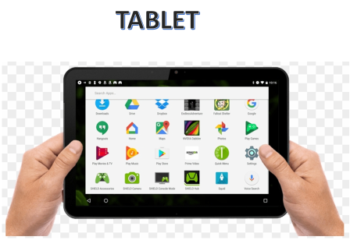  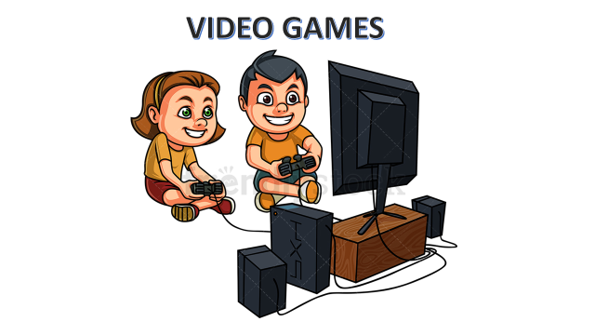  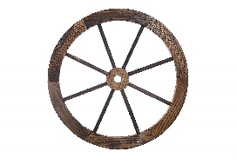  Teacher asks students the following question;  *What do you think is the best invention?  *Which one is better, Facebook or Instagram?  Teacher states that some inventions are better than others, even though they are all important. To compare inventions we can use superlatives and comparatives.  We can use Comparative adjectives to compare one noun to another noun. In these instances, only two items are being compared. For example, someone might say that "Facebook is better than Instagram."  Superlative adjectives are used to compare three or more nouns. They're also used to compare one thing against the rest of a group. Superlative adjectives demonstrate a higher level of comparison between entities. For example, "Facebook is the best social network of the world”  Teacher reviews comparative and superlative forms of the adjectives.  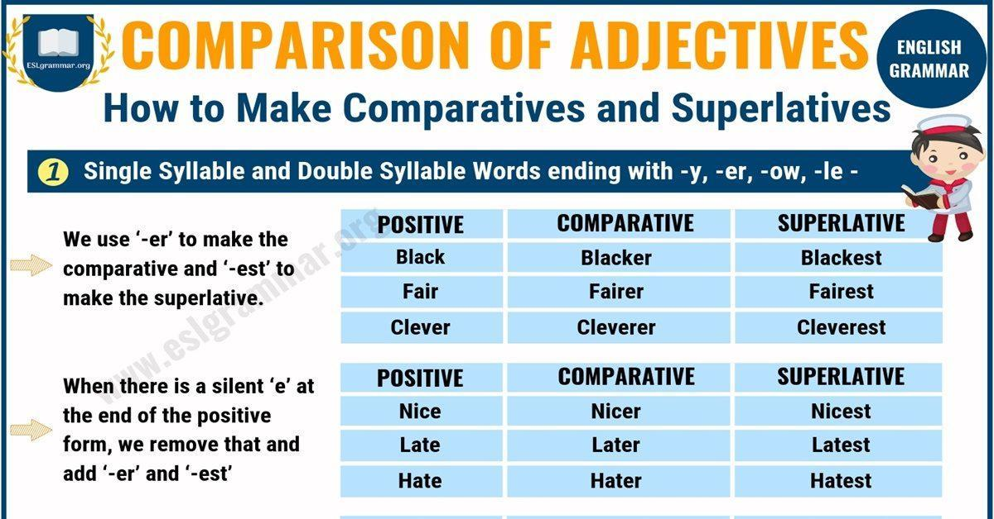  Taken from http://bit.ly/3bI4CH8  Students are going to create sentences using the vocabulary studied before.  For example:  In my opinion Instagram is more popular than snapshot.  I think that Facebook is the most common social media around the world.  You tube ______________________________  The telephone __________________________  Internet _______________________________  The wheel______________________________  Students can practice more in these links:  https://agendaweb.org/exercises/grammar/comparison/comparative-superlative-adjectives  https://www.eltbase.com/quiz/116_02.htm  Oral Comprehension  Pre-listening  Students are going to play the game Find someone who…..  Listening for the first time  You are watching a video about 10 ways internet have changed our life. Find the following pictures in the video. Identify the situation those pictures are related to and label each picture with the situation by writing the corresponding number in the circle.  https://youtu.be/P-ABeWFx5hI  Pair /Group feedback: Learners check  answers with their elbow partner.  Listening for the second time  Learners watch the video again. They have to complete the chart by writing key words or phrases that are related to situations that have changed over the years.  Situation Past Present  Pair/Group feedback: Learners share answers with the rest of the class.  Post-listening  Teacher tapes the following picture on the wall. Randomly, students answer the questions orally.  Written Comprehension  Pre-reading  Learners are going to complete this survey. How often do you _______?  always sometimes rarely never  Wash your clothes  Use a washing machine  Go to the river to wash your clothes  Wash your clothes by hand  Learners share their responses with the class. Teacher tells students that way before the invention of washing machines, people went down to the river and made use of the power of the current to wash their dirty laundry. They loosened the dirt by trampling on the clothing, beating it against a rock or through vigorous scrubbing.  At the time, people would make use of clean water to get their clothes clean. They merely soaked the clothes, pounded the garments, and then rinsed it in the water. Thankfully, automatic washing machines and dryers made life as we know it today a heck of a lot easier. Time will tell what kind of inventions will come our way and how we will wash our clothes in the future.  Reading for the first time  Teacher writes on the board the following task:  You JUST GOT a new washing machine for your grandma. She does not know how to operate it. read the following text to give her some instructions of things she should and shouldn’t DO WHEN using this new washing machine.  Using the popcorn technique learners are going to read the text aloud.  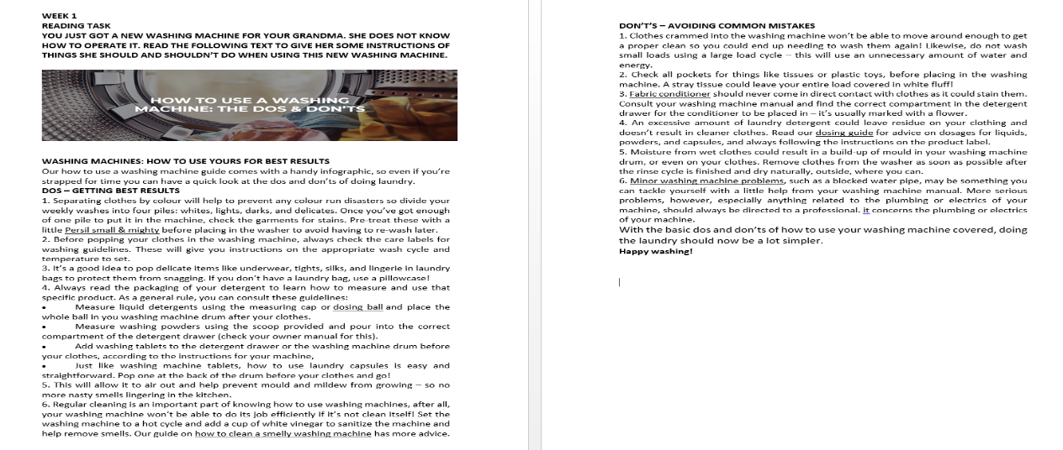  Taken from https://www.persil.com/uk/laundry/laundry-tips/washing-tips/use-washing-machine-dos-donts.html  Then, they are going to recognize some given instructions by answering the following questions:  - What are some of the guidelines you can consult to put detergent in the right place?  - What is the recommendation given if your washing machine presents some serious faults?  Pair/Group feedback: Learners share answers with the rest of the class.  Reading for the second time  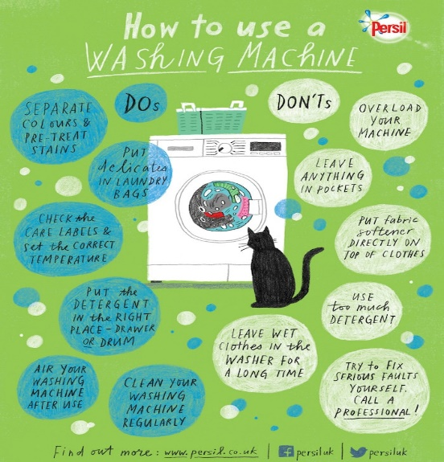  Learners are asked to make an infographic with the information from the text. They have to read the text again and make an infographic with DOS and DON´TS to easily guide her/his grandma on how to use a washing machine. Teacher shows learners an example of an infographic.  Learners will need:  - 1 white bond paper /cardboard  - Color pencils or markers  While learners are creating their infographic, teacher walks around the class to give feedback if necessary. Teacher makes a big sign with the word INVENTIONS and tapes it in a visible location (wall). Students tape their infographics on the wall.  Post Reading:  Learners are asked to make a list of ways modern washing machines have made life better? Teacher posts on the board the following question:  How have modern washing machines made life better?  Students read aloud their answers.  Spoken Production  Planning  Learners watch a video https://www.youtube.com/watch?v=o0etimvtD74 about a TV show called Shark Tank. They are going to create their own invention and present it to the class. Teacher shows them the PowerPoint presentation (oral presentation-an invention-week 1) to guide their job. Teacher tells them to think of an invention, there are some pictures in the first slide to give them some inspiration. Then, students are having 25 minutes to write and practice a presentation using the language on slide 2 and any other language they can think of. Teacher reinforces new vocabulary and explains the way they can use connecting words to express cause and effect, contrast, etc. Teacher tapes on the wall information about linking words. Students then present their inventions to the rest of the class, who can decide, Shark Tank style, if they want to invest or not.  Organizing  Learners are going to use the following guidelines to organize their presentation:  *Brainstorm and outline your ideas  *Research: if you have internet access/mobile  *Write an outline and think on the following questions:  - What is the name of your invention?  - How does it work?  - What is the purpose or function does it have (uses)?  - How would you describe it?  *Plan any visual(drawing or picture)  *Write a draft (make sentences)  Rehearsing  Once learners have their draft done and the presentation is ready, they have some minutes to practice, they get in pairs to practice before presenting. It is important to give feedback to each other while rehearsing.  Producing  At the end each student presents his/her invention and the class decides if they are willing to invest or not. Students tape their drawings and inventions on the wall.  . |  |  |  |  | 5´  5’  5´  25’  15´  10´  10´  5´  5´  15´  32´  20´  10´  5´  30´
Integrated Project |  |  |  |  |  |  |  |  | Time
Phase: 1 Participating  Teacher explains and writes on the board the options of projects learners have. Teacher can also give a copy with the information in order to save time. Learners are asked to think about the project.  Suggested Integrated Mini Project  -“ My new inventions Pictionary” (groups of 3/4)  Task: Create in power point an illustrated dictionary about the most important inventions that have influenced our lives. Include The invention, year of creation, authors, benefits and images. Include at least 10 inventions  -“Role play video, life without toilet paper?” (groups of 3/4)  Task: You and your classmates are going to make a video in which you play a life without all those inventions that we use in daily that we take them from granted; for example, toothpaste, toilet paper, washing machine, soap, stove, etc. Make creative and funny scenarios to make people aware the importance of those inventions. At the end, include a clip in which you and your friends tell a little description of the inventions and when they were created.  -Advertisement “The top ten tips when using internet” (pairs)  Task: You and your partner are in a team from a campaign that intends to make people conscious about the use of internet. So, you must create an ad giving 10 tips when using the internet, include pictures representing every tip. The ad could be digital or printed. |  |  |  |  |  |  |  |  | 3´
Reflective Teaching
What worked well |  |  | What didn’t work well |  |  |  | How to improve
Enduring Understanding Reflection
How well did the learners progress in their understanding of the Enduring Understanding?

Learner Self-Assessment
Unit 2-Week #1
I can… | Yes | In progress | No
label detailed oral instructions and visuals regarding technology.
identify key words and phrases of detailed oral instructions about technology.

recognize simple instructions related to technology

distinguish simple instructions (DOS and DON´TS) related to technology.

plan the information and visuals to give a presentation about inventions, living in a tech world and the next wave of innovations.

organize the information and visuals to give a presentation about inventions, living in a tech world and the next wave of innovations.

make sentences with the information to give a well-organized presentation about inventions, living in a tech world and the next wave of innovations with the appropriate linkers or connecting words.

give a well-organized presentation about inventions, living in a tech world and the next wave of innovations.

Essential Question:
How can technology make us closer or further apart?

Find someone who has…..
Name of student
Used a computer
Traveled by train
used internet every day
Played video games
Had a Smart phone
Used a Tablet daily
Watched TV
Used a PSP
Had lightbulbs in his/her house.
Used a compass.
Traveled by plane

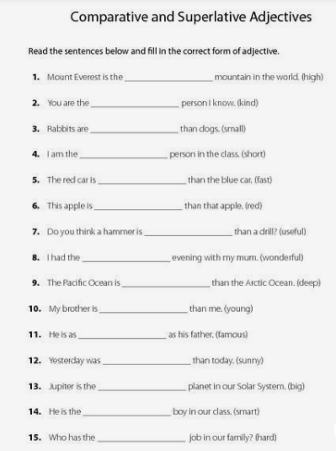

Taken from: https://www.pinterest.pt/pin/735071970406244724/

Listening Task
Week 1
You are watching a video about 10 ways internet have changed our life. Find the following pictures in the video. Identify the situation those pictures are related to and label each picture with the situation by writing the corresponding number in the circle

- A few clicks on your phone – and a toilet paper is delivered to you by one of your family members. Just don’t forget to take your phone to the bathroom.

- Nowadays, you can download three seasons of your favorite show altogether and binge on them during the weekend.

- These days, it’s almost impossible to make kids play outside the house.

- Years ago, you had to call a newspaper to place your ad to sell a car.

Survey
How often do you…? | always | sometimes | rarely | never
Wash your clothes
Use a washing machine
Go to the river to wash your clothes
Wash your clothes by hand

Survey
How often do you…? | always | sometimes | rarely | never
Wash your clothes
Use a washing machine
Go to the river to wash your clothes
Wash your clothes by hand

Survey
How often do you…? | always | sometimes | rarely | never
Wash your clothes
Use a washing machine
Go to the river to wash your clothes
Wash your clothes by hand

week 1

Reading task

You JUST GOT a new washing machine for your grandma. She does not know how to operate it. read the following text to give her some instructions of things she should and shouldn’t DO WHEN using this new washing machine.

WASHING MACHINES: HOW TO USE YOURS FOR BEST RESULTS
Our how to use a washing machine guide comes with a handy infographic, so even if you’re strapped for time you can have a quick look at the dos and don’ts of doing laundry.

DOS – GETTING BEST RESULTS
1. Separating clothes by colour will help to prevent any colour run disasters so divide your weekly washes into four piles: whites, lights, darks, and delicates. Once you’ve got enough of one pile to put it in the machine, check the garments for stains. Pre-treat these with a little Persil small & mighty before placing in the washer to avoid having to re-wash later.
2. Before popping your clothes in the washing machine, always check the care labels for washing guidelines. These will give you instructions on the appropriate wash cycle and temperature to set.

3. It’s a good idea to pop delicate items like underwear, tights, silks, and lingerie in laundry bags to protect them from snagging. If you don’t have a laundry bag, use a pillowcase!
4. Always read the packaging of your detergent to learn how to measure and use that specific product. As a general rule, you can consult these guidelines:
- Measure liquid detergents using the measuring cap or dosing ball and place the whole ball in you washing machine drum after your clothes.
- Measure washing powders using the scoop provided and pour into the correct compartment of the detergent drawer (check your owner manual for this).
- Add washing tablets to the detergent drawer or the washing machine drum before your clothes, according to the instructions for your machine,
- Just like washing machine tablets, how to use laundry capsules is easy and straightforward. Pop one at the back of the drum before your clothes and go!

5. This will allow it to air out and help prevent mould and mildew from growing – so no more nasty smells lingering in the kitchen.
6. Regular cleaning is an important part of knowing how to use washing machines, after all, your washing machine won’t be able to do its job efficiently if it’s not clean itself! Set the washing machine to a hot cycle and add a cup of white vinegar to sanitize the machine and help remove smells. Our guide on how to clean a smelly washing machine has more advice.

DON’T’S – AVOIDING COMMON MISTAKES
1. Clothes crammed into the washing machine won’t be able to move around enough to get a proper clean so you could end up needing to wash them again! Likewise, do not wash small loads using a large load cycle – this will use an unnecessary amount of water and energy.

2. Check all pockets for things like tissues or plastic toys, before placing in the washing machine. A stray tissue could leave your entire load covered in white fluff!

3. Fabric conditioner should never come in direct contact with clothes as it could stain them. Consult your washing machine manual and find the correct compartment in the detergent drawer for the conditioner to be placed in – it’s usually marked with a flower.
4. An excessive amount of laundry detergent could leave residue on your clothing and doesn’t result in cleaner clothes. Read our dosing guide for advice on dosages for liquids, powders, and capsules, and always following the instructions on the product label.
5. Moisture from wet clothes could result in a build-up of mould in your washing machine drum, or even on your clothes. Remove clothes from the washer as soon as possible after the rinse cycle is finished and dry naturally, outside, where you can.
6. Minor washing machine problems, such as a blocked water pipe, may be something you can tackle yourself with a little help from your washing machine manual. More serious problems, however, especially anything related to the plumbing or electrics of your machine, should always be directed to a professional. It concerns the plumbing or electrics of your machine.
With the basic dos and don’ts of how to use your washing machine covered, doing the laundry should now be a lot simpler.
Happy washing!

Answer the following questions:

- What are some of the guidelines you can consult to put detergent in the right place?

- What is the recommendation given if your washing machine presents some serious faults?

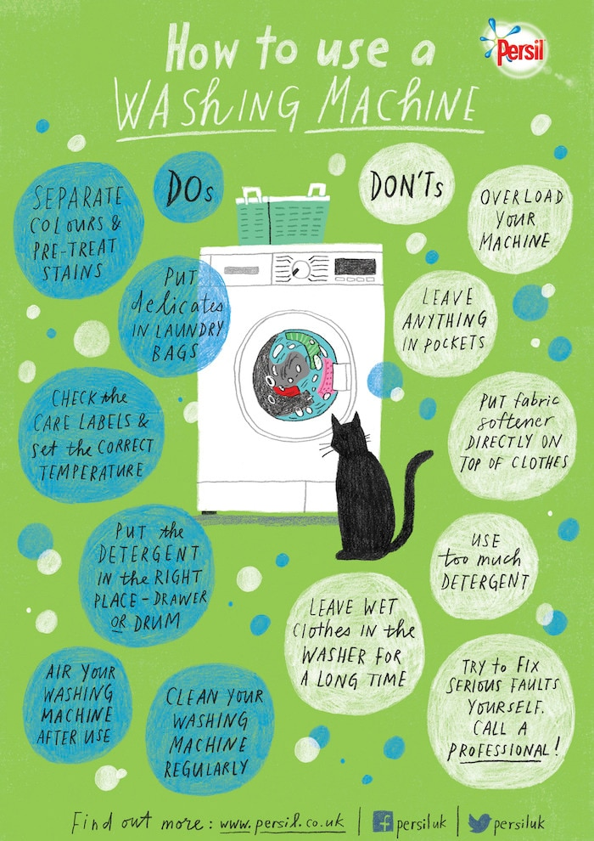

Power Point Presentation

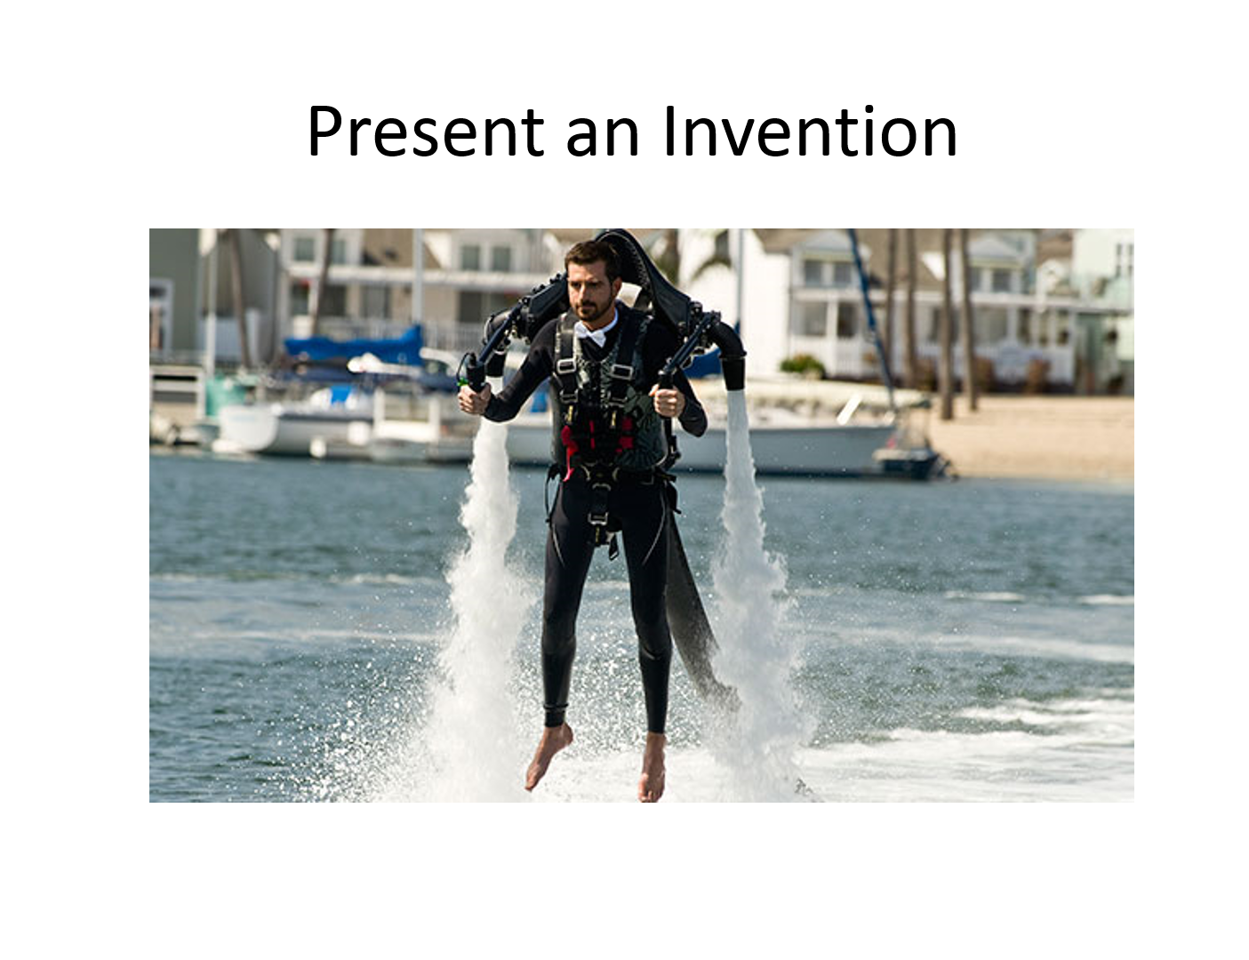

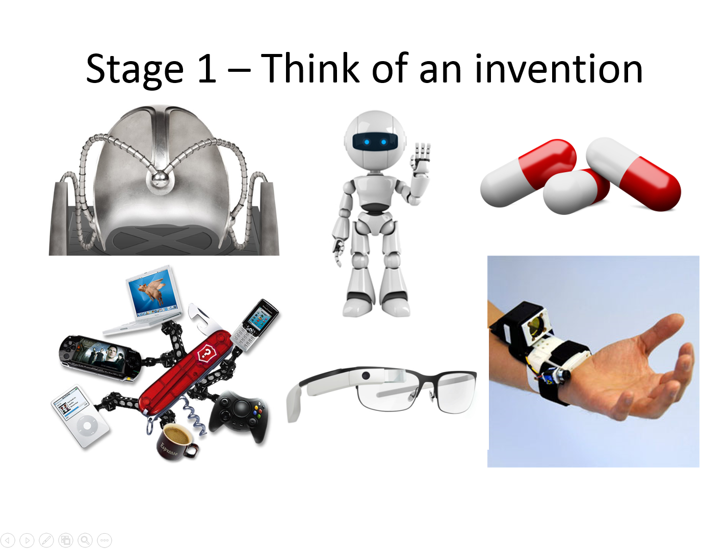

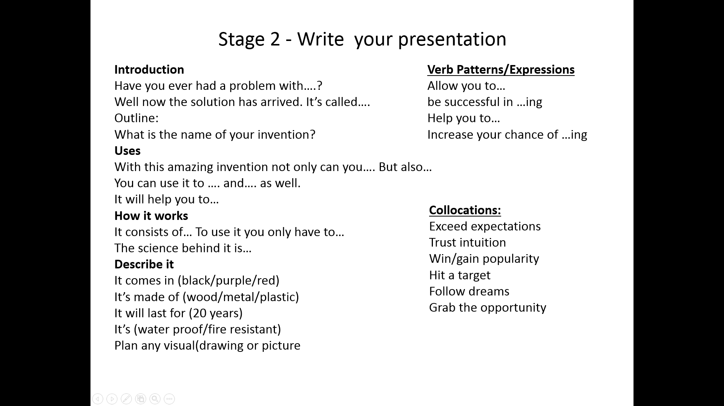

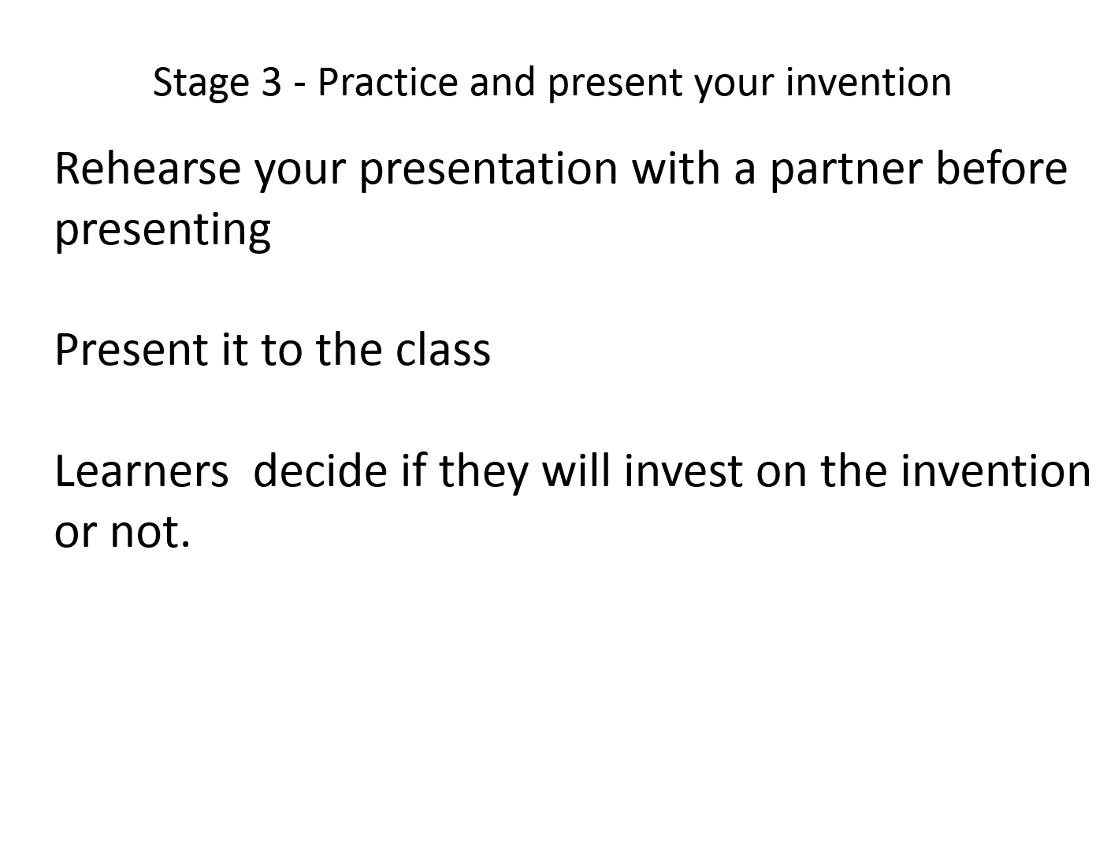

Didactic Planning
Week # 2
Term: I |  | Level: Eleventh |  |  | Unit:2 |  |  | Week: 2
Domain: Socio-Interpersonal and Academic |  |  | Scenario: From the Wheel to the Drone |  |  | Theme: Living in a Tech World
Enduring Understanding: Technology requires responsible users for an effective ethical response.
Essential Question: How can technology make us closer or further apart?
General Competences

Responsible Citizenship ( )
Life Competences ( )
Competences for Employability ( )

Learn to Know |  |  | Learn to Do |  |  | Learn to Be and Live in Community
Grammar &Sentence Frames  Will and going to for prediction  I won´t use on line dating sites because I like romantic, traditional and formal dating.  In the future, the transportation is going to be better  Vocabulary  Living in a Tech World  Pros and cons when you are on line (ethics, internet usage, privacy, cyberbullying, Human relationships versus technology, addictions and dependency, dating, social networks, etc.)  Facebooking, Googling  To tweet, Update, Best technology  to be wise users  To be responsible  Safety, Risk  Information  Selfies |  |  | Function  - Expressing opinions, agreeing and disagreeing about living in a tech world  Discourse Markers  Connecting words expressing cause and effect, contrast, etc.:  On the other hand, we could buy a flash memory and some ink for the printer.  However, this depends on the budget you have to get a new tablet.  Markers to structure informal spoken discourse  Right |  |  | Psycho-social  Engaging in true face-to-face communication and quality moments over digital means.  Sociocultural  Demonstrating disposition to help each other’ within collaborative environments while working with technology.  Idioms  ~Silver-surfer
Assessment Strategies & indicators of learning  (Diagnostic, formative, summative) | Goals |  | Pedagogical Mediation/ Didactic Sequence |  |  |  |  |  | Time
Learner…  L.2. extracts the main points of stories and other text read aloud in the classroom.  Indicators of learning:  Gets main points of videos or conversations related to living in a tech world, safety, and the next wave of innovations.  Recognizes key words of videos or conversations related to living in a tech world, safety, and the next wave of innovations.  Identifies the topic of videos or conversations related to living in a tech world, safety, and the next wave of innovations.  R.2. interprets relations between main ideas and supporting ideas in topical articles and reports  Indicators of learning:  Distinguishes linking words in topical articles and reports about technological advances.  Identifies the topic in topical articles and reports about technological advances. Recognizes important ideas in topical articles and reports about technological advances.  Infers relations between main ideas and supporting ideas in topical articles and reports about technological advances  Gets ideas that support a point of view in topical articles and reports about technological advances.  Distinguishes ideas that go against a point of view in topical articles and reports about technological advances.  SI.2. expresses opinions/makes suggestions while actively participating in-group work.  Indicators of learning:  Plans the language and content to give opinions or make suggestions about inventions, living in a tech world, safety and the next wave of innovations while actively participating in group work.  Makes sentences about inventions, living in a tech world, safety and the next wave of innovations while actively participating in-group work.  Expresses ideas to give opinions/make suggestions about inventions, living in a tech world, safety and the next wave of innovations while actively participating in-group work. | Learner can …  L.2. understand the main points of stories and other text read aloud in the classroom related to inventions, living in a tech world, safety, and the next wave of innovations.  R.2. understand relations between main ideas and supporting ideas in topical articles and reports in which the authors are presenting and defending a particular point of view in regards to technological advance  SI.2. express opinions and make suggestions about inventions, living in a tech world, safety, and the next wave of innovations while actively participating in group work. |  | Pre-teaching  Routine: Checking attendance, checking in with Ls, teacher sticks the Essential Question on the wall and shares Can Do’s, and class agenda, etc.  Participating: Warm up  Students match the gadgets with their corresponding name.  Taken from  https://www.liveworksheets.com/  worksheets/en/English_as_a_Second_Language_  (ESL)/Gadgets_and_electronic_devices/Match_the  _gadgets_yk453705db  Engaging: Activation of prior knowledge  The teacher shares the goals and indicators for the week. Teacher explains that this week we are talking about living in a tech world and how technology has impacted the world. Technology plays an important role in society today. It has positive and negative effects on the world and it impacts daily lives. We are living in an era where technological advances are common. The internet and cell phones are some examples. Teacher asks for more examples and write them down on the board. Teacher also writes “Technology In Our Life Today And How It Has Changed” and students are asked to brainstorm ideas and give more examples on how life has changed. For example:  Technology has changed how we:  Communicate  Date  Pay bills and transfer money  watch TV  live in and outside of our homes  shop  Introducing.  Teacher states that technology has changed a lot over the years and that it will continue changing. Teacher writes the following questions on the board:  How far will technology advance in 20, 30, even 50 years from now?  How will it affect our lives?  Students along with the teacher make a list of some Future Technology Predictions and Scenarios predicted by science fiction writers, futurists and technology experts.  Some examples are:  Computers that predict the future  Extended/eternal life  Human cloning  Alien contact  Digital money  Teacher can find more examples at https://www.futureforall.org/future-technology-predictions.html  Teacher explains that in order to make predictions we use Will and going to. Students watch a video with the explanation. https://www.youtube.com/watch?v=AwP4djLuwAs  Teacher makes sure learners understood the explanation and give more feedback if needed.  Learners are asked to write some sentences using future technology predictions with the following statements. Then, they switch papers with their elbow partner, read the statements and tell him/her if they agree or disagree(use the expressions learned in unit 1)  Examples;  Online dates: I won´t use on line dating sites because I like romantic, traditional and formal dating.  Tele transportation: In the future, the tele transportation is going to be possible.  Pets that live forever: I think pets won´t live forever.  Plasma Engines: We are going to have plasma engines. Tico physicist Franklin Chang Diaz is one step closer to this reality.  Phone implant:______________________________  Time machine:_______________________________  Internet-connection implant:______________________________  Eternal life:________________________________  Tourism to Mars:____________________________  Students watch the video https://www.youtube.com/watch?v=qyzaLMHxVw0  Teacher pauses it before each clip, so students get the chance to read the possible answers. Every time it says "What will happen?" teacher pauses the video, so students get more than 4 seconds to choose the predicted answer.  Oral Comprehension  Pre- listening:  Learners are going to match some vocabulary with its corresponding meaning.  Taken from https://learnenglishteens.britishcouncil.org/sites/teens/files/technology_addiction_-_exercises.pdf  Listening for the first time:  Learners are going to watch the video https://youtu.be/J95DS4PdQZQ and check if the given statements are true or false.  Taken from https://learnenglishteens.britishcouncil.org/sites/teens/files/technology_addiction_-_exercises.pdf  Pair/group Feedback:  Learners check answers orally.  Listening for the second time:  Learners watch the video again and complete the sentences with a number from the box.  Taken from https://learnenglishteens.britishcouncil.org/sites/teens/files/technology_addiction_-_exercises.pdf  Post- Listening:  Based on the information from the video, learners identify the main topic and write it down. They share their answers orally.  Written Comprehension  Pre-reading  Students will participate in a competition. They are asked to scan the text and circle all linking words they can find. Teacher tapes the linking word list on the wall and adds more if necessary. Students share answers orally and wins the one who found more linking words. Teacher gives the winner a prize. Teacher gives learners a copy with the text and the instructions.  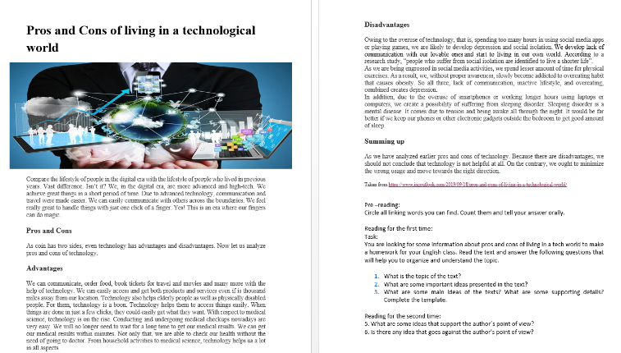  Reading for the first time:  Teacher presents the following task:  You are looking for some information about pros and cons of living in a tech world to make a homework for your English class. Read the text provided before and answer the following questions that will help you to organize and understand the topic.  - What is the topic of the text?  - What are some important ideas presented in the text?  - What are some main ideas of the texts? What are some supporting details? Complete the template.  Pair/Group Feedback: Teacher walks around the class to give feedback if necessary. Randomly, learners give answers.  Reading for the second time:  Learners read the text for the second time and answer the following two questions:  5. What are some ideas that support the author´s point of view?  6. Is there any idea that goes against the author’s point of view?  Teacher clarifies how to look for the author´s point of view using a poster. Teacher can tape the poster on the wall.  Post- reading:  Learners are asked to think about a technological invention. They are asked to draw and show it to the class. The rest of the class will guess what is the invention represented in the drawing. Students raise their hands to give answers. The student who guesses more inventions wins a prize.  Oral production:  Spoken Interaction  Planning  Teacher tells students that we are going to review a topic from the last unit. This topic is giving opinions. Learners watch a video https://www.youtube.com/watch?v=jwFJ9nfJNZ0 and then brainstorm examples of different ways of giving opinions they found on the video. Teacher tapes on the wall a poster with expression to give opinions.  In pairs, learners ask and answer the following questions. Learners take turns.  - What is your opinion about living without telephones?  - What do you think we will do without computers?  - What is your opinion about cloning humans?  Teacher explains that today we are learning about how to make suggestions.  Learners watch a video https://www.youtube.com/watch?v=2zyca6fGo4A and take notes about expressions used to make suggestions. They read their notes aloud and teacher checks their answers. Teacher tapes a poster (make suggestion) on the wall.  Students are going to identify phrases for making suggestions. They underline the phrases.  Learners are going to create phrases for accepting and rejecting suggestions by matching the beginning and end together.  Teacher reviews the language and elicits other phrases the students could use to make suggestions.  Organizing  Students create six suggestions of their own related to the use of technology. Then, take it in turns to make, accept and reject the suggestions with their partner.  Teacher makes sure students understood how to express opinions and make suggestions. Teacher gives feedback or repairs if necessary. Then, learners start a group discussion in the next stage.  Rehearsing  Learners practice for the next activity. Students are given 2 minutes to write down a problem that can be solved through the use of technology. Teacher states a problem and chooses one student to give his/her opinion and make a suggestion. This student states a new problem and chooses another students to give opinions and make suggestions. The activity continues for 5 more minutes.  Teacher: My grandpa is a silver surfer, but he does not have time to go to the bank and he needs to make some urgent transactions. What can he do?  Interacting  Class will be divided into small groups. Using the expressions from the previous activity, each group discusses three problems that can be solved through the use of technology and makes, accepts and rejects suggestions and expresses opinions. The students then decide on the best solution for each situation and tell the class what they decided and why. Teacher checks understanding of the activity.  Teacher writes the three problems on the board. All groups discuss the same problems:  - I HATE shopping for clothes, particularly the slow, painful process of trying things on to finding items that fit my body. What can I do?  - I´m feeling homesick. I really miss my family. What can I do to keep in touch with them?  - My house is really dirty. I don’t have time to clean it. What can I do? |  |  |  |  |  | 5´  5´  10´  25´  5´  5´  5´  5´  5´  5´  15´  15´  10´  40´  5´  5´  10´  7´  25´
Integrated Mini-Project |  |  |  |  |  |  |  |  | Time
 |  |  |  |  |  |  |  |  | 3´
Reflective Teaching
What worked well |  |  |  | What didn’t work well |  |  | How to improve

Learner Self-Assessment
Unit 2-Week #1
I can… | Yes | In progress | No
get main points of videos or conversations related to living in a tech world, safety, and the next wave of innovations
recognize key words of videos or conversations related to living in a tech world, safety, and the next wave of innovations.
identify the topic of videos or conversations related to living in a tech world, safety,
distinguish linking words in topical articles and reports about technological advances.
identify the topic in topical articles and reports about technological advances.
recognize important ideas in topical articles and reports about technological advances.
infer relations between main ideas and supporting ideas in topical articles and reports about technological advances
get ideas that support a point of view in topical articles and reports about technological advances.
distinguish ideas that go against a point of view in topical articles and reports about technological advances.
plan the language and content to give opinions or make suggestions about inventions, living in a tech world, safety and the next wave of innovations while actively participating in group work.
make sentences about inventions, living in a tech world, safety and the next wave of innovations while actively participating in-group work.
express ideas to give opinions/make suggestions about inventions, living in a tech world, safety and the next wave of innovations while actively participating in-group work.

What do you think will happen?
Watch the videos and guess what will happen next. Choose one out of three answers for each video.
Video 1
- The boy will play with the Christmas ball.
- The boy will eat the Christmas ball.
- The boy will throw the Christmas ball on the floor.
Video 2
- The child will run into the dog.
- The child will eat the dog’s treat.
- The child will fall over the dog.
Video 3
- The woman will drop the cake on the floor.
- The woman will sing Happy Birthday.
- The woman will smash her face into the cake.
Video 4
- The girl will run into the wall.
- The girl will fall over the dog.
- The girl will fall on the floor.
Video 5
- The man will drop the turkey on the floor.
- The man will drop the turkey out of the window.
- The man will drop the turkey on his wife.
Video 6
- The girl will blow out the candles.
- The girl will burn her hair.
- The girl will smash her face into the doughnut.
Video 7
- The doll will fly into the fireplace.
- The doll will fall on the floor.
- The doll will fly against the girl's head.
Video 8
- One girl will fall into the water.
- A car will splash water at the girls.
- One girl will fall on the grass.

Pros and Cons of living in a technological world

Compare the lifestyle of people in the digital era with the lifestyle of people who lived in previous years. Vast difference. Isn’t it? We, in the digital era, are more advanced and high-tech. We achieve great things in a short period of time. Due to advanced technology, communication and travel were made easier. We can easily communicate with others across the boundaries. We feel really great to handle things with just one click of a finger. Yes! This is an era where our fingers can do magic.

Pros and Cons
As coin has two sides, even technology has advantages and disadvantages. Now let us analyze pros and cons of technology.

Advantages
We can communicate, order food, book tickets for travel and movies and many more with the help of technology. We can easily access and get both products and services even if is thousand miles away from our location. Technology also helps elderly people as well as physically disabled people. For them, technology is a boon. Technology helps them to access things easily. When things are done in just a few clicks, they could easily get what they want. With respect to medical science, technology is on the rise. Conducting and undergoing medical checkups nowadays are very easy. We will no longer need to wait for a long time to get our medical results. We can get our medical results within minutes. Not only that, we are able to check our health without the need of going to doctor. From household activities to medical science, technology helps us a lot in all aspects.

Disadvantages
Owing to the overuse of technology, that is, spending too many hours in using social media apps or playing games, we are likely to develop depression and social isolation. We develop lack of communication with our lovable ones and start to living in our own world. According to a research study, “people who suffer from social isolation are identified to live a shorter life”.
As we are being engrossed in social media activities, we spend lesser amount of time for physical exercises. As a result, we, without proper awareness, slowly become addicted to overeating habit that causes obesity. So all three, lack of communication, inactive lifestyle, and overeating, combined creates depression.
In addition, due to the overuse of smartphones or working longer hours using laptops or computers, we create a possibility of suffering from sleeping disorder. Sleeping disorder is a mental disease. It comes due to tension and being awake all through the night. It would be far better if we keep our phones or other electronic gadgets outside the bedroom to get good amount of sleep.

Summing up
As we have analyzed earlier pros and cons of technology. Because there are disadvantages, we should not conclude that technology is not helpful at all. On the contrary, we ought to minimize the wrong usage and move towards the right direction.

Taken from https://www.incoutlook.com/2019/09/18/pros-and-cons-of-living-in-a-technological-world/

Pre –reading:
Circle all linking words you can find. Count them and tell your answer orally.

Reading for the first time:
Task:
You are looking for some information about pros and cons of living in a tech world to make a homework for your English class. Read the text and answer the following questions that will help you to organize and understand the topic.

- What is the topic of the text?
- What are some important ideas presented in the text?
- What are some main ideas of the texts? What are some supporting details? Complete the template.

Reading for the second time:
5. What are some ideas that support the author´s point of view?
6. Is there any idea that goes against the author’s point of view?

Term: I |  | Level: Eleventh |  |  | Unit:2 |  |  | Week: 3
Domain: Socio-interpersonal and Academic |  |  |  | Scenario: From the Wheel to the Drone |  | Theme: Safety First
Enduring Understanding: Technology requires responsible users for an effective ethical response.
Essential Question: How can technology make us closer or further apart?
General Competences

Responsible Citizenship ( )
Life Competences ( )
Competences for Employability ( )

Learn to Know |  |  |  | Learn to Do |  | Learn to Be and Live in Community
Grammar & Sentence Frames  Imperatives and infinitives to give instructions or suggestions.  Make sure to…  Don’t forget to…  Remember to...  Don’t forget to…  Try not to…  Useful expressions when giving advice.  Be careful  Don’t share …  Respect  Advice  To denounce  To report  To communicate  Don’t expose  Be smart  Both, either, neither  Both, the internet and the wheel are considered two of the most revolutionary invention of all.  In a near future, neither gasoline nor wires will be used.  Either gas or solar energy will be too important for housing electricity  Vocabulary  Narcissism, Bullying, Fake news, Privacy, Password, Settings, Browser History, source, software, secret code, recharge, update… |  |  |  | Function  - Describing measures to take into account to surf the web safely.  Discourse Markers  Linkers: sequential – past time (later)  He finished the e-mail and then went out for a while.  Later, he looked at it again, to see if he had missed anything important.  After that, he changed the text a little.  Finally, he spellchecked it and send it.  Connecting words expressing cause and effect, contrast, etc.:  On the other hand, we could buy a flash memory and some ink for the printer.  However, this depends on the budget you have to get a new tablet. |  | Psycho-social  Valuing economic, sociocultural and ethical implication when using the latest tech innovations.  Sociocultural  Valuing using conventional ways to communicate with others.  Proverbs / Quotes  The real problem is not whether machines think but whether men do. ~B.F. Skinner
Assessment Strategies & indicators of learning  (Diagnostic, formative, summative) | Goals |  |  | Pedagogical Mediation/ Didactic Sequence |  |  |  |  | Time Total:  200 min  (5 lessons)
Learner…  SP.2. explains how internet is used in a safe way.  Indicators of learning:  S.P.2.1. Plans the language, content and resources to explain how internet is used in a safe way in a well-organized podcast.  S.P.2.2. Makes sentences to explain how internet is used in a safe way in a well-organized podcast with the appropriate linkers or connecting words.  S.P.2.3. Expresses ideas to explain how internet is used in a safe way in a well-organized podcast.  W.1. writes short, detailed descriptions about objects of interest explaining the advantages and disadvantages involved.  Indicators of learning:  W.1.1. Brainstorm ideas of advantages or disadvantages of using technological devices/applications.  W.1.2. Drafts a detailed description about objects of interest explaining the advantages and disadvantages involved including connecting words to express cause, effect and contrast.  W.1.3. Revises a detailed description about objects of interest explaining the advantages and disadvantages involved by checking subject-verb agreement, pronoun and article agreement, capitalization, sentence sense, text structure, word order, content, punctuation and use of commas.  W.1.4. Edits a detailed description about objects of interest explaining the advantages and disadvantages involved before publishing. | Learner can …  SP.2. explain how internet is used in a safe way.  W.1. write short, detailed descriptions about objects of interest explaining the advantages and disadvantages involved (e.g. as digital games, innovations, inventions). |  |  | Pre-teaching  Routine: Checking attendance, checking in with Ls, T posts the Can Do’s on the board, and class agenda, etc.  Participating: Warm up  Learners watch the following memes about social media and reflect about the use of social network.  Useful questions to elicit learners to give their opinion:  - What do you think about the following pictures?  - Do you believe in everything posted on Social Networks?  - Are most people showing the real self?  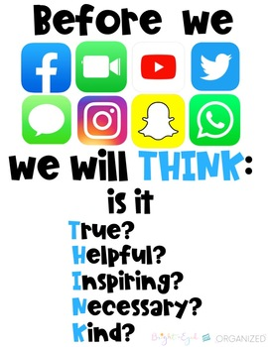  - What do you consider is the number one rule when using social networks?  Teacher writes on the board;  The real problem is not whether machines think but whether men do. ~B.F. Skinner  Orally, students brainstorm their ideas about the phrase. Teacher relates the phrase with the topic.  Engaging: Activation of prior knowledge.  Teacher projects a video where the learners listen some teenagers talking about their experiences when using social media. https://youtu.be/GGGDfciqyvw  After watching the video students point out positive and negative aspects of social media.  Negative aspects Positive aspects  Introducing  The teacher gives/presents students strips with some safety tips to take into account when dealing with specific social media issues, learners arrange each tip by pasting each tip on the corresponding issue.  Narcissism Bullying Fake news Privacy  Speak up. Try to stay calm. Develop a critical mindset. Don’t share your Password  Set boundaries. Be a friend Check the source. Sign-Out of Your Accounts  Find support. Tell someone you trust See who else is reporting the story. Change your Facebook Settings  Demand action. Keep yourself surrounded by people. Examine the evidence. Clear your Browser History.  Teacher explains that when someone wants gives tips or suggestions to surf the web safely, people can use imperatives and infinitive form of verbs to give instructions or suggestions.  Example:  Imperatives + Infinitives  Make sure to have a strong password.  Don’t forget to set the Instagram privacy settings.  Try not to visit unknown pages.  Remember…  Don’t forget…  After that, let learners work in pairs and do the following grammar practice. Then, the whole class checks the answers.  Spoken Production  Planning  Teacher explains that today they are practicing about giving advice. Teacher reviews the expressions learned from the previous unit and explains the task (post cast radio show).  Organizing.  The teacher presents the following statistic about social media:  Social media sites like Facebook, Twitter and Instagram allow teens to share pictures, posts and communicate with friends. However, they are also a hotspot for social media bullying. And the bullying behavior doesn’t always start and stop with teenagers. Many Instagram Influencers are subjected to dozens, if not hundreds and thousands, of rude and bullying comments daily on their accounts. Instagram is known for posting pictures to share with friends, family and followers. However, when teens are using such an app to make hurtful comments, spread rumors and participate in other forms of verbal/written bullying, it can create lasting emotional scars for the victim.  Social Media Bullying - Bullying Statistics  Considering the previous case, students are asked to participate in a podcast radio show reflecting about the use of internet and social network giving advice of how to surf the web and those social network sites safely. In this stage, students organize and write their ideas. Teacher reminds them to use linkers, the previous grammar and the following phrases to give create sentences giving advice.  Be careful  Don’t share …  Respect  Advice  To denounce  To report  To communicate  Don’t expose…  Be smart…  Rehearsing  Learners practice how they would deliver their podcast. In this stage, they can record their speech to check their pronunciation, stress, intonation, and rhythm. Teacher provides feedback to reinforce the speaking aspects (pronunciation, stress, intonation, and rhythm) before they record their definite podcast.  Producing  Learners record their definite podcasts with information required. Then, learners listen to their classmates’ audios and finally, the whole class make a list of rules or protocols to use the internet safety.  Written production  Pre-writing  Set the scenario: Learners are asked to write a short article for an important technology magazine about a social network/digital game/website/ or other technological object of interest. They are asked to give a brief description of the chosen subject matter. They start with a brainstorm of ideas and explain the advantages and disadvantages of using it. In this stage, students make an outline with ideas.  Drafting  Students start writing their first draft, teacher elicits students to use connecting words to express causes and effects of using the technological device/application.  Revising  In pairs, learners check their first article using a checklist. Teacher monitors the process and provides feedback.  Editing/Publishing  Learners edit their article and publish it in a clean sheet of paper. They can add a picture of the technological device/application they chose. Then, they paste it in an expository board for the others to read the articles.  Finally, they decide which technological device/application gives more advantages and which one gives more disadvantages. (Elicit students to use Both, either, neither to make comparisons of the different devices/applications they wrote about) |  |  |  |  | 5´  10´  20’  35’  45’  80’
Integrated Mini-Project |  |  |  |  |  |  |  |  | Time
Phase: 2  Learners start planning, negotiating and finding information collaboratively about the language content and strategies, resources and organizing the work to distribute assignments among the group members. They assign roles of participants, make lists of resources they need, learners do some online research about the selected topic. |  |  |  |  |  |  |  |  | 5´
Reflective Teaching
What worked well |  |  | What didn’t work well |  |  |  | How to improve
Enduring Understanding Reflection
How well did the learners progress in their understanding of the Enduring Understanding?

Learner Self-Assessment
Week #3
I can… | Yes | In progress | No
plan the language, content and resources to explain how internet is used in a safe way in a well-organized podcast.
make sentences to explain how internet is used in a safe way in a well-organized podcast with the appropriate linkers or connecting words.
express ideas to explain how internet is used in a safe way in a well-organized podcast.
brainstorm ideas of advantages or disadvantages of using technological devices/applications.
draft a detailed description about objects of interest explaining the advantages and disadvantages involved including connecting words to express cause, effect and contrast.
revise a detailed description about objects of interest explaining the advantages and disadvantages involved by checking subject-verb agreement, pronoun and article agreement, capitalization, sentence sense, text structure, word order, content, punctuation and use of commas.
edit a detailed description about objects of interest explaining the advantages and disadvantages involved before publishing.

Narcissism | Bullying | Fake news | Privacy

Tell someone you trust.
Set boundaries.

Check the source.
Sign-Out of Your Accounts
See who else is reporting the story.
Don’t Password
Change your Facebook Settings.
keep yourself surrounded by people.
Speak up.

Examine the evidence.
Find support.
Try to stay calm.
Develop a critical mindset.
Clear your Browser history.
Demand action.

Be a friend.

Infinitives grammar practice.
Use the following information to create instructions or suggestions using imperatives and infinitives.
- Write down/ secret code.
______________________________________________________________
- Turn the computer off/ after using it.
______________________________________________________________
- Get the computer wet/ or the keys may get stuck.
______________________________________________________________
- Recharge the cell phone battery/before it dies.
______________________________________________________________
- Keep the software updated.
______________________________________________________________
Write three suggestions about these three situations using the expressions from the previous practice.
- Open a new Facebook account:
____________________________________________________
- Working in a document in Word.
____________________________________________________
- Using WhatsApp
____________________________________________________
Activities adapted and retrieved from Interchange 2, 4th edition, p. 46,47.

Revising and editing:
Editing checklist
The paragraph… | Yes | No | Partially
is well capitalized
has appropriate connectors/linkers
has correct verb conjugations (subject-verb agreement)
has agreement between pronouns and articles
has clear and coherent sentences
has correct word order (nouns/adjectives)
fulfills with the information asked
uses well punctuation marks

Didactic Planning
Week # 4
Week: 4 |  | Level: Eleventh |  |  | Unit:2 |  |  | Week: 4
Domain: Socio-Interpersonal and Academic |  |  |  | Scenario: From the Wheel to the Drone |  | Theme: The Next Wave of Innovations
Enduring Understanding: Technology requires responsible users for an effective ethical response
Essential Question: How can technology makes us closer or further apart?
General Competences

Responsible Citizenship ( )
Life Competences ( )
Competences for Employability ( )

Learn to Know |  |  |  | Learn to Do |  | Learn to Be and Live in Community
Grammar & Sentence Frames  Broader range of intensifiers (too, enough).  The use of technology will be too important for future generation.  Banning commercial drones won’t be enough to avoid aviation incidents.  3rd conditional  If + past perfect + conditional perfect.  If I had built a time travel machine, I would have been around the world in seconds.  Vocabulary  The next wave of Innovations, Robots, Hologram, Space traveling, Electric motors, Spaceships. |  |  |  | Function  Managing interaction (interrupting, changing topic, resuming and continuing) in interviews about the next wave of innovations  Discourse Markers  Linkers: sequential – past time (later)  He finished the e-mail and then went out for a while.  Later, he looked at it again, to see if he had missed anything important.  After that, he changed the text a little.  Finally, he spellchecked it and send it.  Connecting words expressing cause and effect, contrast, etc.:  On the other hand, we could buy a flash memory and some ink for the printer.  However, this depends on the budget you have to get a new tablet.  Markers to structure informal spoken discourse  Right  Really?  Well, anyway.  Oh, I know.  Yes, I supposed so.  I know how you feel.  You know, I don´t like her either |  | Psycho-social  Engaging in true face-to-face communication and quality moments over digital means.  Socio-cultural  Demonstrating disposition to help each other’ within collaborative environments while working with technology.  Proverbs / Quotes  You must do the thing you think you cannot do  ~Eleanor Roosevelt.
Assessment Strategies & indicators of learning  (Diagnostic, formative, summative) | Goals |  |  | Pedagogical Mediation/ Didactic Sequence |  |  |  |  | Time  200  (5 lessons)
Learner…  SI.1. talks lengthy conversations with peers on subjects of common interest.  Indicators of learning:  S.I.1.1. Brainstorms ideas and create questions about subjects of common interest such as technology, safety, and technological innovations.  S.I.1.2. Starts lengthy conversations with peers by checking understanding from the listener's point of view in topics related to technology, safety and technological advances. S.I.1.3. Interrupts the listener in a conversation related to technology, safety and technological advances by using phrases such as: Excuse me, May I say something? No, I'm sorry but…  S.I.1.4. Keeps the conversation going with the conversation related to technology, safety and technological advances by using phrases such as: Really…, Right,…  S.I.1.5. Closes the conversation related to technology, safety and technological advances by using a leave-taking.  W.2. writes expository essays.  Indicators of learning:  W.2.1. Brainstorms ideas about safety while working online.  W.2.2. Drafts an expository essay about safety while working online that includes thesis statement, body paragraphs with supporting details and a conclusion with the appropriate linkers or connecting words.  W.2.3. Revises an expository essay about safety while working online by checking subject-verb agreement, pronoun and article agreement, sentence sense, text structure, word order, content and use of commas.  W.2.4. Edits an expository essay about safety while working online before publishing. | Learner can…  SI.1. participate in relatively lengthy conversations with peers on subjects of common interest such as technology, safety, and technological innovations.  W.2. write an expository essay about safety while working online and check written paragraphs or descriptions to look for mistakes (subject-verb agreement, pronoun and article agreement, capitalization, using commas, sentence sense, word order, text structure, concrete ideas, etc.). |  |  | Pre-teaching  Routine:  Checking attendance, checking in with Learners, teacher shares Can Do’s, and class agenda, etc.  Participating: Warm up  Teacher writes these quotations on the board.  “The use of technology will be too important for future generation.”  “You must do the thing you think you cannot do.” ~Eleanor Roosevelt.  Students express their agreement or disagreement regarding these quotations. As students give ideas the teacher writes them on the board.  Engaging: Activation of prior knowledge  Learners see the video about the Importance of Technology. https://www.youtube.com/watch?v=k03h8Bsrrhs  Learners take notes about what caught their attention and write some unfamiliar words they found to ask for meaning.  In groups they share their ideas.  Introducing  Teacher shows the following pictures:  Learners label the pictures with the words in the box below:  Robots-Hologram -Space Traveling-Electric motors -Spaceships  From the pictures above, students answer the following questions:  - Which one do you think has been the most important technological innovation?  - What images spring to your mind when you hear the word (Spaceship/robots/Holograms…)?  In groups, students select one picture and discuss about all possible things people could do if they had that kind of technology.  Teacher elicits learners to give their opinion.  Then, teacher explains the use and purpose of third conditional.  The third conditional is used to express the past consequence of an unrealistic action or situation in the past. For example:  If he had studied harder, he would have passed the exam.  Form:  if + past perfect ...would have + past participle  If I had built a time travel machine I would have been around the world in seconds.  Teacher gives more examples:  - If she had controlled Boby Robot in a proper way, she would have finished the task on time.  (but really we know she didn't do it and so she had to stay late at work)  - If I had used the drone in the right place, I would have found the right information.  (but I was in the wrong place, and so I didn´t get the information I need).  Adapted from https://www.perfect-english-grammar.com/third-conditional.html  Learners get in pairs. They use the third conditional to complete the statements below.  Example:  If I had had a robot, I would have made it to clean the house.  - If I had used the electric motor up just a few minutes ago, ________________________________________________________  - If I _____________________, I would have invented a hologram for video games.  - If _____________________, ________________________________  - If I had been an astronaut, _________________________________________________________  - If I’d married someone famous, ____________________________________  - If I had invented an app, _____________________________________________________________  Spoken Production  The teacher writes/projects the following question.  “DOES TECHNOLOGY BRING US CLOSER TOGETHER OR FURTHER APART?”  Students take some minutes to think about their response to the question and then share their opinion with the right elbow partner.  Planning  Set the scenario: Students are asked to participate in a conference about the impact of technology in our lives, they must keep a conversation about the following topics.  - Protect my information when using Internet.  - The latest inventions  - The impact of social networks  - Meeting people online  Organizing  Students brainstorm and organize their ideas of each topic and create at least one question per each topic.  Teacher elicits classmates to use third conditional to give their opinion.  Example:  What would have you done if…?  If I had received strange messages in my Internet account, I would have told my parents about it.  Rehearsing  In small groups, students rehearse how they will have the conversation, checking that the ideas and opinions are understandable and that the questions they made are clear for their classmates.  Teacher elicits students to make the conversation as much natural as possible, using good intonation, rhythm, and reacting expressions such as:  - Right  - Really?  - Well, anyway.  - Oh, I know.  - Yes, I supposed so.  - I know how you feel.  - You know, I don’t like her either.  - Excuse me.  - May I say something?  - No, I'm sorry but…  Producing  Students get in round table and imagine they are in a conference talking about the subject matters presented before. On the board/screen each topic is presented to start the conversation. In every topic, students are asked to react and interrupt during the conversation to make it more natural and real. Finally, they must close the conversation thanking and using a leave taking. Option: Give students a set of cards for participation, every time a student wants to participate, interrupt, or ask a question they spend one card. In that way the conversation is balanced in the sense that everybody must spend their cards. It’s a way to control the talkative ones and the quiet ones.  Written production  Pre-writing  Students watch the following video about Being safe on internet. https://www.youtube.com/watch?v=HxySrSbSY7o . They take notes and brainstorm ideas about being safe on internet. Randomly, they read some written ideas.  Planning  Considering the previous video, students are asked to create an article to be published in the newspaper to warn citizens about the use of Internet in school and home.  Organizing  First, students complete the diagram below about the advantages and disadvantages regarding the use of internet.  Venn Diagram  Students can also use the chart below to organize their ideas for the article.  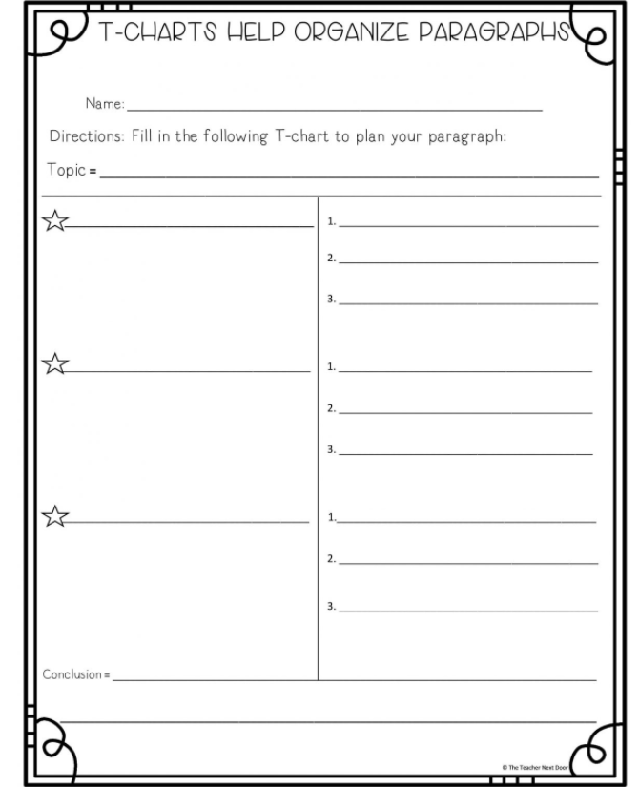  Drafting  Students start writing their first draft, making sure they are including a thesis statement, body paragraphs with supporting details, and a conclusion paragraph.  Revising  Students share their articles with a classmate, they read the article and complete the following checklist. Teacher monitors the process of revising and gives feedback when necessary.  Editing/ Publishing  Students correct what their partners and teacher have suggested to. Then, they publish their article. Teacher elicits students to include pictures in the article to make it more attractive to readers. Finally, students read each other’s articles and comment about the new habits they would have when using internet. |  |  |  |  | 5´  15 ´  15´  35´  55´  70´
Integrated Mini-Project |  |  |  |  |  |  |  |  | Time
Phase: 2  Learners get in their groups and make a list of subject experts in their community or school to interact with them about the Mini Project topic. They can also meet many subject experts from various parts of CR through social media. This helps them in getting suggestions in different possible ways, through which they can get a clear idea on their Mini Project topic.  After getting a clear idea about the topic, they are asked to prepare a rough plan about procurement of resources. They should make a rough schedule and distribute the work among the teammates. This will keep their Mini Project on track and individuals will come to know about their part in the Mini Project rather than any individual (leader) taking full responsibilities.  Learners make sure that the materials will be ready for the next week and that all members know their responsibility. |  |  |  |  |  |  |  |  | 5´
Reflective Teaching
What worked well |  |  | What didn’t work well |  |  |  | How to improve
Enduring Understanding Reflection
How well did the learners progress in their understanding of the Enduring Understanding?

Learner Self-Assessment
Week #4
I can… | Yes | In progress | No
brainstorm ideas and create questions about subjects of common interest such as technology, safety, and technological innovations.
start lengthy conversations with peers by checking understanding from the listener's point of view in topics related to technology, safety and technological advances.
interrupt the listener in a conversation related to technology, safety and technological advances by using phrases such as: Excuse me, May I say something? No, I'm sorry but…
keep the conversation going with the conversation related to technology, safety and technological advances by using phrases such as: Really…, Right…
close the conversation related to technology, safety and technological advances by using a leave-taking.
brainstorm ideas about safety while working online.
draft an expository essay about safety while working online that includes thesis statement, body paragraphs with supporting details and a conclusion with the appropriate linkers or connecting words.
revise an expository essay about safety while working online by checking subject-verb agreement, pronoun and article agreement, sentence sense, text structure, word order, content and use of commas.
edit an expository essay about safety while working online before publishing.

Label the pictures with the words in the box below.

Robots-Hologram -Space Traveling-Electric motors -Spaceships

From the pictures above, answer the following questions:

- Which one do you think has been the most important technological innovation?

- What images spring to your mind when you hear the word (Spaceship/robots/Holograms…)?

Third conditional: Complete the statements below.
Example:
If I had had a robot, I would have made it to clean the house.

      - If I had used the electric motor up just a few minutes ago, ___________________________________________________________

      - If I _____________________, I would have invented a hologram for video games.

      - If _____________________, ____________________________________

      - If I had been an astronaut, _____________________________________________________________

      - If I’d married someone famous, ____________________________________

      - If I had invented an app, _____________________________________________________________

Third conditional extra material
If I had won the lottery, I would have bought a car.
With the third conditional we talk about the past. We talk about a condition in the past that did not happen. That is why there is no possibility for this condition. The third conditional is also like a dream, but with no possibility of the dream coming true.
Last week you bought a lottery ticket. But you did not win. :-(
if | condition | result
 | Past Perfect | would have + past participle
If | I had won the lottery, | I would have bought a car.
Look at these example sentences:
if | condition | result
 | Past Perfect | would have + past participle
If | I had seen Mary, | I would have told her.
If | Tara had been free yesterday, | I would have invited her.
If | it had rained yesterday, | would you have stayed at home?
If | it had rained yesterday, | what would you have done?
Put in the correct third conditional verb form.

1. If you ______________ (not / be) late, we ______________ (not / miss) the bus.
2. If she ______________ (study), she ______________ (pass) the exam.
3. If we ______________ (arrive) earlier, we ______________ (see) John.
4. If they ______________ (go) to bed early, they ______________ (not / wake) up late.
5. If he ______________ (become) a musician, he ______________ (record) a CD.
6. If she ______________ (go) to art school, she ______________ (become) a painter.
7. If I ______________ (be) born in a different country, I ______________ (learn) to speak a different language.
8. If she ______________ (go) to university, she ______________ (study) French.
9. If we ______________ (not / go) to the party, we ______________ (not / meet) them.
10. If he ______________ (take) the job, he ______________ (not / go) travelling.

Third Conditional Answers (remember you can use had or ‘d AND would or ‘d)

1. If you hadn’t been late, we wouldn't have missed the bus.
2. If she had studied, she would have passed the exam.
3. If we had arrived earlier, we would have seen John.
4. If they had gone to bed early, they wouldn't have woken up late.
5. If he had become a musician, he would have recorded a CD.
6. If she had gone to art school, she would have become a painter.
7. If I had been born in a different country, I would have learnt to speak a different language.
8. If she had gone to university, she would have studied French.
9. If we hadn’t gone to the party, we wouldn't have met them.
10. If he had taken the job, he wouldn't have gone travelling.

Retrieved from www.perfect-english-grammar.comThird Conditionals.

Cards/chips/coins to spend during speaking practice.

Revising and editing:
Editing checklist
The paragraph… | Yes | No | Partially
is well capitalized
has appropriate connectors/linkers
has correct verb conjugations (subject-verb agreement)
has agreement between pronouns and articles
has clear and coherent sentences
has correct word order (nouns/adjectives)
fulfills with the information asked
uses well punctuation marks

Review and Integrated Mini-Project
Recordar que la semana 5 es planeada por el docente. Aquí se planea repaso y se da feedback. Además se inicia con la elaboración del proyecto.
Week # 5

Level: 11th |  |  |  |  | Unit: 2
Enduring Understanding: Technology requires responsible users for an effective ethical response
Essential Question: How can technology makes us closer or further apart?
General Competences

Responsible Citizenship ( )
Life Competences ( )
Competences for Employability ( )

Learn to Know |  |  | Learn to Do |  |  | Learn to Be and Live in Community
Grammar & Sentence Frame  - Did Ls use all sentence frames?  Vocabulary  - Did Ls say aloud, write and understand all vocabulary? |  |  | Function  - Did Ls use all functions?  Discourse Markers  - Did Ls practice the discourse markers in spoken interactions? |  |  | Psychosocial  Did Ls show evidence of …  - Valuing economic, sociocultural and ethical implication when using the latest tech innovations.  Sociocultural  Did Ls show evidence of …  - demonstrating disposition to help each other’ within collaborative environments while working with technology.  - valuing using conventional ways to communicate with others.  - Did Ls practice idioms and quotes?
Assessment Strategies & indicators of learning  (Diagnostic, formative, summative) | Learner can | Didactic Sequence Mediation |  |  |  |  | Time  Total:  200 min  (5 lessons)
- Did Ls achieve all indicators of learning? | - Can Ls do all tasks? | Referencing notes from formative assessments throughout the weeks, repeat activities to strengthen Ls in weaker areas or create Optional Activities that follow these plans. (If necessary) |  |  |  |  | 80´
Options |  |  |  | Integrated Mini-Project |  |  | Time
Suggested Integrated Mini Project  Suggested Integrated Mini Project  -“ My new inventions Pictionary” (groups of 3/4)  Task: Create in power point an illustrated dictionary about the most important inventions that have influenced our lives. Include The invention, year of creation, authors, benefits and images. Include at least 10 inventions  -“Role play video life without toilet paper?” (groups of 3/4)  Task: You and your classmates are going to make a video in which you play a life without all those inventions that we use in daily that we take them from granted; for example, toothpaste, toilet paper, washing machine, soap, stove, etc. Make creative and funny scenarios to make people aware the importance of those inventions. At the end, include a clip in which you and your friends tell a little description of the inventions and when they were created.  -Advertisement “The top ten tips when using internet” (pairs)  Task: You and your partner are in a team from a campaign that intends to make people conscious about the use of internet. So, you must create an ad giving 10 tips when using the internet, include pictures representing every tip. The ad could be digital or printed. |  |  |  | Phase: 3  Acting out/ Completing MP:  Learners  - get in their groups  - revise members´ roles  - check the list of resources they will need  - check the schedule  - start working on their MP  - Completes the product  - rehearse  - practice the mini-project presentation  Teacher monitors learners’ work and progress. |  |  | 120´

Integrated Mini-Project
Recordar que la semana 6 es planeada por el docente. Aquí se planea la elaboración y ejecución del proyecto.
Week # 6

Options | Integrated Mini-Project | Time  200 min  (5 lessons)
Integrated Mini Projects:  Suggested Integrated Mini Project  -“ My new inventions Pictionary” (groups of 3/4)  Task: Create in power point an illustrated dictionary about the most important inventions that have influenced our lives. Include The invention, year of creation, authors, benefits and images. Include at least 10 inventions  -“Role play video life without toilet paper?” (groups of 3/4)  Task: You and your classmates are going to make a video in which you play a life without all those inventions that we use in daily that we take them from granted; for example, toothpaste, toilet paper, washing machine, soap, stove, etc. Make creative and funny scenarios to make people aware the importance of those inventions. At the end, include a clip in which you and your friends tell a little description of the inventions and when they were created.  -Advertisement “The top ten tips when using internet” (pairs)  Task: You and your partner are in a team from a campaign that intends to make people conscious about the use of internet. So, you must create an ad giving 10 tips when using the internet, include pictures representing every tip. The ad could be digital or printed. | Phase: 4  Responding and sharing:  Groups  - creatively deliver the mini-project  - answer questions from the audience.  Leaners participate in individual and peer assessment of mini-projects.  Teachers monitor ….  - Did Ls use English during all aspects of Integrated Mini-Project?  - How did project presentations reflect understanding and/or mastery of Can Do statements?  - Did Ls put into practice the focus of Learn to Be and Live in Community?  - Did the Integrated Mini-Project provide answers to the Essential Question?  Teacher uses a check list to check MP every week to track learners’ progress. | 200´

Mini Project
Checklist
Student….. | Yes | No | Partially
chooses a suggested MP (Week1)
gets in a group (Week 2)
distributes assignments (Week 3)
makes a list of resources they will need (Week 3)
does online research about the selected MP (Week 3)
looks for subject experts (Week 4)
prepares a plan (Week 4)
makes and distributes a schedule among teammates (Week 4)
works equally in the group (Week 5)
makes presentation eye catching (Week 5)
makes information neat and organized (Week 5)
shows responsibility in assigned tasks (Week 5)
uses English during all aspect of MP (Week 6)
reflects understanding and/or mastery of can-do statements in their project presentation (Week 6)
puts into practice the focus of learn to BE and Live-in community (Week 6)
provides answers to the Essential Question in MP (Week 6)
pronounces correctly (Week 6)
uses grammar structures correctly (Week 6)
uses a variety of vocabulary and expressions (Week 6)
speaks smoothly with little hesitation according to his/her level (Week 6)

