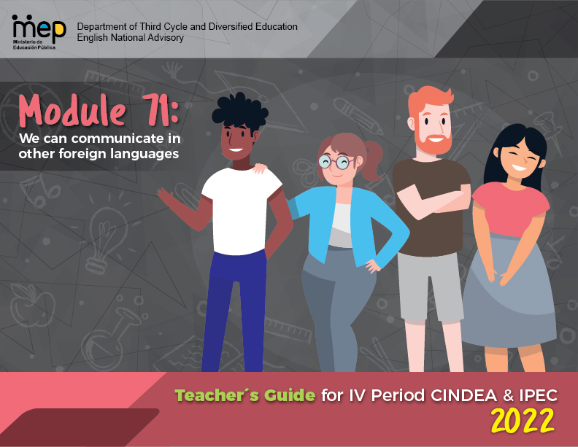
Autoridades

Steven González Cortés
Ministro de Educación Pública

Maria Alexandra Ulate Espinoza
Viceministra Académica de Educación

Nelson Campos Quesada
Director de la Dirección de Desarrollo Curricular

Rigoberto Corrales Zúñiga
Jefe del Departamento de Tercer Ciclo y Educación

Comisión redactora

Mag. Marianella Granados Sirias,
Asesora Nacional de Inglés, Departamento de Tercer Ciclo y Educación Diversificada

Mag. Alfredo Ortega Cordero,
Asesor Nacional de Inglés, Departamento de Tercer Ciclo y Educación Diversificada

Mag. Andrea Cruz Badilla
Asesora Nacional de Inglés, Departamento de Tercer Ciclo y Educación Diversificada

Scenario: Get Ready. Get set. Go!
Paola Artavia Moya
Asesora Regional de Inglés, Dirección Regional de Occidente

Scenario: Really??? (Controversial issues)
Max Arias Segura
Asesor Regional de Inglés Dirección Regional de Liberia
José Enrique Chavarría Chavarría, Colegio Nocturno de Bagaces
Amalia de la O Jiménez , Colegio Artístico Felipe Pérez Pérez
Lilliana Ugalde , Colegio José María Gutiérrez
Elena Chávez Hernández , Colegio Artístico Felipe Pérez Pérez
Didier Villareal, Colegio Guardia
Alejandra Peña Aguilar, Instituto de Guanacaste

Katherine Williams Jiménez
Dirección de Recursos Tecnológicos , Diseño de portada

Forward letter to the teachers

Dear Teacher,
This module focuses on supporting you as facilitators as you help your colleagues in the process of understanding and implementing the new English syllabus. Thank you for your commitment to the goal of transforming English Classrooms across Costa Rica through Action-Oriented Teaching and Learning.

This document contains a range of resources and key elements to assist you in collaborative environments as you make your way through the four following stages (proposed by Patrick Moran, a respected authority in language teacher education):
* Knowing about--by understanding the concepts and principles of the curricular English teaching and learning reform.
* Knowing why--by internalizing the purpose of the English reform as a response to contributing to the formation of the new citizen the country requires.
* Knowing how--by developing and implementing the action-oriented learning tasks when designing lesson plans, assessment instruments and follow up actions to best serve learners.
* Knowing oneself--by reflecting upon and reviewing your personal beliefs and teaching practices.

In conjunction with the materials in this module, we are encouraging you to build partnerships with other colleagues and to contextualize the material and ideas given according to your learners’ needs and context.
Furthermore, we invite you to develop your knowledge and skills as lifelong learners to improve mediation practices and to build confidence and motivation to teach. To assist you with this ongoing process, we will continue to develop and provide online digital resources and professional development opportunities.

Best,
Marianella, Alfredo and Andrea

Asesoría Nacional de Inglés Departamento de Tercer Ciclo y Educación Diversificada

Summary of the Syllabus Theoretical Framework

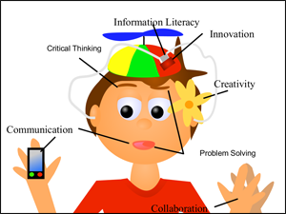
Introduction: Why a new English Curriculum?

1. Learners need an updated curriculum that reflects the knowledge, skills, and abilities needed to succeed in the information age as 21st century learners.
2. Pre-school, elementary, and secondary school´s curriculum required an update in order to have more pertinent target content.
3. Learners who receive English lessons in elementary and high schools are not reaching the expected English proficiency levels after eleven or twelve years of instruction.
4. Citizens need to possess a number of competences to communicate effectively in the global context and to face the challenges of an interconnected world. Purpura (2016) summarized these competences as follows:

Over the years, the geopolitical and technological forces in the workplace have increased the knowledge, skills, and abilities (KSAs) that people need to perform their jobs. We are now asked to read, listen, and synthesize large amounts of information from several sources via multiple modalities; search for information, judge its accuracy, and evaluate its applicability; and use communication technologies to collaborate in teams whose members represent a diverse global community (National Research Council, 1999, 2001). Importantly, many of us are asked to do this in a second, foreign, or heritage language (L2), requiring competencies for communicating ideas and establishing relationships in culturally respectful ways (p. 190).

In addition, he stated that:
To succeed in this environment, L2 users must demonstrate that they have the skills needed to process information, reason from evidence, make decisions, solve problems, self-regulate, collaborate, and learn – and they need to do this in their L2 (p. 190).

Education for a new citizenship reinforces the need of 21st century learners who integrate proactively in a globalized world while strengthening their national and global identity.

Source: http://web.tech4learning.com/blog-0/bid/45149/The-21st-century-classroom-where-the-3-R-s-meet-the-4-C-s

The Learner as a New Citizen

Education for a new citizenship envisions learners as active agents of change able to:
- Use knowledge, skills, and abilities beyond school contexts.
- Express their own points of view.
- Practice peaceful conflict resolution and search for democratic solutions.
- Harmonize social and economic development and environmental sustainability.
- Take action in favor of sustainability of local, national, and global resources.
- Be aware of a global world where national borders have become more diffused.
- Use ICTs and access to knowledge networks as tools for communication, innovation, and proactive social service.
- Be compassionate national and global citizens.
- Practice democratic principles such as freedom of expression and religion, respect for plurality and cultural diversity (sexual, linguistic, and ethnic) as stated in the Costa Rican Constitution.
- Defend and protect Human Rights and be against all forms of discrimination.

Figure 2. Dimension for Educating for a New Citizenship
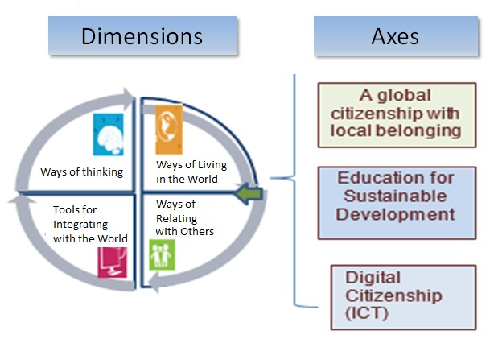

What are the legal underpinnings and how are they related to language teaching and learning?

Policy for the 21th Century highlights three philosophical trends:

 | Rationalism | Humanism | Constructivism
Understanding | Development of complex, challenging, creative and critical thinking skills, | Full realization of the human being, as a person with rights and responsibilities. | Construction and reconstruction of understandings and learnings
Implications for teaching | Cooperative learning and pedagogical scaffolding | Sensitivity to and awareness of learning styles and affective variables | Problem solving, inductive and deductive teaching, and experiential learning

The policy “The School as the Core of the Quality of Costa Rican Education” recognizes three dimensions of learning:

Language Learning Considerations

Considerations | Understanding | Implications for  Language Learning
Philosophical | It focuses on the learner as a social agent who is active, independent, critical, reflective, creative, innovative, inquisitive, and respectful of human rights. | Learning environments and experiences should promote dialogue and creative responses to solve real-life problems.
Psychological | It seeks the whole development of the person and is associated with the person´s affective dispositions. | Pedagogic mediation is flexible, inclusive, and culturally relevant, respecting the individual differences of each student in the classroom.
Neurological | It is related to the brain’s architecture and how maturational processes influence language development. | Underscores the importance of starting the learning of foreign languages early in life and in scaffolding the L1 to help L2 acquisition.
Socio-cognitive | It is related to the brain’s architecture (attention, short-term long-term working memory) and how it functions to process information (metacognition) related to learning and communication. | Connects to the complexity and the cognitive load of tasks presented to learners.
Socio-cultural | It includes the elements of diversity, interdependence, and interconnection with among others. | Addresses learning new behaviors, values, and social skills in line with a human rights approach and through democratic participation.

Which pedagogical trends influence the teaching practices?

The Common European Framework of Reference (CEFR)

CEFR describes proficiency levels based on accumulated evidence gathered over time from learner activities, tasks, or projects. | Implications:  - Standard Terminology  - Track student progress  - Descriptors – teaching, learning, and assessment  - Learners monitor and take responsibility  - Transferability across settings  - Parent communication
Secondary
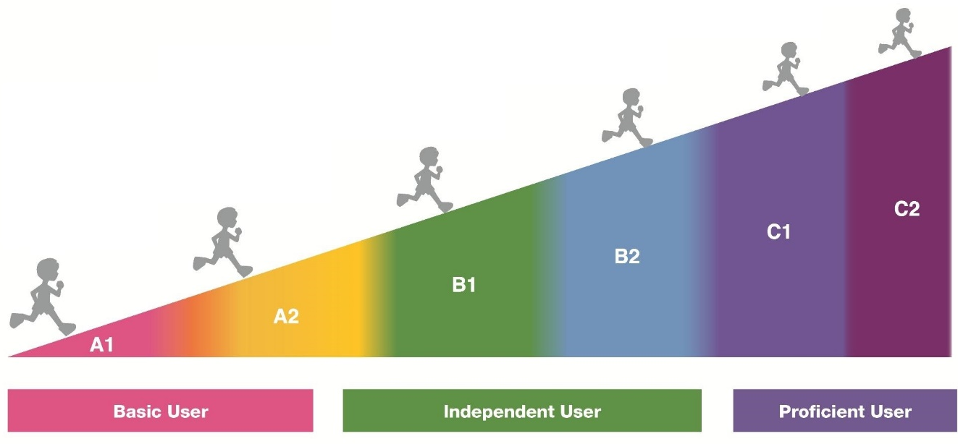
Pr
imary

Costa Rican general descriptors according to CEFR English proficiency bands
Basic User  Basic User | A1 | - Can understand and use familiar everyday expressions and very basic phrases aimed at the satisfaction of needs of a concrete type.  - Can introduce him/herself and others and can ask and answer questions about personal details such as where he/she lives, people he/she knows and things he/she has.  - Can interact in a simple way provided the other person talks slowly and clearly and is prepared to help.  - Can show limited ability to use simple grammatical structures and conventions, such as punctuation and capitalization.  EXTENSION OF THE CEFR STANDARDS - INTEGRATION OF LANGUAGE ABILITIES  - Can use A1 level, grade level and age appropriate linguistic (e.g. present verb forms), socio-cognitive (e.g., associating strategies) and socio-affective (e.g., cooperating or coping strategies) resources to integrate topical content from oral and written text to perform a goal-oriented product (mini-project) based on an integrated sequence of activities within a domain, scenario, and theme. Linguistic resources include grammatical forms and meanings; socio-cognitive resources include a range of meta-cognitive strategies (planning) and cognitive strategies (revising); and socio-affective resources consist of strategies such as cooperating and coping.  - Can use A1 level, grade level and age appropriate digital and telecommunication resources to research, plan, and implement the mini-project.  - Can give, receive, and respond to feedback at critical stages of the creative process.  - Can use level and age appropriate linguistic resources to integrate information from a reading, listening or other inputs to perform from one skill modality to another (e.g., listening to speak, reading to write) to achieve the goal of the scenario.  - Can display awareness and development of non-cognitive dispositions (such as effort, perseverance, engagement, empathy, and focus).
 | A2  A2 | - Can understand sentences and frequently used expressions related to areas of most immediate relevance (e.g., very basic personal and family information, shopping, local geography, employment).  - Can communicate in simple and routine tasks requiring a simple and direct exchange of information on familiar and routine matters.  - Can describe in simple terms aspects of his/her background, immediate environment, and matters in areas of immediate need.  - Can use some simple structures accurately but continues to systematically exhibit basic errors (such as verbs tenses, use of prepositions, articles).  EXTENSION OF THE CEFR STANDARDS- INTEGRATION OF LANGUAGE ABILITIES  - Can use A2 level, grade level and age appropriate linguistic (e.g. past verb forms), socio-cognitive (e.g., grouping strategies) and socio-affective (e.g., cooperating or questioning for clarification strategies) resources to integrate topical content from oral and written text to perform a goal-oriented product (mini-project) based on an integrated sequence of activities within a domain, scenario and theme. Linguistic resources include grammatical forms and meanings; socio-cognitive resources including a range of meta-cognitive strategies (monitoring) and cognitive strategies (resourcing); and socio-affective resources consisting of strategies such as cooperating and coping.  - Can use the A2 level, grade level and age appropriate digital and telecommunication resources to research, plan, and implement the mini-project.  - Can give, receive, and respond to feedback at critical stages of the creative process.  - Can use level and age appropriate linguistic resources to integrate information from a reading, listening, or other input to perform from one skill modality to another (e.g., listening to speak, read to write)in order to achieve the goal of the scenario (e.g. -  - Can display awareness and development of non-cognitive dispositions (such as effort, perseverance, engagement, empathy, and focus).
Independent User  Independent User | B1  B1 | - Can understand the main points of clear standard input on familiar matters regularly encountered in work, school, and/or leisure time like a radio or TV program when the delivery is relatively slow and clear.  - Can understand texts that consist mainly of high frequency every day or job-related language.  - Can understand the description of events, feelings, and wishes in personal letters.  - Can deal with most situations likely to arise while travelling in an area where the language is spoken.  - Can enter into conversations unprepared, on topics that are familiar, of personal interest, or pertinent to everyday life (e.g., family, hobbies, work, travel and current events).  - Can produce simple connected text on topics, which are familiar, or of personal interest.  - Can narrate a story from a book or film and describe personal reaction.  - Can describe experiences and events, dreams, hopes and ambitions and briefly give reasons and explanations for opinions and plans.  - Can express self reasonably accurately in familiar, predictable situations and know enough vocabulary to talk about family, hobbies and interests, work, travel, and news and current events.  EXTENSION OF THE CEFR STANDARDS - INTEGRATION OF LANGUAGE ABILITIES  - Can use the B1 level, grade level and age appropriate linguistic (e.g., complex verb forms), socio-cognitive (e.g., deduction/induction, inference strategies) and socio-affective (e.g., cooperating or questioning for clarification strategies) resources to integrate topical content from oral and written text to perform a goal-oriented product (mini-project) based on an integrated sequence of activities within a domain, scenario and theme. Linguistic resources include grammatical forms and meanings; socio-cognitive resources include a range of meta-cognitive strategies (evaluating) and cognitive strategies (resourcing); and socio-affective resources consist of strategies such as cooperating and coping.  - Can use the B1 level, grade level and age appropriate digital and telecommunication resources to research, plan, and implement the mini-project.  - Can give, receive, and respond to feedback at critical stages of the creative process.  - Can use level and age appropriate linguistic resources to integrate information from a reading or a listening input or other inputs to perform from one skill modality to another (e.g., listening to speak, read to write) to achieve the goal of the scenario.  - Can display awareness and development of non-cognitive dispositions (such as effort, perseverance, engagement, empathy, and focus).

The Action-Oriented Approach

Learner | - An agent/performer with intercultural awareness skills.  - Autonomous, works cooperatively, interacts with others, investigates and solves problems using the tools at his/her disposal (general and specific competences).  - Develops metacognitive, reflective and critical thinking strategies for successful completion of the task.
Teacher | - Facilitator, coach, resource person, guide, advisor, and observer.  - Helps the learner become autonomous and be successful in the completion of the task.  - Provides effective feedback in the process of learning.  - Shows expert role but shares this responsibility with the learner.
Learning Resources  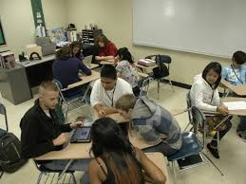 | - Oral or written authentic texts: business cards, bus tickets, newspaper articles, book excerpts, wikis, bus schedules, city maps, bulletin boards, voice messages, and announcements.  - Appropriate to the learner´s needs and competence level.  - Intercultural perspective
Aims of communicative activities/tasks  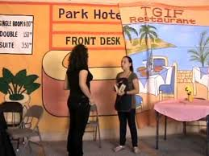 | - Communicative activities become actions that the learner/social agent performs in order to build up general competences and communicative language competences.  - The goal is successful action and accomplishment of tasks in a particular scenario and domain aligned to the learner’s life experience and personality.
Learning Environment | - Real-world contexts (personal, public, educational and vocational domain) collaborative, stimulating, mediated by ICTs.
Assessment  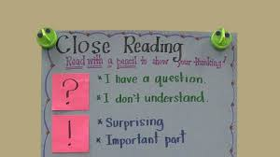 | - Assessment is based on what the social agent is able to do in real-life situations or scenarios and the process he/she requires to develop the competences. Authentic assessment is favored.  - The acquisition and refinement of general and communicative competences is a continuous process, both at school and in the world beyond the school.

General competences

Consist of knowledge, skills, and abilities to learn existential competences that are not language-specific but learners need to know when performing different actions included in language activities.

Competence

The CEFR defines competences as “the sum of knowledge, skills and characteristics that allow a person to perform actions in society.”

Basic Principles of the Action-Oriented Approach

- The students are social agents that use the target language to perform specific actions in real life contexts meaningfully.
- Language performances, in oral or written form, respond to language functions and are carried out in specific scenarios.
- Enabling and communicative activities are task-based and real-life.
- Learners use authentic materials ensuring comprehensible input, as much as possible.
- The ICT becomes an important tool to create meaningful learning experiences.
- A great degree of autonomy is placed on the learner; therefore, the teacher works in the development of learners’ meta-cognitive, meta-affective, and meta-social strategies.
- Intercultural awareness plays an important role for getting meaning across and facilitating communication among cultures.
- Vocabulary, syntax, cohesive forms, and phonology are taught with the purpose of facilitating communication
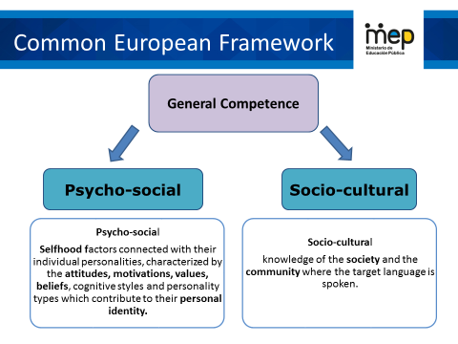

Communicative competence

The communicative language competences involve knowledge, skills, and understanding of each of the following three components:
- Linguistic Component: Deals with the knowledge of phonology, morphology, lexicon and syntax.
- Sociolinguistic Component: Refers to the socio-cultural conditions of language use such as social group repertoires or politeness rules.
- Pragmatic Component: Covers, among others, speaker´s and receptor´s attitudes and beliefs, their understanding of the context of an utterance and the functional use of language; for example, the use in specific scenarios of how to act in a given social event or how to participate in a job interview.
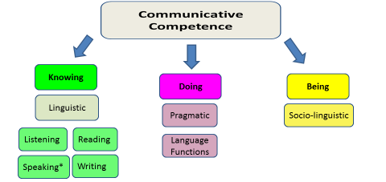
Communication
The CEFR defines communication as a social act, where learners are social agents, developing a range of general and specific communicative language competences, moving from learning about the language to learning to communicate in the language in active, spontaneous, and authentic language interaction.

Tasks
Tasks are defined as any purposeful action considered by an individual, necessary to achieve a given result in the context of a problem to be solved, an obligation to fulfill, or an objective to be achieved. This product may be a brochure for tourists, a blog entry, or a fundraising project for a humanitarian cause.

Task accomplishment by an individual involves the strategic activation of specific linguistic competences (linguistic, pragmatic and socio-linguistic) along with a range of socio-cognitive competences in order to carry out a set of purposeful actions in a particular domain (interpersonal, transactional, academic and professional) with a clearly defined goal and a specific outcome.

How are lessons planned?
Lesson planning will be developed based on scenarios that focus on one or more of four different domains.

A unit is six weeks. Lesson plans are created weekly based on themes. Here is an example of how it can be done.
Week 2
Domain
Scenario
Theme 2
Language function 2
Goals
Three learning pillars
Assessment indicators
Week 1
Domain
Scenario
Enduring understanding Essential question
Theme 1
Language function 1
Goals
Three learning pillars
Assessment indicators

Week 4
Domain
Scenario
Theme 4
Language function 4
Goals
Three learning pillars
Assessment indicators
Week 3
Domain
Scenario
Theme 3
Language function 3
Goals
Three learning pillars
Assessment indicators

Week 5&6
Sharing and responding
Integrated mini-project
Week 5
Feedback, reinforcement and assessment

Didactic Planning for Secondary
Term: |  | Level: |  |  | Unit: |  |  | Week:
Domain: |  |  |  | Scenario: |  | Theme:
Enduring Understanding:
Essential Question:
General Competences | Dimensions
Responsible Citizenship ( )
Life Competences ( ) | 1. Ways of thinking ( )
Competences for Employability ( ) | 2. Ways of living in the world ( )
 | 3. Ways of relating with others ( )
 | 4. Tools for integrating with the world ( )

Learn to Know |  |  |  | Learn to Do |  | Learn to Be and Live in Community
Grammar & Sentence Frames  Vocabulary  Phonology |  |  |  | Function  Discourse Markers |  | Psycho-social  Socio-cultural
Assessment Strategies & indicators of learning  (Diagnostic, formative, summative) | Goals |  |  | Pedagogical Mediation/ Didactic Sequence |  |  |  |  | Time
Learner… | Learner can
Integrated Mini-Project |  |  |  |  |  |  |  |  | Time
Phase: _______
Reflective Teaching
What worked well |  |  | What didn’t work well |  |  |  | How to improve
Enduring Understanding Reflection
Template Elements
Level | Grade level of the unit
Unit | 1 of 6 in a year, includes Scenario, 4 themes, Enduring Understanding, Essential Question, Goals, pillars of learning, mediation strategies, assessment, and an Integrated Mini Project
Domain | Refers to the broad sectors of social life in which social agents (learners) operate
Scenario | A real-life context referenced for an entire unit
Themes | The focus of attention for each week that refers back to the real life scenario. (context rather than content)
Enduring Understanding | Big ideas to guide the teacher that give importance and meaning to a set of curriculum expectations and have a lasting value for learners, beyond the classroom. (1 per unit)
Essential Question | A question which fosters understanding and critical thinking in learners. (Can be adapted to theme.)
Linguistic  Competencies | Oral and Written Comprehension (listening and reading); Oral and Written Production (spoken interaction, spoken production, writing).
Goals | Can-do performance descriptors
Oral and Written Comprehension | What a learner can understand or can do when listening and/or reading.
Oral  and Written Production | What a learner can speak and write.
Learn to Know | Learning pillar that includes Grammar and sentence frames, Vocabulary, and Phonetic Awareness/Phonology.
Grammar & Sentence Frame | The grammatical components that will be covered in the unit.
Phonemic Awareness/  Phonology | The part of the lesson that addresses the Learner’s ability to hear, identify, and manipulate sounds.
Vocabulary | Words learners need to know to communicate effectively within a domain, scenario, and theme.
Learn to Do | Learning pillar that includes Functions and Discourse Markers
Function | The use of spoken discourse and/or written texts in communication for a particular purpose (e.g. asking and giving information, describing).
Discourse Markers | Linking words or phrases that connect one piece of discourse with another one (e.g., and, because).
Learn to Be and Live in Community | The Learning pillar that includes Psycho-social, Sociocultural, Social Language, Idioms, and quotes.

Template Elements
Psycho-social | Attitudes, motivations, values, beliefs, cognitive styles, and personality factors.
Sociocultural | Politeness conventions, expressions of folk wisdoms, register differences, dialects and accents
Suggested Mediation Strategies | Organized, purposeful and scaffolded learning experiences
Assessment Strategies | Required evidence of student´s learning
Integrated Mini Project | A more complex task which includes a four-phase process (participating, thinking, acting out, responding and sharing) that integrates skills and unit’s goals and leads to a final product.

General Mediation Principles for Third Cycle and Diversified Education

English teaching places priority on the fine-tuning of learners’ communicative competence involving oral comprehension and oral and written communication so that they become independent users of English and can reach the B1 or A2+ level, based on the descriptors of the CEFR.
- Teachers can select three or four goals per week from the units. They can combine oral or written comprehension with oral and written production, depending on the pedagogical purpose of the lesson.
- Teachers start each theme of a unit’s scenario and lesson with a warm-up activity. Then they share the essential question with the learners and the learning goals/expected outcomes for that day or week.
- The enduring understanding is shared by the teacher at the beginning of each unit to connect learners with the core ideas that have lasting value beyond the classroom.
- Lessons follow a task-based approach combined with the action-oriented approach.
- Grammar is developed by combining both inductive and deductive instruction within a meaningful context.
- The teacher follows a set of integrated sequence procedures as presented below to develop the different linguistic competences.

Mediation Sequence
Comprehension |  | Production
Oral | Written | Oral | Written
- Planning  - pre-listening  - motivating  - contextualizing  - explaining task goal  - Listening for the first time (general understanding);  - Pair/group feedback  - Listening for the second time (more detailed understanding)  - Self/co- assessment | - Planning  - pre-reading  - explaining task goal  - use typographical clues  - list difficulties and strategies on how to cope  - Reading for the first time  - Pair/group feedback  - Reading for the second time, post–reading (for reacting to the content or focusing on features/language forms)  - Self/co-assessment | - Spoken interaction  - Planning  - Organizing  - Rehearsing  - interacting  - Spoken production  - Planning  - Organizing  - Rehearsing  - Producing | - Pre-writing  - Drafting  - Revising  - Editing  - Publishing

- Teacher makes sure that all learners understand task instructions.
- Teachers should ensure learners know how to use strategies through teacher scaffolding and modeling, peer collaboration and individual practice.
- Learners have at their disposition useful words, phrases and idioms that they need to perform the task. It could be an audio recording with the instructions and the pronunciation of the words and phrases needed.
- The task could involve the integration of listening and speaking or reading and writing and is given to learners individually, in pairs, or teams.
- The learners complete the task together using all resources they have. They rehearse their presentation, revise their written report, present their spoken reports or publish their written reports.
- Teacher monitors the learners’ performance and encourages them when necessary.
- The learners consciously assess their language performances (using rubrics, checklists and other technically designed instruments that are provided and explained to them in advance). Teachers assess performance, provide feedback in the form of assistance, bring back useful words and phrases to learners’ attention, and provide additional pedagogical resources to learners who need more practice.
- At the end of each unit, the learners develop and present Integrated Mini-Projects to demonstrate mastery of the unit goals.
- The enduring understanding and essential question are central to articulate the three learnings: learn to know, learn to do and learn to be and live in community. The Integrated Mini-Project is an opportunity for learners to integrate these three learnings in a single task.
- Teach and plan English lessons in English to engage learners socially and cognitively.

Classroom Setting in the Action Oriented Approach
When implementing the action oriented lessons in your English class; remember to:
- Consider learners’ interests and needs.
- Offer opportunities to work in pairs, in small groups, and as a whole class.
- Create a context for learning and reflecting.
- Provide multiple opportunities to develop communicative competence.
- Use different classroom layouts: the horseshoe, chairs in a circle, traditional rows and nested tables in groups.

Phonological Competence and the Use of RAPPP…
Phonological competence is the ability to recognize and produce the distinctive meaningful sounds of a language, including: consonants, Vowels, tone patterns, intonation patterns, stress and rhythm.

What to do to learn and teach phonological competence

And you can also use
R.A.P.P.P.P.P.P.

- Recognition (aural and cognitive)
- Articulation
- Productive Practice
- They are not linear. But can be... But don’t have to be

Source: Ramirez, R., Scholl, M. Zalazar, L., Cárdenas, N., Rossi, A. Centro Espiral Maná (2017)

How is learning assessed?

Assessment is a purposeful, continuous, contextualized, authentic, reflective, investigative, systematic and multi-phase process, which responds to these four fundamental questions: Why assess learning? What learning to assess? How to assess it? Which are the pedagogical implications in the learning?

The purpose of assessment is to serve each learner’s growth and learning. To prevent student’s failure and allow timely intervention, assessment allows teachers to detect learning gaps so that learners can receive the support needed to be successful. The “what” of assessment involves gaining clarity about the knowledge, skills, abilities, and attitudes (learn to know, learn to do, learn to be and live in community) that learners have to develop as established in the curriculum goals or “can do performance descriptors”. This implies that assessment will mainly be performance-based. Learners are required to demonstrate through integrated-skills tasks within a domain, scenario and theme, specified knowledge, skills and abilities using the target language. Assessment can also be discrete point, which means the use of selected response tasks to isolate and measure discrete units of grammatical knowledge, which encompasses grammatical, semantic and pragmatic knowledge -- form, meaning and use (Purpura, 2014, p 9). Assessment will also be authentic which means that the assessment task will simulate real-life situations within domains and scenarios beyond the classroom setting, and the socio-cognitive, socio-affective, socio-cultural and linguistic demands on the learner will be similar to the one of a speaker in a target language setting.

Classroom assessment mirrors the learning goals, content of instruction and instructional practices; therefore, curriculum, teaching, and assessment must be coherent for learning goals to be achieved and learners’ communicative competence to be developed.
Task design, task performance, and assessment become a fundamental unit of instructed learning; tools such as analytic and/or holistic scales, rubrics, progress indicators and checklists play an important role for obtaining valid and reliable qualitative and quantitative data about learners´ learning and performance.

Integrated Mini- Project

A more complex “learn to do” classroom task for each unit.
- Learners (as social agents) integrate knowledge, skills and abilities (KSA), within the domain, scenario, themes, the enduring understanding and essential questions of the unit
- Proactive (not reactive)
- Interconnected with classroom activities
- Formative, skill-integrated performance
- Collective actions (social dimension)
- Promotes democratic citizenship (CEFR p.12)
- Integrates skills and unit’s goals and leads to a final product.

AOA Task Oriented to a Product
Keep the end in mind!

Phases for the Integrated Mini-Project

- Participating/Negotiating (Week 1 or 2)
Brainstorming, discussing, negotiating, making decisions to form different groups according to their interest, language abilities, etc.
- Thinking/planning (Week 3 or 4)
Planning, negotiating and finding information collaboratively about the language content and strategies, resources and organizing the work to distribute assignments among the group members.
- Acting out/Completing MP (oral/written) (Week 5)
Completing the product, rehearsing, practicing the mini-project presentation.
- Responding and Sharing (Week 6)
Groups creatively deliver the mini-project, answer questions from the audience and in pairs, or groups self or co-assess it.

7th - Unit 3 – Example  Promoting local tourism  Integrated Mini-Project: Tourist Brochure to support local tourism  Task description:  You want to show the most important tourist attractions to support local tourism. Design a brochure to promote local tourist attractions. Keep in mind the following questions to guide your product: Is this an authentic communication action? Is it useful in everyday life?  Phase 1: Participating to negotiate: (5 or 10 minutes in week 1 or 2)  Choose your mini project and get in groups of 3-4 participants and negotiate in order to plan the next phase.  Phase 2: Thinking for planning: (5 or 10 minutes in week 3 or 4)  Plan your brochure. Think what to do (the information you need to find, the time and organization of the work (what to write and distribute what each member is going to do).  Phase 3: Acting out to complete the Mini Project –oral & written: (week 5)  In your group, complete the brochure in class, rehearse and organize the presentation.  Phase 4: Responding and sharing (week 6)  creatively present the brochure to the class, respond to questions from the audience using the instruments to self or co-assess the project (or brochure) | 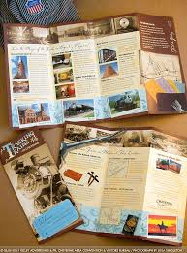

Week 1 | Week 2 | Week 3 | Week 4 | Week 5 |  | Week 6
Introducing Scenario | Some tasks can relate to Integrated Mini-Project | Some tasks can relate to Integrated Mini-Project | Some tasks can relate to Integrated Mini-Project | Completion of Integrated  Mini-Project | Presentation of MP
Participating/  negotiating  Selecting  Integrated Mini-Project  (5-10 min) | Participating/  negotiating  Planning  Integrated Mini-Project  (5-10 min) | Thinking/planning  Planning  Integrated Mini-Project  (5-10 min) | Thinking/planning  Planning  Integrated Mini-Project  (5-10 min) | Acting out/  completing MP  Completion of Integrated Mini-Project |  | Responding and sharing  Presenting the IMP

What is the teacher’s profile to implement this new curriculum?
Teacher’s Profile
What is expected from learners?

Learner´s Exit Profile

Third Level III & IV Period Exit Profile (Learner Exit Profile)

Level B1
Integral Development and Communicative Competence
At this stage, the learner can...
Learn to know | have a level-appropriate language (words, phrases, formulaic expressions) and topical knowledge related to domains, scenarios and themes.
Learn to do | use level-appropriate linguistic and topical resources in order to listen, read, speak and write in response to level and age-appropriate tasks, integrating language and topical knowledge, skills and abilities (KSAs) within domains, scenarios and themes.
Learn to be and live in community | use personal and social dispositions (e.g., engagement, attitudes, cooperation, turn taking, empathy, and other universal values) when interacting and producing in the target language and taking time to search for words using oral and body language for transferable learning beyond the classroom setting (enduring understanding).
Listening | Reading | Speaking  (spoken interaction & production) | Writing
CEFR STANDARDS  - Can note the main points of oral texts at a normal speed related to public (transactional) and vocational (professional) domains.  INTEGRATION OF  LANGUAGE SKILLS  - Can interact in conversations in order to share oral/written information (listening to speak/write).  - Can listen to different opinions or points of view of native speakers of English in order to express argumentations (listening to speak). | CEFR STANDARDS  - Can manage more  - complex texts in the public (transactional) and vocational  - (professional) domains within transactional (job applications/situations, rental forms).  - Can apply strategies before, during and after  - reading a text in order to comprehend more  accurately longer texts (narrative, expository).  INTEGRATION OF  LANGUAGE SKILLS  - Can extract specific information in short media reports, straightforward factual and printed texts to share inferences (reading to write/speak).  - Can interpret passages for explaining own strategies to convey meaning about controversial issues (reading to speak/write). | CEFR STANDARDS  - Can maintain interactions related to public (transactional) and vocational (professional) domains with emerging fluency while still relying on practiced language patterns.  - Can ask for clarification, check for comprehension in less predictable situations.  - Can explain a problem and propose a solution.  - Can handle routines and familiar topics with spontaneous utterances.  INTEGRATION OF  LANGUAGE SKILLS  - Can rehearse presentations supported by notes and illustrations and peer feedback (writing to read/speak).  - Can express arguments/opinions when exchanging interactions (listening to speak).  - Can interact in long conversations with peers and others about controversial issues using interaction and production strategies (listening to speak). | CEFR STANDARDS  - Can write longer texts with more varied sentence structures and a wider range of vocabulary through a series of connected  - paragraphs within expository (advertisement, resume, speech), narrative (biography, personal  - travelogue) and transactional (question and answer interview) genres. Sentences connect with each other in a more cohesive manner.  INTEGRATION OF  LANGUAGE SKILLS  - Can organize thoughts and opinions expressed by group participants for writing persuasive paragraphs (listening to write).  - Can write about online or printed controversial issues for presenting meaningful information to audiences, e.g. Impromptu speech (reading to write/speak).

Distribution of Scenarios for the Third Level Module 71: We can communicate in other foreign languages

Domain | Scenario
III PERIOD
Socio-Interpersonal and Academic | Recipes for Success
Socio-Interpersonal and Academic | From the Wheel to the Drone
Socio-Interpersonal and Academic | The Earth-Our Gift and Our Responsibility
IV PERIOD
Socio-Interpersonal and Academic | Get Ready. Get Set. Go!
Socio-Interpersonal and Academic | Really??? (Controversial Issues)

Weekly Sample Lesson Plans for Third Level III Period IV

Level III
Period IV
CEF Level to be Reached B1 Basic User/Independent User
Scenario: Get Ready. Get set. Go!
Enduring Understanding |  | Decisions can have positive and negative consequences in the future.
Essential Question |  | How can decisions define my future?
General Competences | Dimensions
Responsible Citizenship ( ) | 1. Ways of thinking (√)
Life Competences ( ) | 2. Ways of living in the world (√)
Competences for Employability ( ) | 3. Ways of relating with others (√)
 | 4. Tools for integrating with the world (√)

Goals and Assessment Strategies
Week 1  Goals  L.1. Understand the main point and the important details of audio recordings, provided standard language is used and the topic is one of interest  R.1. read short media reports on familiar events.  SI.1. Speak in a comprehensible and fairly fluent manner using a large number of different words and expressions, though there may be pauses for self-correction. | Week 1  Assessment  L.1.distinguishes the main point and the important details of audio recordings.  R.1. reads short media reports on familiar events.  SI.1.speaks in a comprehensible and fairly fluent manner using a large number of different words and expressions, though there may be pauses for self - correction. | Week 2  Goals  L.2. understand the main points in a relatively long conversation that is overheard  R.2. distinguish between different text purposes (to inform, to argue a point, etc.).  W.1 list the advantages and disadvantages of things that are of personal concern (e.g., future goals, universities, majors, soft skills, careers, events). | Week 2  Assessment  L.2. extracts the main points in a relatively long conversation.  R.2.distinguishes between different text purposes (to inform, to argue a point, etc.).  W1. Lists the advantages and disadvantages of things that are of personal concern (e.g., future goals, universities, majors, soft skills, careers, events). | Week 3  Goals  SP.1. Express an opinion on different topics associated with everyday life and common issues (e.g., give a short talk on the value of developing soft skills).  SP.2. Present an argument clearly enough to be understood most of the time. | Week 3  Assessment  SP.1 expresses an opinion on different topics.  SP.2. expresses an argument clearly enough to be understood most of the time. | Week 4  Goals  W.2. write a descriptive paragraph about universities, majors or soft skills and check written paragraphs or lists to look for mistakes (subject-verb agreement, pronoun and article agreement, capitalization, using commas, sentence sense, word order, text structure, concrete ideas, cohesion, etc.).  R.3. understand most words in narrative and expository text and extract the key ideas from those texts.  SI.2. participate in-group work, expressing opinions and making suggestions actively | Week 4  Assessment  W.2. writes a descriptive paragraph about universities, majors or soft skills.  R.3 extracts the key ideas from narrative and expository texts.  SI.2. . Participates in - group work, expressing opinions and making suggestions actively. | Week 5/6  Assessment  Anecdotal reports / rubrics / instruments for self and co-assessment  Suggested Integrated Mini project  - Essay about future plans.  - A multi-step research Career Research: “Planning my Future”- Gallery Walk (learners explore different careers and professions they want to pursue, complete with educational requirements, salary and job opportunities)
Phonology
- Use of prosodic features (stress, intonation, rhythm) to support the message intended to convey.
Theme  - Get ready: Take a Look at your Dreams and Fears |  | Theme  - Get Set: College or Career? |  | Theme  - Surviving or Thriving? |  | Theme  - Go! The Future is Now
Function  Describing dreams and fears about the future. |  | Function  Talking about college or career decisions. |  | Function  Describing soft skills needed to be successful in working life. |  | Function  Initiating and closing conversations about future plans regarding jobs and studies.
Discourse Markers  Linkers: sequential  – past time (later)  - He finished filling out the university applications then he checked them.  - Later, he looked at them again, to see if he had missed anything important.  - After that, he decided to mail them.  - Finally, he waited for university’s answer. |  | Discourse Markers  Connecting words expressing cause and effect, contrast, etc.  - On the other hand, we take a course to sharpen our soft skills.  - However, the university offers new majors. |  | Discourse Markers  Markers to structure informal spoken discourse  - Right  - Really?  - Well, anyway  - Oh, I know. |  | Discourse Markers  Markers to structure informal spoken discourse  - Oh, I know.  - Yes, I suppose so.  - I know how you feel.  - You know, I don´t like her either.
Grammar & Sentence Frames  Adverb  - My professor of literature tells stories well.  - In this university, you hardly have to work. It´s easy. |  | Grammar &Sentence Frames  Modals  Might, may, probably  - We may go to college next year.  - We might not have time off during test evaluation week. |  | Grammar & Sentence Frames  Future continuous Will+ be+ gerund  - Alex will be arriving later today. He should be punctual to keep his job.  Complex questions tags  - This job is interesting, isn’t it?  - This enterprise doesn’t offer social security insurance, does it? |  | Grammar & Sentence Frames  Embedded Questions  - Main question / statement + interrogative+ subject + verb +  object / complement  - Do you know when I can apply for the job?
Vocabulary  Get ready  Take a Look at your Dreams and Fears.  - college high school  Teachers Counselors  Developing Your Soft Skills - punctuality, responsibility, initiative   Having a part time job |  | Vocabulary  College or Career?  Moving out of the home –time to live alone  College, university, career, study abroad, decision, decide, enroll, analytical, artistic, musical, athletic, compassionate, competent |  | Vocabulary  Surviving or Thriving?  - College dressing  College problems  - Being positive to reach your goals  - Developing a positive attitude towards life events and jobs.  - Being open to changes, creative and proactive |  | Vocabulary  Go! The Future is Now.  - Getting a job (looking for and getting a job, interviews, resumes, filling out forms, financial aid, type of letters, etc.  - Companies Human resources department CEO Soft skills (punctuality, responsibility, initiative, etc.)  Enterprises, business  - Enterprises
Psycho-social  Making decisions that benefit my future.  Sociocultural  Respecting everyone’s choices regarding their future. |  | Psycho-social  - Managing soft skills at different scenarios.  Sociocultural  Respecting everyone’s choices regarding their future. |  | Psycho-social  Making decisions that benefit my future.  Sociocultural  Respecting everyone’s choices regarding their future. |  | Psycho-social  - Managing soft skills at different scenarios.  Sociocultural  Respecting everyone’s choices regarding their future.

Level III
Period IV
Didactic Planning
Week # 1
Domain: Public |  |  | Scenario: Get Ready. Get set. Go! | Theme: Get ready: Take a Look at your Dreams and Fears
Enduring Understanding:
Essential Question: How can decisions define my future?
General Competences

Responsible Citizenship ( )
Life Competences ( )
Competences for Employability ( )

Learn to Know |  |  | Learn to Do | Learn to Be and Live in Community
Grammar & Sentence Frames  Adverb  - My professor of literature tells stories well.  - In this university, you hardly have to work. It´s easy.  Vocabulary  Get ready: Take a Look at your Dreams and Fears.  - college, high school, teachers,counselors  Soft skills (punctuality, responsibility, initiative, etc.)  - Having a part time job |  |  | Functions  Describing dreams and fears about the future.  Discourse Markers  Linkers: sequential  – past time (later)  - He finished filling out the university applications then he checked them.  - Later, he looked at them again, to see if he had missed anything important.  - After that, he decided to mail them.  - Finally, he waited for university’s answer. | Psycho-social  Making decisions that benefit my future.  Sociocultural  Respecting everyone’s choices regarding their future.
Assessment Strategies & indicators of learning  (Diagnostic, formative, summative) | Learner can  (goals) | Didactic Sequence Mediation |  |  | Time  Total:  200 min  (5 lessons)
L.1.distinguishes the main point and the important details of audio recordings.  L1.1 Identifies the topic of audio recordings about future plans regarding jobs and studies.  L1.2 Recognizes main points of audio recordings about future plans regarding jobs and studies.  L1.3 Gets important detail from audio recordings about future plans regarding jobs and studies.  R.1. reads short media reports on familiar events.  R1. 1 Identifies the topic of short media reports on familiar events.  R1.2 Recognizes main points of short media reports on familiar events.  SI.1. speaks in a comprehensible and fairly fluent manner using a large number of different words and expressions, though there may be pauses for self-correction.  Indicators of learning  SI1.1 Starts fairly fluent conversations about college and career decisions with peers by using a large number of different words and expressions, though there may be pauses for self-correction and checking understanding from the listener's point of view.  SI1.2 Interrupts the listener in a conversation related to college and career decisions by using phrases such as: Excuse me, May I say something? No, I'm sorry but…  SI1.3 Keeps the conversation going by using phrases such as: Really…, Right.  SI1.4 Closes the conversation by using a leave-taking. | L.1. Understand the main point and the important details of audio recordings, provided standard language is used and the topic is one of interest  R.1. read short media reports on familiar events.  SI.1. speak in a comprehensible and fairly fluent manner using a large number of different words and expressions, though there may be pauses for self-correction. | Pre-teaching  Routine: Checking attendance, checking in with Ls, T posts the Essential Question on the board, Can Do’s, and class agenda, etc.  Participating: Warm up:  The teacher asks learners about their dreams and fears in their future careers. Then, Teacher asks them if their dreams have changed.  What did you want to be when you were a child? What do you want to be now? And what are your dream careers or professions?  Engaging Activation of prior knowledge  T asks learners if they have had an informal job or a part – time job. T asks if someone has been rejected in a job and asks about the reasons why. Ls get in groups to share their answers.  Introducing  T defines hard and soft skills and gives some examples on the board or screen. Then, T shows a video about soft and hard skills https://www.youtube.com/watch?v=0FFLFcB9xfQ. After watching the video, Ls complete the following graphic organizer by writing the definition and examples for the two types of skills.  Then, T introduces some expressions and vocabulary (adverbs) used in careers and job conversations and descriptions.  T shows a list of the most common adverbs used in job descriptions within samples sentences.  An adverb is a word that is used to change or qualify the meaning of an adjective, a verb, a clause or another adverb. An adverb of manner describes the way something happens. On the hand, An adverb of degree is used to discuss the degree or intensity, of an adjective, an action or another adverb.  Adverbs  Manner: Tell how  timely, quickly, independently, effectively, closely, together, hardly, currently, properly, directly, successfully, actively, efficiently, especially  Degree: Tell in what degree  well, lots, perfectly, rather, enough, pretty  Sample sentences:  Your ability to get things done depends on how well you can focus on one task.  You need to work hardly to get better results.  The plan was achieved successfully.  There are many details to take into account when working with customers from abroad especially online business protocols.  The new worker finished his tasks pretty fast.  After that, T asks Ls to get in groups of four to write some sentences with the previous vocabulary and expressions. Finally, they share them out loud with the rest of the group.  Pre listening  T sets the following question for L to give their opinions.  What occupations are popular among men and women in Costa Rica? Is there any social or cultural stereotype that influences the jobs people have in Costa Rica?  After this, T shares the following expressions:  “learn the ropes” = learn how to do a specific job  “It took me a few months to learn the ropes at my new job.”  “pull one’s weight” = do a person’s share of the work  “If you can’t pull your own weight around here, the boss is going to fire you.”  Listening for the first time  T plays the recording https://www.esl-lab.com/intermediate/career-search/ (Career search) and students take some notes about what they listen and understand trying to answer these questions given by the teacher in advance:  Questions  - What is the track about?  - Do you agree with Bryan? Why or why not?  - Which professions or careers are mentioned in the audio?  Pair/group feedback  L share their notes to answer to the previous questions in small groups.  Listening for second time  Read the following sentences and say if they are true or false based on what you listen.  - Ryan is misunderstanding Ashley at the beginning of the conversation. True False  - Ashley wants to study auto mechanics. True False  - Ryan and Ashley are discussing about gender roles related to jobs. True False  - Ashley thinks that Ryan’s thoughts seems to be old-fashioned. True False  - Ashley’s boyfriend is pursuing a degree medicine. True False  T asks students (individually or in pairs) listen and answer the questions. (script is available at the annexes)  - Ashley wants to pursue a career as _________.  - an auto mechanic X  - a sales associate  - a mechanical engineer  - Right now, Ashley’s boyfriend is ______________.  - pursuing a career in auto mechanics  - getting a degree in a medical field X  - majoring in secondary education  - Ryan thinks that _____________.  - there is no money in James ‘profession  - James is not qualified for the job X  - James is pursuing a job for women  Ryan suggests that women are more suited for jobs in _____.  - nursing and child care  - farming and house cleaning  - education and office work X  - At the end of the conversation, the man ends up ____________.  - taking care of his own car X  - making his own dinner  - apologizing to James  Post -listening  In groups, learners outline ideas to answer the following question. Then, they share their thoughts.  How social and cultural stereotypes affect career choices among teenagers in Costa Rica?  Pre reading  Teacher writes on the board “Top 10 fears that hold people back in their careers”. Then t asks learners to work in pairs and brainstorm a list of possible situations that make a person hold back in his/her career.  Reading for the first time:  The learners get a worksheet. Learners are then given a minute to quickly skim the article and decide what it is about. Then, they use a check mark on the corresponding topic.  - Job demand in Costa Rica _______  - Reasons that make people postpone careers decisions.____X___  - Fears of high demand careers _______  - Fears that make you strong when choosing a career_______  Pair/Group feedback:  In pairs, learners compare their answers, and then share with the whole group.  Reading for the second time  Learners read the article again, but this time they highlight main ideas and circle two or three specific details for each main idea. In pairs, learners compare what they highlighted with a classmate.  Post-Reading  In groups, learners write a ten-sentence paragraph based on the following question:  What are the fears that may hold you back in your future careers?  Task: You got this video from a friend. https://www.cinde.org/en/essential-news/cinde-job-fair-2020. A job fair will take place by the end of the year. You and your classmates want to apply for a job at this fair and you want to find out about your soft skills. In order to be ready for this, it is important to be aware of your strengths and weaknesses. Interview each other using the soft skills survey provided by the teacher. Then, share your findings in small groups.  Checking  T uses comprehension questions to make sure learners understood the task. For example: Do you have to do a presentation? Do you have fill out a survey? How do you share the information from the survey?  Planning  Learners get a survey from the teacher, and they go over it and fill it out individually. T can also show it on the screen for learner to fill it out.  https://www.brookings.edu/research/grading-soft-skills-the-brookings-soft-skills-report-card/  Elaborating  While filling out the survey, learners can ask for or give help to clarify phrases or vocabulary words to improve understanding.  Using/ Interacting  Learners get in small groups. Groups are subdivided into two. They take turns to share the answers and ensure equal participation by all. Part A starts sharing the answers from the survey to Part B. Once part A has finished, learners from Part B share their answers as well. They open the sharing time with a greeting. They can use the following expressions such to start interacting: What are your social skills? / Do you maintain attention to tasks? / What are your main academic skills? etc.  During the sharing time, learners can take turns interrupting each other to ask questions to clarify a point mentioned or to make sure the other learners are following them. They can use phrases such as: Excuse me, May I say something? No, I'm sorry but…  Learners keep the survey sharing time going by using phrases such as: Really…, Right to show interest in the conversation.  Learners close the survey sharing time by using a leave taking.  Finally, T asks one learner from each group to report to the rest of the class giving a brief summary of his/her group’s survey answers. |  |  | 40 m  40 m  40 m  40 m

Integrated Mini-Project
Allow time for the Mini-Project each week. NOTE: All phases of the Integrated Mini-Project should be opportunities for Ls to practice English, not just those related to presentation.  Participating to negotiate: (5 or 10 minutes in week 1 or 2) Students answer the following questions about choosing a career:  - What would you like to study?  - Where could you study that career?  - Why did you choose that place and that career?  Option #1  Learners prepare one presentation about how they look themselves 10 years from now. Ls will design a photo album or a diary creating a possible situation of their future.  Option #2  A multi-step research Career Research: “Planning my Future”- Gallery Walk (learners explore different careers and professions they want to pursue, complete with educational requirements, salary and job opportunities)  Option #3  Writing future goals (pros and cons) of the major’s academic possibilities and occupations.  Option #4  Running a debate or a vocational café. |  |  | Adjust previous times listed above to allow 5 min each week.  Group presentations can be week 5 or 6.
Reflective Teaching
What worked well | What didn’t work well | How to improve
Enduring Understanding Reflection
How well did the learners progress in their understanding of the Enduring Understanding?
Week Plan Self-Assessment
At the end of the week, T guides the learners to check their progress using the checklist below. (Can be translated into Spanish if needed to ensure Ls’ understanding.)

Learner Self-Assessment
I can… | Yes | In progress | No
recognize the topic when people speak at normal speed on familiar topics
identify key words when people speak at normal speed on familiar topics
distinguish main points when people speak at normal speed on familiar topics.
identify the topic of audio text if the topic is familiar and the text can be replayed
recognize key words of audio text if the topic is familiar and the text can be replayed
get main ideas of audio text if the topic is familiar and the text can be replayed.
identify main ideas in factual text and simple reports on familiar topics.
distinguish supporting details in factual text and simple reports on familiar topics.
select the appropriate online information and visuals to give a presentation about personal goals and intentions.
organize the online information and visuals to give a presentation about personal goals and intentions.
make sentences with the online information and with the appropriate linkers or connecting words to give a well-organized presentation about personal goals and intentions.
give a well-organized presentation about personal goals and intentions.

Materials for Week #1

This image shows a chart to be completed with soft and hard skills.
Script : Career Search

Ashley: Ryan. I just want you to know that I’m going to go to school to become an auto mechanic.
Ryan: Uh what? Does Dad know about this?
Ashley: Who cares? It’s my life. I really enjoy working on cars.
Ryan: Oh, I get it. You want to study auto mechanics because of your new boyfriend. What’s his name? Jimmy or something? Listen, auto mechanics is a man’s job.
Ashley: No, you got it all wrong. [What?] First of all, his name is James, and second, he doesn’t work at an auto shop anymore. He had a job there for five years, and he really liked his job because he learned how to identify problems and fix things. You, on the other hand, can’t even change the toilet paper roll in the bathroom.
Ryan: Hey, that’s not fair.
Ashley: And James is now back in college. He’s majoring in nursing.
Ryan: Nursing? Nursing? That’s a woman’s job?
Ashley: I cannot believe I’m hearing this. A man can be a nurse, and they can do the job just as well as anybody else. Nurses, whether they are men or women, care for the sick, the elderly. Things like that.
Ryan: Uh.
Ashley: And are you saying that women can’t be farmers, carpenters, or truck drivers?
Ryan: Well, most men do those jobs, so . . . Anyway, women can do them if they want. I just think that women are better suited to be secretaries, waitresses, piano teachers. You know.
Ashley: Man, you’re stuck in the 18th century. No one will marry you.
Ryan: Oh, well, just forget this. But not to change the subject, but I’m having a problem with my car, and I was wondering if Jimmy, I mean James, could take a look at it.
Ashley: Forget it. Start pushing!
Ryan: Ah!

Vocabulary and Sample Sentences
- auto mechanic (noun): a person who repairs cars
– It took him two years of training to become an auto mechanic.
- get something (idiom): understand something
– At first, I didn’t understand the job very well, but I kept asking questions, and I eventually got it.
- elderly (noun): older people, seniors
– The elderly often receive support from family and friends.
- be suited (verb): be appropriate
– Because of his skills, he is very suited for a teaching job overseas.

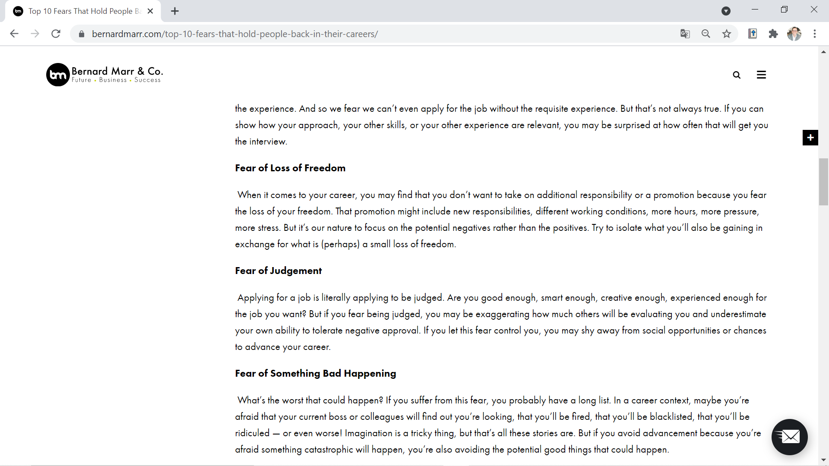

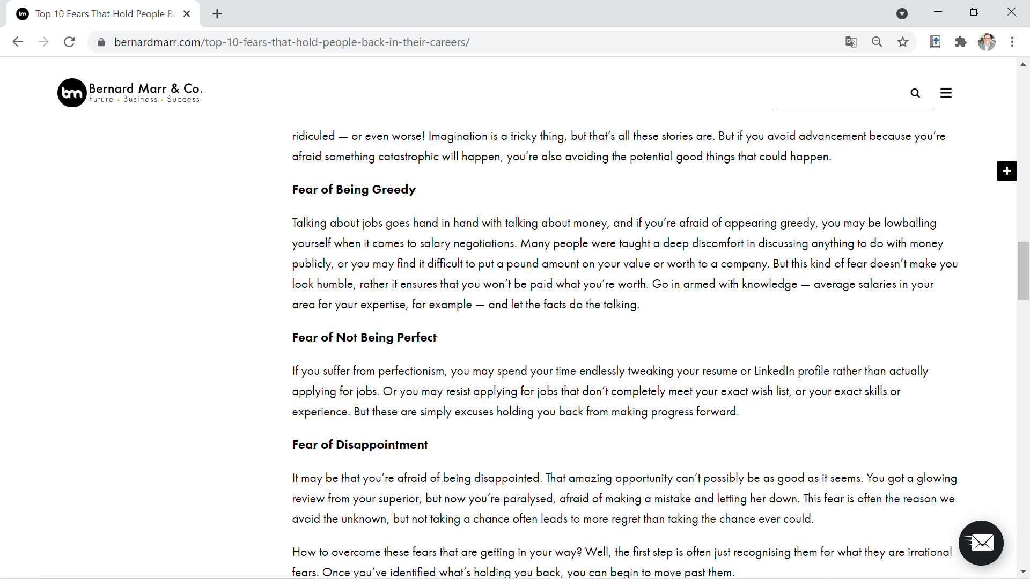

Optional readings (Homework)

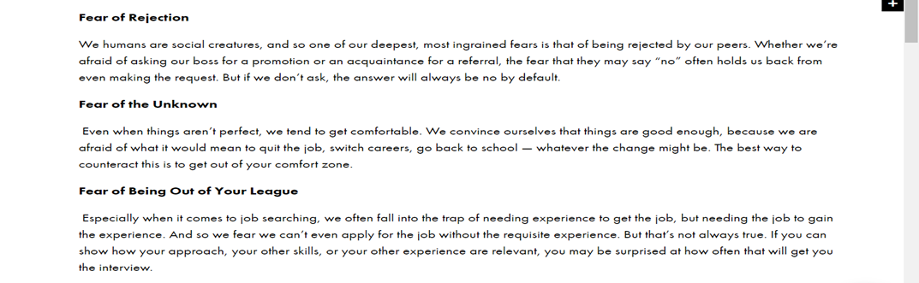

Source: Taken from https://bernardmarr.com/top-10-fears-that-hold-people-back-in-their-careers/

These images show sections of a reading called Top 10 Fears that Hold People Back in Their Careers.

Source for chart below :https://www.brookings.edu/research/grading-soft-skills-the-brookings-soft-skills-report-card/

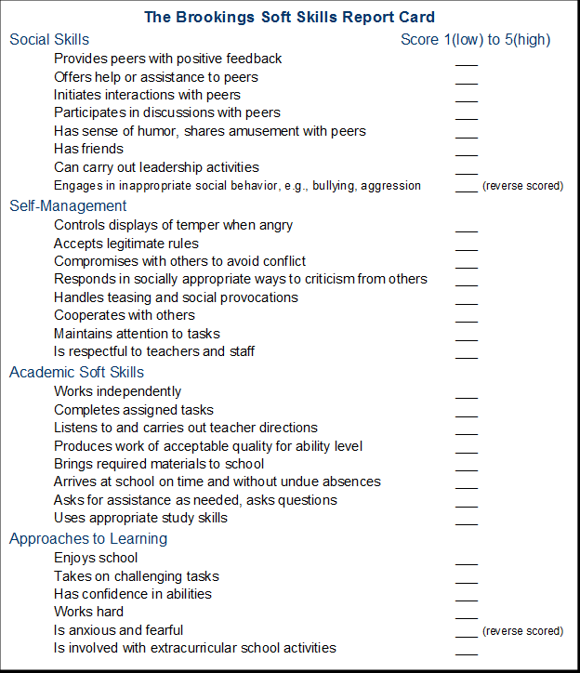
This image above shows a soft skills report card.
Didactic Planning
Week # 2

Level III
Period IV
Didactic Planning
Week #2
Domain: Academic |  |  | Scenario: Get Ready. Get, set, go. |  | Theme: Get Set: College or Career?
Enduring Understanding: Decisions can have positive and negative consequences in the future.
Essential Question: How can decisions define my future?
General Competences

Responsible Citizenship ( )
Life Competences ( )
Competences for Employability ( )

Learn to Know |  |  | Learn to Do |  | Learn to Be and Live in Community
Grammar & Sentence Frames  Modals  might, may, probably   We may go to college next year.   We might not have time off during test evaluation week.  Vocabulary  Get set: College or Career?  Moving out of the home –time to live alone  College, university, career, study abroad, decision, decide, enroll, analytical, artistic, musical, athletic, compassionate, competent |  |  | Function  Talking about college or career decisions.  Discourse Markers  Connecting words expressing cause and effect, contrast, etc.   On the other hand, we take a course to sharpen our soft skills.   However, the university offers new majors. |  | Psychosocial  - Managing soft skills at different scenarios.  Sociocultural  Respecting everyone’s choices regarding their future.
Assessment Strategies & indicators of learning  (Diagnostic, formative, summative) | Learner can  (goals) | Didactic Sequence Mediation |  |  |  |  | Time  Total:  200 min  (5 lessons)
L.2. extracts the main points in a relatively long conversation.  L2.1 Identifies the topic in a relatively long conversation about dreams and fears about the future.  L2.2 Recognizes key words in a relatively long conversation about dreams and fears about the future.  L2.3 Gets main points in a relatively long conversation about dreams and fears about the future.  R.2.Distinguishes between different text purposes (to inform, to argue a point, etc.).  Indicators of learning  R.2.1 Identifies the form (Is it a book? a brochure? a flyer? booklet? a web page? an advertisement? junk mail? An editorial? a newspaper article? a job application form? a survey? a short story? A comic strip? a poem?, a recipe? a manual?, a DIY book? an email?, a travel guide?, bird spotter’s guide)  R2.2 Identifies the source of the text. (Is it to persuade? to inform? to find out? to entertain? to instruct? to explain? to describe?  R2.3 Recognizes sentence structure. (short direct sentences, using the imperative; longer sentences using adjectives)  R2.4 Distinguishes the style of a text. (formal language with a business-like tone, informal language with lots of opinions, impersonal language)  R2.5 Distinguishes the vocabulary type. (easy to read, technical)  W1. Lists the advantages and disadvantages of things that are of personal concern (e.g., future goals, universities, majors, soft skills, careers, events).  icators of learrning  W1.1 Prewrites an advantages and disadvantages list of things that are of personal concern (e.g., future goals, universities, majors, soft skills, careers, events.  W1.2 Drafts sentences to express advantages and disadvantages of things that are of personal concern (e.g., future goals, universities, majors, soft skills, careers, events.  W1.3 Revises sentences to express advantages and disadvantages of things that are of personal concern (e.g., future goals, universities, majors, soft skills, careers, events by checking subject-verb agreement, pronoun and article agreement, capitalization, sentence sense, text structure, word order, content, punctuation and use of commas.  W1.4 Edits sentences to express advantages and disadvantages of things that are of personal concern (e.g., future goals, universities, majors, soft skills, careers, events before publishing. | L.2. understand the main points in a relatively long conversation that is overheard  R.2. distinguish between different text purposes (to inform, to argue a point, etc.).  W.1 list the advantages and disadvantages of things that are of personal concern (e.g., future goals, universities, majors, soft skills, careers, events). | Pre-teaching  Routine: Checking attendance, checking in with Ls, T posts the Essential Question on the board, Can Do’s, and class agenda, etc.  Participating: Warm up  Is it common living on your own in your country? Family? Do you like the idea of living on your own?  Engaging: Activation of prior knowledge  T. asks learners about how they imagine college and how they would organize themselves if living alone away from home.  Pre listening  Write the correct word next to its definition. Use a dictionary if necessary.  to bring up maintenance troublesome to tidy up  a landlord to settle down soaked to strike a balance  - To care for a child until it becomes an adult _________________  - To find a way to do multiple things in an acceptable way_______________  to become calmer and easier ______________  causing problems that are annoying _________________  completely wet _________________  an owner of a building who you pay rent to _________________  to put everything in its place _________________  work needed to keep something in good condition ________________  Listening for first time  Students listen to the track for the first time and guess a title for it.  https://learnenglish.britishcouncil.org/general-english/audio-zone/living-on-my-own  Pair /group feedback  Learners compare their answers, and then they share with the whole group.  Listening for second time  T asks leaners to match key words from the track with their corresponding definition.  Match the key words with their corresponding definitions. (see resources week #2 )  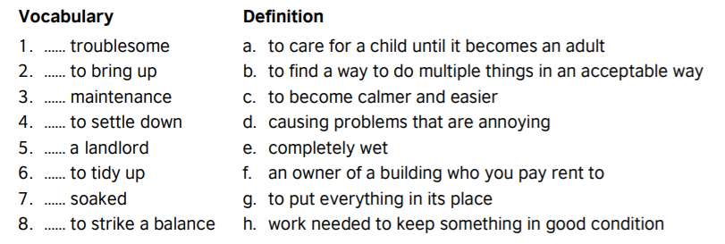  Students listen to the track again and answer the following questions:  - Why do people stay at home rather than moving out? (give 2 reasons)  - What is the most important reason to move out?  - What are some things you have to take into account when you are going to rent an apartment?  - Why is money considered the main issue when living by your own?  Post listening  Students check their answers along with their teacher and comment about them.  Pre-reading  Teacher shows pictures to students and asks them what they think, Teacher asks students to mention the different texts they know and what is the main purpose to use each one of them. Then teacher makes an explanation about the different kinds of texts: descriptive, persuasive, etc.  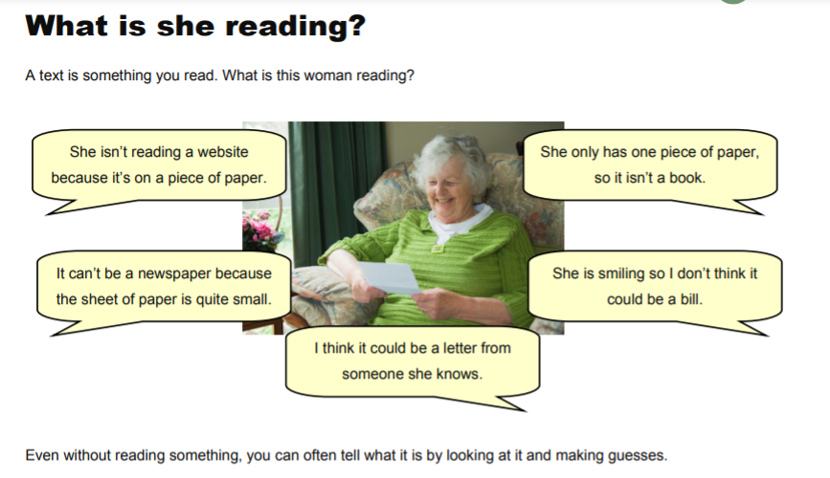  Students identify the different literary sources writing the corresponding number into the parenthesis.  1.Academic journals 2. Magazines 3.Web sites 4.Comic strip  5.Recipe 6.Flyer 7.Newspapers 8.Poem  9.Database 10.Timetable 11.Advertisement 12.Books  In pairs and with the rest of the class comment the next questions:  - In which of these literary sources is more probable that you can find a job?  - Which of these sources are used for academic purposes?  - Which ones are used for entertainment?  - Some of these resources are written in other languages, how did you identify them?  - Which ones inform? Explain? describe? Entertain?  Reading for the first time  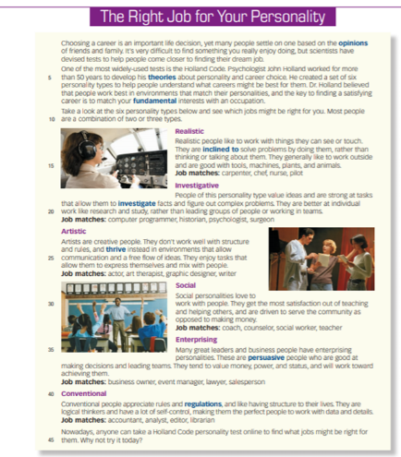  Source: Active Skills for Reading 2 Book, Unit 8., page 103. National Geographic Learning  T asks learners to skim the text above in order to identify its form. After reading, learners circle the text form from the chart below and write two reasons for their choice.  Is it a/an_____?  1. book article 2. magazine 3. web sites 4. comic strip  5. recipe 6. flyer 7. newspaper 8. poem  9. database 10. timetable 11. advertisement 12. book  Reasons: __________________________________________  __________________________________________  Pair/Group feedback  Students share their answer in pairs. They give two reasons for their choice.  Reading for the second time  Learners read the text again but this time they pay special attention to the sentences. Learners recognize different structures using colors as follows.  Red: Short direct sentences  Green: imperatives  Yellow: long sentences (commonly with adjectives)  Based on the second reading, learners circle the style of a text they read and the type of vocabulary in the reading.  Text Styles  1. formal language with a business-like tone 2. informal language with lots of opinions 3. impersonal language  Vocabulary type  easy to read technical  Post-reading  Learners just read an informative article. Now, it is time for them to choose one section of this article and transform it into a persuasive paragraph. They can follow the oreo technique as seen in the image.  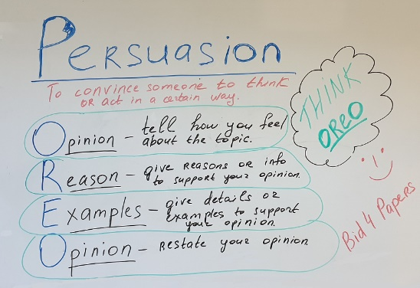  Source: https://bid4papers.com/blog/persuasive-essay/persuasive-article  Task: Alfredo and Andrea have great plans for their future. They want to apply for a major that is not offered in their hometowns. They start doing some research about different majors offered by different public and private universities. They are excited; however, they have not considered some challenges they may or might face studying away from home. So, they decided to write a list of advantages and disadvantages/challenges of moving out to study away from home. For the advantages listed before, they have to write a solution for each.  Pre-writing  T reviews the use of may and might as possibility.  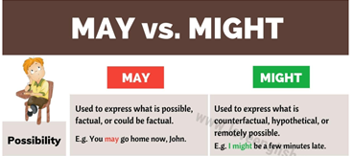  Adapted from: https://loveenglish.org/may-vs-might/  Teacher reminds learners how and when to use may and might with some examples from the unit.  We might not have time off during test evaluation week.  We may go to college next year.  Prewriting  T shows/ draws a graphic organizer on the screen/board. T asks learners to brainstorm ideas for advantages and ideas for disadvantages or challenges about his /her concerns regarding studying away from home.  Drafting  After writing some ideas in the graphic organizer, learners write complete sentences with them. They must include in the sentences may and might.  Revising  Learners check their sentences, and the teacher makes a quick check of their work by using the following chart.  The sentences … My revision Peers revision  Yes No Partially Yes No Partially  are well capitalized.  ‘verbs match with the subject.  have pronoun and article agreement.  include modals may and might.  have a period at the end.  ‘commas are used correctly.  fulfill the information asked in the task.  Editing  Learners correct any mistake found during peer correction and add the suggestions given by his/her teacher.  Publishing  Learners writes their sentences in a blog. |  |  |  |  | 15 m  40 m  40 m  40 m  40 m
Integrated Mini-Project |  |  |  |  |  |  | Time
Allow time for the Mini-Project each week. NOTE: All phases of the Integrated Mini-Project should be opportunities for Ls to practice English, not just those related to presentation.  Thinking for planning: (5 or 10 minutes in week 3 and 4)  Option #1  Learners prepare one presentation about how they look themselves 10 years from now. Ls will design a photo album or a diary creating a possible situation of their future.  Option #2  A multi-step research Career Research: “Planning my Future”- Gallery Walk (learners explore different careers and professions they want to pursue, complete with educational requirements, salary and job opportunities)  Option #3  Writing future goals (pros and cons) of the major’s academic possibilities and occupations.  Option #4  Running a debate or a vocational café. |  |  |  |  |  |  | Adjust previous times listed above to allow 5 min each week.  Group presentations can be week 5 or 6.
Reflective Teaching
What worked well |  |  |  | What didn’t work well |  | How to improve
Enduring Understanding Reflection
How well did the learners progress in their understanding of the Enduring Understanding?

Week Plan Self-Assessment
At the end of the week, T guides the learners to check their progress using the checklist below. (Can be translated into Spanish if needed to ensure Ls’ understanding.)

Learner Self-Assessment
I can… | Yes | In progress | No
identify the topic of texts of various lengths as long as the words used are familiar.
identify key words of texts of various lengths as long as the words used are familiar.
distinguish the gist of texts of various lengths as long as the words used are familiar.
identify the topic in texts of various lengths as long as the words used are familiar and/ or concern areas of student interest.
identify the intended audience in texts of various lengths as long as the words used are familiar and/ or concern areas of student interest.
recognize the text structure in texts of various lengths as long as the words used are familiar and/ or concern areas of student interest.
get main idea in paragraphs or sections of texts of various lengths as long as the words used are familiar and/ or concern areas of student interest.
extract supporting details in paragraphs or sections of texts of various lengths as long as the words used are familiar and/ or concern areas of student interest.
analyze the author’s argument in texts of various lengths as long as the words used are familiar and/ or concern areas of student interest.
draw conclusions texts of various lengths as long as the words used are familiar and/ or concern areas of student interest.
prewrite a summary with a main idea in a few words dealing with familiar subjects.
draft a summary with the main idea in a few words using the appropriate linkers or connecting words.
revise a summary with the main idea in a few words by checking subject-verb agreement, pronoun and article agreement, sentence sense, text structure, word order and punctuation
edit a summary with the main idea in a few words before publishing.

Resources Week #2

Write the correct word next to its definition. Use a dictionary if necessary.

to bring up maintenance troublesome to tidy up
a landlord to settle down soaked to strike a balance
- To care for a child until it becomes an adult _________________
- To find a way to do multiple things in an acceptable way_______________
to become calmer and easier ______________
causing problems that are annoying _________________
completely wet _________________
an owner of a building who you pay rent to _________________
to put everything in its place _________________
work needed to keep something in good condition ________________

Match the definitions

This image shows a matching exercise

Students listen again and answer the questions.

- Why do people stay at home rather than moving out? (give 2 reasons)
- What does *them¨(paragraph 1, line 6) refer to?
- What do ¨they¨(P.2, line 3) refer to?
- What is the most important reason to move out?
- What are some things you have to take into account when you are going to renta n apartment?
- Why money is considered the main issue when living by your own?
Transcript
I want to talk about my experience of moving out and living on my own. Moving out to live on your own is not very common in Hong Kong. Many people still choose to live with their parents even though they have a decent job and they're already at (in) their 30s. Many of them would stay with their parents until they get married. There are several reasons behind – firstly, Hong Kong's rent is expensive. Many people would rather save up more money to purchase an apartment instead of renting one. Secondly, the Chinese traditional value of family is that the parents are the ones who brought you up. When you become an adult, you should also take good care of your parents and you should spend more time to be with them. And of course there are people who are still dependent on their parents for food, clothing, household chores, etc.
When I tell people about the idea of moving out, many people's reaction is like, 'What do your parents say?', because they assume the parents would not like their children to leave them. Well, I don't know if my parents like it, but I can tell you my parents support and respect my decision. They think it is good for me to try and live on my own and then I would know it is the best to stay with my family.
The most important reason for independent living is to save the travelling time to work. It used to take me one hour 15 minutes to travel to work from my previous living place. From my new apartment, it just takes me 30 minutes, so I saved 45 minutes' travelling time. I don't have to get up so early and I save two-third (two-thirds) of my travelling cost. It does not only save my time to travel for work, but also from most of the places in Hong Kong. In addition, I gain my personal space and freedom by independent living. I make my own decision (decisions) all the time, I do not have to say whether I would go home for dinner, I can invite my friends to come up and stay late.
Of course, there are some trade-offs in living on your own. If you want to rent an apartment, there are lots of preparatory works (work) to do. You have to keep visiting the apartments to search for your ideal one. You have to negotiate with the landlord about the price, furniture inclusion, who is responsible for the maintenance of the furniture and equipments (equipment). My experience was that after we moved into the apartment, it was not until the kitchen cupboard was soaked with water that we found out there was water leakage (leak) in the kitchen sink.
Money is the main issue in living on your own. You have to be responsible for all the expenses, for example the rent, electricity, gas, water, telephone, internet bills, etc. Therefore, you've got to be well prepared and save up for your bills. Although I find my transportation time much shorter, the saved time is spent on other things, such as cooking and some other household chores. I think preparing and cooking the food do occupy a significant portion of my time; therefore, I always try to make simple meals. On the other hand, I have to regularly tidy up my apartment and wash my clothes, so it doesn't really save much of my time after all.
Now everything is settled down, I'm getting used to my new life and I am enjoying it. I feel that moving out makes it easier for me to strike a balance between my work, my social life, my study and my family. It may be troublesome, but it may worth (be worth it).

This image shows a woman reading a text.

DIFFERENT FORMS OF LITERATURE

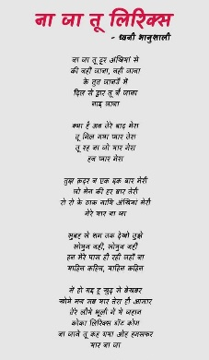
( ) ( ) ( ) ( )

( ) ( ) ( ) ( )
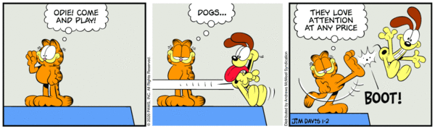
( ) ( ) ( ) ( )

Identify the different literary sources writing the corresponding number into the parenthesis.
1.Academic journals 2.Magazines 3.Web sites 4.Comic strip
5.Recipe 6.Flyer 7.Newspapers 8.Poem
9.Database 10.Timetable 11.Advertisement 12.Books

In pairs ans with the rest of the class comment the next questions:

- In which of these literary sources is more probable that you can find a job?

- Which of these sources are used for academic purposes?

- Which ones are used for entertainment?

- Some of these resources are written in other languages, how did you identify them?

- Which ones inform? Are created to argue? to give a point of view?
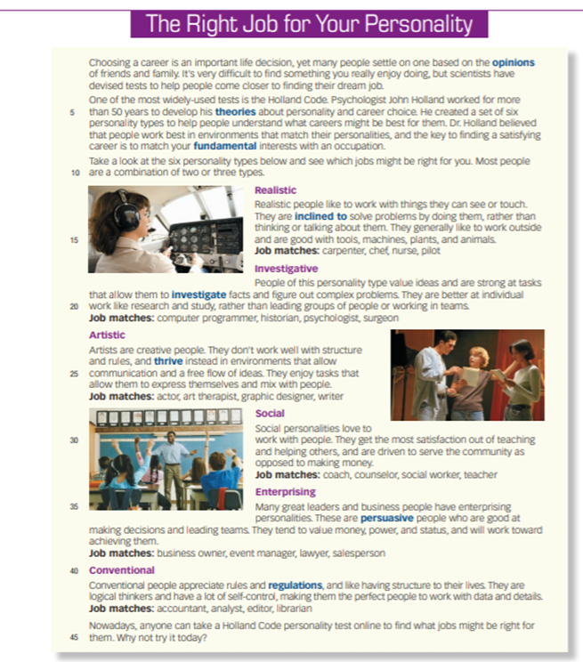

Source: Active Skills for Reading 2 Book, Unit 8., page 103. National Geographic Learning
This image shows a reading called The Right Job for Your Personality

Advantages and disadvantages/challenges of studying away from home

Directions:
Disadvantages/ challenges
Advantages

Level III
Period IV
Didactic Planning
Week # 3
Domain: Academic |  |  | Scenario: Get Ready. Get set. Go! |  | Theme: Surviving or Thriving?
Enduring Understanding: Decisions can have positive and negative consequences in the future.
Essential Question: How can decisions define my future?
General Competences

Responsible Citizenship ( )
Life Competences ( )
Competences for Employability ( )

Learn to Know |  |  | Learn to Do |  | Learn to Be and Live in Community
Grammar & Sentence Frames  Future continuous Will+ be+ gerund  - Alex will be arriving later today. He should be punctual to keep his job.  Complex questions tags  - This job is interesting, isn’t it?  - This enterprise doesn’t offer social security insurance, does it?  Vocabulary  -College dressing  -College problems  -Being positive to reach your goals  - Developing a positive attitude towards life events and jobs.  - Being open to changes, creative and proactive |  |  | Function  Describing soft skills needed to be successful in working life.  Discourse Markers  Markers to structure informal spoken discourse  - Right  - Really?  - Well, anyway  - Oh, I know. |  | Psychosocial  Making decisions that benefit my future.  Sociocultural  Respecting everyone’s choices regarding their future.
Assessment Strategies & indicators of learning  (Diagnostic, formative, summative) | Learner can  (goals) | Didactic Sequence Mediation |  |  |  |  | Time  Total:  200 min  (5 lessons)
SP.1 Expresses an opinion on different topics.  Indicators of learning  SP1.1 Plans the information to express an opinion about dreams and fears for the future.  SP1.2 Organizes the information to express an opinion about dreams and fears for the future supported by sentence frames and illustrations.  SP1.3 Makes sentences with the information to express an opinion about dreams and fears for the future with the appropriate linkers or connecting words supported by illustrations.  SP1.4 Gives an opinion about dreams and fears for the future supported by sentence frames and illustrations.  SP.2. Expresses an argument clearly enough to be understood most of the time.  Indicators of learning  SP2.1 Plans the language, content and resources to express an argument clearly enough to be understood most of the time about future plans regarding jobs and studies, and college problems and dressing.  SP2.2 Makes sentences to express an argument clearly enough to be understood most of the time in a well-organized presentation with the appropriate linkers or connecting words about future plans regarding jobs and studies, and college problems and dressing.  SP2.3Expresses an argument clearly enough to be understood most of the time in a well-organized presentation. | SP.1. Express an opinion on different topics associated with everyday life and common issues (e.g., give a short talk on the value of developing soft skills).  SP.2. Present an argument clearly enough to be understood most of the time. | Pre-teaching  Routine: Checking attendance, checking in with Ls, T posts the Essential Question on the board, Can Do’s, and class agenda, etc.  Participating: Warm up  T asks learners to watch the video What are soft skills? https://www.youtube.com/watch?v=Tiy2LONr050  Engaging: Activation of prior knowledge  After watching the video, T. brainstorms learners’ opinions related to soft skills. Learners can use the following phrases to give their opinions.  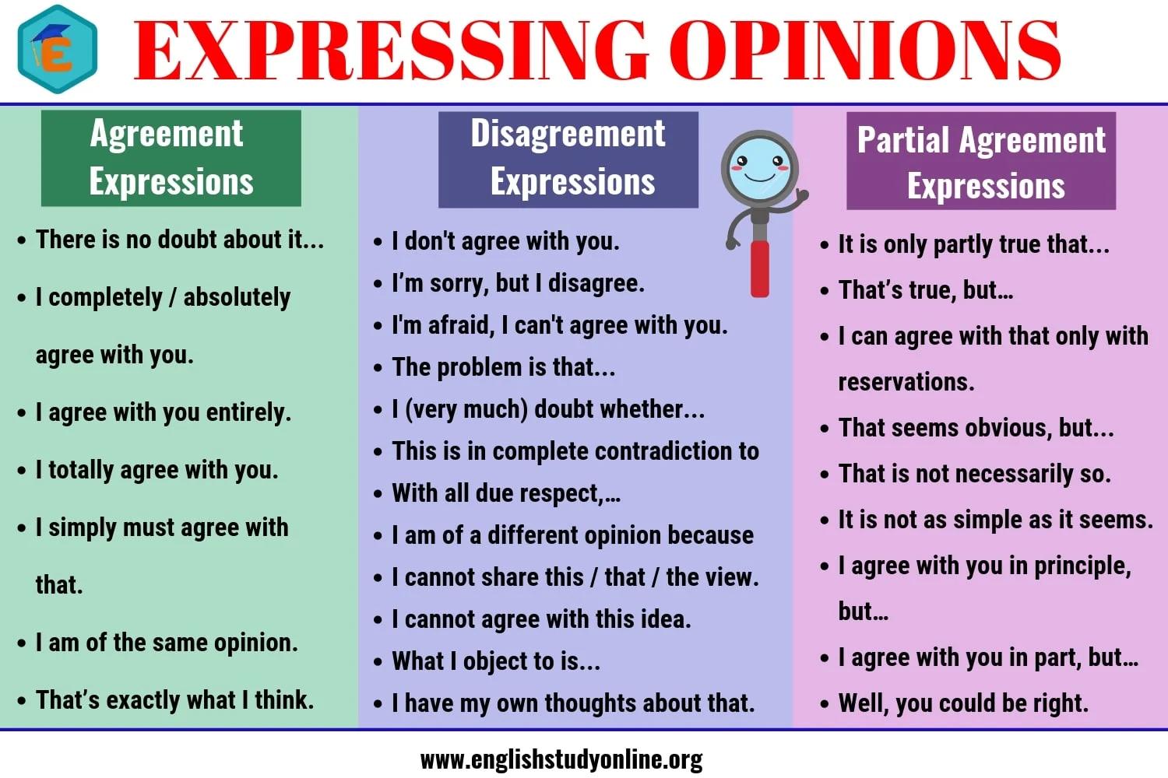  Then, they make a list of their own soft skills and copy them on their notebooks. After that, learners fill out a soft skills KWL chart. If the students are attending virtual classes or have access to technological devices, they can use www.paddlet.com  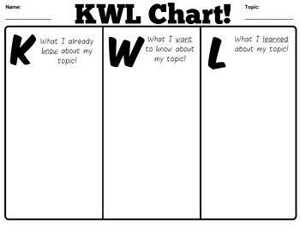  Task: A company wants to hire manpower. So, representatives will be coming to the high school two weeks from today to interview learners. T wants learners to be ready for it. Thus, T asks learners to watch the following video and prepare themselves to give a short talk about it at https://www.youtube.com/watch?v=VuLNCERKVS8, guiding a set of questions.  Planning  Learners watch the video and take notes to answer some questions for their short talk. T presents and clarifies the following questions:  Organizing  Once learners have gotten the answers and their notes, they start organizing the information and looking for resources in order to prepare a well-organized short talk.  Ls make sentences using appropriate linkers in which they specify aspects such as the importance of soft skills, the difference between soft and hard skills, examples, benefits training to achieve dreams or overcome fears.  Rehearsing  Before giving the talk with collected and prepared information, learners practice with other learners what they will share during the short talk. They help each other clarifying if any doubts about pronunciation or vocabulary.  Expressing  Learners share their information and express their personal opinions about how soft skills training can help them achieve dreams and overcome fears.  T asks learners to take a look at the chart below. Then, they have to comment on which stage they think they are and why (in terms of life, career choice, world situation, etc). T asks learners what they can do in order to move forward the stage they are in.  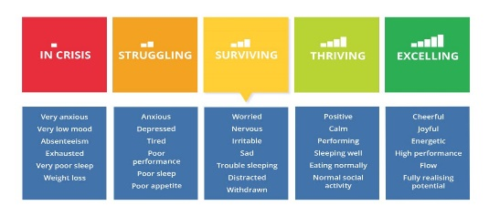  T reviews future continuous will+ be+ gerund. T models some sentences and then, T asks learners to work in pairs and write some sentences in future continuous with the words from the chart.  Examples:  The team will be achieving a high performance after the soft skills training next month.  Task: You will go to college next year. Make a Surviving vs Thriving comparative chart for an oral presentation. Tell your classmates about your future in college (housing, outfit (college dress style, customs, habits), skills you will have to use, etc. Use future continuous in your short talk as well as some colloquial expressions such as: Right, Really? Well, anyway. The short presentation must be 2 or 3 minutes long.  Planning  College Facts Surviving Thriving  Clothes  Housing  Part-time job(job)  Money  Skills for college  Skills for work  Skills for life  Others  Organizing  Ls write sentences using appropriate linkers. They also organize the resources they want to share with classmates (power point presentations, video, etc; to support their presentations).  Rehearsing  Learners rehearse individually first. Then, they practice with a classmate who has already practiced individually, too. L use the following checklist to provide feedback to each other.  Oral Presentation Checklist  The presentation... Yes No Partially  is well -organized (it has beginning, a middle and an end)  ´s sentences are well connected. (use of connectors)  has a logical sequence of ideas  has resources to support it.  has clear sentences.  fulfills the information asked in the task.  Expressing  Learners make a presentation to express arguments clearly enough to the audience. |  |  |  |  | 40 m  40 m  40 m
Integrated Mini-Project |  |  |  |  |  |  | Time
Allow time for the Mini-Project each week. NOTE: All phases of the Integrated Mini-Project should be opportunities for Ls to practice English, not just those related to presentation.  Acting out  Option #1  Learners prepare one presentation about how they look themselves 10 years from now. Ls will design a photo album or a diary creating a possible situation of their future.  Option #2  A multi-step research Career Research: “Planning my Future”- Gallery Walk (learners explore different careers and professions they want to pursue, complete with educational requirements, salary and job opportunities)  Option #3  Writing future goals (pros and cons) of the major’s academic possibilities and occupations.  Option #4  Running a debate or a vocational café.  They also have to mention the skills they will probably use at this job. |  |  |  |  |  |  | Adjust previous times listed above to allow 5 min each week.  Group presentations can be week 5 or 6.
Reflective Teaching
What worked well |  |  |  | What didn’t work well |  | How to improve
Enduring Understanding Reflection
How well did the learners progress in their understanding of the Enduring Understanding?
Week Plan Self-Assessment
At the end of the week, T guides the learners to check their progress using the checklist below.
Learner Self-Assessment
I can… | Yes | In progress | No
prepare questions for an interview about studying in Costa Rica or abroad.
exchange personal experiences, feelings, opinions and reactions about studying in Costa Rica or abroad in an interview.
plan the language, content and resources to express opinions about studying in Costa Rica or abroad.
make sentences to express opinions about studying in Costa Rica or abroad.
express ideas to give opinions about studying in Costa Rica or abroad.
ask for other’s opinions about studying in Costa Rica or abroad.
start the simple face-to-face conversation with a greeting.
keep a face-to-face conversation going about studying in Costa Rica or abroad by checking understanding from the speaker's point of view or listener's point of view
continue with the conversation about studying in Costa Rica or abroad by checking understanding from the speaker's point of view or listener's point of view.
Asks for agreement and disagreement in given statements about studying in Costa Rica or abroad.
Answers questions about studying in Costa Rica or abroad.
Closes the conversation about studying in Costa Rica or abroad

MATERIAL WEEK # 3

This image shows a list of expressions to express opinion.
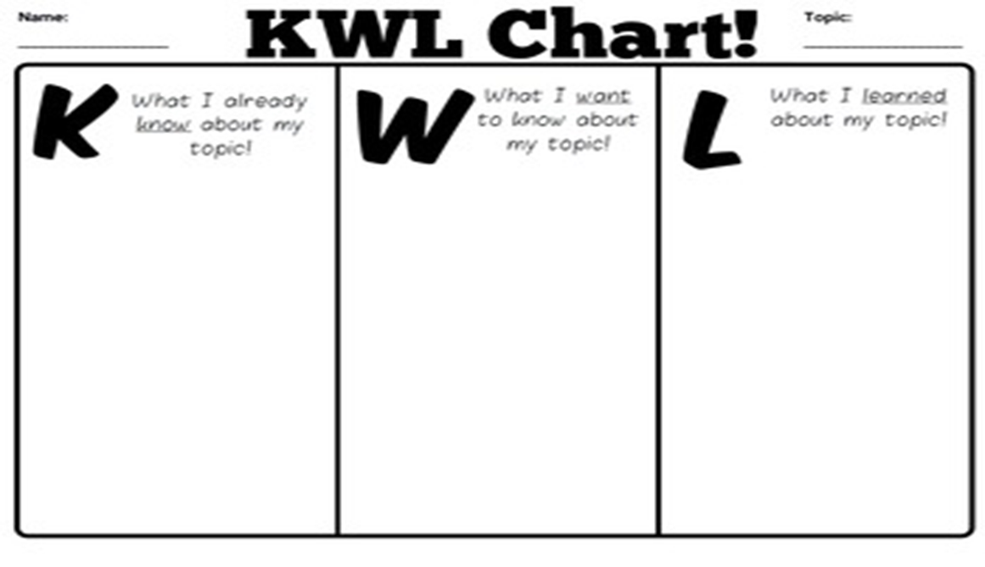
This image shows a KWL Chart.

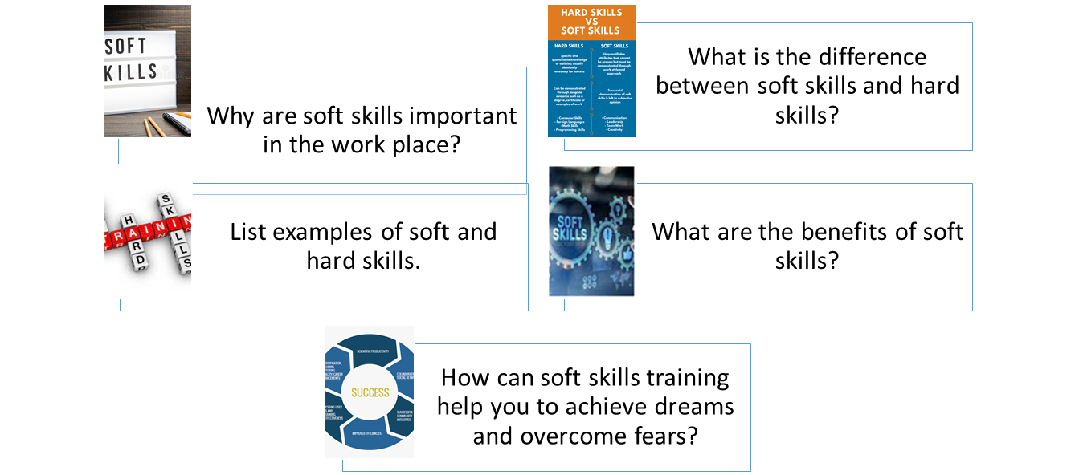

This image shows a list of questions for learners to use.

Form of the future progressive
The future progressive tense is formed by adding will be to the -ing form (gerund form) of the main verb and it is used to indicate an action which will be taking place at some time in the future.
will | be | verb+ing

Affirmative:
I will/'ll be attending a university induction next week. Negative I will not/won't be attending a university induction next week.

Interrogative
Will you be attending a university induction next week?
NOTE:
will be attending = 'll be attending
will not be watching = won't be attending
Examples:
- I will be attending a university induction next Sunday afternoon.
- We'll be working on our project this morning.
- When you arrive, I'll be studying
- I will be leaving for work in a few minutes.

SURVIVING OR THRIVING?

Look at this chart and comment in which stage you think you are and why (in terms of life, career choice, world situation, etc. can you improve it?
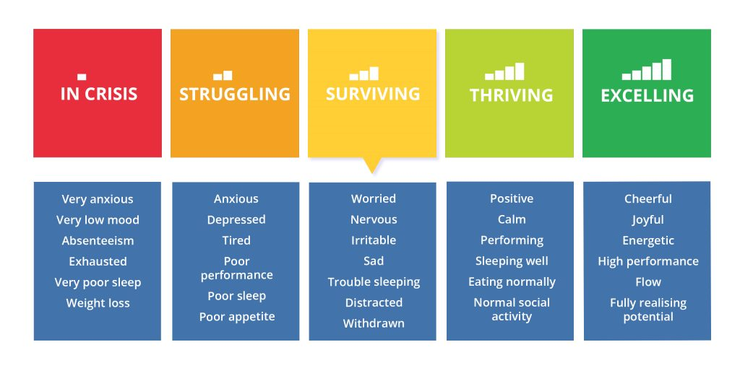
This image shows stages in terms of in terms of life, career choice, world situation.

Level III
Period IV
Didactic Planning
Week # 4
Domain: |  |  | Scenario: Get Ready. Get, Set, Go. | Theme: Go! The Future is Now
Enduring Understanding: Decisions can have positive and negative consequences in the future.
Essential Question: How can decisions define my future?
General Competences

Responsible Citizenship ( )
Life Competences ( )
Competences for Employability ( )

Learn to Know |  |  | Learn to Do | Learn to Be and Live in Community
Grammar & Sentence Frames  Embedded Questions  - Main question / statement + interrogative+ subject + verb + object / complement  - Do you know when I can apply for the job?  Vocabulary  Go! The Future is Now.  - Getting a job (looking for and getting a job, interviews, resumes, filling out forms, financial aid, type of letters, having a part-time job etc.  - Companies Human resources department CEO Soft skills (punctuality, responsibility, initiative, etc.)  - Enterprises, business, companies  Moving out of the home-time to live alone |  |  | Function  Initiating and closing conversations about future plans regarding jobs and studies.  Discourse Markers  Markers to structure informal spoken discourse  - Oh, I know.  - Yes, I suppose so.  - I know how you feel.  - You know, I don´t like her either. | Psychosocial  - Managing soft skills at different scenarios.  Sociocultural  Respecting everyone’s choices regarding their future.
Assessment Strategies & indicators of learning  (Diagnostic, formative, summative) | Learner can  Goals | Didactic Sequence Mediation |  |  | Time  Total:  200 min  (5 lessons)
W.2. writes a descriptive paragraph about universities, majors or soft skills.  Indicators of learning  W2. 1 Prewrites a descriptive paragraph about universities, majors or soft skills  W1.2 Drafts a descriptive paragraph about universities, majors or soft skills that includes topic sentence (what you are writing about), supporting sentences (provide details explaining or supporting the topic sentence) concluding sentence (a sentence that summarizes the ideas expressed in the paragraph) with the appropriate linkers or connecting words.  W1. 3 Revises a descriptive paragraph about universities, majors or soft skills by checking subject-verb agreement, capitalization, pronoun and article agreement, sentence sense, text structure, word order, content, spelling, use of commas, punctuation and cohesion.  W1. 4 Edits a descriptive paragraph about universities, majors or soft skills before publishing.  R.3 extracts the key ideas from narrative and expository texts.  R.3.1 Identifies the topic from narrative and expository texts about college and career decisions.  R.3.3 Gets main points from narrative and expository texts about college and career decisions  R.3.2 Recognizes key words from narrative and expository texts about college and career decisions.  SI.2. Participates in - group work, expressing opinions and making suggestions actively.  Indicators of learning  SI2. 1 Plans a set of sentences to give opinions about soft skills needed to be successful in working life.  SI2. 2 Makes complete sentences to give opinions about soft skills needed to be successful in working life.  SI2.3 Provides suggestions on how to improve soft skills needed to be successful in working life. | W.2. write a descriptive paragraph about universities, majors or soft skills and check written paragraphs or lists to look for mistakes (subject-verb agreement, pronoun and article agreement, capitalization, using commas, sentence sense, word order, text structure, concrete ideas, cohesion, etc.).  R.3. understand most words in narrative and expository text, and extract the key ideas from those texts.  SI.2. participate in-group work, expressing opinions and making suggestions actively. | Pre-teaching  Routine: Checking attendance, checking in with Ls, T posts the Essential Question on the board, Can Do’s, and class agenda, etc.  Participating: Warm up  Teacher writes on the board or projects on the screen the following question:  How can decisions define my future?  After that, the teacher asks learners to move around the classroom asking and answering the question. Teacher can also send students to breakout rooms if they are connected via Teams. Once there, they can take turns asking and answering the question.  Engaging: Activation of prior knowledge  Teacher asks students to think about their preferences in universities /colleges. They think about three names (if they need information they can go to this link: https://waki.cr/ (App to choose Costa Rican ‘universities).The teacher distributes or sends a Comparing Colleges activity form (see it at the resource section for this week at the end of the unit) for each student. Learners fill it out with the information required.  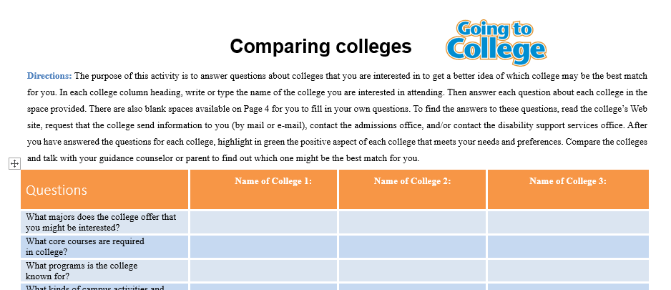  Introducing  T projects on the board or screen a chart with the different types of embedded questions we can formulate. (See resource materials at the end of week 4)  The teacher explains the structures and provide learners with some examples in context and asks students to produce some other questions orally following the structures explained.  Task: My English teacher asked us to do research about universities, majors and/or soft skills online. He/she wants us, within a small or whole group, to write a descriptive paragraph about universities, majors and/or soft skills to become aware of what is coming after graduating from school.  Pre-writing  Learners brainstorm ideas to write a descriptive paragraph about universities, majors and/or soft skills by using previously learned sentence frames for monitoring comprehension. They look at the following questions that could help them with it.  - Do you know what a person can search for if they need to find a good university?  - Have you decided what university could be the best option for?  - Where would you like to study?  - What profession should I choose?  - Do you know what skills do you need to develop to be successful in your future career/job?  - What do you like the best about it?  - What soft skills are required for this major?  Drafting  Learners write their production that includes a topic sentence (what you are writing about), supporting sentences (provide details explaining or supporting the topic sentence) and a concluding sentence (a sentence that summarizes the ideas expressed in the paragraph) with the appropriate linkers or connecting words.  Revising  Then, each learner checks his/her report by using the following editing checklist:  Editing Checklist My revision  The report … Yes No Partially  is well- capitalized.  ‘s verbs match with the subject.  Pronoun and article agreement  has at least 2 embedded questions  Has background information (content)  has a main body of well -sequenced ideas  has a conclusion.  is indented.  has clear sentences.  fulfills with the information asked in the task.  Spelling is correct  has punctuation marks correctly used.  Word order  Editing & Publishing  Considering their own self-assessment, learners correct and modify their descriptive paragraph. Teacher also monitors students and helps them in the editing process before publishing.  Note: (This activity can be useful as a part of the mini project if they choose the essay option)  Pre- reading  Teacher asks some questions such as: What do people do to choose a college major or future career? Are there job fairs in your high schools? Is it a common practice for teenagers to ask parents for guidance when choosing a college major?  Reading for the first time  T. asks learners to skim the article How to Make a Career Choice When You Are Undecided (See materials section for the reading). Then,T asks learners to write a sentence to describe the topic. Later, learners get in groups and share the sentence they wrote and choose the best one to the report to the rest of the group.  Pair/Group feedback  Students check the sentences in pairs and help each other to correct any mistake.  Reading for the second time  Learners read the text again and identify the main idea in each one of the paragraphs writing the corresponding number inside each parenthesis. Note: The ideas are paraphrased.  (P___) Identify your goals. Let the research you did about required education and training be your guide. Study more if you do not have all the details to set long and short-term goals.  (P____) It is advisable to create just one single list, you have to see the careers that you are interested in and write them into a sheet of paper.  (P ___) After this investigation you can make your choice. Choose the job that you think will bring you happiness. Many students change their careers many times.  (P____) Now, you'll be excited you have less options about each of the occupations on your list. Find job requirements and future employment possibilities.  (P__) Take out the careers you do not want to study. And make a “short list." Of at least 5 careers. Be objective and think if you can have the abilities to be successful in it.  (P___) Knowing about someone´s own personality using different instruments or even an expert to evaluate will give the person different possible careers to choose.  (P__) Make a career action plan with all your goals. Write your long- and short-term goals, this will be important steps for you.  (P__) Look for jobs you like and know some about to investigate later on. Also, include professions you don't know much. You will be surprised.  Answer: 7-2-6-4-5-1-8-3  Students recognize key words from the text matching the words on the right to their corresponding definitions on the left by writing the correct number.  - Career (5) ability to do something well; expertise.  - Tool (8) systematic investigation or study of facts.  - Self-assessment (7) object of a person's ambition or effort.  - Requirement (1) occupation undertaken for a significant period of a person's life.  - Skill ( 3 ) evaluation of oneself or one's actions and attitudes.  - Gather ( 9 ) action of teaching someone a particular skill or type of behavior.  - Goal (4) a thing that is needed or wanted.  - Research (2) device especially held in the hand, used to carry out a particular. function.  - Training (6) come together; assemble or accumulate.  - Sources (10) a place, person, or thing from which something comes or can be. obtained.  Post reading  T asks learners to participate in a round table expressing their opinions about the article.  Task: You and your classmates are asked to plan a university fair. Then you searched on the net and found a video that could help you understand what a university fair is. Watch the video you found https://www.youtube.com/watch?v=m50jDshjQlQ to inspire you and your classmate to make groups and create different stands with information about different university majors. Some of your classmates will play the role of university representatives in the stands. Some other classmates will play the role of high school students who will ask university representatives about the soft skills needed to be successful in those careers. Think about the possible questions that you can make to the university representatives. Students playing the role of university representatives must be ready to answer students’ questions.  Planning and organizing  Teacher asks learners to work in groups of 3 or 4 learners to create a stand with information from different universities, plan a set of questions related to the soft skills needed to be successful, with previously learned language structures and content needed for the task, using linking words for time sequence and to be asked to the students playing university representatives. They have to give opinions about specific soft skills they have to develop to be successful in the careers they chose.  Rehearsing  Students rehearse their questions and possible answers with the roles assigned within the group by taking turns. They check fluency, pronunciation, intonation, coherence and sentence structure.  Interacting/Describing  Learners walk around the classroom visiting the different stands asking questions and giving opinions about specific soft skills they have to develop to be successful in the careers they are interested in. They can record some of the interactions with different classmates to later show their videos/audios to the rest of the class. |  |  | 40 m  40 m  40 m  80 m

Integrated Mini-Project |  |  | Time
Allow time for the Mini-Project each week. NOTE: All phases of the Integrated Mini-Project should be opportunities for Ls to practice English, not just those related to presentation  Acting out: Complete their mini projects to present them in week 5 and 6.  Option #1  Learners prepare one presentation about how they look themselves 10 years from now. Ls will design a photo album or a diary creating a possible situation of their future.  Option #2  A multi-step research Career Research: “Planning my Future”- Gallery Walk (learners explore different careers and professions they want to pursue, complete with educational requirements, salary and job opportunities)  Option #3  Writing future goals (pros and cons) of the major’s academic possibilities and occupations.  Option #4  Running a debate or a vocational café.  They also have to mention the skills they will probably use at this job. |  |  | Adjust previous times listed above to allow 5 min each week.  Group presentations can be week 5 or 6.
Reflective Teaching
What worked well | What didn’t work well | How to improve
Enduring Understanding Reflection
How well did the learners progress in their understanding of the Enduring Understanding?

Week Plan Self-Assessment
At the end of the week, T guides the learners to check their progress using the checklist below. (Can be translated into Spanish if needed to ensure Ls’ understanding.)

Learner Self-Assessment
I can… | Yes | In progress | No
plan the language, content and resources to explain points of view, justifying assumptions and plans, briefly about studying in Costa Rica or abroad in a well-organized presentation.
make sentences to explain points of view, justifying assumptions and plans, briefly about studying in Costa Rica or abroad with the appropriate linkers or connecting words in a well-organized presentation.
express ideas to explain points of view, justifying assumptions and plans, briefly about studying in Costa Rica or abroad in a well-organized presentation.
prewrite ideas based on a real event for a one-page report about graduating from school, getting interviewed or choosing a career.
draft the report based on a real event for a one-page report about graduating from school, getting interviewed or choosing a career.
revise the report based on a real event for a one-page report about graduating from school, getting interviewed or choosing a career.by checking subject-verb agreement, pronoun and article agreement, sentence sense, text structure, word order and punctuation and content.
edit the report before publishing.

Materials for week # 4
Comparing colleges
Directions: The purpose of this activity is to answer questions about colleges that you are interested in to get a better idea of which college may be the best match for you. In each college column heading, write or type the name of the college you are interested in attending. Then answer each question about each college in the space provided. There are also blank spaces available on Page 4 for you to fill in your own questions. To find the answers to these questions, read the college’s Web site, request that the college send information to you (by mail or e-mail), contact the admissions office, and/or contact the disability support services office. After you have answered the questions for each college, highlight in green the positive aspect of each college that meets your needs and preferences. Compare the colleges and talk with your guidance counselor or parent to find out which one might be the best match for you.
Questions | Name of College 1: | Name of College 2: | Name of College 3:
What majors does the college offer that you might be interested?
What core courses are required
in college?
What kinds of campus activities and organizations does the college offer?
What are the admission requirements?
Are there foreign language or other courses required for admissions?
What are the admissions deadlines?
How many students with disabilities
are on campus?
Does the college provide classes
or workshops in study skills (time management, note taking, reading, writing)?
Adapted from Virginia’s College Guide for Students with Disabilities: www.doe.virginia.gov/special_ed/transition_svcs/outcomes_project/college_guide.pdf

Embedded questions
An embedded question is a question that is inside another question or statement. This grammar point is sometimes explained on its own or in a lesson on noun clauses or reported speech (more on this below).

Two Types

1. Embedded Questions within Questions
Here are some examples of an embedded question within another question. For patterns and uses, see the notes below the charts.

Common Introductory  Question Phrases | Common Questions | Embedded Questions Examples
Do you know… | When does the course start? | Do you know when the course starts?
Who knows… | What is the best career? | Who knows what the best career is ?
Do you think… | Can he come to take the admission test? | Do you think he can come to take the admission test?
Do you remember… | Where is the admissions office? | Do you remember where the admissions office is?
Could you tell me… | Is there any scholarship program? | Could you tell me if there is any scholarship program?
Would you mind telling me … | What time is the lecture? | Would you mind telling me what time the lecture is?

Embedded Questions within Statements
Here are some examples of an embedded question within an affirmative or negative sentence. Note that we do not use a question mark for these statements even though they contain a question.

Common Introductory Statement Phrases | Common Questions | Embedded Question Examples
I wonder… | Is our professor emphatic? | I wonder whether (or not) our professor is emphatic?
I asked… | Can I have an extension? | I asked if I could have an extension.
I want to know… | How much was the tuition? | I want to know how much tuition was.
I don’t know… | Who does this admission papers belong to? | I don’t know who these admission papers belong to.
I´m not sure | Where are my forms? | I´m not sure where my forms are.
The question is… | Should we go ahead with the scholarship application process? | The question is if we should go ahead with the scholarship application process (or not).
Let´s ask… | Do they like the student induction into university life? | Let´s ask whether they like the student induction into university life (or not) .

Patterns

1. Sentence Pattern
A normal English sentence follows this pattern: Subject + Verb (+ Object) or SVO.
- She (S) studied (V).
- The girl (S) took (V) the test. (O).

2. Question Pattern
A normal question has an inversion of the sentence pattern, and looks like this: (Question Word) + Auxiliary Verb + Subject + Main Verb (+ Object) or VSVO. For the Be verb, it looks like this: VSO.
- What (Question Word) did (Aux V) he (S) study(V)?
- Do (Aux V) you (S) like (V) elective courses (O)?
- Is (Be) he (S) organized?

3. Embedded Question Pattern
In an embedded question, the question inside the statement or other question follows a sentence pattern instead of a question pattern: SVO. The introductory phrases follow the normal sentence (SV) or question (VS) patterns.
- I (S) don’t know (V) [what (question word) I (S) should do with this (V)].
- Do (Aux V) you (S) think (V) [we (S) need (V) more time to complete the admission process. (O)]?

How to Make a Career Choice When You Are Undecided

7 Steps to Choosing a Career
BY DAWN ROSENBERG MCKAY

Updated November 20, 2019
Image by Lisa Fasol © The Balance 2019
With thousands of options, how will you choose a career that's right for you? If you don't have any idea what you want to do, the task may seem insurmountable. Fortunately, it isn't. Follow an organized process and you will increase your chances of making a good decision.

Assess Yourself
P.1 Before you can choose the right career, you must learn about yourself. Your values, interests, soft skills, and aptitudes, in combination with your personality type, make some occupations a good fit for you and others completely inappropriate. Use self-assessment tools, and career tests to gather information about your traits and, subsequently, generate a list of occupations that are a good fit based on them. Some people choose to work with a career counselor or other career development professionals who can help them navigate this process.

Make a List of Occupations to Explore
P2. You probably have multiple lists of occupations at this point—one generated by each of the self-assessment tools you used. To keep yourself organized, you should combine them into one master list. First, look for careers that appear on multiple lists and copy them onto a blank page. Title it "Occupations to Explore." Your self-assessments ​indicated they are a good fit for you based on several of your traits, so they're definitely worth exploring.
P3. Next, find any occupations on your lists that appeal to you. They may be careers you know a bit about and want to explore further. Also, include professions about which you don't know much. You might learn something unexpected.

Explore the Occupations on Your List
P4. At this point, you'll be thrilled you managed to narrow your list down to only 10 to 20 options. Now you can get some basic information about each of the occupations on your list. Find job descriptions and educational, training, and licensing requirements in published sources. Learn about advancement opportunities. Use government-produced labor market information to get data about earnings and job outlook.

Create a "Short List"
P5. Now you have more information, start to narrow down your list even further. Based on what you learned from your research so far, begin eliminating the careers you don't want to pursue any further. You should end up with two to five occupations on your "short list. “If your reasons for finding a career unacceptable are non-negotiable, cross it off your list. Remove everything with duties that don't appeal to you. Eliminate careers that have weak job outlooks. Get rid of any occupation if you are unable or unwilling to fulfill the educational or other requirements, or if you lack some of the soft skills necessary to succeed in it.

Make Your Career Choice
P6. Finally, after doing all your research, you are probably ready to make your choice. Pick the occupation that you think will bring you the most satisfaction based on all the information you have gathered. Realize that you are allowed do-overs if you change your mind about your choice at any point in your life. Many people change their careers at least a few times.

Identify Your Goals
P7. Once you make a decision, identify your long- and short-term goals. This helps to chart a course toward eventually landing work in your chosen field. Long-term goals typically take about three to five years to reach, while you can usually fulfill a short-term goal in six months to three years. Let the research you did about required education and training be your guide. If you don't have all the details, do some more research. Once you have all the information you need, set your goals. An example of a long-term goal would be completing your education and training. Short-term goals include applying to college, apprenticeships, other training programs, and internships.

Write a Career Action Plan
P8. Put together a career action plan, a written document that lays out all the steps you will have to take to reach your goals. Think of it as a road map that will take you from point A to B, then to C and D. Write down all your short- and long-term goals and the steps you will have to take to reach each one. Include any anticipated barriers that could get in the way of achieving your goals—and the ways you can overcome them. This may sound like a lot of work—and it is. But it's much easier to forge a career path when you know what you want. Taking these steps early will save you a lot of struggle and uncertainty in the long run.
Source : https://www.thebalancecareers.com/steps-to-choosing-career-525506

Editing Checklist | My revision
The report … | Yes | No | Partially
is well- capitalized.
‘s verbs match with the subject.
has a summary
Has background information
has a main body of well -sequenced ideas
has a recommendation or conclusion.
is indented.
has clear sentences.
fulfills with the information asked in the task.
has punctuation marks correctly used.

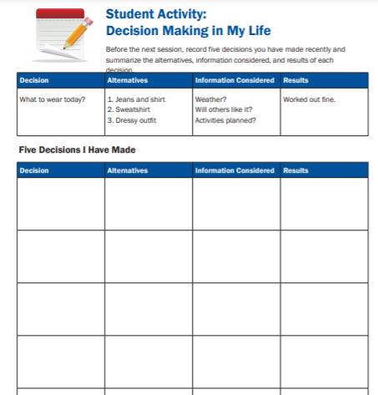This image shows a handout for a student activity: Decision making in my life
Source : https://www.kuder.com/blog/downloads-resources/downloadable-lesson-plan_why-should-students-plan-for-the-future/

Level III
Period IV
Weeks 5 and 6
Review and Integrated Mini-Project
Enduring Understanding: Everyday people are faced with choices – some big, some small – and the way people react to those choices shape their future.
Essential Question: How can decisions?
General Competences

Responsible Citizenship ( )
Life Competences ( )
Competences for Employability ( )

Learn to Know |  |  | Learn to Do | Learn to Be and Live in Community
Grammar & Sentence Frame  - Did Ls use all sentence frames?  Vocabulary  - Did Ls say aloud and write all vocabulary?  Phonology  - Ls recognize, articulate and produce phonological sounds correctly |  |  | Function  - Did Ls use all functions?  Discourse Markers  - Did Ls practice connecting words: and, but, because? | Psychosocial  - Did Ls show evidence of …  - Being aware and committed to protecting the environment  - Appreciating natural wonders  Sociocultural  - Ls practice some idioms and quotes
Assessment Strategies & indicators of learning  (Diagnostic, formative, summative) | Learner can | Didactic Sequence Mediation |  |  | Time  Total:  120 min  (3 lessons)
- Did Ls achieve all learning outcomes? | - Can Ls do all tasks? | Referencing notes from formative assessments throughout the weeks, repeat activities to strengthen Ls in weaker areas or select from Optional Activities that follow these plans.  Practice for test |  |  | All of week 5 or 6
Options |  | Integrated Mini-Project |  |  | Time
Option #1  Learners prepare one presentation about how they look themselves 10 years from now. Ls will design a photo album or a diary creating a possible situation of their future.  Option #2  A multi-step research Career Research: “Planning my Future”- Gallery Walk (learners explore different careers and professions they want to pursue, complete with educational requirements, salary and job opportunities)  Option #3  Writing future goals (pros and cons) of the major’s academic possibilities and occupations.  Option #4  Running a debate or a vocational café.  They also have to mention the skills they will probably use at this job.  . |  | By allowing time for the Mini-Project each week for participating, thinking, and acting out, learners should now have a chosen project and determined content and strategies. In the presentation week Ls focus on:  Responding and sharing: Participating in individual and peer assessment of mini-project.  Integrated Mini-project Self-Assessment  Participating to Negotiate  I participated by  - sharing my own ideas and interests with my family or classmates  - respecting my family or classmates’ opinions,  - communicating respectfully  - making decisions  A lot 5 4 A little 3 2 Not at all 1  Thinking:  I planned by  - looking for information and resources,  - thinking of a design for my presentation  - interacting with my classmates.  - making decisions  A lot 5 4 A little 3 2 Not at all 1  Acting out:  I acted out by  - reviewing the information  - improving my video  - correcting the information,  - rehearsing and working on pronunciation, intonation, fluency and other aspects,  A lot 5 4 A little 3 2 Not at all 1  Responding and Sharing:  I can demonstrate I was well prepared in delivering and sharing the information by  - responsibly delivering the project during the virtual / classroom exchange.  - answering questions from the audience respectfully.  - self-assessing the final product.  A lot 5 4 A little 3 2 Not at all 1  Teachers monitor ….  - Did Ls use English during all aspects of Integrated Mini-Project?  - How did project presentations reflect understanding and/or mastery of Can Do statements?  - Did Ls put into practice the focus of Learn to Be and Live in Community?  - Did the Integrated Mini-Project provide answers to the Essential Question? |  |  | All of week 5 or 6 of unit

Materials for Week # 4

Sample of an action plan
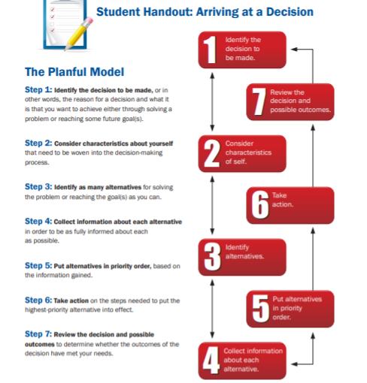 This image shows a student handout for an action plan
Source :https://www.kuder.com/blog/downloads-resources/downloadable-lesson-plan_why-should-students-plan-for-the-future/

Useful web sites
https://www.topuniversities.com/blog/top-5-challenges-studying-abroad
Source: https://www.topuniversities.com/student-info/admissions-advice/how-prepare-university-admission-i

http://going-to-college.org/
How to make a cover letter
https://www.thebalancecareers.com/get-your-cover-letter-noticed-2060153

Job interviews
https://www.thebalancecareers.com/job-interviews-types-4161911

Career search
https://www.esl-lab.com/intermediate/career-search/
Career planning
https://www.youtube.com/watch?app=desktop&v=ABVpi3V8_Hw
Job search
https://www.esl-lab.com/basic-english/job-search-1/
Choosing a job
https://www.allthingstopics.com/uploads/2/3/2/9/23290220/listen-again-jobs-work.pdf
Jobs and work
https://www.allthingstopics.com/jobs-and-work.html
Create a résumé
https://www.resume-now.com/lp/rnarsmsm63.aspx?utm_source=google&utm_medium=display&utm_campaign=174127281&utm_term=&network=d&device=c&adposition=none&adgroupid=14195413641&placement=www.123test.com&gclid=EAIaIQobChMIiej3z6Sa8QIVhZ6nCh2WMAniEAEYASAAEgIR2PD_BwE
Career test link: https://www.hawaiipublicschools.org/DOE%20Forms/CTE/RIASEC.pdf
https://www.123test.com/career-test/id=SGQ7T5ZKMVIA&version
Students watch this video and complete the information in the chart below (Annex 2)

https://www.youtube.com/watch?v=ABVpi3V8_Hw

https://www.elllo.org/english/1151/T1173-Maria-Future.html

https://www.buzzfeed.com/ashleyperez/what-career-should-you-have

allthingtopics.com

https://www.youtube.com/watch?v=zLYECIjmnQs&pbjreload=10

Career workbook
https://alapowers.weebly.com/uploads/8/4/9/8/84985102/career_choices_workbook.pdf
Exploring community colleges
https://files.consumerfinance.gov/f/documents/cfpb_building_block_activities_exploring-community-colleges_worksheet.pdf
Practice for test
Read the next dialogue and do the exercises.
Man: I wonder if this is going to be an interesting class.

Woman: Yeah. Me too. So, what’s your major?

Man: Well, I’ve been batting around the idea of going into business, but I haven’t decided yet. And my dad keeps telling me I have to choose a major, but I’m undeclared at the moment.

Woman: Ah, that’s what happened to me my freshman year.

Man: Oh, so what year are you in school?

Woman: I’m a senior, and I only have to take 10 more credits to graduate. Yeah!

Man: Well. That must feel great to be almost finished with school.

Woman: You can say that again, but once I graduate, I have to start repaying a student loan, so I’m not looking forward to that.

Man: But didn’t your parents help you out with your college tuition?

Woman: No. My dad said he wasn’t made of money, so he thought I should earn my own education, so I worked like crazy in the summer and part-time during the school year to cover most of my costs. [Well, that’s parents for you.] And, I received some financial aid and a scholarship one year, which really saved me. [Ah, that’s nice.] But this past year, school has been more demanding, so I haven’t been able to work as much.

Man: Well, you know, at least you see the light at the end of the tunnel.

Woman: That’s true.

Man: Well, have you lined up a job yet?

Woman: Not yet, but I’m trying to line up a few interviews at the job fair next month.

Man: Well, at least you have some ideas on your future. I mean, I’m taking a business class right now, and the teacher always lectures us by saying that life is difficult, and we should prepare for our futures by setting realistic goals. And the only place that success comes before . . .

Woman: . . . work is in the dictionary. {Yeah!?] Yeah. I’ve heard that all before. Let me guess. Is your teacher Paul Jones?

Man: Yeah. How do you know? I mean, did you have him too? I mean, the guy is, you know, he’s just really . . .

Woman: He’s my dad. Yeap.

Man: Your dad? I mean, I didn’t mean anything by what I said. I wasn’t bad-mouthing him or anything. I mean he’s a good teacher and all. It’s just that . . .

Woman: . . . he’s a dad. That’s what dads do. Lecture. He has about a thousand sermons on life, and he always shares them in his classes.

Man: Yeah. Well, um . . . , nice talking with you. I have . . . I have to go.

Woman: Same here. Bye. I’ll tell Mr. Jones you said hello, and maybe we can study together at my house? [Nah, nah, nah . . .]

