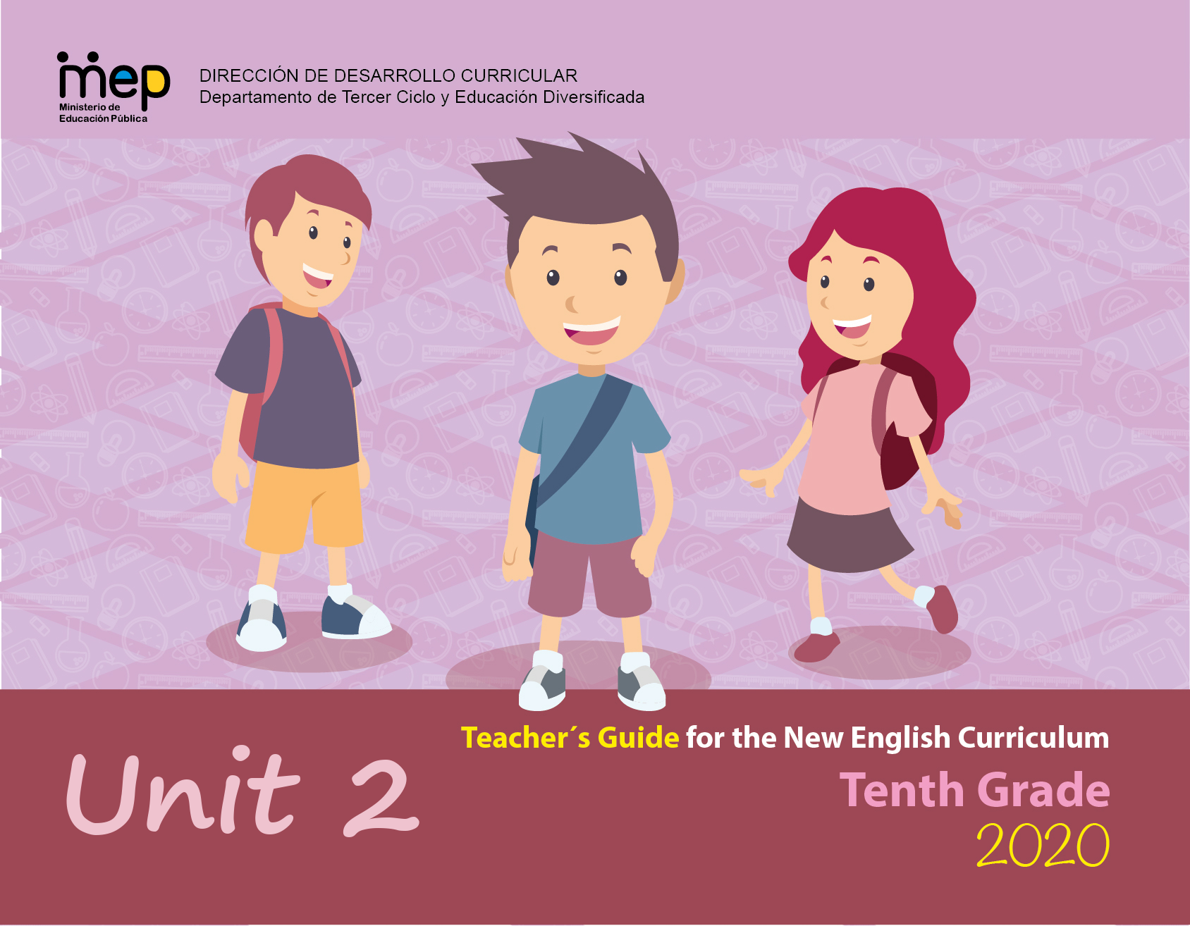
Autoridades

Giselle Cruz Maduro
Ministro de Educación Pública

Melania Brenes Monge
Viceministra Académica de Educación

María Alexandra Ulate Espinoza
Directora de la Dirección de Desarrollo Curricular

Rigoberto Corrales Zúñiga
Jefe del Departamento de Tercer Ciclo y Educación

Comisión redactora

Mag. Marianella Granados Sirias,
Asesora Nacional de Inglés, Departamento de Tercer Ciclo y Educación Diversificada

Mag. Alfredo Ortega Cordero,
Asesor Nacional de Inglés, Departamento de Tercer Ciclo y Educación Diversificada

María Gabriela Castillo Hernández
Edición y construcción
Asesora Regional de Inglés, Dirección Regional San Carlos

Ezequiel Rojas Gutierrez
Asesor Regional de Inglés, Dirección Regional San José Central

Diego Gómez Castro, CTP de Granadilla
Marlon Orozco Campos, Liceo Edgar Cervantes
Yesenia Salazar Mora, CTP Alajuelita
Nathalie Garro, CTP Alajuelita

Construcción de unidades
Docentes de Inglés de Tercer Ciclo y Educación Diversificada

Marco Brenes López
Katherine Williams
Dirección de Recursos Tecnológicos, Diseño de portadas

Level 10th Unit 2
CEF Level to be Reached B1 Basic User/Independent User
Scenario: Stories Come in All Shapes and Sizes
Enduring Understanding |  | Everything from tweets, memes, poems, posts, blogs, comics, short stories, videos and more reveal truths and beliefs about the writers and their culture.
Essential Question |  | What do the stories we share say about us?
General Competences

Responsible Citizenship ( )
Life Competences ( )
Competences for Employability ( )

Assessment and Goals
Week 1  Goals  L1. understand the main points of a relatively long discussion on a familiar topic, related to stories in Standard English.  R1. understand specific factual text and simple reports on familiar topics (e.g., movie reviews, interviews, tweets, posts, etc.).  SP1. describe what is occurring in tweets, blogs, short stories, videos, including his/her personal opinion about them. | Week 1  Assessment  L1. recognizes the main points of even a relatively long discussion on familiar topic, related to stories on standard English.  R1. discriminates factual information from texts and simple reports on familiar topics.  SP1. describes what is occurring in tweets, blogs, short stories, videos, including his/her personal opinion about them. | Week 2  Goals  L2. understand specific details from many web-based broadcasts/ memes, comics, posts, poems dealing with subjects of interest if the people talk clearly.  R.3. understand texts of various lengths, as long as the words used are familiar and/or concern areas of learners’ interest (e.g., tweets, memes, poems, posts, blogs, comics, short stories, videos) supported by the use key of words, diagrams, and illustrations.  SI.2. talk in detail about tweets, memes, poems, posts, blogs, comics, short stories, videos. | Week 2  Assessment  L2. extracts specific details from many web-based broadcasts/ memes, comics, posts, poems.  R.3. Recognizes information from texts of various lengths  SI.2. interacts in a face to face conversation talking in detail about tweets, memes, poems, posts, blogs, comics, and short stories, videos when interacting in pairs or small groups. | Week 3  Goals  SI1. repeat what has been said and convey this information to another person.  SP2. sustain a conversational exchange with a peer in the classroom when the topic is familiar, though there may be some difficulty in understanding and being understood from time to time.  W1. express what has been learned, how it has been learned, and learning goals for the future. | Week 3  Assessment  SI.1. repeats what has been said and conveys this information to another person.  SP2. sustains a conversational exchange with peers.  W1. expresses what has been learned, how it has been learned, and learning goals for the future. | Week 4  Goals  SP3. express opinions of a short story, play, essay, or poem examined in class.  W2. summarize simple text dealing with familiar subjects (e.g., short stories, videos, blogs) and check written sentences to look for mistakes (subject-verb agreement, pronoun and article agreement, capitalization, indentation, commas, appropriate vocabulary and connecting ideas and required format) spelling and basic punctuation accurately enough to be followed most of the time. | Week 4  Assessment  SP3. expresses opinions of a short story, play, essay, or poem examined in class.  W2. summarizes simple text dealing with familiar subjects. (e.g., short stories, videos, blogs). | Week 5/6  Assessment  Anecdotal reports / rubrics / instruments for self and co-assessment  Suggested Integrated Mini Project  A story in several formats (genres): short story, comic, post, tweet, meme.  A short reflection/reaction written about the essential question of the unit in a blog  A reader`s theater using various literary genres.
Phonology

R2. manipulates English language sounds using knowledge in phonics, syllabification and word parts.

- Review of sound articulation (7th to 9th) and of phonological features of most unfamiliar words when needed.
- Use of prosodic features (stress, intonation, rhythm) to support the message intended to convey.
- Even though this goal is still linked to reading in Diversified Education, teachers can reinforce it in Spoken Interaction and Spoken Production activities as well.
Theme  - Tell me a Story |  | Theme  - Thumbs Up /Thumbs Down |  | Theme  - The Reviews Are In* |  | Theme  - You Should Read This
Function  - Describing experiences and events about stories and film reviews. |  | Function  - Talking about films and books. |  | Function  - Expressing opinions about stories and film reviews. |  | Function  - Summarizing stories previously read and film reviews.
Discourse Markers  Connecting words expressing cause and effect, contrast etc.  - On the other hand, we could stay at home and watch a video.  - However, this depends on the kind of book.  - Therefore, it is interesting to watch the new movie. |  | Discourse Markers  Connecting words expressing cause and effect, contrast etc.  - On the other hand, we could stay at home and watch a video.  - However, this depends on the kind of book.  - Therefore, it is interesting to watch the new movie. |  | Discourse Markers  Connecting words expressing cause and effect, contrast etc.  - On the other hand, we could stay at home and watch a video.  - However, this depends on the kind of book.  - Therefore, it is interesting to watch the new movie. |  | Discourse Markers  Connecting words expressing cause and effect, contrast etc.  - On the other hand, we could stay at home and watch a video.  - However, this depends on the kind of book.  Therefore, it is interesting to watch the new movie.
Grammar & Sentence Frames  Present tense  A _______ is someone who _______.  (writer, editor, designer, artist, graphic designer, illustrator, producer, director, poet, blogger)  Past tense  I just read a book about …  Last night I saw a movie about__.  Determiners  - All the memes I saw today were about Mother’s Day.  - Neither the characters nor the plot interested me.  - None of the themes you mentioned are my favorites. |  | Grammar &Sentence Frames  Present tense  A _______ is someone who _______.  (writer, editor, designer, artist, graphic designer, illustrator, producer, director, poet, blogger)  Past tense  I just read a book about …  Last night I saw a movie about__.  Determiners  - All the memes I saw today were about Mother’s Day.  - Neither the characters nor the plot interested me.  - None of the themes you mentioned are my favorites. |  | Grammar & Sentence Frames  Reported speech (range of tenses)  - The lead in the movie then said that he would marry.  - Social media is reporting that people are making the photo viral.  - The reviewer indicated that he didn’t like the movie.  Conditionals, 2nd and 3rd  - If I had enough time, I would have watched the movie again.  - If I had had enough money, I would have bought the book and DVD.  - If I were you, I would post more on Facebook. |  | Grammar & Sentence Frames  Phrases for summarizing  - There are more similarities than differences.  - They are really quite different because…  - One of the few similarities/ differences is…  Phrases for organizing  - The most striking/ most obvious/ most important/ most apparent/ only/ main similarity/ difference is…  - Another/ An additional (subtler) similarity/ difference is…  Modals  - The author might have used fewer characters.  - The movie should have had more action.
Vocabulary  Tell me a Story  - writer, editor, designer, artist, graphic designer, illustrator, producer, director, poet, blogger  You Should Read This  - compose, create, post, present  - graphics, illustrations, pictures, photos, line art, images  - metaphors, comparisons, contrasts, descriptions. |  | Vocabulary  Thumbs Up/Thumbs Down  - tweets, memes, poems, posts, blogs, comics, short stories, videos, reviews, summary, literary analysis, fiction, nonfiction.  The Reviews Are In*  - characters, character development, plot, action, exposition, storytelling. |  | Vocabulary  Thumbs Up/Thumbs Down  - tweets, memes, poems, posts, blogs, comics, short stories, videos, reviews, summary, literary analysis, fiction, nonfiction. |  | Vocabulary  The Reviews Are In*  - characters, character development, plot, action, exposition, storytelling.
Psycho-social  - Practicing self-questioning strategies on a text before making decisions.  - Respecting others’ opinions and emotions.  Sociocultural  - Demonstrating a nonjudgmental position toward other's diverse intercultural skills, beliefs and values.  - Willing to share own contributions in collaborative work respectfully. |  | Psycho-social  - Practicing self-questioning strategies on a text before making decisions.  - Respecting others’ opinions and emotions.  Sociocultural  - Willing to share own contributions in collaborative work respectfully.  - Being aware of importance of constructive feedback. |  | Psycho-social  - Practicing self-questioning strategies on a text before making decisions.  - Respecting others’ opinions and emotions.  Sociocultural  - Demonstrating a nonjudgmental position toward other's diverse intercultural skills, beliefs and values.  - Willing to share own contributions in collaborative work respectfully. |  | Psycho-social  - Practicing self-questioning strategies on a text before making decisions.  - Respecting others’ opinions and emotions.  Sociocultural  - Being aware of importance of constructive feedback.

Didactic Planning
Week # 1
Level: 10th |  |  |  | Unit: 2
Domain: Socio-interpersonal |  | Scenario: Stories Come in All Shapes and Sizes |  |  | Theme: Tell me a Story
Enduring Understanding: Everything from tweets, memes, poems, posts, blogs, comics, short stories, videos and more reveal truths and beliefs about the writers and their culture.
Essential Question: What do the stories we share say about us?
General Competences

Responsible Citizenship ( )
Life Competences ( )
Competences for Employability ( )

Learn to Know |  | Learn to Do |  |  | Learn to Be and Live in Community
Grammar & Sentence Frames  Present tense  A _______ is someone who ______(writer, editor, designer, artist, graphic designer, illustrator, producer, director, poet, blogger)  Past tense  I just read a book about …  Last night I saw a movie about__.  Determiners  - All the memes I saw today were about Mother’s Day.  - Neither the characters nor the plot interested me.  - None of the themes you mentioned are my favorites.  Vocabulary  Tell me a Story  - writer, editor, designer, artist, graphic designer, illustrator, producer, director, poet, blogger  You Should Read This  - compose, create, post, present  - graphics, illustrations, pictures, photos, line art, images metaphors, comparisons, contrasts, descriptions. |  | Function  Describing experiences and events about stories and film reviews.  Discourse Markers  Connecting words expressing cause and effect, contrast etc.  - On the other hand, we could stay at home and watch a video.  - However, this depends on the kind of book.  - Therefore, it is interesting to watch the new movie. |  |  | Psychosocial  - Practicing self-questioning strategies on a text before making decisions.  - Respecting others’ opinions and emotions.  Sociocultural  - Demonstrating a nonjudgmental position toward others’ diverse intercultural skills, beliefs and values.  - Willing to share own contributions in collaborative work respectfully.
Assessment Strategies & indicators of learning  (Diagnostic, formative, summative) | Learner can | Didactic Sequence Mediation |  |  |  | Time  Total:  200 min  (5 lessons)
L1. recognizes the main points of even a relatively long discussion on familiar topic, related to stories on standard English.  R1. discriminates factual information from texts and simple reports on familiar topics.  SP1. describes what is occurring in tweets, blogs, short stories, videos, including his/her personal opinion about them.  R 2. identifies minimal pair sounds: ɜ: / ɔ: using knowledge in phonics, syllabification and word parts. | L1. understand the main points of a relatively long discussion on a familiar topic, related to stories in Standard English.  R1. understand specific factual text and simple reports on familiar topics (e.g., movie reviews, interviews, tweets, posts, etc.).  SP1. describe what is occurring in tweets, blogs, short stories, videos, including his/her personal opinion about them.  R2. identify and manipulates English language sounds using knowledge in phonics, syllabification and word parts. | Pre-teaching  Routine: Checking attendance, checking in with Ls, T posts the Essential Question on the board, Can Do’s, and class agenda, etc.  Participating: Warm up  Teacher talks to learners about the use of GIF’s by many people to tell stories in Instagram, Facebook, WhatsApp and other social media.  The teacher presents a series of GIF’s and learners are asked to make up a story to go with the GIF’s. For example, if a GIF shows a person dancing in a silly manner, the learner may talk about how the person was trying to impress someone with his crazy dancing skills. Learners make up stories with different GIF’s. Teacher encourages learners to tell the stories in past tense.  Engaging: Activation of prior knowledge  The teacher writes the Unit’s Essential Question on the board: What do the stories we share say about us? He or she asks students to think about it. Students share some thoughts with the class.  The teacher hands out graphic organizers with different kinds of storytellers (poets, writers, directors, bloggers, etc.). He or she explains that there are many different ways of telling stories and each one is different.  The students’ job is to fill in what each storyteller makes and what kind of person they think these storytellers are (e.g. poets are creative, directors are bossy). For the last section, there are no right or wrong answers. It is just a chance for students to see that different types of stories can tell us different things about people.  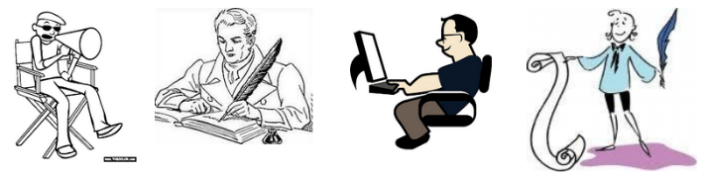  Graphic Organizer - Types of Storyteller  Type of Storyteller: What do they make? What kind of people do you think they are?  Director Example: They make movies Example: I think they are bossy.  Poet  Writer  Blogger  Artist  Illustrator  Graphic designer  Editor  Introducing  The teacher reminds students that this week they are talking about stories. In order to talk about stories, they will need the past simple to retell events (e.g. Clark Kent took off his glasses and became Superman!) and they will need the present simple to talk about their preferences (I love sci-fi movies, but my brother hates special effects.). If necessary, teacher can give a short review of the present and past simple constructions.  Then students fill out a worksheet to practice those two tenses. The worksheet gives students a chance to talk about events in a story and their own preferences for stories.  When students have had time to complete the exercise, they check their papers with a partner. The teacher helps students check.  Oral Comprehension  Pre-listening  Learners watch the video https://www.youtube.com/watch?v=1WxifFqboAA. As they watch it, they have to think of what happened when the characters met.  Learners talk about the video: What happened?  Teacher writes their ideas on the board and monitors the use of past tense to describe what they saw.  Teacher explains that they are going to listen to a story told by Carolina, and they have to pay attention to what happened to her.  Listening for the first time  - Learners listen to a conversation (https://www.esl-lounge.com/student/listening/3L7-love-is-in-the-air.php) (0:01 to 2:27 minutes) for the first time. Learners are asked to choose the topic of the conversation.  - The day Carolina met his best friend  - Carolina’s great love story  - Carolina’s best childhood memory  Pair/Group feedback  Learners, in pairs, decide on a topic, and then they share their decision with the rest of the class.  Listening for the second time  Learners listen to the conversation again and answer a True/False exercise.  Listen to Carolina talking about her great love story. Read the statements and decide if they are True or False. Circle the correct answer.  1. They first met four or five years ago. True False  2. They met for the second time about five years ago. True False  3. Enrico was sitting at a table chatting to some friends. True False  4. Enrico spoke first in the bar. True False  5. Carolina was surprised that Enrico recognized her after so many years True False  Learners compare their answers with their elbow partner and then with the whole group.  Post-listening  Learners think of a person they met.  - When did you meet?  - Where did you meet?  - What happened exactly the day you met?  - Are you still friends?  Using the inside and outside circle technique, learners describe their experience meeting the person they chose.  The teacher splits the class into two halves. One half of the students will form the inside circle and the other half will form the outside circle. The teacher asks students in the inside circle to share their story with the classmate facing them in the outside circle. When they have done this, teacher asks them to say "pass,” at which point their partners in the outside circle will share their responses. On teacher’s signal, the outside circle moves one step to the left or right and the learners talk with a new partner.  Written Comprehension  Pre-reading  Learners listen to the teacher as he/she explains that in today’s class, they’re going to learn a little it about a popular book. Learners watch the following video https://www.youtube.com/watch?v=MABCLn_UlTg ( From 0:36 to 1:45 minutes) and jot down notes on the information they got about the book. Then, as a class, they answer the following questions:  - What is it about?  - What does each chapter celebrate?  - Why is a book like this important nowadays?  Reading for the first time  Learners skim the text ‘Good Night Stories for Rebel Girls: Book Review’ and answer the question:  - Is this book only for girls?  - Is the book about princesses and fairytales?  Pair/Group feedback  In pairs, learners discuss their answers. Then, they share their responses with the class.  Reading for the second time  Learners read the text for the second time and complete the True or False exercise.  Instructions: Read the book review for ‘Good Night Stories for Rebel Girls’ and decide whether the statements below are true or false. Circle the correct answer.  1. The book is written n in a normal writing style for facts and information.  True False  2. Many of the women’s stories have not been told often.  True False  3. The book is about many kinds of women.  True False  4. The book is better for girls than boys.  True False  5. The women are all amazing because they helped other people.  True False  6. You won’t want to stop when you start reading.  True False  In pairs, learners compare their answers, and then they share with the whole group. The teacher monitors learners’ performance while working on the reading exercise.  Post-reading  Learners think about the question:  - Do you think you will like this book? Why or why not? Give two reasons.  A few minutes are given to learners to organize their ideas. Then, the class is divided into groups of three. Each learner shares his/her opinion. At the end, each group summarizes their answers.  Spoken Interaction/Production  Spoken Interaction/Production  Planning / Organizing  Students watch the video https://www.youtube.com/watch?v=wEKLEeY_WeQ  Rehearsing  Individually, the students think and write about the message of the video. The teacher makes questions such as: what do you think happens in the video? What would you do if you could do the same?  In this way the teacher will encourage the learners to write down what happened in the video and their personal opinion about the situation showed in it.  Interacting/Describing  The students move around the classroom talking to their partners about the ideas he/she has concerning the video. And each student has to answer to the following question: If you could change the ending of this video, which one would it be? Each student takes note of each classmate’s answer and then some of them share their partners’ opinions.  The students move around the classroom talking to their partners abo  Phonology  Recognition  The students watch the video https://www.youtube.com/watch?v=vJcW2nwWxkQ in order to reinforce the correct pronunciation of the sounds ɜ: and ɔ:  The teacher writes on the board a series of words that share the same target sounds. Then she/he reads the words out loud to make students aware of the pronunciation of these words. Then, the learners listen to the teacher again and raise their hand if they hear to the sound ɜ: or stamp their feet if they hear the sound ɔ:  The teacher writes down on the board pairs of words that are similar, however the teacher says only one of the words that contain the target sounds in it. The teacher repeats the word twice. Then, each student comes to the board and circles the word he/she listened to. Teacher and students check the answers together.  Articulation  Students watch the video again and using a mirror the learners analyze the position of their teeth, tongue, lips, etc.  Practice / Production  Students work in pairs and write down five sentences with at least one word with the sound ɜ: and five sentences with at least one word with the sound ɔ: Then, learners share the sentences written with all classmates.
Integrated Mini-Project |  |  |  |  | Time
Participating to negotiate: (5 or 10 minutes in week 1)  In pairs, learners choose a movie they have both watch and would like to write a summary about. |  |  |  |  | Adjust previous times listed above to allow 5 min each week.  Group presentations can be week 5 or 6.
Reflective Teaching
What worked well |  |  | What didn’t work well |  | How to improve
Enduring Understanding Reflection
How well did the learners progress in their understanding of the Enduring Understanding?
Week Plan Self-Assessment
At the end of the week, T guides the learners to check their progress using the checklist below. (Can be translated into Spanish if needed to ensure Ls’ understanding.)

Learner Self-Assessment
I can… | Yes | In progress | No
Recognize the topic of an oral conversation
Identify important details from an oral conversation.
Discriminate the most relevant information in a reading passage.
Describe what happened in a video story.

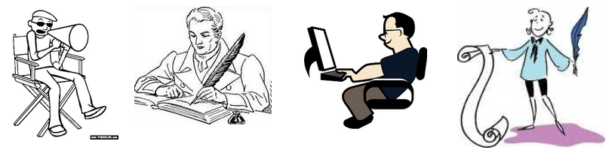
Graphic Organizer - Types of Storyteller

Type of Storyteller: | What do they make? | What kind of people do you think they are?
Director | Example: They make movies | Example: I think they are bossy.
Poet
Writer
Blogger
Artist
Illustrator
Graphic designer
Editor

Present simple and past simple worksheet
Past Simple:
1) I ____________ Harry Potter yesterday. (see)
2) Harry ____________ with his cruel Aunt and Uncle. (live)
3) Then he ____________ he was a wizard! (find out)
4) He ____________ to a school for wizards. (go)
5) It ____________ long to make friends at school. (take)
6) His evil enemy Voldemort ____________ other plans for him! (have)

Present Simple:
Complete the sentences with the following words. You will use one option per sentence, but some of the words need to be changed to make correct sentences in the present simple.

think, love, like, can stand, prefer

1) When it comes to movies, I ____________ thrillers.
2) He ____________ comedies over dramas.
3) ____________ you ____________ movies with lots of action?
4) We ____________ not ____________ that movies need a lot of special effects to be great.
5) I just ______ not ______ the love story between those two characters!

Now write some sentences of your own. What do you like, when it comes to movies?

__________________________________________________________________
__________________________________________________________________
__________________________________________________________________
______________________________________________________________________________________________________________________________________________________________________________________________________

Listen to Carolina talking about her great love story. Read the statements and decide if they are True or False. Circle the correct answer.
1. They first met four or five years ago. True False
2. They met for the second time about five years ago. True False
3. Enrico was sitting at a table chatting to some friends. True False
4. Enrico spoke first in the bar. True False
5. Carolina was surprised that Enrico recognized her after so many years True False
____________________________________________________________________
Listen to Carolina talking about her great love story. Read the statements and decide if they are True or False. Circle the correct answer.
1. They first met four or five years ago. True False
2. They met for the second time about five years ago. True False
3. Enrico was sitting at a table chatting to some friends. True False
4. Enrico spoke first in the bar. True False
5. Carolina was surprised that Enrico recognized her after so many years True False

Good Night Stories for Rebel Girls: Book Review

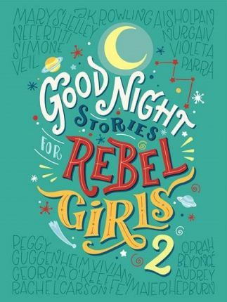
Good Night Stories for Rebel Girls is for people who want something different from fairy tale princesses. Here you can read the stories of one hundred amazing women from the past and present.
We all know how fairy tales go. A beautiful girl waits for a prince to find her. Then she gets married to him and becomes a princess. But what if the girl was clever or strong instead of beautiful? What if she wanted to be an astronaut, a politician or a pirate instead of a princess? And what if she didn’t need a prince to do it? That’s the idea behind the book Good Night Stories for Rebel Girls. It’s a book of fairy tales with a difference: all the stories are true.
The book tells the stories of one hundred amazing women from 1500 BC to today. But, the stories aren’t just boring biographies. Instead, they’re like fairy tales. You probably won’t know the names of most of the women but, when you finish reading, you’ll ask yourself why.
Why haven’t we learned about these women before? Often history remembers men more than women. If you close your eyes and think of a war hero and a pilot, you probably think of men. If you read the book, those pictures might start to become women of all colours and ages. The women in the book did things because they wanted to and they didn’t listen when people told them not to.
One problem with the book, unfortunately, is its name, because it gives the idea it’s a book for girls. It’s a great idea to show young girls what women can do. But the stories are also interesting for boys to read. And it’s also important that boys can think of women in jobs like doctor, Formula One race car driver and president.
Not all the women included are ‘good girls’. One woman, Jingū, Empress of Japan, decided to start a war with Korea because of a dream. Is it a problem that the book doesn’t say that was a bad thing? Another example is pirates. The two women pirates in the book are unusual heroes because pirates were dangerous and they killed other people. It’s good to see a variety of women but why not show a bad ending to their story sometimes? We can understand that just because they’re female, they’re not always good people.
You could read one story every night but you probably won’t want to stop with one. If you finish quickly, don’t worry because there are now two Rebel Girls books.
Nicola Prentis

Instructions: Read the book review for ‘Good Night Stories for Rebel Girls’ and decide whether the statements below are true or false. Circle the correct answer.

1. The book is written in a normal writing style for facts and information.
True False

2. Many of the women’s stories have not been told often.
True False

3. The book is about many kinds of women.
True False

4. The book is better for girls than boys.
True False

5. The women are all amazing because they helped other people.
True False

6. You won’t want to stop when you start reading.
True False

__________________________________________________________________________________

Instructions: Read the book review for ‘Good Night Stories for Rebel Girls’ and decide whether the statements below are true or false. Circle the correct answer.

1. The book is written in a normal writing style for facts and information.
True False

2. Many of the women’s stories have not been told often.
True False

3. The book is about many kinds of women.
True False

4. The book is better for girls than boys.
True False

5. The women are all amazing because they helped other people.
True False

6. You won’t want to stop when you start reading.
True False

Didactic Planning
Week # 2
Level: 10th |  |  |  |  | Unit: 2
Domain: Socio-interpersonal |  |  | Scenario: Stories Come in All Shapes and Sizes |  |  | Theme: Thumbs Up /Thumbs Down
Enduring Understanding: Everything from tweets, memes, poems, posts, blogs, comics, short stories, videos and more reveal truths and beliefs about the writers and their culture.
Essential Question: What do the stories we share say about us?
General Competences

Responsible Citizenship ( )
Life Competences ( )
Competences for Employability ( )

Learn to Know |  |  | Learn to Do |  |  | Learn to Be and Live in Community
Grammar & Sentence Frames  Present tense  A _______ is someone who _______.  (writer, editor, designer, artist, graphic designer, illustrator, producer, director, poet, blogger)  Past tense  I just read a book about …  Last night I saw a movie about__.  Determiners  - All the memes I saw today were about Mother’s Day.  - Neither the characters nor the plot interested me.  - None of the themes you mentioned are my favorites.  Vocabulary  Thumbs Up/Thumbs Down  - tweets, memes, poems, posts, blogs, comics, short stories, videos, reviews, summary, literary analysis, fiction, nonfiction.  The Reviews Are In*  - characters, character development, plot, action, exposition, storytelling.  Phonology  Review of sound articulation (7th to 9th) and of phonological features of most unfamiliar words when needed.  Even though phonology is linked to reading in Diversified Education, teachers can reinforce it in Spoken Interaction and Spoken Production activities as well. |  |  | Function  - Talking about films and books.  Discourse Markers  Connecting words expressing cause and effect, contrast etc.  - On the other hand, we could stay at home and watch a video.  - However, this depends on the kind of book.  Therefore, it is interesting to watch the new movie. |  |  | Psychosocial  - Practicing self-questioning strategies on a text before making decisions.  - Respecting others’ opinions and emotions.  Sociocultural  - Willing to share own contributions in collaborative work respectfully.  - Being aware of importance of constructive feedback.
Assessment Strategies & indicators of learning  (Diagnostic, formative, summative) | Learner can | Didactic Sequence Mediation |  |  |  |  |  | Time  Total:  200 min  (5 lessons)
L2. extracts specific details from oral/aural movie reviews.  R.3.Recognizes information from texts of various lengths  SI.2. interacts in a face to face conversation talking in detail about tweets, memes, poems, posts, blogs, comics, and short stories, videos when interacting in pairs or small groups. | L2. understand specific details from many web-based broadcasts/ memes, comics, posts, poems dealing with subjects of interest if the people talk clearly.  R.3. understand texts of various lengths, as long as the words used are familiar and/or concern areas of learners’ interest (e.g., tweets, memes, poems, posts, blogs,  SI.2. talk in detail about tweets, memes, poems, posts, blogs, comics, short stories, videos. | Pre-teaching  Routine: Checking attendance, checking in with Ls, T posts the Essential Question on the board, Can Do’s, and class agenda, etc.  Participating: Warm up  Learners will play an adaptation of the game “Guess who”, but instead of using that name, they will play “Guess what movie this is?” Teacher will paste a picture of different movies on learners’ backs, and they will not see it nor will tell their classmates what is in their backs. Learners will have to stand up and mingle around. They will have to make pairs. Learner A will see picture in learner B. Learner B will ask “YES/NO questions” trying to guess what the movie on his back is and vice versa. They can ask 3 questions per person, and they will have to pick a different classmate and repeat the strategy by asking different questions. When they have different clues, they will be able to guess what the movie is.  Engaging: Activation of prior knowledge  Learners participate of a gallery walk. Teacher pastes the pictures of films learners may know on different walls inside the classroom. Teacher asks learners to walk around and comment if they know any of those movies and what they know about it.  Then, learners sit in pairs and comment about what they saw in the gallery. Finally, in circles, teacher asks them about what they found, if they have a favorite film, and what they know about those films.  Introducing:  The teacher gestures as he/she can remember something. Then, when the learners ask what’s wrong, the teacher says: “I’m trying to remember the name of a movie, but I can’t think of it. What was the movie called?”  The teacher describes the movie to see if somebody can help him/her remember.  “It was a science fiction film written and directed by James Cameron. The film had incredible special effects, which took people to a spectacular world beyond imagination.  The film was set in the year 2154 on Pandora, a fictional Earth-like moon in a distant planetary system.  Jake Sully, a former U.S Marine paralyzed from the waist down was selected to participate in the program. Using a genetically engineered human hybrid who looked like the creatures in that planet, Jake was sent to gain their trust and convince them to leave their sacred home. “  The teacher interacts with the learners and provides them with clues to guess which the movie is (Avatar).  The teacher then introduces key vocabulary to talk about films: genre, setting, actor, plot, climax, and critics. For each of the sections, the teacher writes the expressions on the board and explains them to the learners using real examples from famous films.  Talking about films  What kind of movie was it? It was a (an) … - romance comedy ( Rom com) - science-fiction (Sci-fi) - horror movie - animated movie - action movie - thriller - documentary - adventure movie - drama  Who was in it? Who was starring in it? ____________ was in it. ____________ was starring in it.  Where did it take place? When did it take place? It took place on a Earth-like planet in 2031. It took place on the moon. It took place in a prison It was set on a train. I was set on the countryside in the 90’s.  What was it about? What happened in it’ It was about…who… It was about two young people who fell in love on a sinking ship. It was about a meteor that was going to destroy the Earth.  How did it end? What happened in the end? In the end, the ring is destroyed. In the end, Harry decided he really loved Sally.  What did the critics say? What kinds of reviews did it get? The critics _________________. It got ___________ reviews. The critics said it was good. The critics panned it. The critics raved about it. It got great reviews. It got poor reviews.  How was the movie? It was heart-warming. It was a total laugh riot. The special effects were breathtaking. It made my blood run cold. It gave food for thought. The plot was intriguing.  Learners get a worksheet in which they have to think about a film they like about each type of gender and write the names of the films in the corresponding column. (Taken from https://www.teach-this.com/)Then, in pairs, learners practice the questions used to talk about films.  Oral Comprehension:  Pre-listening  Learners are asked what they consider are the most important elements of a movie: the plot, special effects, the leading actors, the moral message, the genre? Learners share their thoughts with a partner and then with the whole group.  Learners observe as the teacher writes the sentences below on the board. In pairs, learners read the sentences and guess the meaning of each one by their context. To do so, the teacher provides a definitions bank, so learners can read the sentences and look for the corresponding definition of the words in boldface.(Adapted from https://www.esl-lab.com/difficult/movie-reviews-script/)  - His behavior was so bizarre that he lost his job because of it.  - I was fascinated by the movie's plot and sound track.  - You must admit that the ending of the movie was a little weak.  - The movie was awesome. It was the best I have seen in a long time.  - The book's plot was too weird for me, so I returned it to the library.  - The scene where the doctor was killed by the shark was so fake. You could easily tell that the shark was just a plastic model.  Definitions Bank  not real, not authentic accept or acknowledge  fantastic, great, wonderful strange, absurd, weird  the story of a book, play, or movie strange, absurd, unusual  Listening for the first time  Learners listen to the audio “Movie Reviews” https://www.esl-lab.com/difficult/movie-reviews/ for the first time and answer the following questions:  - Who are the people talking?  - What do they think about the movie they saw? ¿Do both of them think the same way?  Pair/Group feedback  In pairs, learners compare their answers, and then they share with the group.  Listening for the second time  Learners listen for the second time and complete the worksheet below by writing the corresponding answers.  What do they think about… The father The daughter  the movie?  the special effects?  the ship's communications officer  the photography  Learners, in pairs, compare their answers and then share them with the group.  Post-listening  Learners get a black sheet of paper. In the middle of the paper, they write the name of one of their favorite movies. Then, they write key words about, the special effects, the actors, the plot, and the photography.  Using the piece of paper with their notes, learners mingle around and talk about the movie they chose.  Written Comprehension:  Pre-reading  Learners watch the trailer of the movie Annihilation https://www.youtube.com/watch?v=89OP78l9oF0 . Then, they are asked if they have seen the movie or what they think about it just by seeing the trailer. Learners brainstorm adjectives to describe their thoughts about the movie.  The teacher explains that critics use multiple adjectives to describe a movie. Teacher presents some examples and clarifies meaning ( Taken from https://www.edu.xunta.gal/centros/ieslamasabade/system/files/Language_of_FilmReview.pdf)  General comments and opinions ‐ It is rather confusing / long / slow / boring ‐ The cast is excellent / weak / awful / unconvincing ‐ The script/ story is dull / clever / exciting ‐ It has a tragic / surprising / dramatic ending ‐ It does not come across as true / convincing ‐ The music / sound effect is dull / rich ‐ It is a catchy tune as backing music ‐ The theme song is powerful / weak / satisfying ‐ The color in the photography is natural / spectacular / dull / dark and frightening ‐ The acting is true to life / powerful / natural Useful recommendations ‐ Don’t miss it! ‐ It is well worth seeing! ‐ It will change the way you see ( e.g. young people) after watching this film. ‐ It is bound to be a box‐office hit. ‐ I highly / thoroughly / strongly recommend it. ‐ It is highly entertaining. ‐ It is certainly at the top of my list of good movies. ‐ Fans of … will no doubt be thrilled with this. ‐ It’s a must! ‐ I would not recommend this because… ‐ Wait until it comes out on video. ‐ It’s a boring movie. Don’t bother with this one. ‐ Only watch this film if you have plenty of time to spare.  Reading for the first time  Learner are asked to take a look at the title, captions, and pictures in the reading passage “Annihilation review – Natalie Portman thriller leaves a haunting impression” Then, they skim the text and decide if the general review of the movie is a positive or a negative one. Learners are asked to think about reasons for their choice: What makes you think like that?  Pair/Group feedback  In pairs, learners compare their answers and then share them with the class.  Reading for the second time  Learners read the text again. This time, they look for specific information about the movie and the characters to complete the worksheet below.  Annihilation review – Natalie Portman thriller leaves a haunting impression  How does the reviewer describe the movie? Is it a positive review? Why or why not? a. b. c. d. e.  How does the reviewer describe the main characters? Is it a positive review? Why or why not? a. b. c. d. e.  Learners compare their answers and then share with them with the group. Teacher monitors learners’ performance during the reading exercise.  Post-reading  Learners choose a movie they like and create a mind map with adjectives to describe the acting, the special effects, the music, the photography, Then, learners, in pairs, share their opinions about the movie, using the mind map as a guide.  Spoken Interaction/Production  Planning  The class is divided into groups of three. Learners are told that they work as movie critics and they were chosen to participate in a meeting to share their reviews about the last movie they saw.  Learners receive a prompt with some questions about movies.  1. What is the title of the film?  2. What genre is it?  3. What is it about?  4. Is it based on a book?  5. Where is the film set?  6. When is the film set?  7. Who stars in the film?  8. Who plays the main role(s)?  9. Who is your favorite character in the film? (Why?)  10. What’s your opinion about the movie ( acting, special effects, music, photography)  Organizing  Learners take some time to think about each question and to make notes about the answers.  Rehearsing  Students practice asking those questions to each other like in a role play  Interacting/Describing  Learners present their role plays to the class. |  |  |  |  |  | 10 min  20 min
 | R2. manipulates English language sounds using knowledge in phonics, syllabification and word parts. | Phonology  Review of sound articulation (7th to 9th) and of phonological features of most unfamiliar words when needed.  By using the RAP methodology (Repetition, articulation and productive practice) of different English diphthongs.  Even though phonology is linked to reading in Diversified Education, teachers can reinforce it in Spoken Interaction and Spoken Production activities as well.
Integrated Mini-Project |  |  |  |  |  |  |  | Time
Participating to negotiate: (5 or 10 minutes in week 2)  In pairs, and based on the movie chosen in week 1, learners look for information about the movie: actors/actress, special effects, plot, etc. |  |  |  |  |  |  |  | Adjust previous times listed above to allow 5 min each week.  Group presentations can be week 5 or 6.
Reflective Teaching
What worked well |  |  |  | What didn’t work well |  |  | How to improve
Enduring Understanding Reflection
How well did the learners progress in their understanding of the Enduring Understanding?
Week Plan Self-Assessment
At the end of the week, T guides the learners to check their progress using the checklist below. (Can be translated into Spanish if needed to ensure Ls’ understanding.)

Learner Self-Assessment
I can… | Yes | In progress | No
- Extract specific details about the elements of movies from oral /aural stimulus,

- Gest the gist of a written movie review.

- Recognize key vocabulary used in movie reviews.

- Ask questions about my partner’s favorite movie.

- Answer questions about my favorite movie.

Materials for Unit 2, Theme 2

Materials for “WARM UP”
Pictures of movies to paste in earners´ backs:
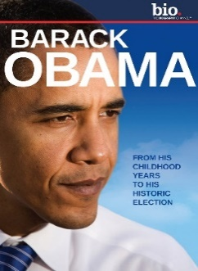
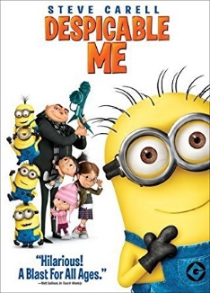
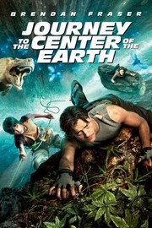
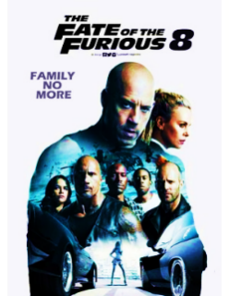
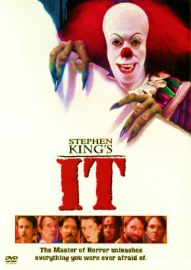

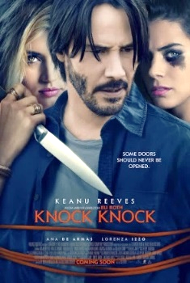
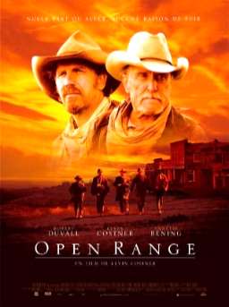

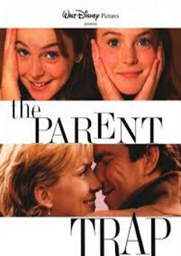
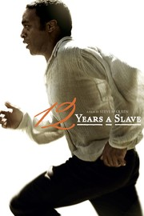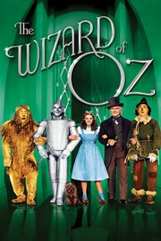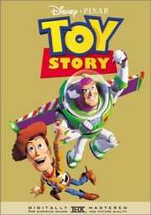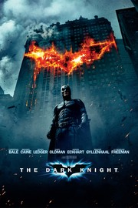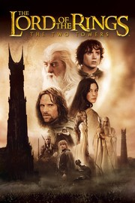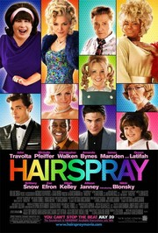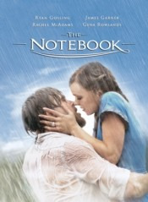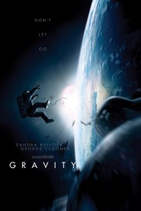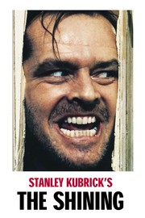

Materials for Engaging activity:
Movies for the gallery walk

Film Genres
Think of a film that you like for each type of genre. Write the names of the films in the ‘Film Title’ column.

Film genres | Film title
Action
Contains: high energy, big-budget stunts and chases

Adventure:
Contains: exotic and historical places, searches and expeditions.

Comedy
Contains: funny or comical events, jokes

Drama
Contains: realistic characters, settings, and real-life situations.

Horror
Contains: frightening scenes, a shocking finale, ghosts, monsters.

Sci-fi
Contains: heroes, aliens, distant planets, futurist technology.

B. In pairs, talk about the films you like from the different genres using the language below.

What’s your favorite genre? What (action film) do you like?

What is/was it about? When was it made?

Where/when was it set? Who is the director?

Talking about films
General comments and opinions  ‐ It is rather confusing / long / slow / boring  ‐ The cast is excellent / weak / awful / unconvincing  ‐ The script/ story is dull / clever / exciting  ‐ It has a tragic / surprising / dramatic ending  ‐ It does not come across as true / convincing  ‐ The music / sound effect is dull / rich  ‐ It is a catchy tune as backing music  ‐ The theme song is powerful / weak / satisfying  ‐ The color in the photography is natural / spectacular / dull / dark and frightening  ‐ The acting is true to life / powerful / natural | Useful recommendations  ‐ Don’t miss it!  ‐ It is well worth seeing!  ‐ It will change the way you see ( e.g. young people) after watching this film.  ‐ It is bound to be a box‐office hit.  ‐ I highly / thoroughly / strongly recommend it.  ‐ It is highly entertaining.  ‐ It is certainly at the top of my list of good movies.  ‐ Fans of … will no doubt be thrilled with this.  ‐ It’s a must!  ‐ I would not recommend this because…  ‐ Wait until it comes out on video.  ‐ It’s a boring movie. Don’t bother with this one.  ‐ Only watch this film if you have plenty of time to spare.

Talking about films
General comments and opinions  ‐ It is rather confusing / long / slow / boring  ‐ The cast is excellent / weak / awful / unconvincing  ‐ The script/ story is dull / clever / exciting  ‐ It has a tragic / surprising / dramatic ending  ‐ It does not come across as true / convincing  ‐ The music / sound effect is dull / rich  ‐ It is a catchy tune as backing music  ‐ The theme song is powerful / weak / satisfying  ‐ The color in the photography is natural / spectacular / dull / dark and frightening  ‐ The acting is true to life / powerful / natural | Useful recommendations  ‐ Don’t miss it!  ‐ It is well worth seeing!  ‐ It will change the way you see ( e.g. young people) after watching this film.  ‐ It is bound to be a box‐office hit.  ‐ I highly / thoroughly / strongly recommend it.  ‐ It is highly entertaining.  ‐ It is certainly at the top of my list of good movies.  ‐ Fans of … will no doubt be thrilled with this.  ‐ It’s a must!  ‐ I would not recommend this because…  ‐ Wait until it comes out on video.  ‐ It’s a boring movie. Don’t bother with this one.  ‐ Only watch this film if you have plenty of time to spare.

Annihilation review –

Natalie Portman thriller leaves a haunting impression

(Adapted from https://www.theguardian.com/film/2018/feb/22/annihilation-review-natalie-portman-thriller-leaves-a-haunting-impression)
4 / 5 stars4 out of 5 stars.

Ex Machina writer-director Alex Garland’s unnerving sci-fi concoction combines gut-wrenching body horror and trippy science to compelling effect

Natalie Portman and Gina Rodriguez in Annihilation, a genre film that revolves around intelligent characters reacting intelligently to fantastical events. Photograph: Photo credit: Peter Mountain/Peter Mountain
There are ample reasons to be both excited and concerned about Annihilation. It’s the writer-director Alex Garland who has chosen to adapt Jeff VanderMeer’s award-winning novel, packed with visceral horror, weighty ideas and unusual storytelling.
Lena (Natalie Portman), a biologist, is in a daze. Her soldier husband (Oscar Isaac) is missing in action and without him, she is struggling to focus on what remains of her life. But when he suddenly returns, her brief hope that normality will ensue is shattered when his odd behavior turns into something far more destructive. He’s hospitalized and she’s whisked away by a psychologist (Jennifer Jason Leigh) who informs her that his mission took him inside “the shimmer”, a rapidly expanding area that’s taken the lives of everyone who has entered, bar him. She soon joins a new mission to find out what’s inside and discover whether she can save her husband’s life.
It’s hugely refreshing, and remarkably uncommon, to watch a genre film that revolves around intelligent characters reacting intelligently to fantastical events. The team is made up of briskly efficient problem-solvers who remain practical and focused while dealing with otherworldly chaos. Unlike with so many superficially similar films, as an audience we understand and empathize with the decision-making process, the script never sacrificing its smarts for suspense. It’s tightly constructed and empty of unnecessary exposition yet the characters mostly feel like they are more than their various professions. This is also down to a strong set of performers and while it’s rare to see an all-female ensemble in a film of this ilk, Garland has little time for gender, imagining a future where such distinctions don’t warrant recognition.

Annihilation review – Natalie Portman thriller leaves
a haunting impression
How does the reviewer describe the movie?  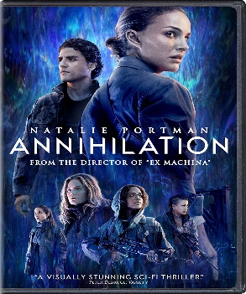  Is it a positive review? Why or why not? | a.  b.  c.  d.  e.
How does the reviewer describe the main characters?  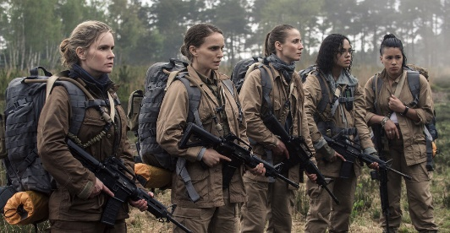  Is it a positive review? Why or why not? | a.  b.  c.  d.  e.

Didactic Planning
Week # 3
Level: 10th |  |  |  |  | Unit: 2
Domain: |  |  | Scenario: Stories Come in All Shapes and Sizes |  |  | Theme: 3. The Reviews Are In*
Enduring Understanding: Everything from tweets, memes, poems, posts, blogs, comics, short stories, videos and more reveal truths and beliefs about the writers and their culture.
Essential Question: What do the stories we share say about us?
General Competences

Responsible Citizenship ( )
Life Competences ( )
Competences for Employability ( )

Learn to Know |  |  | Learn to Do |  |  | Learn to Be and Live in Community
Grammar & Sentence Frames  Reported speech (range of tenses)  - The lead in the movie then said that he would marry.  - Social media is reporting that people are making the photo viral.  - The reviewer indicated that he didn’t like the movie.  Conditionals, 2nd and 3rd  - If I had enough time, I would have watched the movie again.  - If I had had enough money, I would have bought the book and DVD.  If I were you, I would post more on Facebook.  Vocabulary  Thumbs Up/Thumbs Down  - tweets, memes, poems, posts, blogs, comics, short stories, videos, reviews, summary, literary analysis, fiction, nonfiction. |  |  | Function  Expressing opinions about stories and film reviews.  Discourse Markers  Connecting words expressing cause and effect, contrast etc.  - On the other hand, we could stay at home and watch a video.  - However, this depends on the kind of book.  - Therefore, it is interesting to watch the new movie. |  |  | Psychosocial  - Practicing self-questioning strategies on a text before making decisions.  - Respecting others’ opinions and emotions.  Sociocultural  - Demonstrating a nonjudgmental position toward other's diverse intercultural skills, beliefs and values.  - Willing to share own contributions in collaborative work respectfully.
Assessment Strategies & indicators of learning  (Diagnostic, formative, summative) | Learner can | Didactic Sequence Mediation |  |  |  |  |  | Time  Total:  200 min  (5 lessons)
SP.2 Sustains a conversation exchange with a peer.  SI.Repeats what has been said and conveys this information to another person.  W1. expresses what has been learned, how it has been learned, and learning goals for the future. | SP2. Sustain a conversation exchange with a peer in the classroom when the topic is familiar , though they may be some difficulty understanding and being understood from time to time.  SI.1 Repeat what has been said and convey this information to another person.  W1. Express what has been learned, how it has been learned, and the learning goals for the future. | Pre-teaching  Routine: Checking attendance, checking in with Ls, T posts the Essential Question on the board, Can Do’s, and class agenda, etc.  Participating: Warm up  The teacher asks learners to name all the movies they can think of. (Usually, stop after about 20-30, but you can leave the list on the board during the activity)  The class is then divided into groups of 4-5 members.  Step 1: Students must describe a movie; they brainstorm about it using anything they want. For example, the director is George Lucas, and the main actors are Mark Hamil and Harrison Ford.  Step 2: Groups take turns to go in front of the class to role-play or imitate lines that the characters from the movie would say, ie: "I am your father Luke," or "I'm gonna kill Darth Vader for killing Obi Wan Kenobi" etc. In other words, they can only say character names, places in the movie, etc. The class collects 4-5 pieces of information and then starts to guess which movie it is.  Optional: Students cannot talk. They must act out a scene from the movie without talking. For example, act out the lightsaber fight using two pencils.  Engaging : Activation of prior knowledge  Learners watch the video ‘73 Questions With Rosie Huntington-Whiteley | Vogue’ https://www.youtube.com/watch?v=6sSQZw6G2yA&list=PLztAHXmlMZFRBzyTy_w8r15g3OrNb36r6&index=2&t=163s . Learners watch the first 90 seconds of the video, so they get familiar with the format. After this intro, learners are asked to predict what kind of questions might be asked to the model.  Learners watch the video again and this time they have to write down 7 answers they hear in the video. Learners are reminded that they don’t need to remember and understand all the questions and answers. (Those Vogue videos are a bit long so it’s up to you whether you want to play the whole video or just a few minutes)  After watching the video, the teacher asks: “What did the girl answer? The class is divided into groups of three and each group brainstorms the answers they heard.They share their information with the whole class, and the teacher writes the answers on the board.  Introducing  Using the answers the learners wrote, the teacher explains the use of reported speech to report what a person said. First, the teacher explains the distinction between direct speech and reported speech. (Info taken from https://www.myenglishpages.com/site_php_files/grammar-lesson-reported-speech.php)  Direct speech Reported speech  She says: "I like tuna fish." She says that she likes tuna fish.  She said: "I'm visiting Paris next weekend" She said that she was visiting Paris the following weekend.  A. Reporting Statements  When transforming statements, check whether you have to change:  1- Pronouns  In reported speech, you often have to change the pronoun depending on who says what.  Example:  She says, “My dad likes roast chicken.” – She says that her dad likes roast chicken.  2- Tenses  If the sentence starts in the present, there is no backshift of tenses in reported speech.  If the sentence starts in the past, there is often backshift of tenses in reported speech.  Direct speech Reported speech  (no backshift) “I write poems.” He says that he writes poems.  (backshift) “I write poems.” He said that he wrote poems.  No backshift  Do not change the tense if the introductory clause is in a present tense (e. g. He says). Note, however, that you might have to change the form of the present tense verb (3rd person singular).  Example:  He says, “I write poems.” – He says that he writes English.  Backshift  You must change the tense if the introductory clause is in a past tense (e. g. He said).  Example:  He said, “I am happy.” – He said that he was happy.  Examples of the main changes in tense:  Direct Speech Reported Speech  Simple Present He said: "I am happy" Simple Past He said that he was happy  Present Progressive He said: "I'm looking for my keys" Past Progressive He said that he was looking for his keys  Simple Past He said: "I visited New York last year" Past Perfect Simple He said that he had visited New York the previous year.  As a practice, learners read a part of an interview with a fictitious book writer, Joe Harrplayer and fill out a table. (See Annexes) (Taken from https://eslbrains.com/wp-content/uploads/2019/08/ESL-Brains-Reported-speech-with-Vogue-SV.pdf)  Also, learners play a Reported Speech sentence completion guessing game. The teacher gives the students a list of sentence stems that should be completed with reported speech such as “I forgot to tell someone…”, “ or “Someone told me that I…”. They complete as many sentences as they can and then read out only the part they have written for the other students to guess which sentence that comes from.  Spoken Interaction/Production  Planning  The learners think of a movie they have watched recently and about which they have a strong opinion. Their pick can be a new release or an old favorite, and it can be a film they loved or one they loathed, but that they remember well.  Organizing  Then, learners take a minute to jot down a few notes about this film using the following guiding questions:  - What was your opinion of it? Why?  - What details do you remember best?  Rehearsing  The class is divided into pairs and a timer is set.Each learners has two minutes to rehearse the following, in any order:  Tell your partner about this movie. The learner has to assume that his/her partner knows nothing about it, and provide enough detail so the listener gets a broad idea of what happens, the characters and the setting.  Express your opinion of the movie. The learner tells his/her partner if his/her partner should see it? Why or why not?  Support your opinion: The learner gives details about the movie that make it one he/she would recommend — or not?  When the first learner finishes. They switch roles.  Interacting/Describing  Learners make groups of three. Each one takes turns to share information and their opinion about the movie they chose. The rest of the group asks follow up questions to find out more details about the movie and their peer’s opinion about it.  Planning  Learners are told that for this class, they are going to play two roles. a) an interviewer who is going to interview a famous actor or actresses from the movies their classmates talked about last class, and b) one of the main actors /actresses of the movie they talked about last time.  Organizing  In their roles as interviewers, learners think of five questions they would like to ask the famous actor/actress.  In their role as an actor/actress, they think of possible questions he/she could be asked and a possible answer.  Rehearsing  The class is divided into pairs. Each learner takes roles to be the interviewer and the famous actor. Learners switch roles. Also, learners take notes on the answers he/she got during the interview. Then , learners report to each other the answers they got:”You said that…”  The teacher monitors learners’ performance closely and provides help if necessary.  Interacting/Describing  Learners look for another partner and play the actor/actress/interviewer role again to collect information again. After that, learners report to the group the answers they got from the actors/actresses. The teacher provides general feedback.  Pre-writing  Learners are told that they were hired by a local newspaper to write a report about a movie they have seen and can find information about.  To do so, learners use the following guiding questions:.  - When was the movie released?  - Who was the main cast of the movie?  - What was the movie about?  - What are the best qualities of this movie?  - What were people’s opinions about the movie?  - What did critics say about the movie?  - Would you recommend this movie?  recall, organize, plan, write  Drafting  Learners jot down their first ideas about the movie they chose. Then, they organize those ideas into a clear logical sequence.  Revising  The class is divided into pairs. Learners peer-correct each other’s report using the following checklist.  Editing Checklist  Criteria The report includes information about.. Yes Partially No  when the movie was released  the cast of the movie  the plot of the movie  the best qualities of the movie  people’s opinions about the movie  critics opinions about the movie  personal recommendation  The report...  it is written in a clear, logical sequence  is well-capitalized  General Feedback:  Editing  Learners correct and modify their report, considering their partner’s suggestions and feedback.  Publishing  Learners present their report orally to the class. They talked about what they learned about the movie and how they learned it.
Integrated Mini-Project |  |  |  |  |  |  |  | Time
Allow time for the Mini-Project each week. NOTE: All phases of the Integrated Mini-Project should be opportunities for Ls to practice English, not just those related to presentation.  Thinking for planning  In pairs and continuing with the project guide for week 1 and 2, learners write their first draw about the movie, including their personal opinions about it. |  |  |  |  |  |  |  | Adjust previous times listed above to allow 5 min each week.
Reflective Teaching
What worked well |  |  |  | What didn’t work well |  |  | How to improve
Enduring Understanding Reflection
How well did the learners progress in their understanding of the Enduring Understanding?
Week Plan Self-Assessment
At the end of the week, T guides the learners to check their progress using the checklist below. (Can be translated into Spanish if needed to ensure Ls’ understanding.)

Learner Self-Assessment
I can… | Yes | In progress | No
sustain a conversation with a peer
report what someone said
report what I have learned
Show how I have worked with others this week.

Let’s Practice
Instructions: Read a part of an interview with a fictitious book writer, Joe Harrplayer. Next, fill in the table below the text.
David: Tell us what made you begin your writing career.
Joe: I was in my last year at the university when I realized I didn’t really know what I wanted to do with my life. At that time, my best friend told me that he liked reading my blog and I should try writing something longer. So I did, and that’s how my first book came into existence. : We should thank your best friend, then. Personally, I believe that you are a master at storytelling! Where do you get inspiration from?
J: That’s funny! My wife asked me where I got all the ideas from the day before. To be honest, I don’t how it works. It just happens - sometimes out of nowhere.
D: What’s your next move and when can we expect your next book?
J: Well, I’m planning to start a new book tomorrow! Just kidding. I say that all the time, but my busy schedule makes it impossible. I can tell you that I came up with a great story last summer. So I know what I want to write and I promise that I will start writing this year.
D: Thanks for talking and good luck with your new project.
J: Thanks for having me. You don’t realize it but you’ve just made my father’s dream come true. He said once that he’d always dreamt of seeing me in this show!

DIRECT SPEECH | REPORTED SPEECH
I really like reading your blog! | My best friend told me that he _________ reading my blog
I believe that you _________ a master at storytelling! | David said that Joe is a master at storytelling!
“Where do you get all the ideas from?” – asked John’s wife yesterday. | My wife asked me where I _________ all the ideas from the day before.
I _________ to start a new book tomorrow! | Joe said that he was planning to start a new book the next day
“I’ve always dreamt of seeing you in that show” said Joe’s father | Joe’s father said that he ______________ of seeing me in your show!

Didactic Planning
Week # 4
Level: 10th |  |  |  | Unit: 2
Domain: Socio-interpersonal |  | Scenario: Stories Come in All Shapes and Sizes |  |  | Theme: Tell me a Story
Enduring Understanding: Everything from tweets, memes, poems, posts, blogs, comics, short stories, videos and more reveal truths and beliefs about the writers and their culture.
Essential Question: What do the stories we share say about us?
General Competences

Responsible Citizenship ( )
Life Competences ( )
Competences for Employability ( )

Learn to Know |  | Learn to Do |  |  | Learn to Be and Live in Community
Grammar & Sentence Frames  Phrases for summarizing  - There are more similarities/differences than differences.  Adverbial phrases of degree extent  - They are really quite different because one is an action film and the other is a romantic movie.  - One of the few similarities (or differences) is that there is too much action.  Phrases for organizing  - The most striking /obvious / apparent / important characteristic is that this film is very old  - The main difference is that this is a new film.  - An additional / subtle similarity is that the movie is a low budget production.  Modals  - The character might have used more passion.  - The director should have had less extras.  Vocabulary  Characteristics  - obvious, important, striking, apparent, similar, different.  The review is in  characters, plot, action, development, exposition, storytelling, subtle. |  | Function  · Summarizing stories previously read and film reviews.  Discourse Markers  Connecting words:  - It´s not futuristic; however, it has good special effects.  - …on the other hand, the actors were really good.  - Therefore; the plot is different. |  |  | Psychosocial  - Practicing self-questioning strategies on a text before making decisions.  - Respecting others’ opinions and emotions.  Sociocultural  Being aware of the importance of constructive feedback.
Assessment Strategies & indicators of learning  (Diagnostic, formative, summative) | Learner can | Didactic Sequence Mediation |  |  |  | Time  Total:  200 min  (5 lessons)
L1. Recognizes the main points of even a relatively long discussion on familiar topic, related to stories on standard English  R1. Discriminates factual information from texts and simple reports on familiar topics.  SI 1. Repeat what has been said and convey this information to another person.  SP1. Describes what is occurring in tweets, blogs, short stories, videos, including his/her personal opinion about them.  .  W1. Summarize simple text dealing with familiar subjects (e.g. , short stories, videos, blogs) and check written sentences to look for mistakes (subject-verb agreement, pronoun verb agreement, capitalization, indentation, commas, appropriate vocabulary and connecting ideas and required format) spelling and basic punctuation accurately enough to be followed most of the time. | L1. Understands the main points of a relatively long discussion on a familiar topic, related to stories in standard English  R1. Understand specific factual text and simple reports on familiar topics (e.g. movie reviews, memes, interviews, tweets, posts, etc.)  SI1. Repeating what has been and conveying this information to another person and talking in detail about tweets, films, memes, short stories, posts, and blogs.  SP 1. Express personal opinions of a short story, films, TV series, blogs or, videos, sustaining a conversational exchange with a peer and descripting about what is occurring in tweets, blogs, short stories, videos.  W1: Describe, review and summarize simple text dealing with familiar subjects (e.g. , short stories, videos, blogs) and check written sentences to look for mistakes (subject-verb agreement, pronoun, punctuation, vocabulary, spelling and coherent ideas). | Pre-teaching  Routine:  - Checking attendance  - T checks the lessons goal and class agenda.  · E.g.: This week we are going to summarize stories previously read and film reviews.  Participating: Warm up:  T asks Ls about their favorite films, characters and/or TV series; as well as the more recent film they have watched, and the type of films they prefer. T writes some clue words on the board; characteristics and production names. T also shares his own film and TV program preferences.  Engaging: Activation T writes on the board the question What do you think of this film?  Ls get in groups of four then T shows pictures (whether on flashcards, a powerpoint presentation or a handout) with posters of at least six known TV series and/or films. Ls share their opinion of the films by using simple characteristics. Later, T elicits students to share their opinions with the rest of the class.  Introducing  T selects two film titles from the previous activity (or two different movies or TV series) to make a comparison of both. T introduces the phrases for organizing, and the intensifiers in phrases like “These two films are really quite different because…”, “the most important difference of those films is that…” and “This character is very similar to the other one…” One of the few similarities (or differences) is that there is too much action.  - The most striking /obvious / apparent / important characteristic is that this film is very old  - The main difference is that this is a new film.  - An additional / subtle similarity is that the movie is a low budget production.  Oral Comprehension:  Pre-listening  Ls get a handout with synonyms of vocabulary then Ls write the number of the matching synonym on the column of numbers. Ls do it based on either their previous knowledge or word meaning in context. These words will be used throughout the exercise. The vocabulary includes old, curse, violence, best, issues, budget, character, plot, and effects.  Later, t and Ls check the outcomes.  Listening for the first time  Ls listen to the audio “Old Movies” for the first time https://drive.google.com/open?id=1MysND3aCUSgx0_OAmtB4hk0RjZKtrD5I . T writes these three questions on the board:“Who are the speakers?”, “What are they talking about?” “How old do you think the speakers are?”  Pair/Group feedback  Ls pair off and discuss those three questions. Then they share the outcomes with the rest of the class.  Listening for the second time  Still in pairs, Ls listen to the audio for the second time and check the sentences that correctly reflect what the speakers say, on a comparative chart.  Post-listening  Ls make a circle in the classroom or outside. T cuts some paper stripes with names of films, TV series, comics and books on them. T puts them in a plastic bag and asks two Ls pick up one paper each. Each L has to read the name on the paper and compare it with his/her mate´s title, orally by using adverbial phrases and phrases for organizing. T goes around with the bag asking two other people do the same on and on.  Written Comprehension:  Pre-reading:  Ls participate in a Game Show exercise (trivia) about TV, films, comics and others. Ls get in groups of three or four; they get a handout with some pop culture questions that they read and discuss to choose the correct answer out of some options. The trivia includes vocabulary about the topic.  During the activity Ls must reach the answer they think is right, based on previous knowledge, intuition or peer opinion; therefore, T makes clear that the main goal is to have fun. This can also be developed when using TICs through applications such as; Edmodo, Kahoot, Classroom and the likes.  Reading for the first time  T hands out a review film-page where Ls read three different short film reviews. They try to guess the name of the films based on the information read. Later, T tells the titles: #1 Joker, #2 Wonder Woman and #3 Parasite.  Pair/Group feedback  In pairs or groups, Ls classify sentences that reflect an arguable aspect in the reviews. . E.g.: This film contains violence.  Reading for the second time  T writes on the board the question What do you think this production should have had? Then by using the same handout with the three short film reviews, Ls discuss what they think those productions must or should have had less and more; they take short notes or write simple sentences. Ls write a short solution to the problem by using the modal phrases in past “should/must have had more/less. Ls share their solutions with the rest of the class. E.g. L= “It should have had less violent scenes”  Finally, T draws to columns on the board; with the words more and less, and T writes some words given by Ls on those columns.  Post-reading  T asks Ls to check the current movie listings on their cellphones; select one and write a short description /review in a form of a 5-line chat message. Then send it to one of their mates in the class through WhatsApp or Facebook. (If Ls do not have access to these tools; they write it on a sheet of paper). The description includes:  - Name of the film  - Type  - Some characteristics  - An opinion of what should/must have had more/less  At the end, some volunteers read the messages to the rest of the class. * Spelling is not evaluated.  Spoken Interaction  Planning and organizing:  T shows a “frozen” image of a short film entitled “Snack Attack”* that Ls will watch soon. Ls´ opinions are elicited through questions like:  “What do you think is this short film about?  “Who do you think is the main character?”  “How many characters do you think it has?”  “What origin do you think it has?”, and others.  *T can use any other animated short film  Rehearsing  For an information gap activity, T asks Ls to pair off and get a handout with list of sentences about visual productions and their characteristics for both participants. L 1 utters and L 2 completes them orally, with any words that come up to their minds spontaneously. then Ls swap roles.  Example: Student 1: “El Chavo contains a lot of …” Student 2 “violence”, “funny moments”, “comedy”, etc.  Ls take notes on what his/her classmate said.  Interacting/Describing  Two pairs sit together. Each learner reports to the other what his/her classmate said during the info-gap activity. Some volunteers report to the whole class.  Spoken Interaction/Production  Planning  Ls watch the 4-minute animated short film “Snack Attack”. Ls pay attention and take brief notes (if they find it necessary). Short Animated Film: Snack Attack YouTube https://youtu.be38y_1EWIE9I  Organizing  Ls watch the short film a second time and T hands out a set of 8 event cards. Each card contains one or two sentences of events from the film. Ls discuss and rearrange the events into the correct order by numbering them. Later, Ls share the outcomes with the rest of the class.  Ls pair off or make groups to answer the questions below, orally; Ls share opinions among their peers,  Questions are written by T on the board or on a piece of paper.  What are some characteristics that define this film?  What should this film have had more/less?  How can you compare this short film with a TV series or a full-length movie?  What do you think about the film?  What's the moral of the story?  Rehearsing  Learners pair up. They practice describing the short film by using the questions as a guide.  Describing  Some volunteers share their description of the short film with the rest of the class.  Written Production  Pre writing:  Ls work on an associogram (list of lexical items and/or ideas that relate to a topic.); to generate vocabulary to be used.  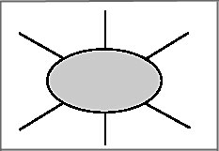  Drafting:  During a controlled-composition task, and based on the associogram, T and Ls construct ten questions on the board for Ls to answer in a complete way.  1. What kind of films do you like?  2. And why?  3. When do you like to go to the movies?  4. Whom do you like to go with?  5. What´s the title of the last film you watched? And  6. What type of film is it?  7. What did you like the most of the film (or the least)?  8. Why?  9. What should this film have had more (or less)?  10.How would you recommend this film?  In pairs, Ls eliminate the ten questions only and organize the relevant information in the answers. Ls notice how the information is fitting and goes from general to specific, comparing and reviewing a film in a basic but coherent way. Ls also pay attention to verb-subject agreement, spelling and orthography.  Then, in collaboration with their mates, Ls compiles all the answers into a solid paragraph by rewriting and linking them with some connectors if necessary. Ls re-read it to make sure it sounds logical, coherent and descriptive.  Revising:  The learners share their paragraph with another pair of students for peer-correction. To do so, the following checklist is used:  Great job! Needs a little of work Comments  Is punctuation correct?  Are all the words spelled correctly?  Is the vocabulary varied, interesting, and relevant to the film being reviewed?  Does the review include the information requested?  Are ideas written in a clear, logical sequence?  Editing  Ls read the feedback provided by their peers and edit the paragraph.  Publishing  Ls publish their written reviews by pasting them on a mural entitled: Film Reviews. Ls take time to walk around and read their peer’s film review.
Integrated Mini-Project |  |  |  |  | Time
Acting out/ Completing MP:  In the same pairs and continuing with the project guide for weeks 1, 2 and 3, learners share their summary with another pair of students to get feedback. Then, they edit and correct the summary, considering their peers suggestions.  Responding and sharing: Learners share the summary of the movie they wrote. To do so, the teacher creates a blog where learners post their papers and their classmates respond to them.  Leaners participate in individual and peer assessment of mini-project.  Teachers monitor ….  - Did Ls use English during all aspects of Integrated Mini-Project?  - How did project presentations reflect understanding and/or mastery of Can Do statements?  - Did Ls put into practice the focus of Learn to Be and Live in Community?  Did the Integrated Mini-Project provide answers to the Essential Question? |  |  |  |  | Adjust previous times listed above to allow 5 min each week.  Group presentations can be  week 5 or 6.
Reflective Teaching
What worked well |  |  | What didn’t work well |  | How to improve
Enduring Understanding Reflection
How well did the learners progress in their understanding of the Enduring Understanding?
Week Plan Self-Assessment
At the end of the week, T guides the learners to check their progress using the checklist below. (Can be translated into Spanish if needed to ensure Ls’ understanding.)

Learner Self-Assessment
I can… | Yes | In progress | No
Describe characteristics of a film, documentary, TV series, short animated film, cartoon, etc.
Identify important details from oral passages.
Express my opinion about films, stories, TV shows, and so on.
Reply to other´s ideas about films, and other productions.
Write a film review
Show how I have worked with others this week.

Oral comprehension (pre-listening stage handout)
Sentences | Synonyms | numbers
1. That's an old joke - I've heard it about a thousand times. | don´t make money
2. The actor´s dialogue was limited; he just cursed all the time. | story
3. Local films are watched by just a few people. They don’t sell tickets because people prefer Hollywood films. | hurt people
4. This is a far superior movie of the saga. | ancient | 1
5. Modern films and TV series show lots of guns,  violence and crimes. | use impolite vocabulary
6. Documentaries expose relevant people´s problems. | the best
7. There are three main characters in that film. | back then
8. The film has a very simple plot. | protagonists
9. The sounds and visuals of this movie make things seem very real. | issues
10. In the past, memes and stickers did not exist. | effects

Oral comprehension (listening for the second time chart)
Older Movies |  | Modern Movies
1. are the best. |  | 1. are in 2 colors.
2. are in black and white. |  | 2. have actors that curse too much.
3. have better plots. |  | 3. have a lot of violence.
4. have lots of action. |  | 4. have less action.
5. have actors with real issues. |  | 5. make much money.
6. show much better characters. |  | 6. include real people.

Oral comprehension (Post-Listening)
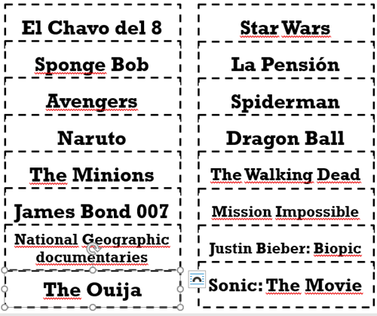

Written Comprehension: Pre-reading: Trivia
Game Show
1. The film Toy Story 2 was about to be cancelled because…
a. the first part was not popular.
b. a computer problem deleted the files of the film.
c. the director used too many special effects affecting the plot.
2. In 2007, the film Ratatouille inspired many children to…
a. to become chefs.
b. to visit restaurants.
c. to ask their parents for a rat as a pet.
3. The film Finding Nemo provoked that…
a. the population of clownfish in their natural habitats dropped.
b. people were more conscious about nature.
c. people loved sharks.

4. The cartoon character that appears in the most films is …
a. Superman.
b. Sponge Bob.
c. Donald Duck.

5. Animators of the film Up created the balloons that lift the house.
They created a total of _________________ balloons.
a. 10,297
b. 1,270
c. 150

6. In the film Jurassic World, the place where dinosaurs live is …
a. Jamaica.
b. Australia.
c. Costa Rica.
7. In the TV series The Simpsons all characters have…
a. four fingers.
b. a big house.
c. a cat and a dog.

8. In the film Maleficent the horns of the actress were so heavy that she could have…
a. fallen down.
b. broken her neck.
c. destroyed the set.

Reading Comprehension: Reading for the first time
Film reviews
Review #1  This is a fictional story of a man struggling to find his way in Gotham´s society. He works as a clown by day but he wants to be a stand-up comic at night. He discovered that his existence is cruel then he takes a bad decision.  This film contains violence but it also has a lot of a psychological drama. You can love it or hate it.  Positives: acting, plot, make up and visual effects.  Negatives: occasionally it is a slow movie (sometimes boring), and it needs more supporting characters. | Review #2  An Amazon princess who lives on an island occupied only by women. Until an event makes her go to the city and fight.  This is a fictional story that contains lots of action and special effects, drama and love.  Positives: acting, plot, great costumes, amazing scenarios and cool visual effects.  Negatives:The rival´s performance, sometimes it is boring because it's slow (sometimes boring), finally, it has many slow motion scenes. | Review #3  Members of an unemployed family target a wealthy household to survive. This is a well-written, horribly fascinating comedy-drama.  Parasite is a black comedy, a movie about status aspiration, materialism, the patriarchal family unit and the satiric idea of having servants.  Positives: acting, plot, reflects perfectly the Korean society.  Negatives: inability to contend with society; it is a conservative film in some moments.

Spoken Interaction

Planning and elaborating:
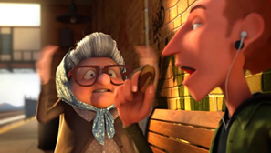
Example of a “frozen” image of the short film “Snack Attack”

Taken from:
https://images.app.goo.gl/6n7gzEAEjPCFoep46

Spoken Interaction
Repeating and Interacting: Information Gap task
Student 1 | Student 2
1. The Star Wars saga has a lot of …  2. The characters of a drama film should have …  3. Sometimes film reviews are…  4. Actors of Mexican soup operas should have had less…  5. Comedy films are…  6. Costa Rican films are very …  7. A good documentary must have more…  8. The main characters of Titanic are…  9. The film Spiderman uses more special effects than…  10. Usually reggaeton music videos contains too much … | 1. In your opinion the movie The Ouija is …  2. Black and white comedies were more…  3. The Avengers should have had less…  4. The best role an actor can interpret is not comedy, it is…  5. Movies must include more…  6. Film festivals are important because…  7. The most important person in a movie is…  8. Independent movies are not…  9. The most underrated productions are…  10. In this moment reality TV shows are considered…

Spoken Interaction Production

Describing: Snack Attack event cards
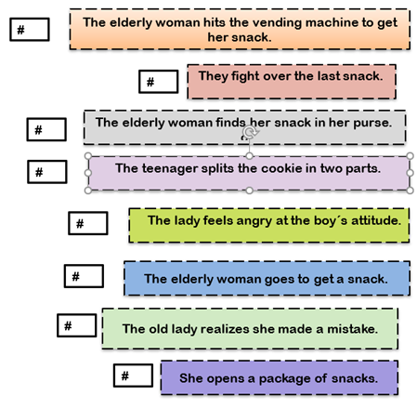

Spoken Interaction: Phonology
Video: https://youtu.be/EeToarNceeM
Phonology /OƱ/ and /ɔ:/
So Saw
Exercise 1: Pronounce these words along with your partner.

OƱ | ɔ:
Boat | Bought
Board | Bored
Code | Cord
Coke | Cork
Cone | Corn
Choke | Chalk
Close | Claws
Dome | Dorm
Foam | Form
Foe | For
Goal | Gall
Home | Horn
Know | Nor
Low | Law
Poke | Pork
Show | Sure
Snow | Snore
Toe | Torn

Exercise 2: Identify the word based on the correct sound you hear.
OƱ ɔ:

Stoke Stoke
Morning Morning
Code Code
Stork Stork
Poke Poke
Bought Bought
Pork Pork
Horn Horn
Cord Cord
Boat Boat

Weeks 5 and 6
Review and Integrated Mini-Project

Level: 10th |  |  |  | Unit: 1
Enduring Understanding: Literature opens the imagination and adds value to cultural knowledge and language.
Essential Question: How can literature change the way we see the world?
General Competences

Responsible Citizenship ( )
Life Competences ( )
Competences for Employability ( )

Learn to Know |  |  | Learn to Do |  | Learn to Be and Live in Community
Grammar & Sentence Frame  - Did Ls use all sentence frames?  Vocabulary  - Did Ls say aloud and write all vocabulary?  Phonology  - Did Ls recognize, articulate and produce phonological sounds? |  |  | Function  - Did Ls use all functions?  Discourse Markers  - Did Ls practice connecting words: and, but, because? |  | Psychosocial  - Did Ls show evidence of …  - Being aware and committed to protecting the environment  - Appreciating natural wonders  Sociocultural  - Did Ls practice idioms and quotes?
Assessment Strategies & indicators of learning  (Diagnostic, formative, summative) | Learner can | Didactic Sequence Mediation |  |  |  | Time  Total:  120 min  (3 lessons)
- Did Ls achieve all learning outcomes? | - Can Ls do all tasks? | Referencing notes from formative assessments throughout the weeks, repeat activities to strengthen Ls in weaker areas or select from Optional Activities that follow these plans. |  |  |  | All of week 5 or 6
Options |  | Integrated Mini-Project |  |  |  | Time
 |  | Participating to negotiate: (5 or 10 minutes in week 1)  In pairs, learners choose a movie they have both watch and would like to write a summary about.  Thinking for planning  In pairs and continuing with the project guide for week 1 and 2, learners write their first draw about the movie, including their personal opinions about it.  Thinking for planning  In pairs and continuing with the project guide for week 1 and 2, learners write their first draw about the movie, including their personal opinions about it.  Acting out/ Completing MP:  In the same pairs and continuing with the project guide for weeks 1, 2 and 3, learners share their summary with another pair of students to get feedback. Then, they edit and correct the summary, considering their peers suggestions.  Responding and sharing: Learners share the summary of the movie they wrote. To do so, the teacher creates a blog where learners post their papers and their classmates respond to them. Each group has its own blog as a way to monitor their performance more closely.  Leaners participate in individual and peer assessment of mini-project.  Teachers monitor ….  - Did Ls use English during all aspects of Integrated Mini-Project?  - How did project presentations reflect understanding and/or mastery of Can Do statements?  - Did Ls put into practice the focus of Learn to Be and Live in Community?  Did the Integrated Mini-Project provide answers to the Essential Question? |  |  |  | All of week 5 or 6 of unit

Images taken from:
https://images.app.goo.gl/T9qEsoGHwf9iq4mPA
https://images.app.goo.gl/FqfSgfG4ykZY88rw7
https://images.app.goo.gl/JFatvsYQV8dbWkE89
https://images.app.goo.gl/5Goh8qhUNyt1CtjH8
https://images.app.goo.gl/mPH2XaQPCxZcLgRP7
AilSoft Cl. https://images.app.goo.gl/T4ciXJFyFPyknP2c8
https://images.app.goo.gl/LqWE2KBgaCwwNVwV9
https://images.app.goo.gl/gytc8hcA8DDtr6hA9
https://images.app.goo.gl/h9ks1ngDVGEH1atB8

Reviews taken and re-adapted from:

- The Guardian www.the guardian.com › film › parasite-review-bong-joon-ho…
By Peter Bradshaw. Feb, 7 2020.

- The New Yorker. How Parasite Falls Short of Greatness by Richard Brody. Oct. 14, 2019. https://www.newyorker.com›howparasitefallsshortofgreatness

- Joker Rotten Tomatoeshttps://www.rottentomatoes.com›joker

- Wonder Woman (2017) Rotten Tomatoes. https://www.rottentomatoes.com›wonderwoman

