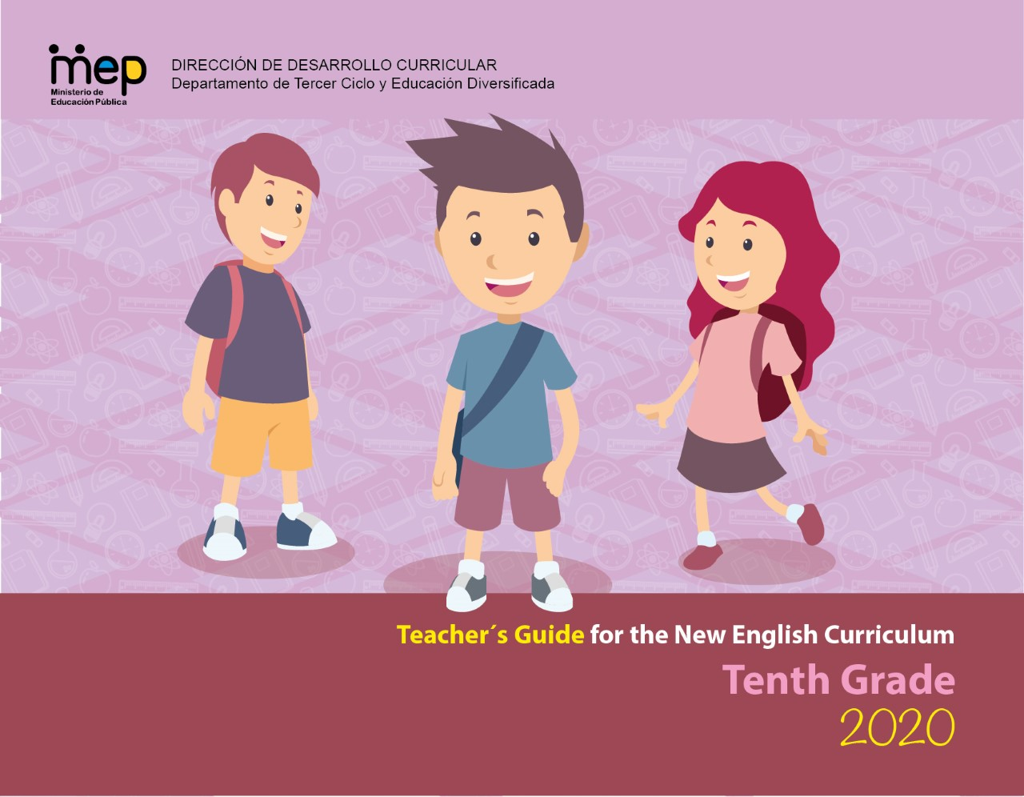

**Autoridades**

**Giselle Cruz Maduro**

Ministro de Educación Pública

**Melania Brenes Monge**

Viceministra Académica de Educación

**María Alexandra Ulate Espinoza**

Directora de la Dirección de Desarrollo Curricular

**Rigoberto Corrales Zúñiga**

Jefe del Departamento de Tercer Ciclo y Educación

**Comisión redactora**

**Mag. Marianella Granados Sirias,**

Asesora Nacional de Inglés, Departamento de Tercer Ciclo y Educación Diversificada

**Mag.Alfredo Ortega Cordero**,

Asesor Nacional de Inglés, Departamento de Tercer Ciclo y Educación Diversificada

**María Gabriela Castillo Hernández**

Asesora Regional de Inglés, Dirección Regional San Carlos

**Randall Centeno Hernández**

Asesor Regional de Inglés, Dirección Regional San José Norte

**Ezequiel Rojas Gutierrez**

Asesor Regional de Inglés, Dirección Regional San José Central

**Josue Sanchez Marín**

Asesor Regional de Inglés, Dirección Regional Los Santos

**MSc. Henry Enríquez**

Asesor Regional de Inglés, Dirección Regional Cañas

**Docentes de Inglés de Tercer Ciclo y Educación Diversificada**

Randall Murillo Benavides, Liceo Boca Arenal

Karol Vega Villegas: Colegio San Francisco de La Palmera

Sussan Miles Vargas Blanco: Colegio Técnico Profesional Regional San Carlos

Maricela Salazar Acosta: Liceo San Carlos

Yessenia Fuentes Pérez- Liceo Rural Santa Cruz

Luis Calderón Pérez- CTP San Pablo León Cortés

Estefanía López Mata- Liceo San Carlos

Karen Piedra Chacón- Liceo Copey

**Voluntarios Cuerpo de Paz**

Breanne Schnell

Daniel Larson

**Marco Brenes López**

Dirección de Recursos Tecnológicos, Diseño de portada

# Forward letter to the teachers

Dear Teacher,

This module focuses on supporting you as facilitators as you help your colleagues in the process of understanding and implementing the new English syllabus. Thank you for your commitment to the goal of transforming English Classrooms across Costa Rica through Action-Oriented Teaching and Learning.

This document contains a range of resources and key elements to assist you in collaborative environments as you make your way through the four following stages (proposed by Patrick Moran, a respected authority in language teacher education):

* Knowing about--by understanding the concepts and principles of the curricular English teaching and learning reform.

* Knowing why--by internalizing the purpose of the English reform as a response to contributing to the formation of the new citizen the country requires.

* Knowing how--by developing and implementing the action-oriented learning tasks when designing lesson plans, assessment instruments and follow up actions to best serve learners.

* Knowing oneself--by reflecting upon and reviewing your personal beliefs and teaching practices.

In conjunction with the materials in this module, we are encouraging you to build partnerships with other colleagues and to contextualize the material and ideas given according to your students’ needs and context.

Furthermore, we invite you to develop your knowledge and skills as lifelong learners to improve mediation practices and to build confidence and motivation to teach. To assist you with this ongoing process, we will continue to develop and provide online digital resources and professional development opportunities.

Best,

Marianella and Alfredo

*Asesoría Nacional de Inglés Departamento de Tercer Ciclo y Educación Diversificada*

# **Summary of the Syllabus Theoretical Framework**

**Introduction: Why a new English Curriculum?**

1. Learners need an updated curriculum that reflects the knowledge, skills, and abilities needed to succeed in the information age as 21st century learners.

2. Pre-school, elementary, and secondary school´s curriculum required an update in order to have more pertinent target content.

3. Learners who receive English lessons in elementary and high schools are not reaching the expected English proficiency levels after eleven or twelve years of instruction.

4. Citizens need to possess a number of competences to communicate effectively in the global context and to face the challenges of an interconnected world. Purpura (2016) summarized these competences as follows:

Over the years, the geopolitical and technological forces in the workplace have increased the knowledge, skills, and abilities (KSAs) that people need to perform their jobs. We are now asked to read, listen, and synthesize large amounts of information from several sources via multiple modalities; search for information, judge its accuracy, and evaluate its applicability; and use communication technologies to collaborate in teams whose members represent a diverse global community (National Research Council, 1999, 2001). Importantly, many of us are asked to do this in a second, foreign, or heritage language (L2), requiring competencies for communicating ideas and establishing relationships in culturally respectful ways (p. 190).

In addition, he stated that:

To succeed in this environment, L2 users must demonstrate that they have the skills needed to process information, reason from evidence, make decisions, solve problems, self-regulate, collaborate, and learn – and they need to do this in their L2 (p. 190).

[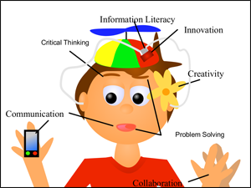](http://www.google.com/url?sa=i&rct=j&q=&esrc=s&source=images&cd=&cad=rja&uact=8&ved=0ahUKEwi5v9THj5nOAhUCqR4KHY65AgUQjRwIBw&url=http://web.tech4learning.com/blog-0/bid/45149/The-21st-century-classroom-where-the-3-R-s-meet-the-4-C-s&bvm=bv.128617741,d.dmo&psig=AFQjCNGYuLPA0bsB7OxZyCkRAtz3u23QIw&ust=1469897018703898)Education for a new citizenship reinforces the need of 21st century learners who integrate proactively in a globalized world while strengthening their national and global identity.

Source: <http://web.tech4learning.com/blog-0/bid/45149/The-21st-century-classroom-where-the-3-R-s-meet-the-4-C-s>

## 

# **The Learner as a New Citizen**

Education for a new citizenship envisions learners as active agents of change able to:

* Use knowledge, skills, and abilities beyond school contexts.
* Express their own points of view.
* Practice peaceful conflict resolution and search for democratic solutions.
* Harmonize social and economic development and environmental sustainability.
* Take action in favor of sustainability of local, national, and global resources.
* Be aware of a global world where national borders have become more diffused.
* Use ICTs and access to knowledge networks as tools for communication, innovation, and proactive social service.
* Be compassionate national and global citizens.
* Practice democratic principles such as freedom of expression and religion, respect for plurality and cultural diversity (sexual, linguistic, and ethnic) as stated in the Costa Rican Constitution.
* Defend and protect Human Rights and be against all forms of discrimination.

Figure 2. Dimension for Educating for a New Citizenship

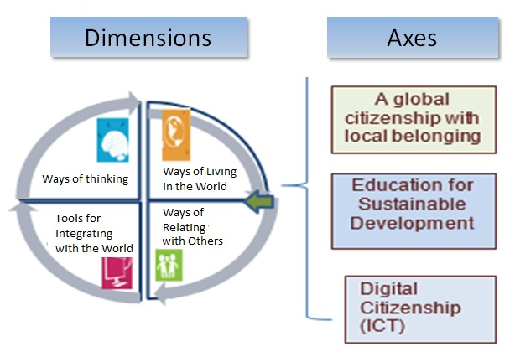

## What are the legal underpinnings and how are they related to language teaching and learning?

*Policy for the 21th Century* highlights three philosophical trends:

|  |  |  |  |
| --- | --- | --- | --- |
|  | **Rationalism** | **Humanism** | **Constructivism** |
| **Understanding** | Development of complex, challenging, creative and critical thinking skills, | Full realization of the human being, as a person with rights and responsibilities. | Construction and reconstruction of understandings and learnings |
| **Implications for teaching** | Cooperative learning and pedagogical scaffolding | Sensitivity to and awareness of learning styles and affective variables | Problem solving, inductive and deductive teaching, and experiential learning |

The policy “*The School as the Core of the Quality of Costa Rican Education”* recognizes three dimensions of learning:

Language Learning Considerations

|  |  |  |
| --- | --- | --- |
| **Considerations** | **Understanding** | **Implications for  Language Learning** |
| Philosophical | It focuses on the learner as a social agent who is active, independent, critical, reflective, creative, innovative, inquisitive, and respectful of human rights. | Learning environments and experiences should promote dialogue and creative responses to solve real-life problems. |
| Psychological | It seeks the whole development of the person and is associated with the person´s affective dispositions. | Pedagogic mediation is flexible, inclusive, and culturally relevant, respecting the individual differences of each student in the classroom. |
| Neurological | It is related to the brain’s architecture and how maturational processes influence language development. | Underscores the importance of starting the learning of foreign languages early in life and in scaffolding the L1 to help L2 acquisition. |
| Socio-cognitive | It is related to the brain’s architecture (attention, short-term long-term working memory) and how it functions to process information (metacognition) related to learning and communication. | Connects to the complexity and the cognitive load of tasks presented to students. |
| Socio-cultural | It includes the elements of diversity, interdependence, and interconnection with among others. | Addresses learning new behaviors, values, and social skills in line with a human rights approach and through democratic participation. |

## 

## Which pedagogical trends influence the teaching practices?

|  |  |
| --- | --- |
| **The Common European Framework of Reference (CEFR)** | |
| ***CEFR*** *describes proficiency levels based on accumulated evidence gathered over time from learner activities, tasks, or projects.* | **Implications:**   * Standard Terminology * Track student progress * Descriptors – teaching, learning, and assessment * Students monitor and take responsibility * Transferability across settings * Parent communication |
| Secondary  D:\Users\yramirez\Documents\CEFR level of proficiency.jpg  Pr  imary | |

### 

### Costa Rican general descriptors according to CEFR English proficiency bands

|  |  |  |
| --- | --- | --- |
| **Basic User**  **Basic User** | A1 | * Can understand and use familiar everyday expressions and very basic phrases aimed at the satisfaction of needs of a concrete type. * Can introduce him/herself and others and can ask and answer questions about personal details such as where he/she lives, people he/she knows and things he/she has. * Can interact in a simple way provided the other person talks slowly and clearly and is prepared to help. * Can show limited ability to use simple grammatical structures and conventions, such as punctuation and capitalization.   **EXTENSION OF THE CEFR STANDARDS - INTEGRATION OF LANGUAGE ABILITIES**   * Can use A1 level, grade level and age appropriate linguistic (e.g. present verb forms), socio-cognitive (e.g., associating strategies) and socio-affective (e.g., cooperating or coping strategies) resources to integrate topical content from oral and written text to perform a goal-oriented product (mini-project) based on an integrated sequence of activities within a domain, scenario, and theme. Linguistic resources include grammatical forms and meanings; socio-cognitive resources include a range of meta-cognitive strategies (planning) and cognitive strategies (revising); and socio-affective resources consist of strategies such as cooperating and coping. * Can use A1 level, grade level and age appropriate digital and telecommunication resources to research, plan, and implement the mini-project. * Can give, receive, and respond to feedback at critical stages of the creative process. * Can use level and age appropriate linguistic resources to integrate information from a reading, listening or other inputs to perform from one skill modality to another (e.g., listening to speak, reading to write) to achieve the goal of the scenario. * Can display awareness and development of non-cognitive dispositions (such as effort, perseverance, engagement, empathy, and focus). |
|
| A2  A2 | * Can understand sentences and frequently used expressions related to areas of most immediate relevance (e.g., very basic personal and family information, shopping, local geography, employment). * Can communicate in simple and routine tasks requiring a simple and direct exchange of information on familiar and routine matters. * Can describe in simple terms aspects of his/her background, immediate environment, and matters in areas of immediate need. * Can use some simple structures accurately but continues to systematically exhibit basic errors (such as verbs tenses, use of prepositions, articles).   **EXTENSION OF THE CEFR STANDARDS- INTEGRATION OF LANGUAGE ABILITIES**   * Can use A2 level, grade level and age appropriate linguistic (e.g. past verb forms), socio-cognitive (e.g., grouping strategies) and socio-affective (e.g., cooperating or questioning for clarification strategies) resources to integrate topical content from oral and written text to perform a goal-oriented product (mini-project) based on an integrated sequence of activities within a domain, scenario and theme. Linguistic resources include grammatical forms and meanings; socio-cognitive resources including a range of meta-cognitive strategies (monitoring) and cognitive strategies (resourcing); and socio-affective resources consisting of strategies such as cooperating and coping. * Can use the A2 level, grade level and age appropriate digital and telecommunication resources to research, plan, and implement the mini-project. * Can give, receive, and respond to feedback at critical stages of the creative process. * Can use level and age appropriate linguistic resources to integrate information from a reading, listening, or other input to perform from one skill modality to another (e.g., listening to speak, read to write)in order to achieve the goal of the scenario (e.g. - * Can display awareness and development of non-cognitive dispositions (such as effort, perseverance, engagement, empathy, and focus). |
|
| **Independent User**  **Independent User** | B1  B1 | * Can understand the main points of clear standard input on familiar matters regularly encountered in work, school, and/or leisure time like a radio or TV program when the delivery is relatively slow and clear. * Can understand texts that consist mainly of high frequency every day or job-related language. * Can understand the description of events, feelings, and wishes in personal letters. * Can deal with most situations likely to arise while travelling in an area where the language is spoken. * Can enter into conversations unprepared, on topics that are familiar, of personal interest, or pertinent to everyday life (e.g., family, hobbies, work, travel and current events). * Can produce simple connected text on topics, which are familiar, or of personal interest. * Can narrate a story from a book or film and describe personal reaction. * Can describe experiences and events, dreams, hopes and ambitions and briefly give reasons and explanations for opinions and plans. * Can express self reasonably accurately in familiar, predictable situations and know enough vocabulary to talk about family, hobbies and interests, work, travel, and news and current events.   **EXTENSION OF THE CEFR STANDARDS - INTEGRATION OF LANGUAGE ABILITIES**   * Can use the B1 level, grade level and age appropriate linguistic (e.g., complex verb forms), socio-cognitive (e.g., deduction/induction, inference strategies) and socio-affective (e.g., cooperating or questioning for clarification strategies) resources to integrate topical content from oral and written text to perform a goal-oriented product (mini-project) based on an integrated sequence of activities within a domain, scenario and theme. Linguistic resources include grammatical forms and meanings; socio-cognitive resources include a range of meta-cognitive strategies (evaluating) and cognitive strategies (resourcing); and socio-affective resources consist of strategies such as cooperating and coping. * Can use the B1 level, grade level and age appropriate digital and telecommunication resources to research, plan, and implement the mini-project. * Can give, receive, and respond to feedback at critical stages of the creative process. * Can use level and age appropriate linguistic resources to integrate information from a reading or a listening input or other inputs to perform from one skill modality to another (e.g., listening to speak, read to write) to achieve the goal of the scenario. * Can display awareness and development of non-cognitive dispositions (such as effort, perseverance, engagement, empathy, and focus). |

### The Action-Oriented Approach

|  |  |
| --- | --- |
| **Learner**  [Resultado de imagen de learner images](https://www.google.com/imgres?imgurl=https://learnerview.ofsted.gov.uk/sites/default/files/learner-view-homepage-banner.jpg&imgrefurl=https://learnerview.ofsted.gov.uk/&docid=5PJQQILrnbOq6M&tbnid=ztgfT50v_lCz6M:&w=665&h=300&bih=691&biw=1455&ved=0ahUKEwi7x6L9xpnOAhWJ1R4KHQxmDAQQMwg8KBQwFA&iact=mrc&uact=8) | * An agent/performer with intercultural awareness skills. * Autonomous, works cooperatively, interacts with others, investigates and solves problems using the tools at his/her disposal (general and specific competences). * Develops metacognitive, reflective and critical thinking strategies for successful completion of the task. |
| **Teacher**  Resultado de imagen de teacher images working with learners | * Facilitator, coach, resource person, guide, advisor, and observer. * Helps the learner become autonomous and be successful in the completion of the task. * Provides effective feedback in the process of learning. * Shows expert role but shares this responsibility with the learner. |
| **Learning Resources**  [Resultado de imagen de images of innovative classrooms](https://www.google.com/imgres?imgurl=http://cdn.patch.com/users/33150/2010/10/T600x450/123f96ec19a783aa3d14f7ec1a7c23fb.jpg&imgrefurl=http://patch.com/illinois/oaklawn/spartan-education-foundation-allows-teachers-to-creat6a888cc1c2&docid=p6ec_p7CxNZgTM&tbnid=mkpmu_Q8DdoEFM:&w=600&h=450&bih=691&biw=1455&ved=0ahUKEwjAtJfEy5nOAhWK1h4KHWS_A1o4ZBAzCFsoWDBY&iact=mrc&uact=8) | * Oral or written authentic texts: business cards, bus tickets, newspaper articles, book excerpts, wikis, bus schedules, city maps, bulletin boards, voice messages, and announcements. * Appropriate to the learner´s needs and competence level. * Intercultural perspective |
| **Aims of communicative activities/tasks**  D:\Users\acamposce\Pictures\roleplay.png | * Communicative activities become actions that the learner/social agent performs in order to build up general competences and communicative language competences. * The goal is successful action and accomplishment of tasks in a particular scenario and domain aligned to the learner’s life experience and personality. |
| **Learning Environment**  [Resultado de imagen de images of students having fun](https://www.google.com/imgres?imgurl=http://www.unr.edu/Images/student-services/cultural-diversity/API%204.jpg&imgrefurl=http://www.unr.edu/cultural-diversity/programs-and-services/programming&docid=Flvpi_I3n3uTnM&tbnid=7J00HYKKtlXtXM:&w=350&h=250&bih=691&biw=1455&ved=0ahUKEwif17PuzpnOAhXGox4KHbJxB0QQMwheKDowOg&iact=mrc&uact=8) | * Real-world contexts (personal, public, educational and vocational domain) collaborative, stimulating, mediated by ICTs. |
| **Assessment**  [Resultado de imagen de images of innovative teaching materials](https://www.google.com/imgres?imgurl=http://www.weareteachers.com/images/default-source/blog-images/close-reading.png?sfvrsn=0&imgrefurl=http://www.weareteachers.com/blogs/post/2015/05/27/10-super-innovative-teacher-ideas-for-close-reading&docid=xFbAhMl4I4vvIM&tbnid=SeRAeBryAMcSqM:&w=630&h=354&bih=691&biw=1455&ved=0ahUKEwiS57CcypnOAhVKWh4KHb_LBdoQMwhJKCUwJQ&iact=mrc&uact=8) | * Assessment is based on what the social agent is able to do in real-life situations or scenarios and the process he/she requires to develop the competences. Authentic assessment is favored. * The acquisition and refinement of general and communicative competences is a continuous process, both at school and in the world beyond the school. |

### Competence

The CEFR defines competences as “the sum of knowledge, skills and characteristics that allow a person to perform actions in society.”

### General competences

Consist of knowledge, skills, and abilities to learn existential competences that are not language-specific but learners need to know when performing different actions included in language activities.

### Basic Principles of the Action-Oriented Approach

1. The students are social agents that use the target language to perform specific actions in real life contexts meaningfully.
2. Language performances, in oral or written form, respond to language functions and are carried out in specific scenarios.
3. Enabling and communicative activities are task-based and real-life.
4. Learners use authentic materials ensuring comprehensible input, as much as possible.
5. The ICT becomes an important tool to create meaningful learning experiences.
6. A great degree of autonomy is placed on the learner; therefore, the teacher works in the development of learners’ meta-cognitive, meta-affective, and meta-social strategies.
7. Intercultural awareness plays an important role for getting meaning across and facilitating communication among cultures.
8. Vocabulary, syntax, cohesive forms, and phonology are taught with the purpose of facilitating communication

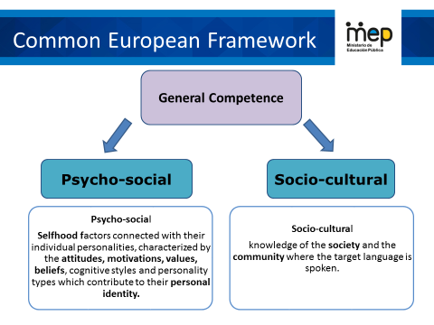

## Communicative competence

The communicative language competences involve knowledge, skills, and understanding of each of the following three components:

* **Linguistic Component:** Deals with the knowledge of phonology, morphology, lexicon and syntax.
* **Sociolinguistic Component:** Refers to the socio-cultural conditions of language use such as social group repertoires or politeness rules.
* **Pragmatic Component:** Covers, among others, speaker´s and receptor´s attitudes and beliefs, their understanding of the context of an utterance and the functional use of language; for example, the use in specific scenarios of how to act in a given social event or how to participate in a job interview.

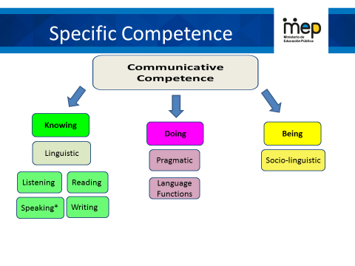

**Communication**

The CEFR defines communication as a social act, where learners are social agents, developing a range of general and specific communicative language competences, moving from learning about the language to learning to communicate in the language in active, spontaneous, and authentic language interaction.

**Tasks**

Tasks are defined as any purposeful action considered by an individual, necessary to achieve a given result in the context of a problem to be solved, an obligation to fulfill, or an objective to be achieved. This product may be a brochure for tourists, a blog entry, or a fundraising project for a humanitarian cause.

Task accomplishment by an individual involves the strategic activation of specific linguistic competences (linguistic, pragmatic and socio-linguistic) along with a range of socio-cognitive competences in order to carry out a set of purposeful actions in a particular domain (interpersonal, transactional, academic and professional) with a clearly defined goal and a specific outcome.

### How are lessons planned?

Lesson planning will be developed based on scenarios that focus on one or more of four different domains.

A unit is six weeks. Lesson plans are created weekly based on themes. Here is an example of how it can be done.

**Week 1**

Domain

Scenario

Enduring understanding Essential question

**Theme 1**

Language function 1

Goals

Three learning pillars

Assessment indicators

**Week 2**

Domain

Scenario

**Theme 2**

Language function 2

Goals

Three learning pillars

Assessment indicators

**Week 4**

Domain

Scenario

**Theme 4**

Language function 4

Goals

Three learning pillars

Assessment indicators

**Week 3**

Domain

Scenario

**Theme 3**

Language function 3

Goals

Three learning pillars

Assessment indicators

**Week 5&6**

Sharing and responding

Integrated mini-project

**Week 5**

Feedback, reinforcement and assessment

## Didactic Planning for Secondary

|  |  |  |  |  |  |  |  |  |  |
| --- | --- | --- | --- | --- | --- | --- | --- | --- | --- |
| **Term:** | | **Level:** | | | **Unit:** | | | **Week:** | |
| **Domain:** | | | | **Scenario:** | | **Theme:** | | | |
| **Enduring Understanding**: | | | | | | | | | |
| **Essential Question:** | | | | | | | | | |
| |  | | --- | | **General Competences** | | **Responsible Citizenship ( )** | | **Life Competences ( )** | | **Competences for Employability ( )** | | | | | | | | | | |
| **Learn to Know** | | | | **Learn to Do** | | **Learn to Be and Live in Community** | | | |
| **Grammar & Sentence Frames**  **Vocabulary**  **Phonology** | | | | **Function**  **Discourse Markers** | | **Psycho-social**  **Socio-cultural** | | | |
| **Assessment Strategies & indicators of learning**  (Diagnostic, formative, summative) | **Goals** | | | **Pedagogical Mediation/ Didactic Sequence** | | | | | **Time** |
| Learner… | Learner can | | |  | | | | |  |
| **Integrated Mini-Project** | | | | | | | | | **Time** |
| Phase: _______ | | | | | | | | |  |
| **Reflective Teaching** | | | | | | | | | |
| What worked well | | | What didn’t work well | | | | How to improve | | |
| **Enduring Understanding Reflection** | | | | | | | | | |
|  | | | | | | | | | |

|  |  |
| --- | --- |
| **Template Elements** | |
| **Level** | Grade level of the unit |
| **Unit** | 1 of 6 in a year, includes Scenario, 4 themes, Enduring Understanding, Essential Question, Goals, pillars of learning, mediation strategies, assessment, and an Integrated Mini Project |
| **Domain** | Refers to the broad sectors of social life in which social agents (learners) operate |
| **Scenario** | A real-life context referenced for an entire unit |
| **Themes** | The focus of attention for each week that refers back to the real life scenario. (context rather than content) |
| **Enduring Understanding** | Big ideas to guide the teacher that give importance and meaning to a set of curriculum expectations and have a lasting value for learners, beyond the classroom. (1 per unit) |
| **Essential Question** | A question which fosters understanding and critical thinking in learners. (Can be adapted to theme.) |
| **Linguistic**  **Competencies** | Oral and Written Comprehension (listening and reading); Oral and Written Production (spoken interaction, spoken production, writing). |
| **Goals** | Can-do performance descriptors |
| **Oral and Written Comprehension** | What a learner can understand or can do when listening and/or reading. |
| **Oral**  **and Written Production** | What a learner can speak and write. |
| **Learn to Know** | Learning pillar that includes Grammar and sentence frames, Vocabulary, and Phonetic Awareness/Phonology. |
| **Grammar & Sentence Frame** | The grammatical components that will be covered in the unit. |
| **Phonemic Awareness/**  **Phonology** | The part of the lesson that addresses the Learner’s ability to hear, identify, and manipulate sounds. |
| **Vocabulary** | Words learners need to know to communicate effectively within a domain, scenario, and theme. |
| **Learn to Do** | Learning pillar that includes Functions and Discourse Markers |
| **Function** | The use of spoken discourse and/or written texts in communication for a particular purpose (e.g. asking and giving information, describing). |
| **Discourse Markers** | Linking words or phrases that connect one piece of discourse with another one (e.g., *and*, *because*). |
| **Learn to Be and Live in Community** | The Learning pillar that includes Psycho-social, Sociocultural, Social Language, Idioms, and quotes. |

|  |  |
| --- | --- |
| **Template Elements** | |
| **Psycho-social** | Attitudes, motivations, values, beliefs, cognitive styles, and personality factors. |
| **Sociocultural** | Politeness conventions, expressions of folk wisdoms, register differences, dialects and accents |
| **Suggested Mediation Strategies** | Organized, purposeful and scaffolded learning experiences |
| **Assessment Strategies** | Required evidence of student´s learning |
| **Integrated Mini Project** | A more complex task which includes a four-phase process (participating, thinking, acting out, responding and sharing) that integrates skills and unit’s goals and leads to a final product. |

## General Mediation Principles for Third Cycle and Diversified Education

English teaching places priority on the fine-tuning of learners’ communicative competence involving oral comprehension and oral and written communication so that they become independent users of English and can reach the B1 or A2+ level, based on the descriptors of the CEFR.

* Teachers can select three or four goals per week from the units. They can combine oral or written comprehension with oral and written production, depending on the pedagogical purpose of the lesson.
* Teachers start each theme of a unit’s scenario and lesson with a warm-up activity. Then they share the essential question with the learners and the learning goals/expected outcomes for that day or week.
* The enduring understanding is shared by the teacher at the beginning of each unit to connect students with the core ideas that have lasting value beyond the classroom.
* Lessons follow a task-based approach combined with the action-oriented approach.
* Grammar is developed by combining both inductive and deductive instruction within a meaningful context.
* The teacher follows a set of integrated sequence procedures as presented below to develop the different linguistic competences.

## Mediation Sequence

|  |  |  |  |
| --- | --- | --- | --- |
| **Comprehension** | | **Production** | |
| **Oral** | **Written** | **Oral** | **Written** |
| * *Planning* * pre-listening * motivating * contextualizing * explaining task goal * *Listening for the first time* (general understanding); * *Pair/group feedback* * *Listening for the second time* (more detailed understanding) * *Post listening: Reacting to content , focusing on features or language forms and Self/co- assessment* | * *Planning* * pre-reading * explaining task goal * use typographical clues * list difficulties and strategies on how to cope * *Reading for the first time* * *Pair/group feedback* * *Reading for the second time*, *post–reading* (for reacting to the content or focusing on features/language forms) * *Post Reading: Reacting to content , focusing on features or language forms and Self/co- assessment* | * *Spoken interaction* * Planning * Organizing * Rehearsing * Interacting * *Spoken production* * Planning * Organizing * Rehearsing * Producing | * *Pre-writing* * *Drafting* * *Revising* * *Editing* * *Publishing* |

* Teacher makes sure that all learners understand task instructions.
* Teachers should ensure learners know how to use strategies through teacher scaffolding and modeling, peer collaboration and individual practice.
* Learners have at their disposition useful words, phrases and idioms that they need to perform the task. It could be an audio recording with the instructions and the pronunciation of the words and phrases needed.
* The task could involve the integration of listening and speaking or reading and writing and is given to students individually, in pairs, or teams.
* The learners complete the task together using all resources they have. They rehearse their presentation, revise their written report, present their spoken reports or publish their written reports.
* Teacher monitors the learners’ performance and encourages them when necessary.
* The learners consciously assess their language performances (using rubrics, checklists and other technically designed instruments that are provided and explained to them in advance). Teachers assess performance, provide feedback in the form of assistance, bring back useful words and phrases to learners’ attention, and provide additional pedagogical resources to learners who need more practice.
* At the end of each unit, the learners develop and present Integrated Mini-Projects to demonstrate mastery of the unit goals.
* The enduring understanding and essential question are central to articulate the three learnings: learn to know, learn to do and learn to be and live in community. The Integrated Mini-Project is an opportunity for students to integrate these three learnings in a single task.
* Teach and plan English lessons in English to engage learners socially and cognitively.

# **Classroom Setting in the Action Oriented Approach**

When implementing the action oriented lessons in your English class; remember to:

1. Consider learners’ interests and needs.
2. Offer opportunities to work in pairs, in small groups, and as a whole class.
3. Create a context for learning and reflecting.
4. Provide multiple opportunities to develop communicative competence.
5. Use different classroom layouts: the horseshoe, chairs in a circle, traditional rows and nested tables in groups.

## Phonological Competence and the Use of RAPPP…

Phonological competence is the ability to recognize and produce the distinctive meaningful sounds of a language, including: consonants, Vowels, tone patterns, intonation patterns, stress and rhythm.

**What to do to learn and teach phonological competence**

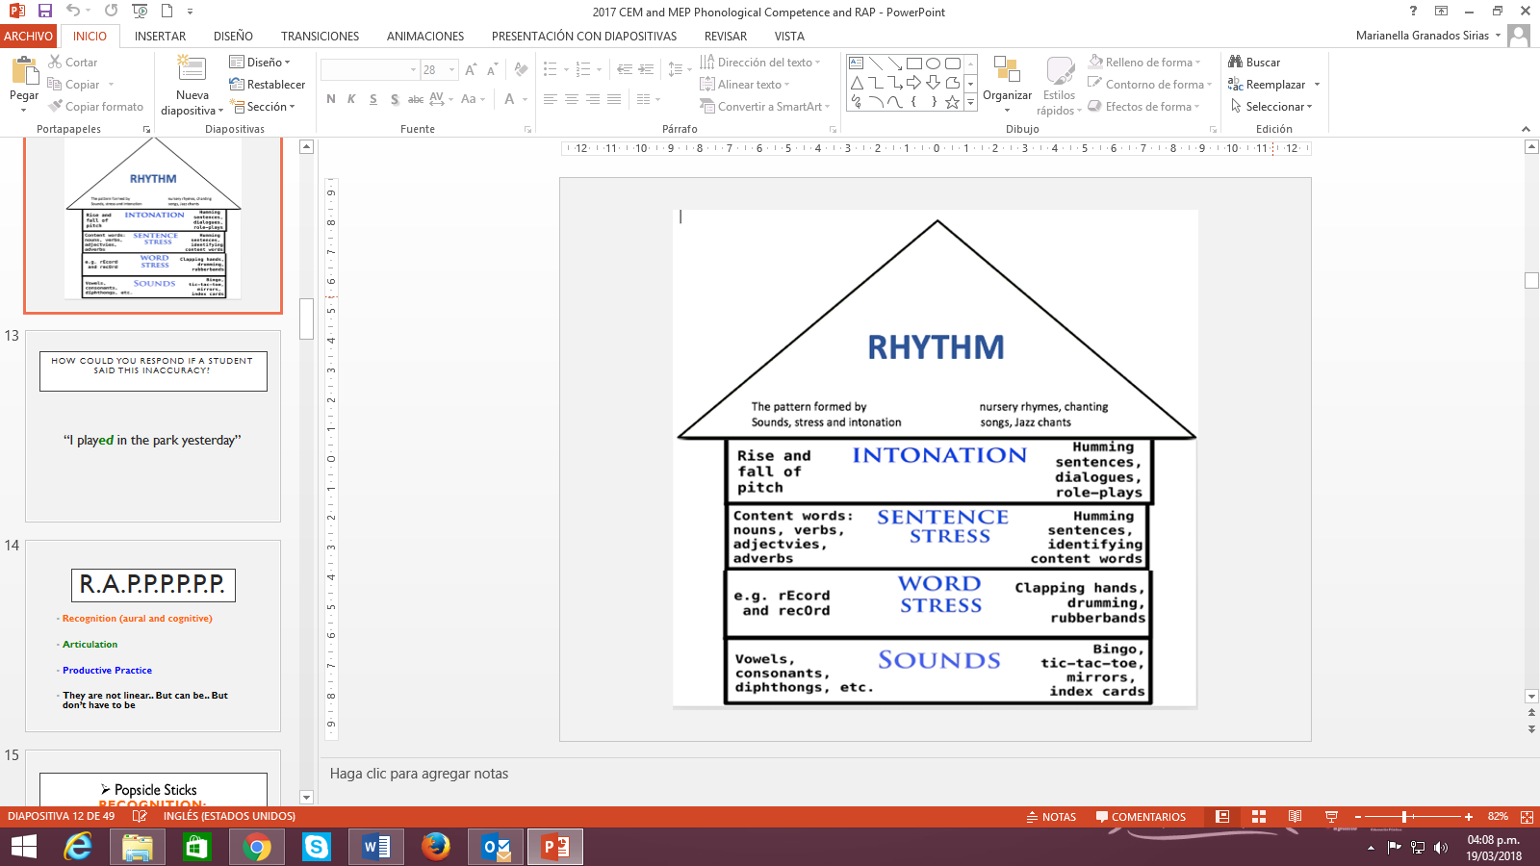

And you can also use

**R.A.P.P.P.P.P.P.**

* **Recognition (aural and cognitive)**
* **Articulation**
* **Productive Practice**
* **They are not linear. But can be... But don’t have to be**

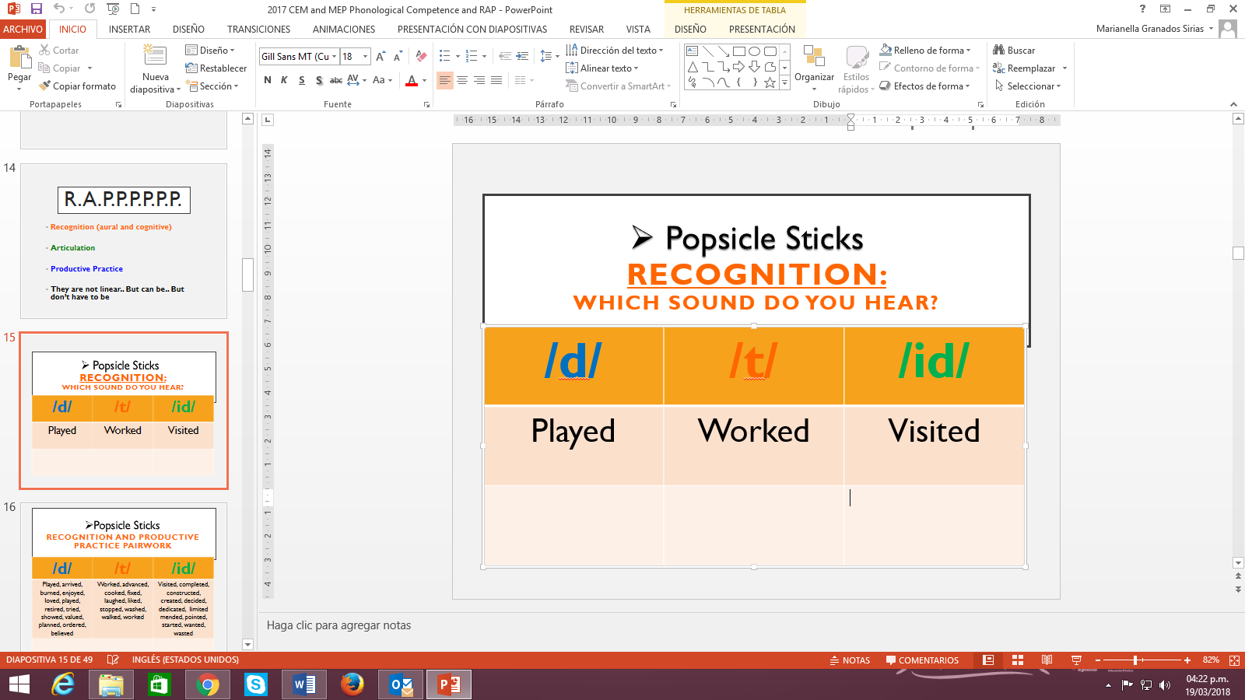 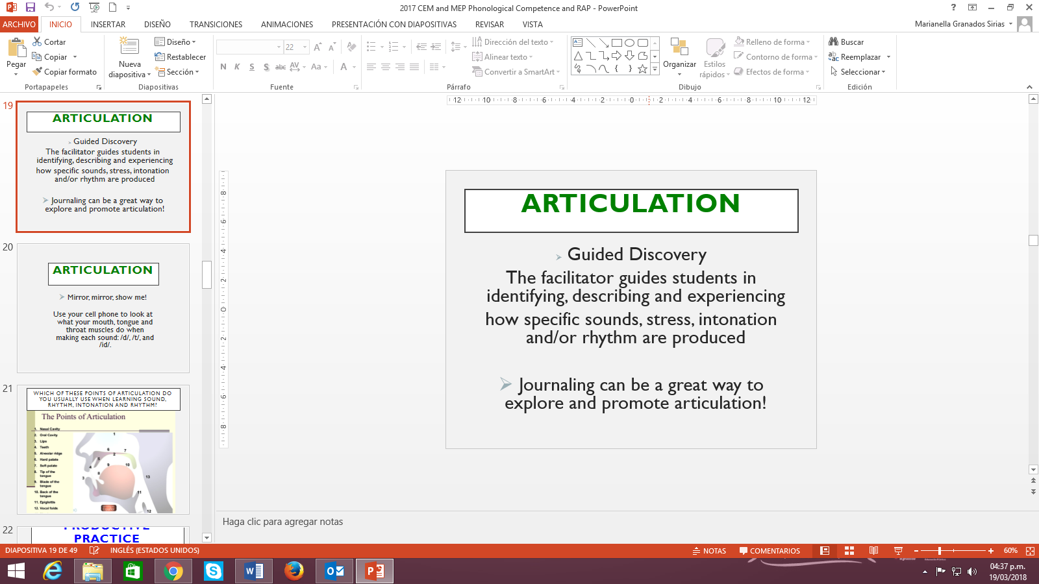 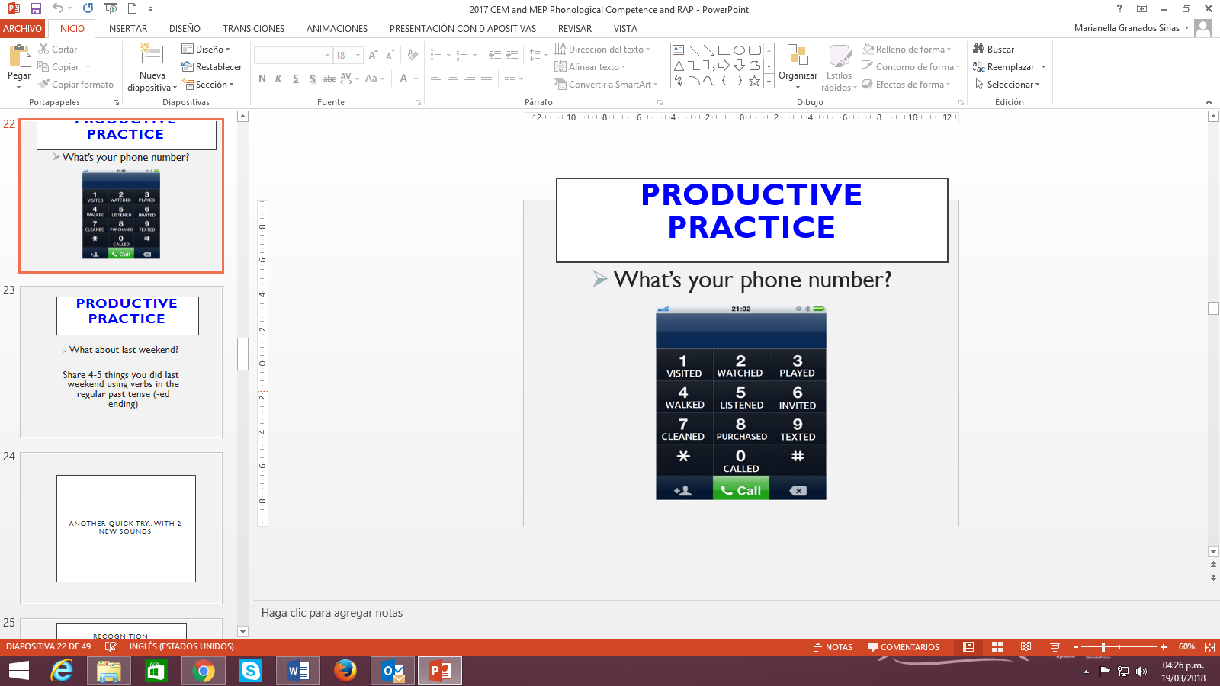

**Source:** Ramírez, R., Scholl, M. Zalazar, L., Cárdenas, N., Rossi, A. Centro Espiral Maná (2017)

# **How is learning assessed?**

Assessment is a purposeful, continuous, contextualized, authentic, reflective, investigative, systematic and multi-phase process, which responds to these four fundamental questions: Why assess learning? What learning to assess? How to assess it? Which are the pedagogical implications in the learning?

The purpose of assessment is to serve each learner’s growth and learning. To prevent student’s failure and allow timely intervention, assessment allows teachers to detect learning gaps so that learners can receive the support needed to be successful. The “what” of assessment involves gaining clarity about the knowledge, skills, abilities, and attitudes (learn to know, learn to do, learn to be and live in community) that learners have to develop as established in the curriculum goals or “can do performance descriptors”. This implies that assessment will mainly be performance-based. Learners are required to demonstrate through integrated-skills tasks within a domain, scenario and theme, specified knowledge, skills and abilities using the target language. Assessment can also be discrete point, which means the use of selected response tasks to isolate and measure discrete units of grammatical knowledge, which encompasses grammatical, semantic and pragmatic knowledge -- form, meaning and use (Purpura, 2014, p 9). Assessment will also be authentic which means that the assessment task will simulate real-life situations within domains and scenarios beyond the classroom setting, and the socio-cognitive, socio-affective, socio-cultural and linguistic demands on the learner will be similar to the one of a speaker in a target language setting.

Classroom assessment mirrors the learning goals, content of instruction and instructional practices; therefore, curriculum, teaching, and assessment must be coherent for learning goals to be achieved and learners’ communicative competence to be developed.

Task design, task performance, and assessment become a fundamental unit of instructed learning; tools such as analytic and/or holistic scales, rubrics, progress indicators and checklists play an important role for obtaining valid and reliable qualitative and quantitative data about students´ learning and performance.

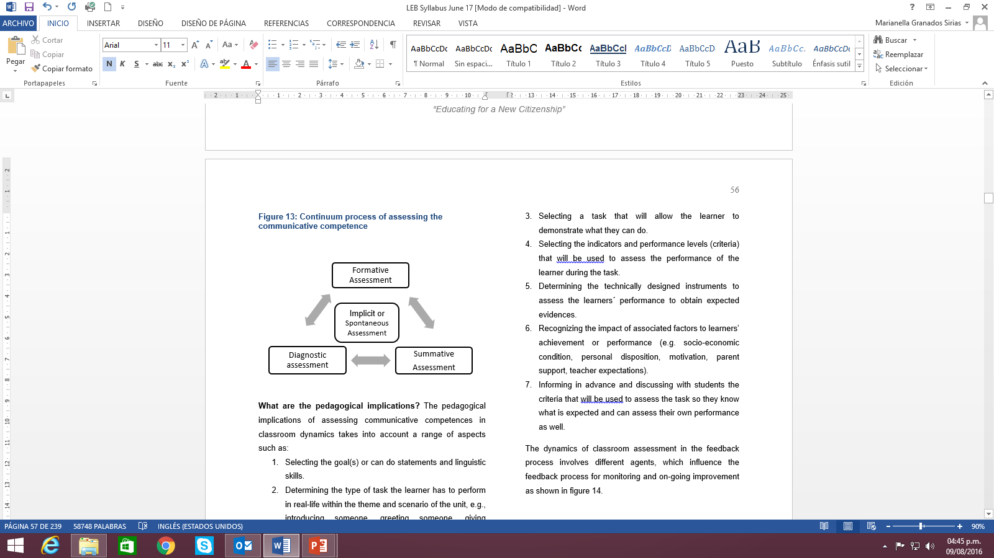

**Integrated Mini- Project**

|  |  |
| --- | --- |
| A more complex “learn to do” classroom task for each unit.   * Learners (as social agents) integrate knowledge, skills and abilities (KSA), within the domain, scenario, themes, the enduring understanding and essential questions of the unit * Proactive (not reactive) * Interconnected with classroom activities * Formative, skill-integrated performance * Collective actions (social dimension) * Promotes democratic citizenship (CEFR p.12) * Integrates skills and unit’s goals and leads to a final product. |  |

**AOA Task Oriented to a Product  
Keep the end in mind!**

**Phases for the Integrated Mini-Project**

1. **Participating/Negotiating (Week 1 or 2)**

Brainstorming, discussing, negotiating, making decisions to formdifferent groups according to their interest, language abilities, etc.

1. **Thinking/planning (Week 3 or 4)**

Planning, negotiating and finding information collaboratively about the language content and strategies, resources and organizing the work to distribute assignments among the group members.

1. **Acting out/Completing MP *(oral/written)* (Week 5)**

Completing the product, rehearsing, practicing the mini-project presentation.

1. **Responding and Sharing (Week 6)**

Groups creatively deliver the mini-project, answer questions from the audience and in pairs, or groups self or co-assess it.

|  |  |
| --- | --- |
| **7th - Unit 3 – Example**  **Promoting local tourism**  Integrated Mini-Project: Tourist Brochure to support local tourism  Task description:  You want to show the most important tourist attractions to support local tourism. Design a brochure to promote local tourist attractions. Keep in mind the following questions to guide your product: Is this an authentic communication action? Is it useful in everyday life?  Phase 1: **Participating to negotiate:** (5 or 10 minutes in week 1 or 2) Choose your mini project and get in groups of 3-4 participants and negotiate in order to plan the next phase.  Phase 2: **Thinking for planning**: (5 or 10 minutes in week 3 or 4) Plan your brochure. Think what to do (the information you need to find, the time and organization of the work (what to write and distribute what each member is going to do).  Phase 3: **Acting out to complete the Mini Project –oral & written:** (week 5)  In your group, complete the brochure in class, rehearse and organize the presentation.  Phase 4: **Responding and sharing** (week 6)  creatively present the brochure to the class, respond to questions from the audience using the instruments to self or co-assess the project (or brochure) | Imagen relacionada |

|  |  |  |  |  |  |  |
| --- | --- | --- | --- | --- | --- | --- |
| **Week 1** | **Week 2** | **Week 3** | **Week 4** | **Week 5** | | **Week 6** |
| **Introducing Scenario** | **Some tasks can relate to Integrated Mini-Project** | **Some tasks can relate to Integrated Mini-Project** | **Some tasks can relate to Integrated Mini-Project** | **Completion of Integrated  Mini-Project** | **Presentation of MP** | |
| *Participating/*  *negotiating*  Selecting Integrated Mini-Project (5-10 min) | *Participating/*  *negotiating*  Planning Integrated Mini-Project  (5-10 min) | *Thinking/planning*  Planning Integrated Mini-Project  (5-10 min) | *Thinking/planning*  Planning Integrated Mini-Project  (5-10 min) | *Acting out/*  *completing MP*  Completion of Integrated Mini-Project | | *Responding and sharing*  Presenting the IMP |

# What is the teacher’s profile to implement this new curriculum?

**Teacher’s Profile**

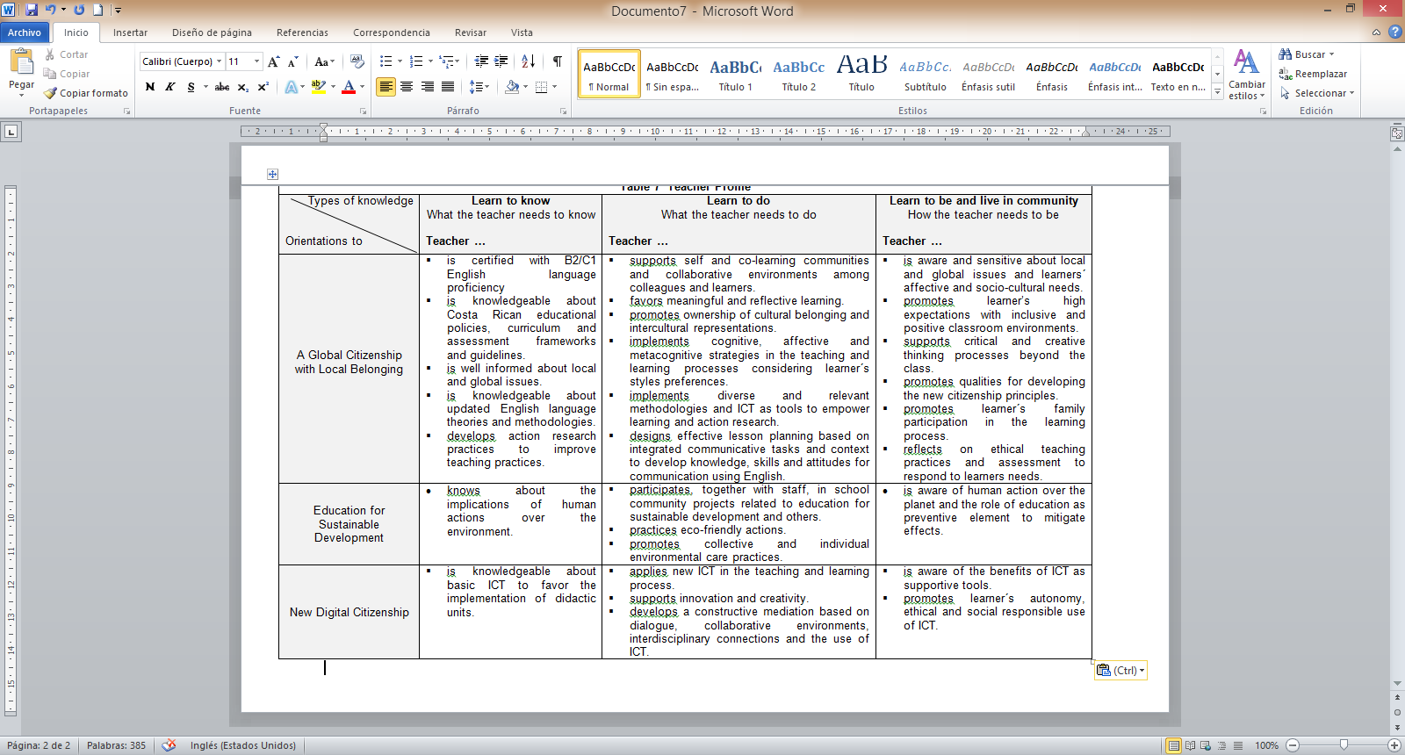

**What is expected from learners?**

**Learner´s Exit Profile**

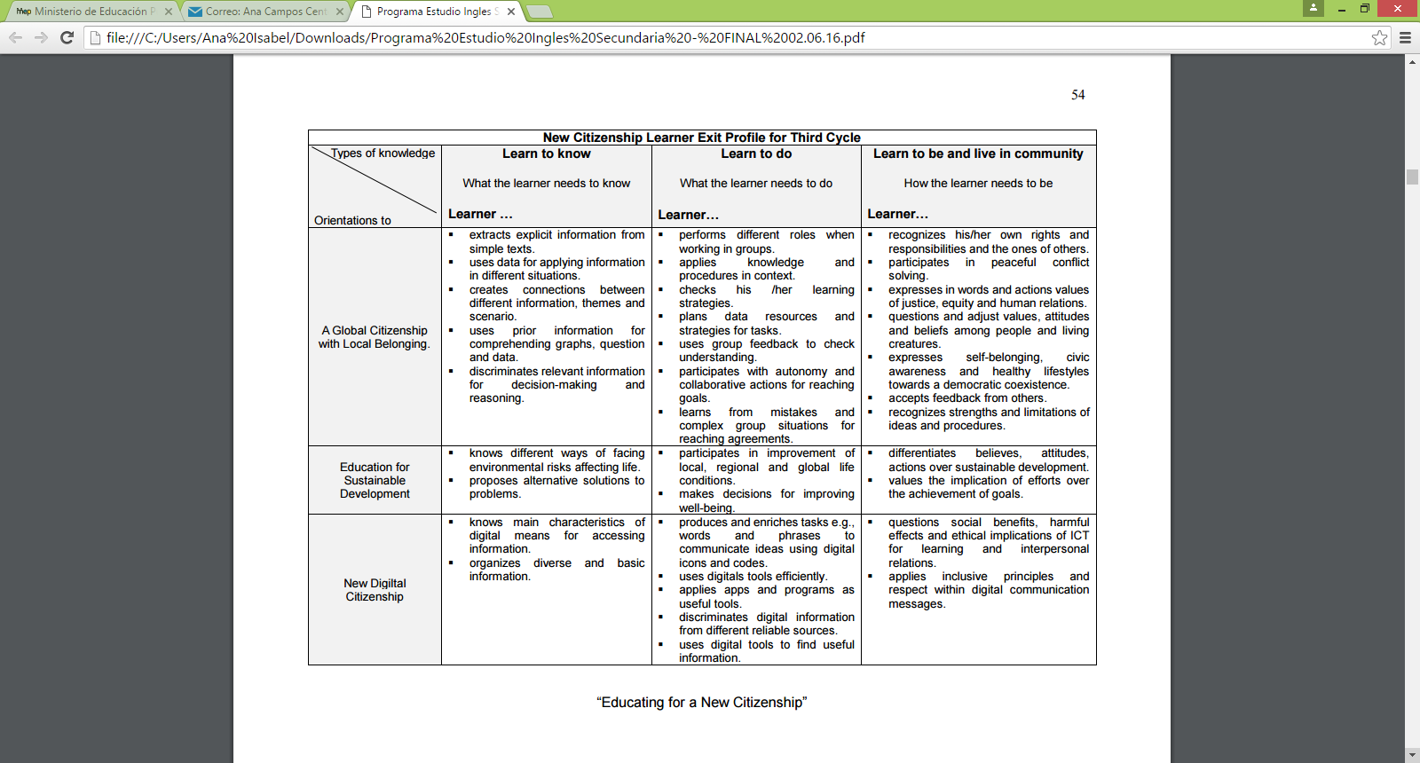

# **Distribution of Scenarios Academic and Technical Diversified Education**

|  |  |  |  |  |
| --- | --- | --- | --- | --- |
| **Academic Diversified Education** | | **Technical Diversified Education** | | |
| **10th Level Scenarios** | **11th Level Scenarios** | **10th Level Scenarios** | **11th Level Scenarios** | **12th Level Scenarios** |
| * Love What We Do! * Stories Come in All Shapes and Sizes * A World of Differences * Caution: Fragile World- Handle with Care. * #High Tech High Touch * * What Comes Next | * Recipes for Success * From the Wheel to the Drone * The Earth–Our Gift and Our Responsibility * Get Ready. Get Set. Go! * Really? (Controversial issues) | * Love What We Do! * Stories Come in All Shapes and Sizes * A World of Differences * Caution: Fragile World- Handle with Care | * #High Tech High Touch * * What Comes Next * Recipes for Success * From the Wheel to the Drone | * The Earth–Our Gift and Our Responsibility * Get Ready. Get Set. Go! * Really? (Controversial issues) |

**\*Se realiza corrección del cuadro que aparece en la página 59 del programa de estudio.**

# **Sequence of Scenarios and Themes for Third Cycle and Diversified Education**

|  |  |  |  |  |  |  |
| --- | --- | --- | --- | --- | --- | --- |
| **Scope and Sequence Third Cycle** | | | | | | |
| **Level** | **Unit 1** | **Unit 2** | **Unit 3** | **Unit 4** | **Unit 5** | **Unit 6** |
| **Seventh** | **Scenario:** Here I Am!  **Themes:**   * Hello, Hi there, Hey, Bye * Building Community * Let´s Get Personal * Meet My Family | **Scenario:** Enjoying Life  **Themes:**   * My Daily Routine * Eating Habits * Hanging out * Things I Like to Do | **Scenario:** Getting Back to Nature  **Themes:**   * Natural Wonders in My Backyard * Marvels in Costa Rica * A World of Wonders * Where can I go next? | **Scenario:** Checking Things off a Shopping List  **Themes:**   * My Family´s Grocery List * Going Shopping * Does This Fit Me? * How Much Does It Cost? | **Scenario:** Let’s Celebrate Costa Rican Culture!  **Themes:**   * How my family and I celebrate “Tico” culture * How my community celebrates “Tico” culture * How other Costa Rican communities celebrate “Tico” culture * How Costa Ricans celebrate national “Tico” culture | **Scenario:** Getting from Here to There  **Themes:**   * Knowing where I want to go * Knowing where It is * Knowing how to get there * Knowing what I need and when |
| **Eighth** | **Scenario:**  My High School…Our place  **Themes:**   * High School -- Bring it on! * A Day in the Life of My High School. * What is Your Next Class? * High School Through the Eyes of my Friends. | **Scenario:**  Let the Good Times Roll  **Themes:**   * Fun times: Inside and Out * What´s your favorite ____? * Ready to Play: Tell Me the Rules * Up Close and Personal | **Scenario:**  Something to Celebrate!  **Themes:**   * Let’s Celebrate: Holidays with My Family * Let’s Celebrate: Latin American Holidays and Festivals * Let’s Celebrate: Holidays and Festivals around the World * A Holiday to Remember: One of my favorites | **Scenario:**  Going Shopping!  **Themes:**   * Welcome to My Town * Getting what I need at the right place * Where is it? * How can I get there? | **Scenario:** Unforgettable Events  **Themes:**   * A Day I’ll Never Forget: in my Personal Life * An Event I’ll Never Forget: with my Family * An Event I’ll Never Forget: in Costa Rica * An Event I’ll Never Forget: in the World | **Scenario:**  Amazing Costa Rica  **Themes:**   * Beautiful Costa Rica * Hiking, Biking and Walking Around Costa Rica * Traveling Necessities * Planning My Perfect Vacation |
| **Ninth** | **Scenario:**  Time to Have Fun!  **Themes:**   * Let’s Workout * Once Upon a Time I Enjoyed... * Try it! * The Most Fun I've Ever had! | **Scenario:**  Online & Connected  **Themes:**   * Yesterday, Today and Future Media * Virtual Communities and Networks * New Media and Public Safety * The Magical World of Apps | **Scenario:**  Lights, Camera & Action  **Themes:**   * What´s on TV? * The Best Show Ever… * Through the Lens of the Documentary * Daily News | **Scenario:**  In the Public Eye  **Themes:**   * Success vs. Fame * National Role Models * Contributions of Outstanding Figures to Society * Breaking News: Read All About It | **Scenario:**  Unexpected Situations  **Themes:**   * Home Emergencies * Emergency Traveling Situations * Unanticipated Appointments * Making a Complaint at a Restaurant | **Scenario:**  Open a Book, Open Your Mind  **Themes:**   * Keep it simple * Show me: Comic Strips * Biographies of Writers * The Moral of the Costa Rican Legend is … |
| **Tenth** | **Scenario:**  Love What We Do!  **Themes:**   * Help wanted * Jobs * Interviewing * Working to Live or Living to Work? | **Scenario:**  Stories Come in All Shapes and Sizes  **Themes:**   * Tell me a Story * Thumbs Up/Thumbs Down * The Reviews Are In * You Should Read This | **Scenario**:  A World of Differences  **Themes:**   * These Are My People * Cultures, Subcultures and Cliques * Cultural Norms and Cultural Storms * I Am Not My Hair | **Scenario:**  Caution: Fragile World - Handle with Care  **Themes:**   * What Makes Something Sustainable * Products and Practices around the World. * Products and Practices in Costa Rica * Am I Environmentally friendly? | **Scenario:**  #HighTech HighTouch  **Themes:**   * Hot Apps * Danger Zones in a Digital World * Tech Tools for Positive Change * My Future Is in My Hands | **Scenario:**  What Comes Next?  **Themes:**   * Pass or Fail? * College or Career? * Study Here or Abroad? * Getting by or Getting ahead? |
| **Eleventh** | **Scenario:**  Recipes for Success  **Themes:**   * Ingredients for Healthy Living * Add a Pinch of a Positive Attitude * Follow the recipe: a Plan for success * Give me a Taste: Stories of Successful People | **Scenario:**  From the Wheel to the Drone  **Themes:**   * Inventions that have Changed our Lives * Living in a Tech World * Safety First * The Next Wave of Innovations | **Scenario:**  The Earth–Our Gift and Our Responsibility  **Themes:**   * Natural Disasters-Is Nature Against us? * What´s the Problem? * A Helping Hand (possible solutions) * Who is Doing What? (Nonprofit and NGOs) | **Scenario:**  Get Ready. Get set. Go!  **Themes:**   * Get ready: Take a Look at Your Dreams and Fears * Get Set: College or Career? * Surviving or Thriving? (Developing Your Soft Skills) * Go! The Future is Now | **Scenario:** Really??? (Controversial issues)  **Themes:**   * You gotta be kidding…World facts * Shut up…Issues from Health and Medicine * No way…Controversies and the Law * OMG… Stereotypes and Cultural Differences | |

# **Tenth Grade Exit Profile (Learner Exit Profile)**

|  |  |  |  |
| --- | --- | --- | --- |
| **Level**  **B1 Grade 9-10** | | | |
| **Integral Development and Communicative Competence** | | | |
| At this stage, the learner can... | | | |
| **Learn to know** | have a level-appropriate language (words, phrases, formulaic expressions) and topical knowledge related to domains, scenarios and themes. | | |
| **Learn to do** | use level-appropriate linguistic and topical resources in order to listen, read, speak and write in response to level and age-appropriate tasks, integrating language and topical knowledge, skills and abilities (KSAs) within domains, scenarios and themes. | | |
| **Learn to be and live in community** | use personal and social dispositions (e.g., engagement, attitudes, cooperation, turn taking, empathy, and other universal values) when interacting and producing in the target language and taking time to search for words using oral and body language for transferable learning beyond the classroom setting (enduring understanding). | | |
| **Listening** | **Reading** | **Speaking**  **(spoken interaction & production)** | **Writing** |
| **CEFR STANDARDS**   * Can note the main points of oral texts at a normal speed related to personal and educational domains.   **INTEGRATION OF LANGUAGE SKILLS**   * Can recognize key points in T.V programs radio, web-based broadcast announcements, videos, audio recordings to ask for clarification and expressing thoughts (listening to speak). * Can interpret online explanations supported by resources to convey meaning in texts (listening to read). * Can write different text types heard to check comprehension in collaborative work before editing (listening to write /speak). | **CEFR STANDARDS**   * Can comprehend texts containing more varied sentence and vocabulary within expository, narrative, procedural and transactional genres.   **INTEGRATION OF LANGUAGE SKILLS**   * Can read texts on familiar topics to start, maintain, and close a conversational exchange (reading to speak/listen). * Can read different passages to summarize information (reading to write). * Can read familiar and unfamiliar topics for self-correction after listening to the oral version (reading to listen). | **CEFR STANDARDS**   * Can sustain conversations related to personal and educational routines and domains with fluency. * Can maintain interactions related to public and vocational domains with hesitation, backtracking and repairing while searching for vocabulary and grammar structures.   **INTEGRATION OF LANGUAGE SKILLS**   * Can interpret information by asking for clarification and confirm understanding when listening to texts (listening to speak). * Can exchange information supported by a written source for completing information (speaking to read/write) * Can use written sources to explain and justify points of view (reading to speak). | **CEFR STANDARDS**   * Can produce short, basic paragraphs with a topic sentence and supporting details within an expository genre. Sentences start to connect with each other. * Can produce a narrative paragraph with characters, plot and setting.   **INTEGRATION OF LANGUAGE SKILLS**   * Can write to exchange personal experiences (writing to speak). * Can use graphic organizers to plan language, content and express information (writing to speak/write). * Can react to an oral text expressing written thoughts and feelings (listening to write). |

# **Tenth Grade Distribution of Domains and Scenarios by Term**

|  |  |  |
| --- | --- | --- |
| **Domain** | **Scenario** | **Unit** |
| **Term 1** | | |
| Socio-Interpersonal and Academic | Love What We Do! | **1** |
| Socio-Interpersonal and Academic | Stories Come in All Shapes and Sizes | **2** |
| **Term 2** | | |
| Socio-Interpersonal and Academic | A World of Differences | **3** |
| Socio-Interpersonal and Academic | Caution: Fragile World -- Handle with Care | **4** |
| **Term 3** | | |
| Socio-Interpersonal and Academic | #HighTech HighTouch | **5** |
| Socio-Interpersonal and Academic | What Comes Next? | **6** |

# **Sample Weekly Plans and Materials**

# **Unit 5 for Tenth Grade**

|  |  |  |  |  |  |  |  |  |
| --- | --- | --- | --- | --- | --- | --- | --- | --- |
| **Level 10th Unit 5**  **CEF Level to be Reached B1 Basic User/Independent User** | | | | | | | | |
| **Scenario:**  **#HighTech HighTouch** | | | | | | | | |
| **Enduring Understanding** | | Technology is a powerful tool and, in the right hands, it can make the world a better or worse place. | | | | | | |
| **Essential Question** | | How can technology help me make my world better? | | | | | | |
| |  | | --- | | **General Competences** | | **Responsible Citizenship ( )** | | **Life Competences ( )** | | **Competences for Employability ( )** | | | | | | | | | |
| **Assessment and Goals** | | | | | | | | |
| **Week 1**  **Goals**  **L.1.** understand many television, radio, and web-based broadcasts/ announcements dealing with subjects of interest if the people talk clearly.  **L.3.** follow the main idea of audio text if the topic is familiar and the text can be replayed.  **R.1.** understand factual text and simple reports on familiar topics (e.g., interviews). | **Week 1**  **Assessment**  **L.1.** recognizes many television, radio, and web-based broadcasts/ announcements.  **L.3.** extracts the main idea of audio text if the topic is familiar and the text can be replayed.  **R.1**. recognizes factual text and simple reports on familiar topics. | **Week 2**  **Goals**  **L.2.** understand when people speak at normal speed on familiar topics. There may be a need to repeat particular words and phrases.  **R.3.** understand clear, simple instructions with some visual support (e.g., how to use an app).  .  **SI.1**. ask questions about procedures. | **Week 2**  **Assessment**  **L.2.** recognizes when people speak at normal speed on familiar topics. There may be a need to repeat particular words and phrases.  **R.3.** interprets clear, simple instructions with some visual support (e.g., how to use an app).  **SI.1**. asks questions about procedures. | **Week 3**  **Goals**  **SI.2.** sustain a conversational exchange with a peer in the classroom when the topic is familiar, though there may be some difficulty in understanding and being understood from time to time.  **W.1.** summarize simple text dealing with familiar subjects.  **SP.1.** express opinions on familiar subjects and ask for others’ opinions.  **R.2.** manipulate English language sounds using knowledge in phonics, syllabification and word parts. | **Week 3**  **Assessment**  **SI.2.** starts, sustains and closes a conversational exchange with a peer in the classroom when the topic is familiar.  **W.1** summarizes simple text dealing with familiar subjects.  **SP.1**. expresses opinions and asks for others’ opinions about the digital world.  **R.2**.indentify and manipulate English language sounds using knowledge in phonics, syllabification and word parts. | **Week 4**  **Goals**  **SP.2.** explain and justify points of view, briefly, about the digital world.  **W.2**. describe applications or tech tools (e.g., apps, video games, programs, tech tools) using | **Week 4**  **Assessment**  **SP.2.** gives explanations and justifications on points of view, briefly.  **W.2**. writes expository paragraphs about tech tools (e.g., apps, video games, programs, tech tools), using complete sentences that are connected to each other. | **Week 5/6**  **Assessment**  Anecdotal reports / rubrics / instruments for self and co-assessment  **Suggested Integrated Mini project**   * Own app, explaining what it will do, how it will work, what it will look like. * Giving own opinions/ answers to the Essential Question of the unit, using available technology or posters/paper. |
| **Phonology**  **R2.** manipulates English language sounds using prior knowledge in phonics, syllabification and word parts.   * Review of sound articulation (7th to 9th) and of phonological features of most unfamiliar words when needed. * Use of prosodic features (stress, intonation, rhythm) to support the message intended to convey. * Even though this goal is still linked to reading in Diversified Education, teachers can reinforce it in Spoken Interaction and Spoken Production activities as well. | | | | | | | |
| **Theme**   1. Hot Apps | | **Theme**   1. Danger Zones in a Digital World | | **Theme**   1. Tech Tools for Positive Change | | **Theme**   1. My Future is in My Hands | |
| **Function**   * Giving directions and advice about useful hot apps. | | **Function**   * Giving directions and advice about Danger Zones in a Digital World | | **Function**   * Describing tech tools for positive changes in people´s lives. | | **Function**   * Expressing opinions about how my future is in my hands. | |
| **Discourse Markers** **Connectors** **(Cause and effect)**I think/I believe that people share too much information online.I think my cell phone is more than a phone, so I should get to use it in class.  * Apps make life easier; therefore, I try to keep up with the latest versions, so: because, consequently, for this reason | | **Discourse Markers** **Connectors** **(Cause and effect)**I think/I believe that people share too much information online.I think my cell phone is more than a phone, so I should get to use it in class.  * Apps make life easier; therefore, I try to keep up with the latest versions, so: because, consequently, for this reason | | **Discourse Markers** **Connectors** **(Cause and effect)**I think/I believe that people share too much information online.I think my cell phone is more than a phone, so I should get to use it in class.  * Apps make life easier; therefore, I try to keep up with the latest versions, so: because, consequently, for this reason | | **Discourse Markers** **Connectors** **(Cause and effect)**I think/I believe that people share too much information online.I think my cell phone is more than a phone, so I should get to use it in class. Apps make life easier; therefore, I try to keep up with the latest versions, so: because, consequently, for this reason | |
| **Grammar & Sentence Frames**  Simple Passive   * Instagram **was created** as an online, photo-sharing, video-sharing and social networking service.  **This ap**p was designed **to provide free video and phone calls, messaging and group chats for up to 50 people.****Emoticons** were designed **to help make texts shorter.** **Hashtags** were created **to help search for information.**  Sequencing   * **First,** go to the Apps store * **Then,** search for the app you want. * **Nex**t, tap to download * **Finally**, check the settings.  **Imperatives**  * Use a nickname instead of your real name. * Check your settings. * Delete old accounts. * Get anti-virus software. * Guard your personal information. | | **Grammar &Sentence Frames** Present Perfect ContinuousI have been using **Facebook. You should too.**You have been looking **for a new video game to play. What do you suggest?**Present PerfectI have used **Instagram but I don’t really like it.** **We** have purchased **a new computer. I think it’s much faster.**The class has watched **YouTube videos to learn English. I like it when we do that.** | | **Grammar & Sentence Frames**  Noun Phrases   * __Mary___ needs to know (math, science, logic, etc.) so he/she can____. (job function) * (software engineers, systems analysts, web developers, graphic designers) | | **Grammar & Sentence Frames**  Sequencing   * **First,** go to the Apps store * **Then,** search for the app you want. * **Nex**t, tap to download * **Finally,** check the settings.   Noun Phrases   * __Mary___ needs to know (math, science, logic, etc.) so he/she can____. (job function) * (software engineers, systems analysts, web developers, graphic designers) | |
| **Vocabulary**  Hot Apps  -Facebook, WhatsApp,  Instagram, Twitter  social apps  interactive apps, multimedia apps, text, tag, google apps, surf  emoticons, applications (apps), hashtags, line (video chat)  hangouts  Skype, Messenger  Viber, Spotify | | **Vocabulary**  Danger Zones in a Digital World   * Virus, spam, * Risks of the digital world: cyber-bullying, identity theft, hacking, copyright infringement, plagiarism | | **Vocabulary**  Tech Tools for Positive Change   * Social network**,** website, sites, storyboard, Audacity, Google, Dropbox, YouTube Prezi, moviemaker, | | **Vocabulary**  My Future is in My Hands   * Technology to improve life not only within a career or profession * Software engineers, systems analysts, web developers, graphic designers * Instagram, Facebook, Twitter, Snapchat | |
| **Psycho-social**   * Being aware of the ethical responsibility when up or downloading data from the web. * Thinking critically when searching and visiting websites.   **Sociocultural**   * Practicing e-safety and ethical digital regulations. | | **Psycho-social**   * Being aware of the ethical responsibility when up or downloading data from the web.   **Sociocultural**   * Practicing e-safety and ethical digital regulations. * Being socially creatively, and reflectively. responsible when interacting with others digitally * Respecting everyone's opinions. | | **Psycho-social**   * Thinking critically when searching and visiting websites.   **Sociocultural**   * Practicing e-safety and ethical digital regulations. * Being socially creatively, and reflectively. responsible when interacting with others digitally * Respecting everyone's opinions. | | **Psycho-social**   * Being aware of the ethical responsibility when up or downloading data from the web. * Thinking critically when searching and visiting websites.   **Sociocultural**   * Being socially creatively, and reflectively. responsible when interacting with others digitally * Respecting everyone's opinions. | |

**Didactic Planning**

**Week # 1**

|  |  |  |  |  |  |  |
| --- | --- | --- | --- | --- | --- | --- |
| **Level: 10th** | | | | **Unit: 5** | | |
| **Domain:** | | | **Scenario: HighTech HighTouch** | | **Theme: Hot Apps** | |
| **Enduring Understanding**: Technology is a powerful tool and, in the right hands, it can make the world a better or worse place.  **Essential Question: How can technology help me make my world better?** | | | | | | |
| |  |  |  |  |  | | --- | --- | --- | --- | --- | | |  | | --- | | **General Competences** | | **Responsible Citizenship ( )** | | **Life Competences ( )** | | **Competences for Employability ( )** | | | | | | | | |
| **Learn to Know** | | | **Learn to Do** | | **Learn to Be and Live in Community** | |
| **Grammar & Sentence Frames**  **Simple Passive**   * Instagram was created as an online, photo sharing, video sharing and social networking service. * This app was designed to provide free video and phone calls, messaging and group chats for up to 50 people. * Emoticons were designed to help make texts shorter. * Hashtags were created to help search for information.   **Vocabulary**  **Hot Apps**  -Facebook, WhatsApp, Instagram, Twitter social apps interactive apps, multimedia apps, text, tag, google apps, surf emoticons, applications (apps), hashtags, line (video chat) hangouts Skype, Messenger Viber, Spotify. | | | **Function**  Giving directions and advice about useful hot apps.  **Discourse Markers**  Connectors (Cause and effect)   * I think/I believe that people share too much information online | | **Psychosocial**  -Being aware of the ethical responsibility when up or downloading data from the web.  **Sociocultural**  -Practicing e-safety and ethical digital regulations. | |
| **Assessment Strategies & indicators of learning**  (Diagnostic, formative, summative) | **Learner can** | **Didactic Sequence Mediation** | | | | **Time** Total:  200 min (5 lessons) |
| **L.1.** recognizes many television, radio, and web-based broadcasts/ announcements.  Indicators of learning  Identifies the topic in many television, radio, and web-based broadcasts/ announcements dealing with subjects of interest if the people talk clearly.  Identifies main ideas in many television, radio, and web-based broadcasts/ announcements dealing with subjects of interest if the people talk clearly.  Distinguishes supporting points in many television, radio, and web-based broadcasts/ announcements dealing with subjects of interest if the people talk clearly.  **L.3.** extracts the main idea of audio text if the topic is familiar and the text can be replayed.  Indicators of learning  Identifies the topic of audio text if the topic is familiar and the text can be replayed.  Distinguishes important details of audio text if the topic is familiar and the text can be replayed.  **R.1**. recognizes factual text and simple reports on familiar topics.  Indicators of learning  Identifies main ideas in factual texts and simple reports on familiar topics (e.g., movie review, interviews, and meeting agendas).  Distinguishes supporting details in factual texts and simple reports on familiar topics (e.g., movie review, interviews, and meeting agendas). | **L.1.** understand many television, radio, and web-based broadcasts/ announcements dealing with subjects of interest if the people talk clearly.  **L.3.** follow the main idea of audio text if the topic is familiar and the text can be replayed.  **R.1.** Understand factual text and simple reports on familiar topics (e.g., movie review, interviews, and meeting agendas). | **Pre-teaching**  **Routine:** Checking attendance, checking in with Ls, T posts the Essential Question on the board, Can Do’s, and class agenda, etc.  **Participating: Warm up**  The teacher pastes different apps pictures around the classroom, then, asks learners about their favorite app, and Ls have to stand next to their favorite app. Teacher asks them: Why? What do they use the app for? How often do they use the app.?  **Engaging: Activation of prior knowledge**  The teacher pastes the following phrases on the board.   |  |  |  |  | | --- | --- | --- | --- | | SEND MESSAGES | READ IMPORTANT INFORMATION | CREATE / WATCH/ VIDEOS | ADD FRIENDS | | POST = PUBLISH | CALL FRIENDS | SEND VOICE MESSAGES | LISTEN TO MUSIC | | COMMENT SHARE | WRITE ABOUT ME | LOOK FOR INFORMATION | FIND NEW SONGS | | CHAT | KNOW THE LATEST NEWS | DOWNLOAD MUSIC | PLAY GAMES | | LOOK AT MY FRIEND´S PHOTOS | | | |   When the teacher reads a phrase, learners have to mention which app is used for that purpose. OR Ls can paste the app drawing next to the different uses.  **Introducing**  T explains the topic of active vs. passive voice by using the following chart.  **Passive Voice Chart**    Then, T models more sentences by using the unit vocabulary and theme. After that, learners work in pairs and create sentences using each app following the pattern of passive voice. For example   * Instagram was created to post your photos. * WhatsApp and Messenger were designed to chat with friends.   Then, learners share their sentences with another couple of classmates.  **Pre-listening**  Learners do the following match:  Freedom ( ) 6. A secret or underhand agreement  Joined ( ) 2. Only one, unique  Single ( ) 4. Having knowledge  Bothered ( ) 3. To come together  Wise ( ) 5. The state of being free or liberty  Deal ( ) 1. annoy  **Listening for the first time**  Learners listen to the Social Networking audio on the following link: <https://listenaminute.com/s/social_networking.html>  Then, they answer the following questions:   1. What was the audio about?   **Pair/Group feedback**  Learners check their answers and help each other to make the apps list longer.  **Listening for the second time**  Learners listen to the script again and fill in the blanks of the script.   1. What app did the man mention? 2. Is the man against or in favor of social networking? 3. Is it wise to post personal information on Facebook? 4. What´s the man’s ideal of social networking?   **Post-listening**  Learners work in pairs answer the following questions:  What’s the big deal with social networking?  Do you agree or disagree with the man on his conclusion? Why?  **Pre-listening**  In the following link: <https://careerkarma.com/blog/best-tech-jobs/>, there is a list of the best Tech jobs of 2020 and the future with their correspondent definition. T can also use the QR code to read the information before doing the listening activity.  First of all, T asks learners what careers or professions they consider to be the best tech jobs in the future. Some possible answers can be:   1. Artificial Intelligence/ Machine Learning Developer 2. Information Security Analyst. 3. C:\Users\Luis Calderon\Downloads\Best Tech Jobs of 2020 and the Future.pngWeb developer. 4. Data Scientist 5. Software Engineer/ Software Developer 6. Computer Programmer 7. DevOps Enginner 8. Python Developer 9. Computer Research Scientist. 10. Mobile Application Developer 11. IT Manager   **For teachers’ use only.**   1. PHP Developer 2. Data Analyst 3. Java Developer   **Taken from** <https://careerkarma.com/blog/best-tech-jobs/>  Next, learners pay attention about their classmates’ answers and take notes.  C:\Users\Luis Calderon\Downloads\Top 5 Technology Careers in Demand by Rubén Harris.png  **Listening for the first time** Students watch the video, “Top 5 Technology Careers in Demand by Rubén Harris” taken from <https://www.youtube.com/watch?v=PdtczZkgmi8&feature=youtu.be> Then, learners take notes of the most relevant aspects included in the video.  T writes on the board:   * What was the video about?   **Pair/Group feedback**  Learners compare their answers. After that, in groups, learners discuss the video and share ideas with the whole class using their notes.  **Listening for the second time**  Learners watch the video for the second time and answer some specific questions from the video.   * What are the Top 5 Technology Careers in Demand? **Answer:** software engineers, sales, data analyst/ scientist, designers and marketers. * Who are the ones in charge to write codes, create Apps? **Answer:** Software engineers. * What professions support Software engineers (SE)? **Answer:** Designers, Data Analyst/Scientist, Digital markers * What is a code? **Answer:** Given Instructions to a computer.to do what you want. * What is an SDR? **Answer:** Sales development representative. * What is customer success? **Answer:** Close deals and set appointments, and provide feedback to SE. * What is customer support? **Answer:** solve customer’s problems. * What does a designer do? **Answer:** Create a user interface that is easy to understand * What is a data analyst /scientist? **Answer:** collect data that comes fromthe engineering team. * What is a SEM? **Answer:** Search Engine Marketing * What is a SEO? **Answer:** Search Engine Optimization   **Post-listening**  Learners share their answers and give opinions orally with the whole class about their career preferences in the future.  **Pre-reading**  Teacher asks learners to work in groups and comment on the importance of protecting a person ‘s private information online.  **Reading for the first time**  Learners read the text “Protecting your identity.” Then, they read some statements and tell if they are true or false. After that, they write a reason to support each answer.    **Taken from:** [***https://es.liveworksheets.com/worksheets/en/English_as_a_Second_Language_(ESL)/Passive_voice/Reading_comprehension_and_passive_voice_rp1326052ap***](https://es.liveworksheets.com/worksheets/en/English_as_a_Second_Language_(ESL)/Passive_voice/Reading_comprehension_and_passive_voice_rp1326052ap)    **Taken from:** [***https://es.liveworksheets.com/worksheets/en/English_as_a_Second_Language_(ESL)/Passive_voice/Reading_comprehension_and_passive_voice_rp1326052ap***](https://es.liveworksheets.com/worksheets/en/English_as_a_Second_Language_(ESL)/Passive_voice/Reading_comprehension_and_passive_voice_rp1326052ap)  **Pair/Group feedback**  In groups of four, learners check the answers and reasons. Learners help each other if finding difficulties to solve the exercise or problems understanding vocabulary words.  **Reading for the second time**  In pairs, learners match the correct statements, and they decide if each statement is in active or passive voice. After that, they choose the correct verb to complete some sentences.    **Taken from:** [***https://es.liveworksheets.com/worksheets/en/English_as_a_Second_Language_(ESL)/Passive_voice/Reading_comprehension_and_passive_voice_rp1326052ap***](https://es.liveworksheets.com/worksheets/en/English_as_a_Second_Language_(ESL)/Passive_voice/Reading_comprehension_and_passive_voice_rp1326052ap)  Finally, learners read the text again, and extract the main idea and supporting details to complete the following graphic organizer.    **Post-reading**  Learners discuss the *Topic Boosters* on page 2 in a line up activity. Learners form two straight lines parallel to each other. Each learner in line #1 faces a partner in line #2. Then, learner from line#1 asks a recall or a thinking question. He/she provides time for learners to state an answer. After one 30 seconds one student from line #1 moves to the end of the line while all the other Ls from line #2 move up one place in line facing a new partner. | | | | 5 min  10 min  15 min  20 min  40 min  45 min  60 min |

|  |  |  |  |
| --- | --- | --- | --- |
| **Integrated Mini-Project** | | | **Time** |
| Allow time for the Mini-Project each week. NOTE: All phases of the Integrated Mini-Project should be opportunities for Ls to practice English, not just those related to presentation.  **Participating to negotiate:** (5 or 10 minutes in week 1 or 2)  **Possible projects:**   * Own app, explaining what it will do, how it will work, what it will look like. * Giving own opinions/ answers to the Essential Question of the unit, using available technology or posters/paper. | | | Adjust previous times listed above to allow 5 min each week.  Group presentations can be week 5 or 6. |
| **Reflective Teaching** | | | |
| What worked well | What didn’t work well | How to improve | |
| **Enduring Understanding Reflection**  How well did the learners progress in their understanding of the Enduring Understanding? | | | |
| **Week Plan Self-Assessment** | | | |
| At the end of the week, T guides the learners to check their progress using the checklist below. (Can be translated into Spanish if needed to ensure Ls’ understanding.)   |  |  |  |  | | --- | --- | --- | --- | | ***Learner Self-Assessment*** | | | | | ***I can…*** | ***Yes*** | ***In progress*** | ***No*** | | identify the topic in many television, radio, and web-based broadcasts/ announcements dealing with subjects of interest if the people talk clearly. |  |  |  | | identify main ideas in many television, radio, and web-based broadcasts/ announcements dealing with subjects of interest if the people talk clearly. |  |  |  | | distinguish supporting points in many television, radio, and web-based broadcasts/ announcements dealing with subjects of interest if the people talk clearly. |  |  |  | | identify the topic of audio text if the topic is familiar and the text can be replayed. |  |  |  | | distinguish important details of audio text if the topic is familiar and the text can be replayed. |  |  |  | | identify main ideas in factual texts and simple reports on familiar topics (e.g., movie review, interviews, and meeting agendas). |  |  |  | | distinguish supporting details in factual texts and simple reports on familiar topics (e.g., movie review, interviews, and meeting agendas). |  |  |  | | | | |

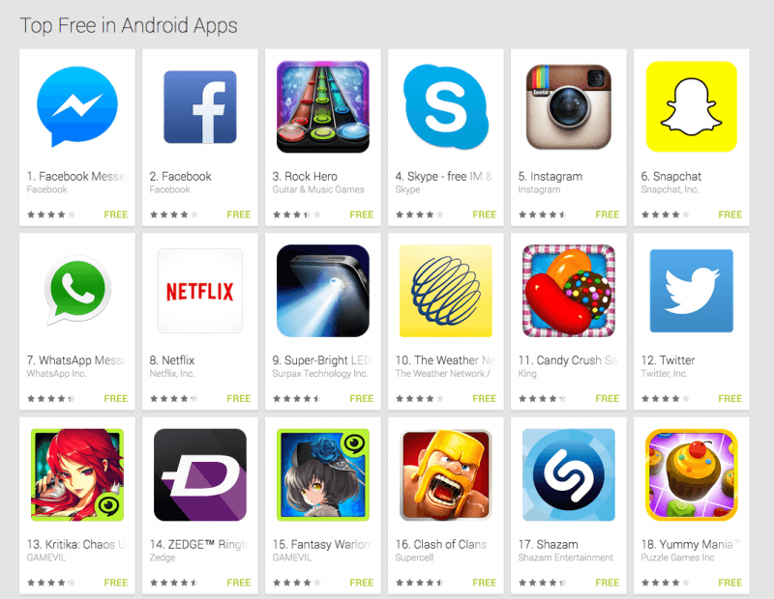**Materials**

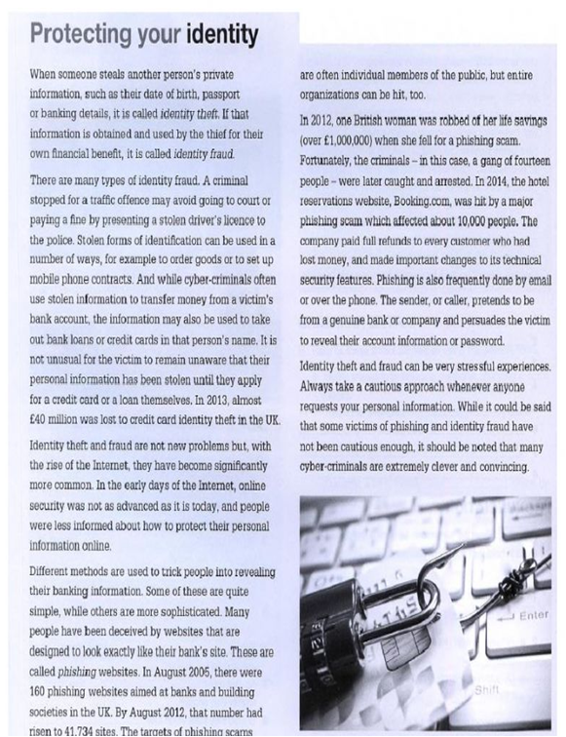

**Taken from** [***https://es.liveworksheets.com/worksheets/en/English_as_a_Second_Language_(ESL)/Passive_voice/Reading_comprehension_and_passive_voice_rp1326052ap***](https://es.liveworksheets.com/worksheets/en/English_as_a_Second_Language_(ESL)/Passive_voice/Reading_comprehension_and_passive_voice_rp1326052ap)

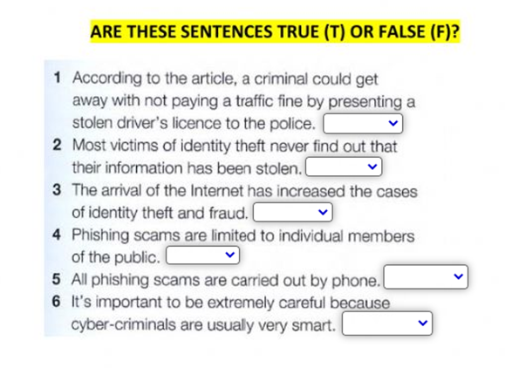

**Taken from** [***https://es.liveworksheets.com/worksheets/en/English_as_a_Second_Language_(ESL)/Passive_voice/Reading_comprehension_and_passive_voice_rp1326052ap***](https://es.liveworksheets.com/worksheets/en/English_as_a_Second_Language_(ESL)/Passive_voice/Reading_comprehension_and_passive_voice_rp1326052ap)

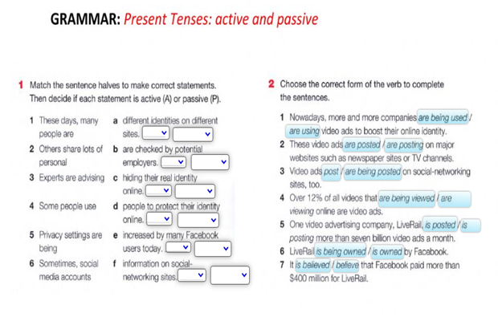

***Taken from https://es.liveworksheets.com/worksheets/en/English_as_a_Second_Language_(ESL)/Passive_voice/Reading_comprehension_and_passive_voice_rp1326052ap***

**Topic Boosters**



**Didactic Planning**

**Week # 2**

|  |  |  |  |  |  |  |  |  |
| --- | --- | --- | --- | --- | --- | --- | --- | --- |
| **Level: 10th** | | | | | **Unit: 5** | | | |
| **Domain:** | | | **Scenario: #High Tech High Touch** | | | **Theme: Danger Zones in a Digital World** | | |
| **Enduring Understanding**: Technology is a powerful tool and, in the right hands, it can make the world a better or worse place.  **Essential Question: How can technology help me make my world better?** | | | | | | | | |
| |  |  |  |  |  | | --- | --- | --- | --- | --- | | |  | | --- | | **General Competences** | | **Responsible Citizenship ( )** | | **Life Competences ( )** | | **Competences for Employability ( )** | | | | | | | | | | |
| **Learn to Know** | | | **Learn to Do** | | | **Learn to Be and Live in Community** | | |
| **Grammar & Sentence Frames** Present Perfect ContinuousI have been using **Facebook. You should too.**You have been looking **for a new video game to play. What do you suggest?**Present PerfectI have used **Instagram but I don’t really like it.** **We** have purchased **a new computer. I think it’s much faster.**The class has watched **YouTube videos to learn English. I like it when we do that.** **Vocabulary**  Danger Zones in a Digital World   * Virus, spam, Risks of the digital world: cyber-bullying, identity theft, hacking, copyright infringement, plagiarism | | | **Function**  Giving directions and advice about Danger Zones in a Digital World  **Discourse Markers** **Connectors****(Cause and effect)**I think/I believe that people share too much information online.I think my cell phone is more than a phone, so I should get to use it in class. Apps make life easier; therefore, I try to keep up with the latest versions, so: because, consequently, for this reason | | | **Psycho-social**   * Being aware of the ethical responsibility when up or downloading data from the web.   **Sociocultural**   * Practicing e-safety and ethical digital regulations. * Being socially creatively, and reflectively. responsible when interacting with others digitally * Respecting everyone's opinions. | | |
| **Assessment Strategies & indicators of learning**  (Diagnostic, formative, summative) | **Learner can** | **Didactic Sequence Mediation** | | | | | | **Time** Total:  200 min (5 lessons) |
| **L.2.**recognizes when people speak at normal speed on familiar topics. There may be a need to repeat particular words and phrases.  Indicators of learning  Identifies the topic when people speak at normal speed on familiar topics.  Distinguishes key points when people speak at normal speed on familiar topics.  **R.3.** interprets clear, simple instructions with some visual support (e.g., how to use an app).  Indicators of learning  Identifies specific clear, simple instructions with some visual support (e.g., how to use an app).  Gets the meaning of specific clear, simple instructions (e.g., how to use an app). by using context clues and illustrations.  **SI.1.** ask questions about procedures.  Indicators of learning  Plans a set of yes/no and wh- questions to ask questions about procedures.  Uses yes/no and wh- questions to ask about procedures. | **L.2.** understand when people speak at normal speed on familiar topics. There may be a need to repeat particular words and phrases.  **R.3.** understand clear, simple instructions with some visual support (e.g., how to use an app).  **SI.1**. asks questions about procedures. | **Pre-teaching**  **Routine:** Checking attendance, checking in with Ls, T posts the Essential Question on the board, Can Do’s, and class agenda, etc.  **Participating: Warm up**  T and Ls participate in an activity called: “Close-up pictures.” This activity is great for speculative language. T shows the learners some very close-up pictures that he/she took with his/her smartphone. This can be done very quickly by going into the classroom or looking around the teacher’s desk and taking very, very close-up pictures of different objects (technological devices). After that, T shows them to the students and asks them to guess what they are. Another way to do this, it is displaying these pictures using a projector, or pasting the pictures on the board. The idea is to take close-up photos, so that learners have difficulty recognizing them.  Example: What is this? The students try to guess what the name of the device is.  http://learningtechnologiesineap.org/wp-content/uploads/2014/04/20140313_093051.jpg  **Engaging**  **Activation of prior knowledge:** Once finished the warm-up activity, T shows Ls some pictures related to Danger Zones in a Digital World. (Cyberbullying—identity theft—hacking—copyright—infringement—plagiarism—sexual abuse—exploitation of children and young people—virus—spam, etc.) T shows the pictures without words, so T gives a paper with the vocabulary of each picture and learners match the picture with the words or phrase. Learners can use the following sentence frame to guess the name of each picture. Example: I think this picture shows cyberbullying because…  **Introducing**  T will show a PPT about the grammar structure of Present Perfect Continuous. First of all, T shows sentences expressing some situations they can see or live when browsing in social networking sites.  Example:   * -I **have been using** Facebook lately, and **I have been noticing** that most of my contacts are not my friends. * -My mom told me yesterday that, **I have been chatting** with friends a lot. As a consequence, she will allow me to use my cellphone just one hour a day. * -Recently, many cases of cyberbullying **have been occurring** on social networks, so if that happens to us or someone we know, do not hesitate to report it.   T explains the use and structure of the Present Perfect Continuous. (Affirmative and Negative Statements, Yes/No questions, and Wh-questions) with examples in context and to the theme and vocabulary for this unit.  Finally, T gives learners an envelope with some paper strips with different parts of sentences.  Teacher asks learners to organize them and form sentences using the present perfect continuous form. When learners finish, they will read the sentences to the rest of the group out loud.  **Pre-listening**  T asks learners if they know about the impact that technology has been having on human beings, especially on teenagers. T says that it could be pros and cons of technology. T brainstorms learners’ ideas on the board.  **Listening for the first time**  T plays learners a video called Negative Effects of Technology on Teens.  <https://youtu.be/wVqfu8qynvo>  Then, learners listen to it very carefully and at the end of the video they will write down what the video is about.  **Pair/Group feedback**  T asks learners to work in pairs and comment on the content of video. Learners help each other if finding difficulties to solve the exercise or problems understanding vocabulary words.  **Listening for the second time**  Learners listen to the video once again, and write notes of details, words and phrases that they recognize most while listening. Learners share to the rest of the group the notes they wrote while listening to the video.   1. How was life in the past without technology? 2. What problems do teens face nowadays because of technology?   **Post-listening**  T writes some questions on the board. Then, learners mingle to ask other classmates about what they think regarding technology and based on what they saw in the video.   1. What positive aspects can you mention about technology? 2. What negative aspects can you mention about technology? 3. Have you been facing any digital danger lately?   **Pre-reading**  T gives Ls a list of useful key vocabulary related to the topic. (sitcom—advertisements—thriller—website—browser—blogs—hackers—stalkers—influencers—cyberbullying—identity theft—spam—virus—apps—social networks—infringement—copyright—plagiarism, etc.) Once learners write the vocabulary on their notebooks, following teacher instructions, they will use the Merriam Webster free application to find out the English meaning of the previous key vocabulary from the unit. While learners write the meaning of the words in English, they will read meaning by meaning silently, the idea is that they recognize the connotation of the words while reading.  **Reading for the first time**  Ls work in pairs and read a wiki called, <https://www.wikihow.com/Use-WhatsApp> for first time by scrolling up and down. They highlight the following typographical clues: tittle, subtitles and words in bold. After that, they list the instructions on how to use WhatsApp.  **Pair/Group feedback**  T asks learners to work in pairs and comment on the content of the wiki. Learners help each other when finding difficulties to understand instructions.  **Reading for the second time**  Ls read the wiki again, then answer the following questions.   1. What is the first step you should follow to install WhatsApp on your cell phone? 2. After tapping the button agree and continue on your screen, what comes next? 3. How can you enter your name and a photo? 4. How can you create a chat?   **Post-reading**  Learners discuss the following questions with their classmates and share their opinions with the rest of the class.   1. What do you think about WhatsApp? 2. How many times a day do you chat on WhatsApp? 3. What kind of information do you post on a WhatsApp status? 4. Do you think it is good for you to post everything that happens to you on WhatsApp? 5. Have you seen cyberbullying is your WhatsApp chats? 6. Comment on some good practices to protect your privacy online.   **Planning/Organizing.**  **Task:** Ronald has been working hard during the past days. He wants to quickly send and receive WhatsApp messages and documents by using WhatsApp Web right from his desktop computer. He doesn’t know how to set up WhatsApp Web on his computer, so he decided to ask one of his coworkers for help.  Learners plan a set of a possible list of yes/no and wh- questions by using next template including sequence words such first, then, next, finally.     |  |  | | --- | --- | | **Planning questions to ask about the steps to follow to install WhatsApp Web** | | | **YES/NO QUESTIONS** | **WH- QUESTIONS** | |  |  | |  |  | |  |  | |  |  |   **Rehearsing**  In pairs, learners take turns asking each other the questions they planned before. They help each other clarifying structures, difficulties with pronunciation ensuring equal support.  **Interacting**  In small groups, learners perform interviews using the questions they planned and rehearsed before. They take notes of their classmates’ answers. Finally, they participate in whole group discussion. | | | | | | 5 min  15 min  20 min  45 min  50 min  60 min |
| **Integrated Mini-Project** | | | | | | | | **Time** |
| Allow time for the Mini-Project each week. NOTE: All phases of the Integrated Mini-Project should be opportunities for Ls to practice English, not just those related to presentation.  **Participating:** (5 or 10 minutes in week 1 or 2)  **Possible projects:**   * Own app, explaining what it will do, how it will work, what it will look like. * Giving own opinions/ answers to the Essential Question of the unit, using available technology or posters/paper. | | | | | | | | Adjust previous times listed above to allow 5 min each week.  Group presentations can be week 5 or 6. |
| **Reflective Teaching** | | | | | | | | |
| What worked well | | | | What didn’t work well | | | How to improve | |
| **Enduring Understanding Reflection**  How well did the learners progress in their understanding of the Enduring Understanding? | | | | | | | | |
| **Week Plan Self-Assessment** | | | | | | | | |
| At the end of the week, T guides the learners to check their progress using the checklist below. (Can be translated into Spanish if needed to ensure Ls’ understanding.)   |  |  |  |  | | --- | --- | --- | --- | | ***Learner Self-Assessment*** | | | | | ***I can…*** | ***Yes*** | ***In progress*** | ***No*** | | identify the topic when people speak at normal speed on familiar topics. |  |  |  | | distinguish key points when people speak at normal speed on familiar topics. |  |  |  | | identify specific clear, simple instructions with some visual support (e.g., how to use an app). |  |  |  | | get the meaning of specific clear, simple instructions (e.g., how to use an app). by using context clues and illustrations |  |  |  | | plan a set of yes/no and wh- questions to ask questions about procedures. |  |  |  | | use yes/no and wh- questions to ask about procedures. |  |  |  | | | | | | | | | |

**Didactic Planning**

**Week # 3**

|  |  |  |  |  |  |  |  |  |  |
| --- | --- | --- | --- | --- | --- | --- | --- | --- | --- |
| **Level: 10th** | | | | | | **Unit: 5** | | | |
| **Domain:** Socio-Interpersonal | | | | **Scenario: #High-tech High Touch** | | | **Theme:** Tech Tools for Positive Change | | |
| **Enduring Understanding**: Technology is a powerful tool, and, in the right hands, it can make the world a better or worse place.  **Essential Question:** How can technology help me make my world better? | | | | | | | | | |
| |  |  |  |  |  | | --- | --- | --- | --- | --- | | |  | | --- | | **General Competences** | | **Responsible Citizenship ( )** | | **Life Competences ( )** | | **Competences for Employability ( )** | | | | | | | | | | | |
| **Learn to Know** | | | | **Learn to Do** | | | **Learn to Be and Live in Community** | | |
| **Grammar & Sentence Frames**  Noun Phrases   * __Mary___ needs to know (math, science, logic, etc.) so he/she can____. (Job function) * (software engineers, systems analysts, web developers, graphic designers)   First conditional   * If I were you, I would be aware of (cyberbullying, identity theft, online predators, * hacking, copyright infringement, plagiarism)   **Vocabulary**  Tech Tools for Positive Change  Social network**,** website, sites, storyboard, Audacity, Google, Dropbox, YouTube Prezi, moviemaker, | | | | **Function**  Describing tech tools for positive changes in people´s lives.  **Discourse Markers** Connectors(Cause and effect)I think/I believe that people share too much information online.I think my cell phone is more than a phone, so I should get to use it in class. Apps make life easier; therefore, I try to keep up with the latest versions, so: because, consequently, for this reason | | | **Psychosocial**   * Thinking critically when searching and visiting websites.   **Sociocultural**   * Practicing e-safety and ethical digital regulations.   Being socially creatively, and reflectively. | | |
| **Assessment Strategies & indicators of learning**  (Diagnostic, formative, summative) | **Learner can** | **Didactic Sequence Mediation** | | | | | | | **Time** Total:  200 min (5 lessons) |
| **SI.2.** starts, sustains and closes a conversational exchange with a peer in the classroom when the topic is familiar.  Indicators of learning  Starts a conversation using greetings.  Keeps a face-to-face conversation going about social networks at work.  Continues with the conversation about social networks at work.  Asks for agreement and disagreement in given statements about social networks at work.  Answers questions about social networks at work.  .  Closes the conversation about social networks at work.  **SP.1.** expresses opinions and asks for others’ opinions about the digital world.  Indicators of learning  Plans the language and content to give opinions about the digital world.  .  Makes sentences to give opinions about the digital world.  Expresses ideas to give opinions about the digital world.  **W.1**. summarizes simple text dealing with familiar subjects.  Indicators of learning  Prewrites important details about a simple text dealing with familiar subjects.  Drafts a summary with important details about simple text dealing with familiar subjects.  Revises a summary with important details about simple text dealing with familiar subjects by checking subject-verb agreement, pronoun and article agreement, capitalization, indentation, sentence sense, text structure, word order, punctuation and content.  Edits the summary with important details about simple text dealing with familiar subjects before publishing. | **SI.2.** sustain a conversational exchange with a peer in the classroom when the topic is familiar, though there may be some difficulty in understanding and being understood from time to time.  **SP.1.** expresses opinions and asks for others’ opinions about the digital world.  **W.1.** summarize simple text dealing with familiar subjects. | | **Pre-teaching**  Routine: Checking attendance, checking in with Ls, T posts the Essential Question on the board, Can Do’s, and class agenda, etc.  **Participating: Warm up**  T shows some pictures about different tech tools (see Resources Section) and give learners different descriptions about them. Then, Ls match pictures with the corresponding description.  **Engaging: Activation of prior knowledge**  In groups, learners discuss about the most popular tech tools.   * What is your favorite tech tool? * How often do you use your favorite tech tool? * What is the main advantage of your favorite tech tool?   Then, they fill the blanks with the names of each tech tool by looking at the pictures.  A screenshot of a computer  Description automatically generated    **Introducing**  T gives a worksheet with different tech tools. Learners match the tool with the corresponding description.    After that, T explains the grammar aspect related to noun phrases by using the chart below and then models some sentences combining noun phrases and the previous vocabulary. See examples.      **Taken from: ESL.COM.**  Examples:   * A fully equipped 3d printer is on sale. * An ultra MicroSDXC UHS-I Memory Card combines great photo capabilities with faster transfer speed. * A wide selection of tablets is promoted for black Friday.   Finally, learners get in groups of three and write sentences using the vocabulary from the second column.  **Task:** The use of social networks within a company or an organization has the potential to make a great difference. An organization intends to improve employees’ interactions. Imagine that you work in this organization and you are having meeting in which you have to make decisions regarding the implementation of social networking strategies. So, you decided to get informed before the meeting.  **Planning & Organizing.**  Read the article, take notes, and write some questions about the benefits of social networking related to what read in the article 5 Benefits of Social Networks at Work.    [**https://workology.com/5-benefits-of-social-networks-at-work/#:~:text=The%20use%20of%20internal%20social,and%20what%20makes%20them%20tick**](https://workology.com/5-benefits-of-social-networks-at-work/#:~:text=The%20use%20of%20internal%20social,and%20what%20makes%20them%20tick)  T writes the following questions on the board.   1. What exactly is networking? What is the difference between networking and social networking? 2. Which social networking sites / tools have you heard of? Which have you used? Which would you recommend? 3. What is the relationship between social networking and face-to-face socializing? 4. Do you see social networking as something you do for work or for pleasure? 5. What can you do to get the most out of social networking for work?   **Rehearsing**  In pairs, learners take turns asking each other the questions they planned with the notes they took from the articles. They help each other clarifying structures, difficulties with pronunciation ensuring equal support. They ask for agreement or disagreement about the shared ideas.  **Interacting**  Students discuss the questions in small groups. After a few minutes. T opens up the discussion to include the whole class. Learners read the blog post (Kim´s blog) <https://www.teachingenglish.org.uk/sites/teacheng/files/Socialising%203_Social%20networking_worksheets.pdf> to share additional ideas.  **Planning &Organizing**  T asks students the types of technology they have used today. Then, T asks to students to list the positive and negative aspects of technology. T writes what Ls said on the board.  Then, T asks to students to listen to the audio on <https://www.teachingenglish.org.uk/article/technology> to expand their ideas about technology. After that, T posts three questions and Ls need to choose one in order to do an oral presentation about one of them.   1. If you could uninvent any piece of technology, what would it be and why? 2. What’s the most important piece of technology in your life? 3. What piece of technology has had the most impact on society?   (Question from: Derek Spafford, <https://www.teachingenglish.org.uk/sites/teacheng/files/loveandhate-technology_Activities_Answers_Final.pdf>)  Once, they have chosen one of the questions. They work individually to create an outline and do some research for a three-minute presentation.  **Rehearsing**  Ls work in pairs to rehearse the presentations they designed before and to put into practice peer feedback to improve any detail from the presentation.  **Producing (Giving opinions)**  Ls share the presentation and ask others for their opinions about the ideas presented.  **Task**: This year, learners are studying using a blended modality, some days school and others at home. You consider teachers can encourage interactions at school and help each other in this new way of teaching and learning. So, you decided to talk to the principal to give some recommendations about it. But before going the principal’s office, you did some research on social networks and their benefits.  **Prewriting**  After reading different articles, learners make a list of the benefits to promote social networks at school.  **Drafting**  Learners start writing their summary with the ideas, important details and the appropriate linkers or connecting words.  **Revising**  In teams, learners share their summaries. Each group checks summaries using the following checklist:  **Revising**   |  |  |  |  | | --- | --- | --- | --- | | **Checklist** | | | | | The summary …. | Yes | No | Partially | | is well – capitalized. |  |  |  | | ‘s verbs match with the subject. |  |  |  | | is indented. |  |  |  | | has clear sentences. |  |  |  | | fulfills the requirements (information) asked in the task. |  |  |  | | has punctuation marks correctly used. |  |  |  |   **Editing**  Considering their classmates’ feedback, learners correct and modify their summary. Teacher also monitors students and helps them in the editing process.  **Publishing**  Learners write their definite summary. Finally, they paste their work on the wall and learners walk around the classroom to read each summary like in a gallery walk. | | | | | | 5 minutes  10 minutes  10 minutes  40 minutes  50 minutes  45 minutes  40 minutes |
| **Integrated Mini-Project** | | | | | | | | | **Time** |
| Allow time for the Mini-Project each week. NOTE: All phases of the Integrated Mini-Project should be opportunities for Ls to practice English, not just those related to presentation.  **Thinking:** (5 or 10 minutes in week 3)  **Possible projects:**   * Own app, explaining what it will do, how it will work, what it will look like. * Giving own opinions/ answers to the Essential Question of the unit, using available technology or posters/paper. | | | | | | | | | Adjust previous times listed above to allow 5 min each week.  Group presentations can be week 5 or 6. |
| **Reflective Teaching** | | | | | | | | | |
| What worked well | | | | | What didn’t work well | | | How to improve | |
| **Enduring Understanding Reflection**  How well did the learners progress in their understanding of the Enduring Understanding? | | | | | | | | | |
| **Week Plan Self-Assessment** | | | | | | | | | |
| At the end of the week, T guides the learners to check their progress using the checklist below. (Can be translated into Spanish if needed to ensure Ls’ understanding.)   |  |  |  |  | | --- | --- | --- | --- | | ***Learner Self-Assessment*** | | | | | ***I can…*** | ***Yes*** | ***In progress*** | ***No*** | | start a conversation using greetings. |  |  |  | | Keep a face-to-face conversation going about social networks at work. |  |  |  | | continue with the conversation about social networks at work. |  |  |  | | ask for agreement and disagreement in given statements about social networks at work. |  |  |  | | answer questions about agreement and disagreement in given statements about social networks at work. |  |  |  | | close the conversation about social networks at work. |  |  |  | | plan the language and content to give opinions about the digital world. |  |  |  | | make sentences to give opinions about the digital world. |  |  |  | | express ideas to give opinions about the digital world. |  |  |  | | prewrite important details about a simple text dealing with familiar subjects. |  |  |  | | draft a summary with important details about simple text dealing with familiar subjects. |  |  |  | | revise a summary with important details about simple text dealing with familiar subjects by checking subject-verb agreement, pronoun and article agreement, capitalization, indentation, sentence sense, text structure, word order, punctuation and content. |  |  |  | | edit the summary with important details about simple text dealing with familiar subjects before publishing. |  |  |  | | | | | | | | | | |

**WARM UP**



**STORYBOARD**

**SOCIAL NETWORK**



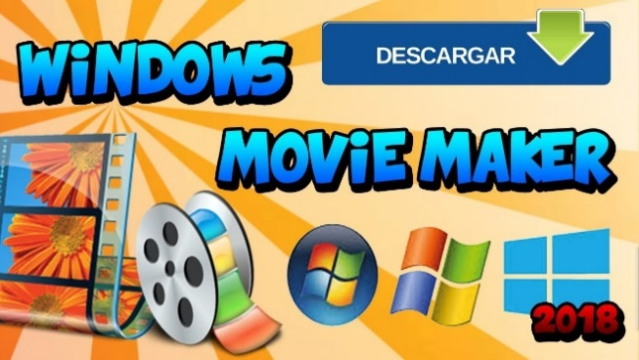

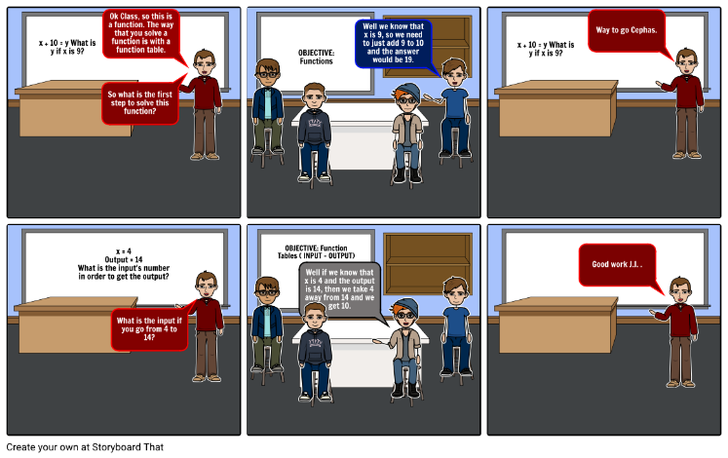

|  |  |  |  |  |  |  |
| --- | --- | --- | --- | --- | --- | --- |
| To use the Google search engine to obtain information about (someone or something) on the World Wide Web. | It is the video editing program that is included with Windows XP.  It allows you to quickly build a personalized movie that incorporates video, still images, background music, and narration. | It is a sequence of drawings, typically with some directions and dialogue, representing the shots planned for a movie or television production. | Upload a video of (someone or something) to the video-sharing website.   * Search for or watch on this video website | It is a dedicated website or other application which enables users to communicate with each other by posting information, comments, messages, images, etc. | It is a location connected to the Internet that maintains one or more pages on the World Wide Web | It is a presentation tool that can be used as an alternative to traditional slide making programs such as PowerPoint. Instead of slides, **it** makes use of one large canvas that allows you to pan and zoom to various parts of the canvas and emphasize the ideas presented there. |



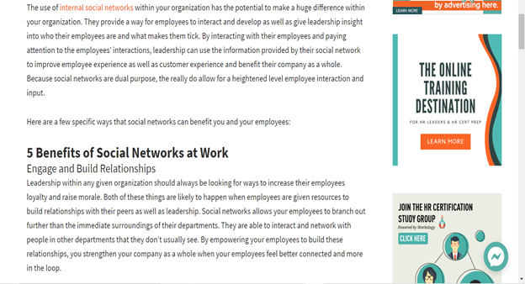

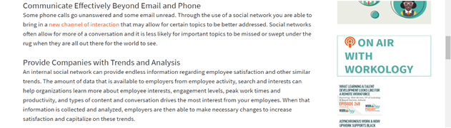

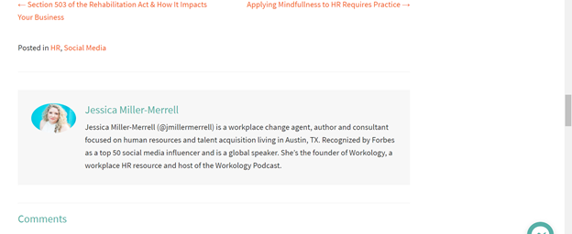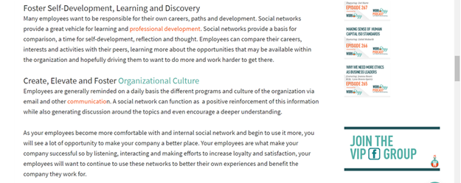

**WRITTEN COMPREHENSION**

|  |  |  |  |
| --- | --- | --- | --- |
| **Checklist** | | | |
| The summary …. | Yes | No | Partially |
| is well – capitalized. |  |  |  |
| ‘s verbs match with the subject. |  |  |  |
| is indented. |  |  |  |
| has clear sentences. |  |  |  |
| fulfills the requirements (information) asked in the task. |  |  |  |
| has punctuation marks correctly used. |  |  |  |

|  |  |  |  |
| --- | --- | --- | --- |
| **Checklist** | | | |
| The summary …. | Yes | No | Partially |
| is well – capitalized. |  |  |  |
| ‘s verbs match with the subject. |  |  |  |
| is indented. |  |  |  |
| has clear sentences. |  |  |  |
| fulfills the requirements (information) asked in the task. |  |  |  |
| has punctuation marks correctly used. |  |  |  |

**Didactic Planning**

**Week # 4**

|  |  |  |  |  |  |  |
| --- | --- | --- | --- | --- | --- | --- |
| **Level: 10th** | | | | **Unit: 5** | | |
| **Domain:** Socio-Interpersonal | | | **Scenario: #HighTech HighTouch** | | **Theme:** My Future is in My Hands | |
| **Enduring Understanding**: Technology is a powerful tool and, in the right hands, it can make the world a better or worse place.  **Essential Question:** How can technology help me make my world better? | | | | | | |
| |  |  |  |  |  | | --- | --- | --- | --- | --- | | |  | | --- | | **General Competences** | | **Responsible Citizenship ( )** | | **Life Competences ( )** | | **Competences for Employability ( )** | | | | | | | | |
| **Learn to Know** | | | **Learn to Do** | | **Learn to Be and Live in Community** | |
| **Grammar & Sentence Frames**  First conditional   * If I were you, I would be aware of (cyberbullying, identity theft, online predators, hacking, copyright infringement, plagiarism)   **Vocabulary**  My Future is in My Hands   * Technology to improve life not only within a career or profession. * Software engineers, systems analysts, web developers, graphic designers * Instagram, Facebook, Twitter, Snapchat | | | **Function**  Expressing opinions about how my future is in my hands.  **Discourse Markers** Connectors(Cause and effect)I think/I believe that people share too much information online.I think my cell phone is more than a phone, so I should get to use it in class.Apps make life easier; therefore, I try to keep up with the latest versions, so: because, consequently, for this reason | | **Psychosocial**   * Being aware of the ethical responsibility when up or downloading data from the web. * Thinking critically when searching and visiting websites.   **Sociocultural**   * Being socially creatively, and reflectively. responsible when interacting with others digitally * Respecting everyone's opinions. | |
| **Assessment Strategies & indicators of learning**  (Diagnostic, formative, summative) | **Learner can** | **Didactic Sequence Mediation** | | | | **Time** Total:  200 min (5 lessons) |
|  |  | **Pre-teaching**  **Routine:** Checking attendance, checking in with Ls, T posts the Essential Question on the board, Can Do’s, and class agenda, etc.  **Participating: Warm up**:  T begins the class by showing some printed famous Apps icons. Then, T asks learners some questions:   * Do you recognize this App icon? * What is this App used for?   Resultado de imagen para Apps icons  **Engaging: Activation of prior knowledge**  T writes the essential question “How can technology help me make my world better? on the board and then he makes a three-column chart to describe the advantages and disadvantages of technology/ social networks such as Instagram, Facebook, Twitter or Snapchat. Learners can use the following charts with sentences and sample ideas to express opinions:   |  | | --- | | EXPRESSING OPINIONS | | 1. *In my* ***opinion****, ... In my eyes, ...* 2. *To my mind, ... As far as I am concerned, ... ...* 3. *From my point of view, ... As for me / As to me, ...* 4. *My view /* ***opinion*** */ belief / impression / conviction is that ... ...* 5. *I would* ***say*** *that ... ...* 6. *My impression is that ... ...* 7. *I have the feeling that ... ...* 8. *I have no doubt that ...* |  |  |  | | --- | --- | | **Advantages of __________** | **Disadvantages of ___________** | | I would say that apps make life easier. | As far as I know, apps can be a distractor when you have to study or work. | | My impression is that Facebook is a way to be in contact with friends you usually do not share time with. | I think Facebook pictures or information can be used by third parties to commit a crime such scams. | | I have no doubt that reaches a large number of people quickly through tweets and retweets. | In my opinion, Twitter is additive. |   **Introducing:**  T shows some pictures of different professions or careers and learners describe them by using different adjectives. For example: T pastes the pictures on the board and learners go to the whiteboard and write the possible characteristics or skills that are required to be a professional/ specialist in a career. For example, you can observe the picture below to get an idea.  infografic  ***C:\Users\Luis Calderon\Downloads\Animated Grammar GuidesNoun Phrases.png*Picture taken from** <https://careerkarma.com/careers/software-engineer>  T writes a list of professions or careers and writes noun phrases by using the previous adjectives. Ls watch a video called “” in the following link taken from <https://www.youtube.com/watch?v=RaSqg8vdxn0> to improve their writing skills while writing noun phrases  .  **For example**: Problem solving skills are required for software engineers.   |  |  | | --- | --- | | **CONNECTORS OF CAUSE AND EFFECT** | | | **Subordinating**  **Conjunctions** | The most important conjunctions are because, as, since, and so. “Because”, “as”, and “since” introduce a **cause**; “so” introduces an **effect**. ... | | **Transitions** | The most important transitions are **therefore**, **consequently**, and **as a result**. ... to give an effect. | | **Prepositions** | The most important prepositions are **due to** and **because of** usedfor causes. | | | | | 5 min  10 min  30 min  20 min |
| **SP.2.** gives explanations and justifications on points of view, briefly.  Indicators of learning  Plans the language, content and resources to explain in a well-organized presentation his/her a software company.  Makes sentences to explain his/her software company briefly in a well-organized presentation.  Expresses ideas to explain his/her software company in a well-organized presentation. | **SP.2.** explain and justify points of view, briefly, about the digital world. | **Planning**  The class is divided into 4 groups. Each group will create a software company. Each group will describe the company considering the following aspects:    <https://smallbusiness.patriotsoftware.com/how-to-write-company-description-business-plan/>  Once the company is created, learners will imagine they will participate in a fair in which they have to present their company to find sponsors and budget to support their business. Learners will explain and justify the reasons why their company is unique and deserves to be supported. One of the company´s main advantages is the skills of their software engineers in charge of creating their products and give services.  **Organizing**  Learners select the appropriate oral and visual forms to share the information they planned before in a well-organized presentation using relevant sentence frames and connecting words covered in the unit.  **Rehearsing**  Learners practice with the oral and visual forms prepared before. T helps them by giving feedback correcting mistakes like grammar, vocabulary, pronunciation, and intonation among others.  C:\Users\Luis Calderon\Downloads\Introduction to Stress and Intonation - English with Jennifer.png  Learners can watch the following video called “Introduction to Stress and Intonation - English with Jennifer” in the following link taken from <https://www.youtube.com/watch?v=kIapQVNq3D4> T can also use the QR code on the right side. Based on the information provided in the video, the Learners use stress and intonation patterns in their presentation.  **Producing**  Each group gives a well–organized presentation to the rest of the group. At the end of the presentations, T asks students for personal experiences and challenges to create a company and the take- away from this experience. | | | | 60 min |
| **W.2.** writes expository paragraphs about tech tools (e.g., apps, video games, programs, tech tools), using complete sentences that are connected to each other.  Indicators of learning  Collects information about mobile hot apps.  Writes sequential and logical ideas about mobile a hot app that includes an introductory, main body and concluding paragraph.  Revises paragraph.  .  Edits his/her draft about a mobile hot app before publishing. | **W.2**. describe applications or tech tools (e.g., apps, video games, programs, tech tools) using | **Task:** You are in charge of the technology section of your school digital newspaper. Write a review of a mobile hot app that was released recently. Include an introduction (topic sentence), a body with information on how to use the app, main features (speed, image, security, search options, notifications, user feedback, and updates), popular use cases, and a conclusion.  **Prewriting**  Learners collect information in a chart about applications or tech tools. They complete the following chart to organize their ideas.   |  |  | | --- | --- | | **Ideas** | **App** | | How to use the app |  | | A list of main features(speed, image, security, search options, notifications, user feedback and updates) |  | | A list of popular use cases |  | | User reviews or quotes |  |   **Drafting**  Learners write their production that includes introductory, main body and concluding paragraphs.  **Revising**    Then, each learner shares his/her paragraph with another classmate and he/she checks it using the following checklist.   |  |  |  |  | | --- | --- | --- | --- | | **Editing Checklist** | | | | | The expository paragraph | Yes | No | Partially | | is well capitalized. |  |  |  | | ‘s verbs match with the subject. |  |  |  | | has an introduction |  |  |  | | has a main body of well sequenced ideas |  |  |  | | has a conclusion. |  |  |  | | is indented. |  |  |  | | has clear sentences. |  |  |  | | fulfills with the information asked in the task. |  |  |  | | has punctuation marks correctly used. |  |  |  |   **Editing**  Considering their classmates’ feedback, learners correct and modify their paragraph. Teacher also monitors students and helps them in the editing process before publishing. | | | | 60 min |

|  |  |  |  |
| --- | --- | --- | --- |
| **Integrated Mini-Project** | | | **Time** |
| Allow time for the Mini-Project each week. NOTE: All phases of the Integrated Mini-Project should be opportunities for Ls to practice English, not just those related to presentation.  **Acting out and responding:** (5 or 10 minutes in week 3 or 4)  **Possible projects:**   * Own app, explaining what it will do, how it will work, what it will look like. * Giving own opinions/ answers to the Essential Question of the unit, using available technology or posters/paper. | | | Adjust previous times listed above to allow 5 min each week.  Group presentations can be in week 5 or 6. |
| **Reflective Teaching** | | | |
| What worked well | What didn’t work well | How to improve | |
| **Enduring Understanding Reflection**  How well did the learners progress in their understanding of the Enduring Understanding? | | | |

|  |
| --- |
| **Week Plan Self-Assessment** |
| At the end of the week, T guides the learners to check their progress using the checklist below. (Can be translated into Spanish if needed to ensure Ls’ understanding.)   |  |  |  |  | | --- | --- | --- | --- | | ***Learner Self-Assessment*** | | | | | ***I can…*** | ***Yes*** | ***In progress*** | ***No*** | | plan the language, content and resources to explain in a well-organized presentation his/her a software company. |  |  |  | | make sentences to explain his/her software company briefly in a well-organized presentation. |  |  |  | | express ideas to explain his/her software company in a well-organized presentation. |  |  |  | | collect information about mobile hot apps. |  |  |  | | write sequential and logical ideas about mobile a hot app that includes an introductory, main body and concluding paragraph. |  |  |  | | revise paragraph. |  |  |  | | edit his/her draft about a mobile hot app before publishing. |  |  |  | |

**Weeks 5 and 6**

**Review and Integrated Mini-Project**

|  |  |  |  |  |  |  |
| --- | --- | --- | --- | --- | --- | --- |
| **Level: 10th** | | | | **Unit: 5** | | |
| **Enduring Understanding**: Technology is a powerful tool and, in the right hands, it can make the world a better or worse place.  **Essential Question:** How can technology help me make my world better? | | | | | | |
| |  |  |  |  |  |  | | --- | --- | --- | --- | --- | --- | | |  |  |  |  |  | | --- | --- | --- | --- | --- | | |  | | --- | | **General Competences** | | **Responsible Citizenship ( )** | | **Life Competences ( )** | | **Competences for Employability ( )** | | | | | | | | | |
| **Learn to Know** | | | **Learn to Do** | | **Learn to Be and Live in Community** | |
| **Grammar & Sentence Frame**   * Did Ls use all sentence frames?   **Vocabulary**   * Did Ls say aloud and write all vocabulary?   **Phonology**   * Did Ls recognize, articulate and produce phonological sounds? | | | **Function**   * Did Ls use all functions?   **Discourse Markers**   * Did Ls practice connecting words: and, but, because? | | **Psychosocial**   * Did Ls show evidence of … * Being aware and committed to protecting the environment * Appreciating natural wonders   **Sociocultural**   * Did Ls practice idioms and quotes? | |
| **Assessment Strategies & indicators of learning**  (Diagnostic, formative, summative) | **Learner can** | **Didactic Sequence Mediation** | | | | **Time** Total:  200 min (5 lessons) |
| * Did Ls achieve all learning outcomes? | * Can Ls do all tasks? | Referencing notes from formative assessments throughout the weeks, repeat activities to strengthen Ls in weaker areas or select from Optional Activities that follow these plans. | | | | All of week 5 or 6 |
| **Options** | | **Integrated Mini-Project** | | | | **Time** |
| **Possible projects:**   * Own app, explaining what it will do, how it will work, what it will look like. * Giving own opinions/ answers to the Essential Question of the unit, using available technology or posters/paper. | | By allowing time for the Mini-Project each week for participating, thinking, and acting out, learners should now have a chosen project and determined content and strategies. In the presentation week Ls focus on:  **Responding and sharing:** Participating in individual and peer assessment of integrated mini-project.   |  |  |  |  |  | | --- | --- | --- | --- | --- | | ***Integrated Mini-project Self-Assessment*** | | | | | | ***Participating to Negotiate***  I participated by   * sharing my own ideas and interests with my family or classmates * respecting my family or classmates’ opinions, * communicating respectfully * making decisions | | | | | | **A lot**  **5** | **4** | **A little**  **3** | **2** | **Not at all**  **1** | | ***Thinking****:*  I planned by   * looking for information and resources, * thinking of a design for my app/paper /poster * interacting with my classmates. * making decisions | | | | | | **A lot**  **5** | **4** | **A little**  **3** | **2** | **Not at all**  **1** | | ***Acting out:***  I acted out by   * reviewing the information * improving my app/paper /poster design * correcting the information, * rehearsing and working on pronunciation, intonation, fluency and other aspects, | | | | | | **A lot**  **5** | **4** | **A little**  **3** | **2** | **Not at all**  **1** | | ***Responding and Sharing****:*  I can demonstrate I was well prepared in delivering and sharing the information by   * responsibly delivering the project during the virtual / classroom exchange. * answering questions from the audience respectfully. * self-assessing the final product. | | | | | | **A lot**  **5** | **4** | **A little**  **3** | **2** | **Not at all**  **1** |   Teachers monitor ….   * Did Ls use English during all aspects of Integrated Mini-Project? * How didproject presentations reflect understanding and/or mastery of Can Do statements? * Did Ls put into practice the focus of Learn to Be and Live in Community? * Did the Integrated Mini-Project provide answers to the Essential Question? | | | | All of week 5 or 6 of unit |