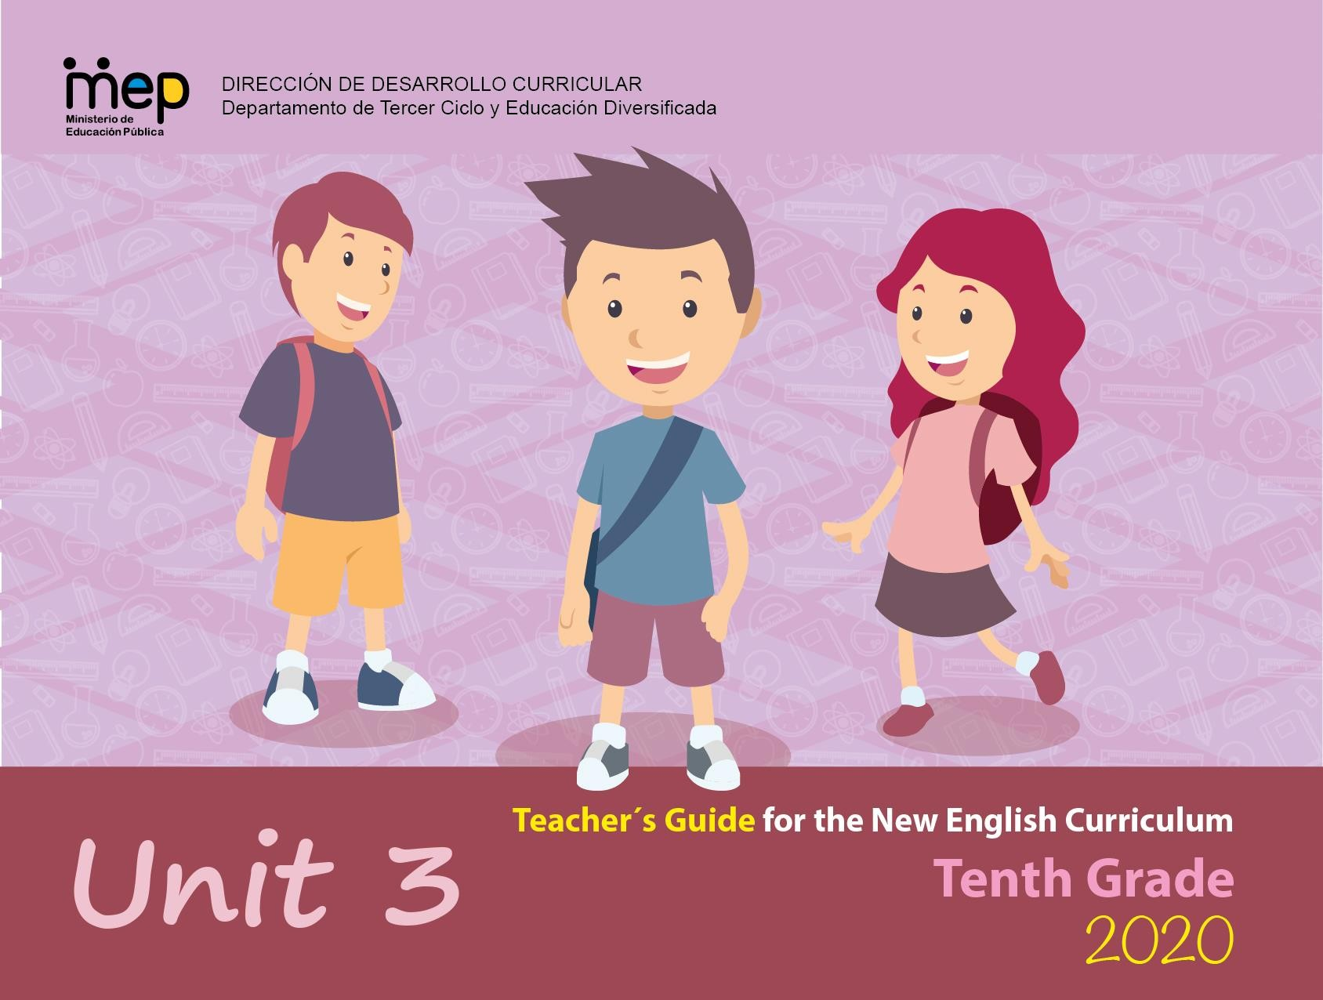

Autoridades

Giselle Cruz Maduro
Ministra de Educación Pública

Melania Brenes Monge
Viceministra Académica de Educación

María Alexandra Ulate Espinoza
Directora de la Dirección de Desarrollo Curricular

Rigoberto Corrales Zúñiga
Jefe del Departamento de Tercer Ciclo y Educación

Comisión redactora

Mag. Marianella Granados Sirias,
Asesora Nacional de Inglés, Departamento de Tercer Ciclo y Educación Diversificada

Mag. Alfredo Ortega Cordero,
Asesor Nacional de Inglés, Departamento de Tercer Ciclo y Educación Diversificada

Mag. Randall Centeno Hernández
Asesor Regional de Inglés, Dirección Regional San José Norte

Edición y construcción

Jason Steelman Peace Corps Response Edición y construcción

Mag. Daniela Barrantes Torres,
Colegio Científico de San Pedro y CNV Braulio Carrillo

Edición y construcción

Marco Brenes López Katherine Williams
Dirección de Recursos Tecnológicos, Diseño de portadas y subida al sitio

Level 10th Unit 3
CEF Level to be Reached B1 Basic User/Independent User
Scenario: A World of Differences
Enduring Understanding |  | The world is made up of diverse people groups who nurture one another.
Essential Question |  | How does understanding people’s differences help us all become better human beings?
General Competences

Responsible Citizenship ( )
Life Competences ( )
Competences for Employability ( )

Assessment and Goals
Week 1 Goals  - understand many television, radio, and web- based broadcasts/ announcements dealing with  subjects of interest if the people talk clearly.  - follow the main idea of audio text if the topic is  familiar and the | Week 1 Assessment  - distinguishes many television, radio, and web- based broadcasts/ announcements.  - extracts main idea of audio texts in many television, radio, and web- | Week 2 Goals  R.1. read textbook explanations and examples with aid of  word list and/or dictionary support.  R.3.  understand many subject specific words when encountered in text (e.g.,  diversity, | Week 2 Assessment  R.1. recognizes textbook explanations and examples.  R.3. interprets  many subject  specific words when encountered in text. | Week 3 Goals  SP.1. express opinions on familiar subjects and ask for others’ opinions.  SP.2. derive interviews from others, if the questions have been prepared beforehand.  Sometimes, can pose a further question without having to pause very long to | Week 3 Assessment  SP.1.  expresses opinions on familiar subjects and ask for others’ opinions.  SP.2. asks question to others if the questions have been prepared beforehand. | Week 4 Goals  SI.2. express opinions about cultural identity and cultural diversity.  W.2 write a simple, short descriptive narrative paragraph of personal experiences on cultural diversity, without using  an aid such as | Week 4 Assessment  SI.2. expresses opinions about cultural identity and c diversity.  W.2.writes a simple, short descriptive narrative paragraph based on real or imagined event related to cultural diversity, including | Week 5/6 Assessment  Anecdotal reports / rubrics / instruments for self and co- assessment  Suggested Integrated Mini project  A survey to gather findings,

text can be replayed.  SI.1. repeat what has been said and convey this  information to another person. | based broadcasts/ announcements.  SI.1. repeats what has been said and convey this information to another person. | culture, cultural norms, stereotypes) to support reading comprehensio n by key words, diagrams and illustrations.  W.1 express what has been learned, how it has been  learned, and learning goals for the future related to cultural  diversity. | W.1. writes completing specific graphic organizers and sentence frames aimed at  monitoring comprehension. | formulate the question.  SP.3. explain  and justify, briefly points of view, assumptions and plans. | SP.3. explains points of view, justifying assumptions, and plans, briefly. | a dictionary, and check it to look for  mistakes (subject-verb agreement, pronoun and article agreement, capitalization, using commas, sentence sense, word  order, text structure, concrete ideas, spelling and basic punctuation, etc.). | characters, plot, and setting. | regarding cultural norms and cliques at their school.  A cultural fair – “A Little Closer to Home” – (similar to what Culture Day is) including various cliques that can be found in their schools and  others. The  key is to encourage representing the groups respectfully and reflecting on the  essential question of the unit.
Phonology

R2. manipulates English language sounds using prior knowledge in phonics, syllabification and word parts.

- Review of sound articulation (7th to 9th) and of phonological features of most unfamiliar words when needed.
- Use of prosodic features (stress, intonation, rhythm) to support the message intended to convey.
- Even though this goal is still linked to reading in Diversified Education, teachers can reinforce it in Spoken Interaction and Spoken Production activities as well.
Theme  1. These Are My People |  | Theme  2. Cultures, Subcultures  and Cliques |  | Theme  3. Cultural Norms and  Cultural Storms |  | Theme  4. I Am Not My Hair*

Function  - Describing people and places, feelings, emotions, and attitudes. | Function  - Expressing opinions,  agreement and disagreement. | Function  - Expressing opinions,  agreement and disagreement.  - Managing interaction (resuming or continuing). | Function  - Expressing opinions,  agreement and disagreement.  - Managing interaction (resuming or continuing).
Discourse Markers  - On the other hand, we could go to the clinic.  - However, this depends on the number of passengers.  Initiating  - Can I talk to you for a minute?  - Excuse me, please. Do you have a minute?  Managing interaction Interrupting  - Sorry to interrupt you but …  - I have a question.  - Could I interrupt here?  Closing  - It´s been nice talking to you. See you later.  - I´m sorry, I have to go now.  - Must go. | Discourse Markers  Changing the topic  - Anyway…, by the way, there´s something else I wanted to tell you…  Resuming a conversation  - Anyway…, anyway, what I was saying?  - What were we talking about?  - To get back to what I was saying  Continuing  - Anyway….  - So, as I was saying  - Well… | Discourse Markers  Changing the topic  - Anyway…, by the way, there´s something else I wanted to tell you…  Resuming a conversation  - Anyway…, anyway, what I was saying?  - What were we talking about?  - To get back to what I was saying  Continuing  - Anyway….  - So, as I was saying  - Well… | Discourse Markers  Changing the topic  - Anyway…, by the way, there´s something else I wanted to tell you…  Resuming a conversation  - Anyway…, anyway, what I was saying?  - What were we talking about?  - To get back to what I was saying  Continuing  - Anyway….  - So, as I was saying Well…
Grammar & Sentence Frames  Broader range of intensifiers such as too, enough | Grammar &Sentence Frames  Contrasting opinions  - On the one hand, different  cultures are very interesting. | Grammar & Sentence Frames  Managing interaction Resuming a conversation  - Anyway, what I was | Grammar & Sentence Frames  Managing interaction Resuming a conversation

- Jocks spend too much time in the gym.  - nerds/ computer lab; pretty girls/looking in the mirror; theater geeks/theater; stoners/inhaling; shy kids/alone)  - I have heard enough racist comments.  Conditionals, 2nd and 3rd  - If we had more understanding, we would get along with other people.  - If I have been born somewhere else, I would have acted differently than I do now.  - If we could make people listen to each other, we might see peace in the world. | On the other hand, different cultures can cause misunderstandings.  - Mind you, he is still very much a citizen of Costa Rica.  - All societies have cultural norms. Even though norms influence our values, attitudes, and how we behave, we are often unaware that we are influenced at all.  Wh- questions in the past  - What clique are you a part of?  - What are some cultural norms that Costa Ricans have?  - What makes a Costa Rican Costa Rican?  − | saying?  - What were we talking about?  - To get back to what I was saying  Continuing  - Anyway….  - So, as I was saying  - Okay  Expressing agreement/ disagreement  - I think so too …  - Well, not really…  - I’m sorry but I think you’re wrong.  - I see what you mean, but …  - Yes, I agree.  - No, I disagree.  Modals  - Cliques are small exclusive groups of people that might choose to separate themselves from others.  - Stereotypes may be positive or negative.  - Subculture is a group having traits they have to follow that are different from others within the same culture. | - Anyway, what I was saying?  - What were we talking about?  - To get back to what I was saying  Continuing  - Anyway….  - So, as I was saying  - Okay  Expressing agreement/ disagreement  - I think so too …  - Well, not really…  - I’m sorry but I think you’re wrong.  - I see what you mean, but  …  - Yes, I agree.  - No, I disagree.  Modals  - Cliques are small exclusive groups of people that might choose to separate themselves from others.  - Stereotypes may be positive or negative.  - Subculture is a group having traits they have to  follow that are different

 |  |  | from others within the same culture.
Vocabulary  These Are My People  - maleku, cabécar, bribri, ngäbe, buglé, boruca, térraba, chorotega, huetar  - Hang out, talk down, put up, take out, speak up, put down  - Some types of stereotypes include: Gender, Race, Age, Ethnicity, Religion, Sexual orientation, Body type, Dress, Income, Career/job, country of  origin, city of origin | Vocabulary  Cultures, Subcultures and Cliques  - Jocks, geeks, nerds, stoners (examples of cliques).  - values, attitudes, behavior, background, interests, skills, exclusive, separate, stereotypes, reputation, peers | Vocabulary  Cultural Norms and Cultural Storms  - Prejudice, racist, cliques, ethnic, form, peace, insensitive, misunderstandings, culture, subculture, citizen, cultural norms, influence, society,  positive, negative, typical. | Vocabulary  I Am Not My Hair*  - education level, school or college attended, married or single, introverted or extroverted, language,  - complexion, hair or skin color, clothing, body art, political party, favorite sports, favorite teams
Psycho-social  - Valuing and preserving own personal /country´s cultural identify.  Sociocultural  - Valuing an open- minded communication as a strategy to future understanding.  - Showing empathy: putting oneself in the shoes of others’ and listening to their needs. | Psycho-social  - Valuing and preserving own personal /country´s cultural identify.  Sociocultural  - Valuing an open- minded communication as a strategy to future understanding.  - Showing empathy: putting oneself in the shoes of others’ and listening to their needs. | Psycho-social  - Valuing and preserving own personal /country´s cultural identify.  Sociocultural  - Valuing an open- minded communication as a strategy to future understanding.  - Showing empathy: putting oneself in the shoes of others’ and listening to their needs. | Psycho-social  - Valuing and preserving own personal  /country´s cultural identify.  Sociocultural  - Valuing an open- minded communication as a strategy to future understanding.  - Showing empathy: putting oneself in the shoes of others’ and  listening to their needs.

- Adopting a non-judgmental attitude towards others cultural diversity. | - Adopting a non- judgmental attitude towards others cultural diversity. | - Adopting a non- judgmental attitude towards others cultural diversity. | - Adopting a non- judgmental attitude towards others cultural diversity.
*I am not my hair = your hair does not determine who you are; you are not defined solely by your appearance.

Didactic Planning Week # 1
Level: 10th |  | Unit: 3
Domain: Psycho-social & Sociocultural | Scenario: A World of Differences |  | Theme: These Are My People
Enduring Understanding: The world is made up of diverse groups of people who nurture one another.
Essential Question: How does understanding people’s differences help us all become better human beings?
General Competences

Responsible Citizenship ( )
Life Competences ( )
Competences for Employability ( )

Learn to Know | Learn to Do |  | Learn to Be and Live in Community
Grammar & Sentence Frames  − Broader range of intensifiers such as too, enough  − Jocks spend too much time in the gym.  − I have heard enough racist comments.  Conditionals, 2nd and 3rd  − If we had more understanding, we would get along with other people.  − If I had been born somewhere else, I would have acted differently than I do now.  − If we could make people listen to each other, we might see peace in the world.  Vocabulary  − maleku, cabécar, bribri, ngäbe, buglé, boruca, térraba, chorotega, huetar, indigenous, spread out, settle, hunter-gatherers, retreat, tight-knit, staged, mingling, hold on to, crops, survived, struggles, | Function  - Describing people and places, feelings, emotions, and attitudes.  Discourse Markers  - On the other hand, we could go to the clinic.  - However, this depends on the number of passengers.  Initiating  - Can I talk to you for a minute?  - Excuse me, please. Do you have a minute?  Managing interaction Interrupting  - Sorry to interrupt you but …  - I have a question.  - Could I interrupt here? |  | Psychosocial  − Valuing and preserving own personal /country´s cultural identify.  Sociocultural  − Valuing an open- minded communication as a strategy to future understanding.  − Showing empathy: putting oneself in the shoes of others and listening to their needs.  − Adopting a non-judgmental attitude towards others’ cultural diversity.

defeated, native, identity, crafts, carved, design, fierce, settlement |  |  | Closing  - It´s been nice talking to you. See you later.  - I´m sorry, I have to go now.  - Must go.
Assessment |  |  |  |  | Time Total: 120 min  (3  lessons)
Strategies &
indicators of  learning | Learner can | Didactic Sequence Mediation
(Diagnostic,
formative,
summative)
 |  | Pre-teaching  Routine: Checking attendance, checking in with Ls, T posts the Essential Question on the board, Can Do’s, and class agenda, etc.  Participating: Warm - up  Play Kai (traditional indigenous game from Australia) Students form groups of 5 players. Each group forms a circle. The ball (soft one) is thrown into the air and each player passes it to another by striking the ball upwards with the palm of the hand. As they hit the ball, they call the letters of the alphabet.  Basic rules are: No hitting the ball twice in a turn. Ball should never touch the ground. If the ball touches the ground, the alphabet starts over.  The first group to finish calling the alphabet wins.  (taken and modified from https://www.qld.gov.au/ data/assets/pdf_file/0021/13548/indigenous-games- yulunga.pdf#page=47)  Very quickly, teacher tells the students that this is a traditional indigenous game from Australia. He/She asks some of them what they think about the game.  Engaging: Activation of prior knowledge  Teacher asks students to look at three different pictures (See APPENDIX 1). They have to write down what they know (or think that they know) about each of them. When finished, they will share the answers with a classmate and then with the whole group. |  |  | 5

R.3. interprets many subject specific  words when encountered in text. | R.3. understand  many subject specific words when encountered in text (e.g., diversity,  culture, cultural norms, stereotypes) to support reading comprehension by key words, diagrams and illustrations. | Introducing  Teacher can play this short audio for students as background music: ENCUENTRO CABECAR 2014- [AudioTrimmer.com].mp3 (Adapted from https://www.youtube.com/watch?v=rTQUeLyv62U)  Then, the teacher shows students three pictures of Costa Rican indigenous people (See APPENDIX 2). He/She reads the following reflection:  Did you know that there are several indigenous groups in our country? How much do we know about them and their culture? What do we know about the places where they live, how they dress, and what they believe in? They are our people. They are Costa Ricans, too. This week, we are going to open our minds to a whole new world!  Optional: He/She can ask them what they think about the background music.  Pre-reading  Pairwork: Show the students APPENDIX 3 and ask them to talk about the following questions: How are these pictures similar and different?  What do you know about each of the items portrayed? Who made them?  Teacher asks volunteers to share their answers with the group.  Teacher introduces the goal of the lesson: understand many specific words in the text.  Teacher introduces the key words by showing pictures with sentences. The teacher or a volunteer reads every word aloud and the students listen. (See APPENDIX 4)

Then, he/she reads every word and the corresponding sentence (he/she can use gestures to enhance understanding). Students listen and repeat words and sentences.

Students copy them in their notebooks (teacher can give them a copy).

Key words: spread out, settle, hunter-gatherers, retreat, tight-knit, staged, mingling, hold on to, crops

Teacher clarifies the meaning of the words by asking questions such as What is something that can be spread out on a table? What do people do when they settle? etc.

Pairwork: Teacher projects numbered pictures of the key words (See APPENDIX 5) and gives students a copy of the sentences previously studied (See APPENDIX 6). One student at a time, reads a sentence at random from his/her copy and the classmate has to tell the number of the picture.

Reading for the first time (Find the reading in APPENDIX 7)

Teacher asks the students to read the text for a general understanding. Students choose the best option to answer the question below.

What is the article about? It is about the

( ) origins of the indigenous peoples in Costa Rica

( ) characteristics of the indigenous groups in Costa Rica (correct answer)

( ) arts and crafts of indigenous tribes in Costa Rica

Reading for the second time:

1. How did indigenous settlements change after the Spanish arrival?

( ) They lived spread out throughout the country trying to keep their culture intact. ( ) They became hunters and gatherers as they became more organized.
( ) They had to retreat to the jungle due to concerns about their safety. (correct answer)

- How are Borucas and Guatusos tribes different in relation to the preservation of their culture?

( ) Borucas try to keep their own culture while Guatusos have mixed with other cultures. (correct answer)

( ) Borucas respect their traditions while Guatusos have forgotten about them.

( ) Borucas have traditions to preserve their culture while Guatusos do not have any tradition.

- What do Cabécares, Chorotegas and Guatusos tribes have in common? ( ) The three of them produce beautiful ceramics.
( ) They all cultivate the land. (correct answer)

( ) The three of them have preserved their native language.

L.1. distinguishes many television, radio, and web- based broadcasts/ announcements. | L.1. understand  many television, radio, and web- based broadcasts/ announcements dealing with subjects of interest if the people talk clearly. | 4. How are Cabécares and Guatusos tribes different in terms of the use of their native language?  ( ) Both tribes teach Spanish and their native languages at school. ( ) Guatusos speak their native language.  ( ) Cabécares have a more consolidated use of their native language. (correct answer) Pair/Group feedback  Teacher goes over every student’s answer and then checks answers orally.  Post-reading  Student A: With the English that you have learned at school, you got a job on vacation at a travel agency. A tourist comes in and wants to visit an indigenous group in our country. Give her/him information about the characteristics of the different groups for her/him to make a decision.  Student B: You are a tourist visiting Costa Rica. You are very interested in visiting an indigenous territory. Ask the person at the travel agency information about these groups in our country. Make a decision about one to visit.  Switch roles.  Pre-listening  Teacher shows students two pictures of two Boruca masks (See APPENDIX 8). He/She shows them the masks and asks them:  What are they? They are Boruca masks.  Have you seen similar ones before? Where? What do they represent? The Borucans' fierce resistance to colonization.

 | . | Teacher introduces the goal of the lesson: Understand announcements dealing with subjects of interest.  Key words: survived, struggles, defeated, native, identity, crafts, carved, design  Teacher presents the key words. He/She shows a series of pictures (APPENDIX 9). And gives students a handout with some sentences related to the pictures or asks them to write them down (See APPENDIX 10). Students match the sentences with the corresponding pictures.  Students compare answers in pairs. Then, teacher asks students to share their answers with the group. Teacher reads the bolded words and the students listen.  Teacher points at a word at a time and students pronounce it. Teacher reads the sentences, and students repeat them.  Teacher asks students questions to make sure that they understand the meaning of the words. Example: What is a synonym for the word struggles? If in a game, Saprissa defeated Alajuela, who won the game?  Pairwork: Teacher projects Appendix 9 for students to quiz each other. One student reads a sentence from Appendix 10 (make copies or ask students to write the sentences down), and the other student calls out the corresponding number of the picture.

3 | 5 | 2
4 | 1

Listening for the first time This is the link to the video: tps://www.youtube.com/watch?v=jvOtmysFwMQ Boruca Festival of the Little Devils the masks. Up to 2:10.

Project Appendix 11. Teacher asks students to draw the table from the appendix. Students will listen to the audio/watch the video, and they will number the pictures according to it. Example of table and answers:

Pair/Group feedback

In pairs, learners compare their answers. Then, the teacher points to every square and calls numbers from 1 to 5 outloud and asks students to raise their hand if that is the number that they wrote in the square that he/she is pointing to.

Listening for the second (and third time).

Listen and choose the correct answer to complete each statement.

1. Borucas reserve is located in the

( ) North Pacific part of Costa Rica ( ) Eastern part of our country
( ) South Pacific part of our country (correct)

- Borucas do not consider themselves defeated by conquistadors because

( ) they can still make masks

( ) their culture is still alive today (correct)

( ) they survived the struggles against conquistadors

- Some ancient Boruca traditions that have survived are

( ) crafts, legends and dance (correct)

( ) carves, masks and paints

( ) dance, masks and language

- Masks are unique because

( ) colors, size and designs

( ) materials, size and paints

( ) colors, designs and paints (correct)

SI.1. repeats what has been said and convey this  information to another person. | SI.1. repeat what has been said and convey this  information to another person. | Pair/Group feedback  Teacher walks around the classroom and takes a look at the answers of the students. He/She takes notes about students’ performance, if necessary.  Post-listening:  As part of your visit to the Boruca tribe, you have decided to produce a small brochure to distribute around some travel agencies in the South Pacific area. Elaborate your brochure with the information that you consider that visitors should know about.  Spoken Interaction/Production  Teacher projects/writes some example sentences describing people, places, feelings, emotions and attitudes. Teacher will join two different sentences by using contrasting words such as even though, on the other hand, although and however. Example:  Even though the day was beautiful, we could not swim in the ocean because the waves were really rough.  Planning  The teacher explains the task.  Pairwork. You just arrived from your trip to the Boruca site. You learned a lot about them. You have a conversation with a friend in which you tell them everything you remember about it. (Let students use the video: Festival of the Little Devils as their resource and ask them to use the contrasting words to report.)  Organizing  In pairs, students organize their conversation including the requested information and structure studied.  Rehearsing

Students take some time to practice the conversation until they have mastered its content and organization and both have switched roles.

Interacting/Describing

Pairs can also call the teacher to their places when ready and perform for him/her. Some students can go to the front to perform for their classmates.

Phonology Review Diphthongs
Each student is given a copy of a chart (see APPENDIX 12 - Answer Key on APPENDIX 13). T. posts different sentences on the wall (see APPENDIX 14). Ss work in pairs. They walk around the classroom. They read each sentence out loud and identify the word that belongs to any of the diphthongs in the chart. They have to make sure that the number of the sentence corresponds to the number in the chart. Once they finish, they compare their answers with another pair. T. checks their answers orally.
Integrated Mini-Project |  |  | Time
Allow time for the Integrated Mini-Project each week. NOTE: All phases of the Integrated Mini-Project should be opportunities for Ls to practice English, not just those related to presentation.  Participating to negotiate: (5 or 10 minutes in week 1 or 2)  Option 1 Make up a festivity that celebrates a particular event worth remembering. It may be something in the community, at school or even in the classroom. What is it? How do people celebrate it? What does it represent or mean?  Option 2 Look for information about cliques, subcultures and cultural norms that you consider interesting. Make a list of them (2 of each). Describe them. Express your opinions in relation to them what things you agree and disagree with of those cliques, subcultures and cultural norms.  Option 3 In a small group, explore the culture, subculture and cultural norms that every member has. Describe them. Explain how those ideas  make interactions easier or harder. Express which ideas you agree or disagree with from your culture, subculture and cultural norms. |  |  | Adjust previous times listed above to allow 5 min each week.  Group presentation s can be week 5 or 6.

Reflective Teaching
What worked well | What didn’t work well | How to improve
Enduring Understanding Reflection
How well did the learners progress in their understanding of the Enduring Understanding?
Week Plan Self-Assessment
At the end of the week, T guides the learners to check their progress using the checklist below. (Can be translated into Spanish if needed to ensure Ls’ understanding.)

Learner Self-Assessment
I can… | Yes | In progress | No
interpret many subject specific words when encountered in text.
distinguish many television, radio, and web-based broadcasts/ announcements.
repeat what has been said and convey this information to another person.
show how I have worked with others this week.

APPENDIX 1

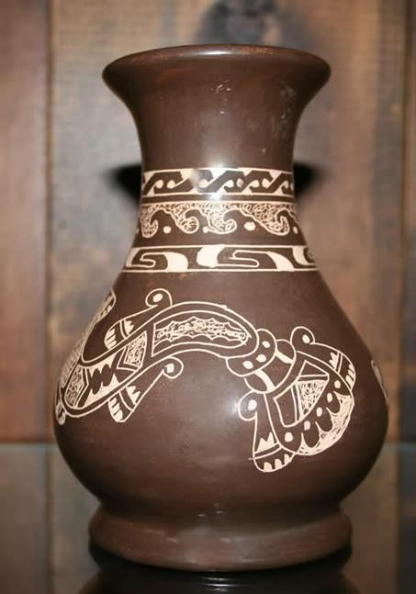
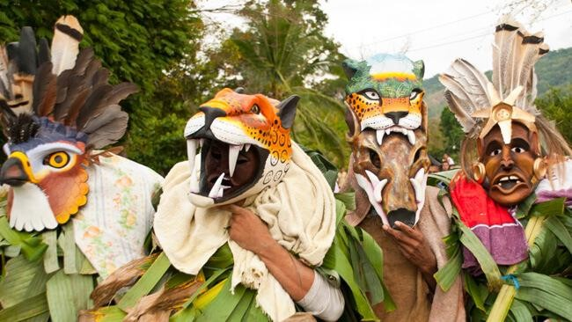
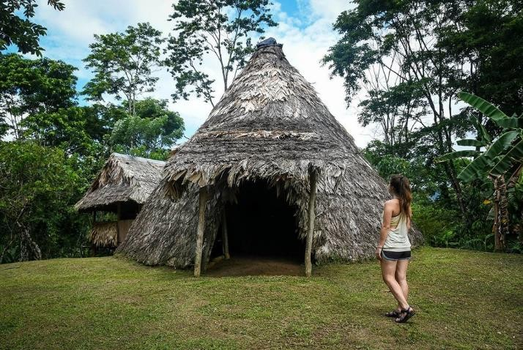

https://images.app.goo.gl/8v1mFqfrj7wtRfn9A https://images.app.goo.gl/sJRKQVby2fGkXmgq9 https://images.app.goo.gl/nRjYq7BGS9tDBH4i9

APPENDIX 2
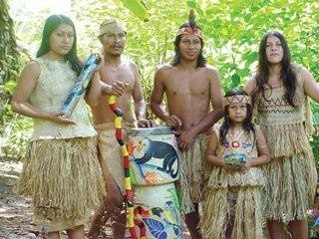
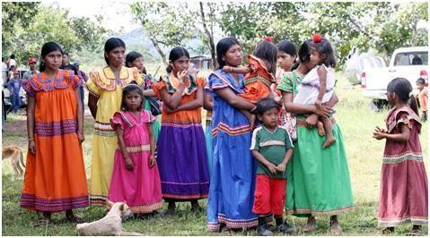
https://images.app.goo.gl/FDptoCMVygCfw9DW8 https://images.app.goo.gl/iRQH89o3L5Zboe2J9

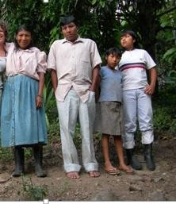
https://images.app.goo.gl/RoTXzHUkiNECNVVD6

APPENDIX 3
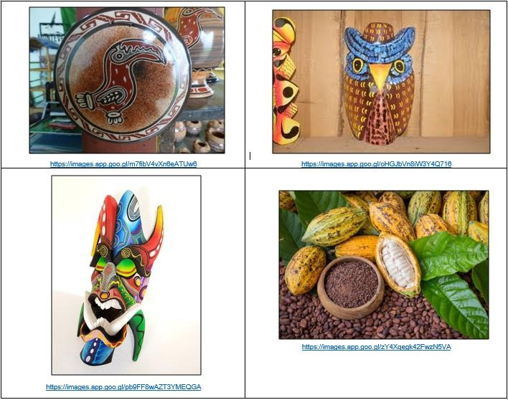

APPENDIX 4

https://www.mostphotos.com/en-us/25068698/playing- cards-spread-out-face-up-poker-cards  Luis spread out the cards on the table. | 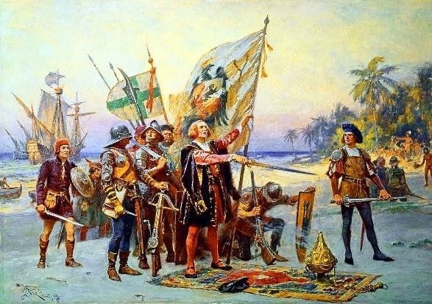  https://images.app.goo.gl/eJjmpDDL9KyP6AwH9  The Spanish were among the first Europeans to settle in America. | 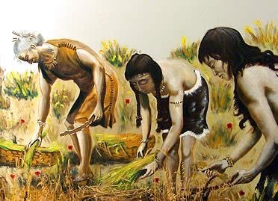  https://images.app.goo.gl/2ytSjHmvz8Xrsuk69  Ancient tribes were hunter-gatherers.
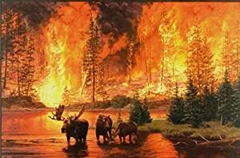  https://images.app.goo.gl/QyHfH4n7o1abeNou7  The fire made the animals retreat. | 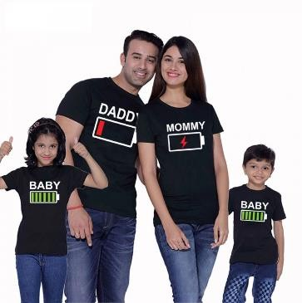  https://images.app.goo.gl/fQMQF8wGAfvnqrD17  We have a tight-knit family. | 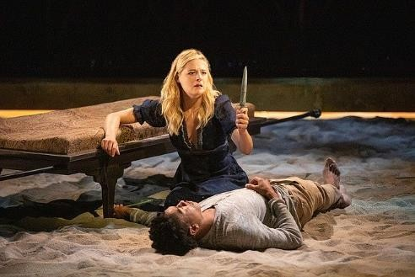  https://images.app.goo.gl/fyDacxKVkwtuYNkj6  Romeo and Juliet was staged by the tenth grade students.

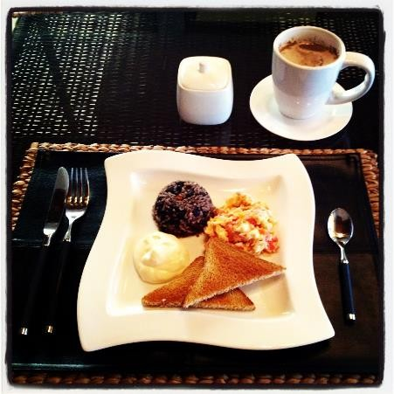  https://images.app.goo.gl/HU7pS8t88bbRd8yR9  The kitchen was filled with the mingling  scents of coffee, toasts, eggs and pinto. | 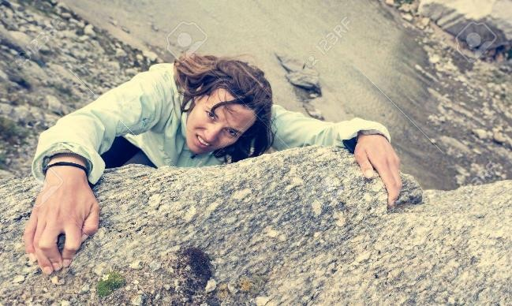  https://images.app.goo.gl/Q4Ci4hSoPD7br9aJ7  The climber had to hold on to the rock firmly. | 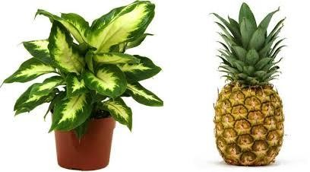  https://images.app.goo.gl/T1REFFzRef6vKcih9 https://images.app.goo.gl/owp194cbJA5kvxFo7  Costa Rica has been successful in exporting new crops such as pineapples and ornamental plants.

APPENDIX 5

1 | 2 | 3

4 | 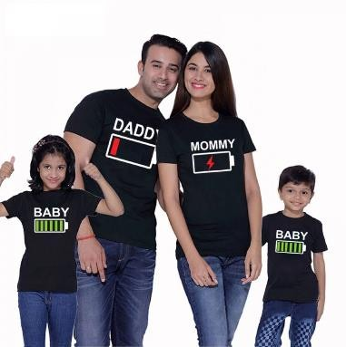  5 | 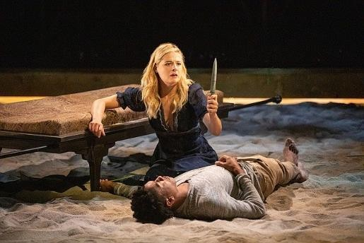  6

7 | 8 | 9

APPENDIX 6

Luis spread out the cards on the table.

The Spanish were among the first Europeans to settle in America. Ancient tribes were hunter-gatherers.
The fire made the animals retreat. We have a tight-knit family.
Romeo and Juliet was staged by the tenth grade students.

The kitchen was filled with the mingling scents of coffee, toasts, eggs and pinto. The climber had to hold on to the rock firmly.
Costa Rica has been successful in exporting new crops such as pineapples and ornamental plants.

APPENDIX 7

A Brief Introduction to the Indigenous Tribes of Costa Rica

JENN PARKER/ MAY 3, 2017

Before the arrival of the Spanish conquistadores, Costa Rica – like other countries in Central and South America – was entirely populated by indigenous tribes. Prior to 1502, between 400,000 and 500,000 native people lived in Costa Rica in distinct cultural groups, spread out throughout the country. It is thought that at one point there were as many as 25 tribes.

The first tribes to settle in Costa Rica were hunters and gatherers. As time passed, and experience and knowledge of the land, plants, and animals developed, tribes became more organized, civilized, and sophisticated. Groups became more permanently based and stable communities were formed. It wasn’t until the Spanish conquistadors arrived that many of the tribes retreated to the deep jungles of Costa Rica for safety.

Tribes of Macro-Chibcha ethnic origin

There are five tribes that have been traced back to Macro-Chibcha origin, which is mainly from the northern region of South America, including the Amazon. The Guaymíes, Cabécares, Bribris, Térrabas, and Borucas tribes all emigrated to Costa Rica from the south. Today these tribes are still present in Costa Rica, but in much smaller numbers. Unfortunately, many of the indigenous people were run out of their territories, enslaved, or died from foreign diseases.

Borucas tribe

The indigenous Borucas people of Costa Rica are still deeply rooted to their ancestral traditions. They are well known for their annual Fiesta de los Diablitos, which is a festival to celebrate their resistance and cultural survival against the conquistadores. During the festival, a performance of the devils (the Indians) versus the bull (the Spanish conquistadores) is staged. The Borucas make beautiful and detailed wooden masks for the festival.

Cabécares tribe

There are around 10,000 members of the Cabécares tribe still present in Costa Rica. The tribe continues to speak their native language and practice their traditional medicine and way of life. The cacique (the chief) of the tribe is permitted to marry several wives, as this tribe is a patrimonial culture. This tight-knit tribe are proud farmers of cocoa, coffee, and bananas, as well as fishermen and bird hunters.

Tribes of the Mesoamerican ethnic origin

There are three tribes in Costa Rica that are of Mesoamerican descent. The Huetares, Chorotegas, and Guatusos or Malekus tribes all traveled to Costa Rica from the north. These tribes were traced back to indigenous groups from Mexico and Guatemala, such as the Mayans and Aztecs.

Chorotegas tribe

The Chorotegas are the largest and most developed tribal group in Costa Rica. They are excellent farmers and produce crops such as cotton, cacao, corn, and beans. They are also well known for their ceramics. Typically, the women are the artisans and they create beautiful pieces that depict native animals of Costa Rica, like the jaguar and crocodile.

Guatusos tribe

This tribe, sometimes also called the Malekus tribe, are one of the smallest indigenous tribes in Costa Rica. Unfortunately, the majority of their land no longer belongs to them. There is also a very high rate of unemployment and inter-cultural mingling. They still make traditional ceramics and art, and also grow crops and keep bees. One thing that the tribe is trying to hold on to is their native language. In Guatusos schools, both Spanish and Maleku are taught to students.

(Taken and modified from https://theculturetrip.com/central-america/costa-rica/articles/a-brief-introduction-to-the-indigenous-tribes-of-costa-rica/)

APPENDIX 8

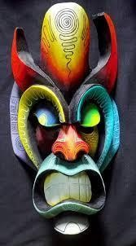
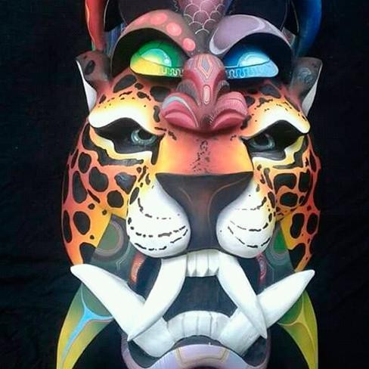

https://images.app.goo.gl/5Yy3JyzEVRnpbCZV9 https://images.app.goo.gl/jByumBncGQ6LQYY67

Appendix 9

1  https://images.app.goo.gl/Usrnn8WFgHtJok9AA | 2  https://images.app.goo.gl/m76Lr8Bc4oCmwoPi6 | 3  https://images.app.goo.gl/S86hhFFd2aUhpXvq6
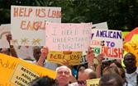 4  https://images.app.goo.gl/Dtgn5jjQt7y8XySp9 | 5  https://images.app.goo.gl/g3ai3X4Qwy2pSvLy9 | 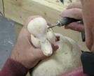 6  https://images.app.goo.gl/KDfsManabCffiHpb6
7  https://images.app.goo.gl/76HADUPFS8t92YVY9 | 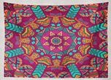 8  https://images.app.goo.gl/KDfsManabCffiHpb6

Appendix 10

Look at the pictures. Match the sentences with the corresponding pictures by writing down the number of the picture in the given space.

Chandler is a native New Yorker. He was born there and has lived there all his life.
Immigrants that go to the USA face many struggles like not knowing any English.
Manuel carved a beautiful wooden duck.
Many artisans sell their handmade crafts online.
The tapestry had such a beautiful design.
Roger Federer defeated Rafael Nadal in four sets.

She was happy that she had survived the surgery.
Masks protect the identity of super heroes.

Appendix 11

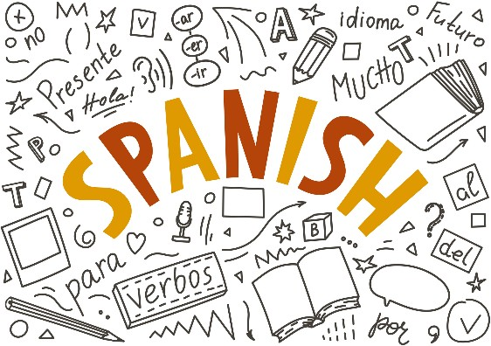  https://images.app.goo.gl/9asmmEneEHmpvbs67 | 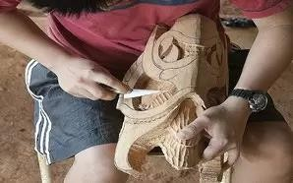  https://images.app.goo.gl/PmzmULV6tiL4X7ps6 | 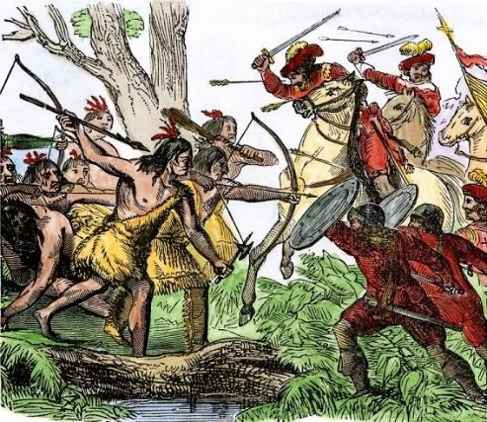  https://images.app.goo.gl/kvytTAtQsuD8QuCW6

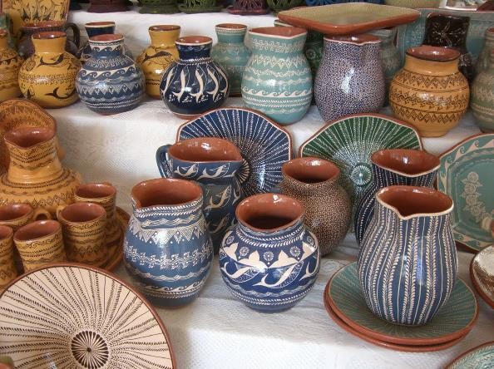  https://images.app.goo.gl/iqkocTrG2PyXGtAk8 | 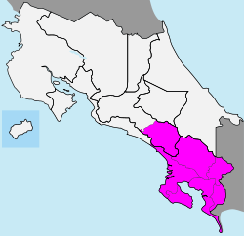  https://images.app.goo.gl/c6kQXaWdwpZVxMXZ7

Appendix 12

Sentence | /eɪ/ | /əʊ/ | /aɪ/ | /aʊ/
Example |  |  | design
1
2
3

4
5
6
7
8
9
10

Appendix 13 ANSWER KEY

Sentence | /eɪ/ | /əʊ/ | /aɪ/ | /aʊ/
Example |  |  | design
1 | Ancient |  | tribes
2 | staged | Romeo
3 |  | toasts / pinto
4 |  | hold | climber
5 | table |  |  | out
6 | face | knowing | like
7 | handmade |  | online
8 |  |  | survived

9 | native |  | life
10 |  | heroes | identity

Appendix 14

EXAMPLE: The tapestry had such a beautiful design.

1. Ancient tribes were hunter-gatherers.
2. Romeo and Juliet was staged by the tenth grade students.

3. The kitchen was filled with the mingling scents of coffee, toasts, eggs and pinto.

4. The climber had to hold on to the rock firmly.
5. Luis spread out the cards on the table.

6. Immigrants that go to the USA face many struggles like not knowing any English.

7. Many artisans sell their handmade crafts online.
8. She was happy that she had survived the surgery.

- Chandler is a native New Yorker. He was born there and has lived there all his life.

10. Masks protect the identity of superheros.

Didactic Planning Week # 2
Level: 10th |  | Unit: 3
Domain: Psycho-social & Sociocultural | Scenario: A World of Differences |  | Theme: Cultures, Subcultures and Cliques
Enduring Understanding: The world is made up of diverse people groups who nurture one another.
Essential Question: How does understanding people’s differences help us all become better human beings?
General Competences

Responsible Citizenship ( )
Life Competences ( )
Competences for Employability ( )

Learn to Know | Learn to Do |  | Learn to Be and Live in Community
Grammar & Sentence Frames  Contrasting opinions  On the one hand, different cultures are very interesting.  On the other hand, different cultures can cause misunderstandings.  Mind you, he is still very much a citizen of Costa Rica.  All societies have cultural norms. Even though norms influence our values, attitudes, and how we behave, we are often unaware that we are influenced at all.  Stating your opinion  I think… I believe…. I feel….In my opinion  Agreeing  I agree with you./That's so true./ That's exactly how I feel. | Function  - Expressing opinions, agreement and disagreement  Discourse Markers  Changing the topic  - Anyway…, by the way, there´s something else I wanted to tell you…  Resuming a conversation  - Anyway…, anyway, what was I saying?  - What were we talking about?  - To get back to what I was saying, ...  Continuing  - Anyway, …  - So, as I was saying, |  | Psychosocial  - Valuing and preserving own personal  /country´s cultural identity.  Sociocultural  - Valuing open-minded communication as a strategy to future understanding.  - Showing empathy: putting oneself in the shoes of others’ and listening to their needs.  - Adopting a non-judgmental attitude towards others’ cultural diversity.

Disagreeing  You may have a point there;however, I think.../I don’t think so./ I’m afraid I disagree.  Vocabulary  Cultures, Subcultures and Cliques  -clique (examples of cliques), fit in, left out, exclude, ridicule, mean, make fun of, deal with, herd, hang out, self-esteem, value, compatible  -Culture, subculture, high culture, popular (pop) culture, gamers, fandoms, bikers, etc, pattern, attitudes, wealth, mainstream, spread, heritage, traits, embraces, die-hard values, interests, exclusive, stereotypes, diversity |  |  | Well…
Assessment Strategies & indicators of learning  (Diagnostic, formative, summative) | Learner can | Didactic Sequence Mediation |  |  | Time Total: 120 min  (3  lessons)
Pre-teaching
Routine: Checking attendance, checking in with Ls, T posts the Essential Question on the board, Can Do’s, and class agenda, etc.

Participating: Warm- up
Things in common: Teacher asks students to make groups of 4 students. They have to group themselves according to something that all four have in common, whether it is something physical, personality, likes, dislikes, clothing, etc. Teacher asks each group what the criteria for grouping was. Teacher asks them to
do it one or two times more with different students and different criteria.

.  L.2. extracts main idea of audio texts in many television, radio, and web- based broadcasts/ announcements. | L.2. follow the main idea of audio text if the topic is familiar and the text can be replayed. | Engaging: Activation of prior knowledge  Teacher uses the warm -up activity as a starting point for a conversation about the theme of the week.  He/She prompts the conversation by means of questions such as:  - Did you find different classmates with whom you have things in common?  - How do students group themselves in this group?  - How do people group themselves in society?  - What makes a Costa Rican, Costa Rican?  Introducing  Using the information from previous activities, the teacher shares three sentences with the students. He/She will ask them to read the sentences and classify them as: 1. express opinions 2.show agreement 3. show disagreement  We are all different; however, we also find many aspects in common.  In my opinion, we have many things in common with each other.  I agree with Carlos. Differences make us unique.  Pre-listening  Activation of schema. Teacher presents a picture of a group of characters from school See (APPENDIX 1). He/She asks them: What do you see in the picture? How many of them have you seen at school? Do you relate to any of the characters? What is a clique? Teacher asks students to share the answers to those questions with a classmate and then share with the rest of the group.  Clique: A small group of people, with shared interests or other features in common, who spend time together and do not readily allow others to join them. https://www.lexico.com/en/definition/clique

Teacher introduces the goal for the lesson: L.2. follow the main idea of audio text about subcultures and cliques. Video for the task can be accessed at https://www.youtube.com/watch?v=dn5Rs9PbdA0 up to 2:30

Teacher presents the key words by giving students a piece of paper with incomplete sentences. (See APPENDIX 2) Students fill in the blanks with the correct words from the list.

Every student compares his/her answers with a classmate. Teacher shares the answers with the whole group. After giving every answer, the teacher explains the meaning of the word or phrase.

Teacher reads every sentence, putting emphasis on the key word. Students repeat.

Key words: fit in, left out, excluded, ridicule, mean, make fun of, deal with, herd, hang out

Teacher clarifies the meaning of the words by asking questions such as What animals live in herds? What is something that you can do to hang out with your friends?

Pair work: Teacher projects the key words. One student reads one of the sentences from APPENDIX 2 without mentioning the key word. The other student has to call out the word that finishes the sentence correctly. Switch roles.

Listening for the first time. Choose the right answer.

Write down a check mark on the ideas that are mentioned in the video:

Cliques are exclusive groups.

Cliques respect differences.

Cliques are formed by popular kids.

There are different ways to deal with cliques.

Pair/Group feedback

In pairs, learners compare their answers, and the teacher asks students to raise their hands to show which option they checked.

Listening for the second (and third time)

Listen again and choose the best answer.

1. What is a characteristic of cliques mentioned in the video?

- They help kids fit in at school.

- They do not allow others to be part of the clique. (Correct answer)

- They offer different options for every student.

2. Why do some students consider cliques as mean? Because

- students in cliques make fun of others or ridicule them. (Correct answer)

- they are exclusive.

- only students who are similar hang out.

3. How long have cliques been around our society?

- They are a new social phenomenon in our society.

- Nobody knows how long they have been around.

- Students have been dealing with them for years. (Correct answer)

4. How is “Don’t be one of the herd” explained in the video?

- Get to know people as individuals.

- Find people you are more compatible with.

- If people don’t like who you are, ignore them. (Correct answer)

5. Which of the following recommendations was NOT mentioned in the video?

- Value your individuality.

- Choose your friends based on who they are.

- Organize your own clique at school. (Correct answer)

Pair/Group feedback

Teacher walks around and checks the students’ answers.

R.1. recognizes textbook explanations and examples. | R.1. read textbook explanations and examples with aid of word list and/or dictionary support. | Post-listening:  Pair work: Listen again and take notes about the pieces of advice given by the students. After that, play the following roles: a friend of yours wants to be part of a clique. Tell him/her what you think of cliques and give him/her two good pieces of advice. Some volunteers will go to the front to present their conversations.  Pre-reading  Teacher enlarges words on APPENDIX 3, cuts them out and pastes them on the walls around the classroom (definitions for each term are attached). The teacher asks the students to go and stand up in front of the word that they like or that describes them. Once every student has done that, the teacher will ask for volunteers to explain what that word means and describe people who are part of that group. Then, the teacher asks them: Are you all Costa Ricans? Looking at this example, can you tell me how you perceive culture and subcultures? What do you think that we are studying today?  Teacher introduces the goal of the lesson: read textbook explanations and examples with aid of word list  Key words: pattern, attitudes, wealth, mainstream, spread, heritage, traits, embraces, diehard  Teacher presents the key words by reading them out loud. Then, he/she asks students to match questions related to the key words with the corresponding answers individually. Teacher can print APPENDIX 4 for that purpose.  Students answer individually. Compare answers with a partner. Then, check with the rest of the group. Teacher clarifies the meaning of the key words by giving them a synonym, and students have to give the key word.  Synonyms: decorative design, point of view, riches, popular, diffusion, patrimony, characteristic, accepts, fanatic

Pairwork: With the copy from Appendix 4, the teacher asks the students to make pairs. Both students hold the copy, but one one them folds it in half, so he/she can see only the answers. The other student asks the questions at random while his/her classmate answers. Switch roles.

Reading for the first time (the text is in Appendix 5)
Read the following statements and number them in the order in which they are mentioned in the reading.

High and pop cultures have patterns of experiences directed to different audiences.
Gamers and Fandoms are examples of subcultures.
Subcultures are small cultural groups within a larger culture.
There are a multitude of cultural differences between societies in the world. Answer key: 2, 4, 3, 1

Pair/Group feedback
Students share answers in pairs. Then, share their answers with the group.

Reading for the second time
Read the text and fill in the graphic organizer with the information (See Appendix 6).

Teacher walks around the classroom and looks at students’ answers. Then, he/she writes/pastes/projects the answers on the board.

Post-reading

Pair work. One of the two students states an opinion using information from the article, and the other says something to agree or disagree with what was said. Switch roles.
Stating your opinion: I think… I believe…. I feel….In my opinion Agreeing: I agree with you./That's so true./ That's exactly how I feel.
Disagreeing: You may have a point there; however, I think.../I don’t think so./ I’m afraid I disagree. Example: A: I think that we we are not defined by one single preference.
B: That’s true. We can like things from different subcultures. We are diverse.

W.1. writes completing specific graphic organizers and sentence frames aimed at monitoring comprehension. | W.1 express what has been learned, how it has been learned, and learning goals for the future related to cultural diversity. | Pre-writing  Teacher projects/writes the following headings on the board: What I Have Learned this Week / How I Have Learned It / What I would like to learn in the future. Teacher asks students to think about the different headings. After a few minutes, he/she asks them to share ideas with a partner orally. Finally, the teacher asks for three volunteers to share one idea per heading, and the teacher proceeds to write them down on the board just to set an example. Teacher uses complete sentences to do so.  Teacher distributes copy on Appendix 7 and shares the task with the students. The school is going to organize a round table about diversity and culture and your teacher has selected you as a representative of your group. Your teacher gives you a graphic organizer to help you write down your ideas. Fill in the organizer.  Drafting  Students will write down their ideas for every heading in their notebooks or on a piece of paper. Teacher clarifies that they have to use complete sentences.  Revising  Students check if all important ideas were included. They go over grammar, spelling, punctuation, etc.  Editing & Publishing  Students go over spelling, grammar, punctuation, capitalization and word choice. They can use their cell phone, a dictionary and/or ask a partner. After that, they proceed to fill in the graphic organizer.  Phonology Review  The teacher copies the words from a set of minimal pairs on board. Students drill them. After that, teacher asks students to pick seven words from the board and write them down in their notebooks. Students should read their words either to the class or to a partner. The listeners should write down the words they hear. After the words have been given and repeated (if necessary), the listeners compare their lists with the original list. The teacher can also write her/his own list of perceived words on the board to compare with the student’s list.  (The words in bold are words taken from the material provided in this week)

fit feet fun fan been bean most must share chair food foot
customs costumes

T. can also read sentences to students so that they identify the words.They write down the words they hear in order.
A fan had fun during the concert. A bean has been planted.
Food fell on my foot.
My feet don’t fit in these shoes.
Most doors must be locked.
These customs involve wearing costumes. I’ll share my chair with you.
Integrated Mini-Project |  |  |  |  | Time
Allow time for the Mini-Project each week. NOTE: All phases of the Integrated Mini-Project should be opportunities for Ls to practice English, not just those related to presentation.  Participating to negotiate: (5 or 10 minutes in week 1 or 2) |  |  |  |  | Adjust previous times listed above to allow 5 min each week.  Group presentation  s can be week 5 or 6.
Reflective Teaching
What worked well |  |  | What didn’t work well | How to improve
Enduring Understanding Reflection

How well did the learners progress in their understanding of the Enduring Understanding?
Week Plan Self-Assessment
At the end of the week, T guides the learners to check their progress using the checklist below. (Can be translated into Spanish if needed to ensure Ls’ understanding.)

Learner Self-Assessment
I can… | Yes | In progress | No
extract main idea of audio texts in many television, radio, and web-based broadcasts/ announcements.
recognize textbook explanations and examples.
write completing specific graphic organizers and sentence frames aimed at monitoring comprehension.
Show how I have worked with others this week.

APPENDIX 1
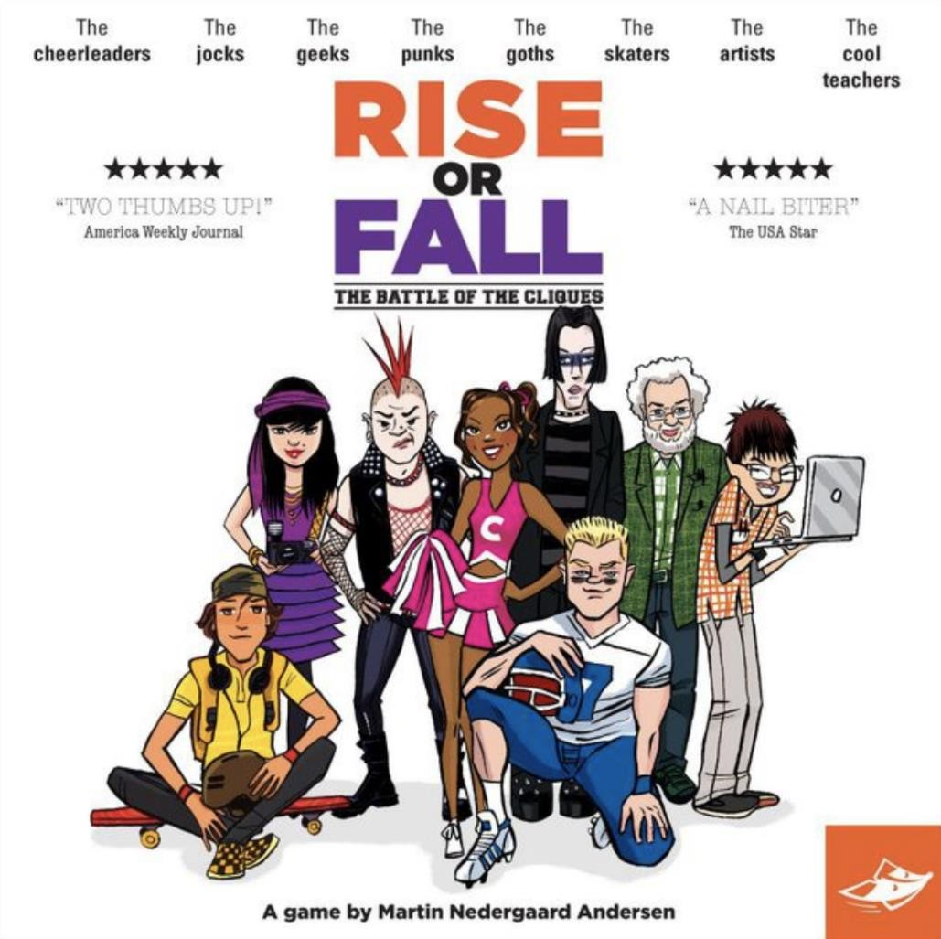

https://images.app.goo.gl/5KDhjoC6kPtmwsme8

APPENDIX 2

Complete the sentences using the words in the list:

fit in, left out, excluded, ridicule, mean, make fun of, deal with, herd, hang out

  - Before the evaluation week, students hardly have time to with their friends.

  - Students are afraid of making mistakes because they think that others might them.

  - Some students think that they have the right to others.

  - You do not have to be part of the . It is important to value your individuality.

  - Rosibel thinks that she does not at her new school.

  - Students with special needs should not be from the school system.

  - Alina was to her classmates. She never played with them.

  - Rudy was of the theater group.

  - Some students learn how to bullying in a very positive way.

APPENDIX 3
Bodybuilding | Metalcore | Cosplay | Otaku | Emo | Rave Scene | Gamer
Skater | Goth | Bikers | Hip hop | Fandom | Hipsters | Surfers
Bodybuilding - using certain exercises to train the body into a highly sculpted, muscular form Cosplay - a group involved in full immersion into a fictional character

Emo - short for "emotional," a movement directed at fans of emotional, expressive hardcore punk rock
Gaming - a group of people who enjoy playing video games, either individually, with friends, or through a virtual platform Goth - people who find beauty in things others might find dark, including clothing and attire, decor, and more

Hip hop - started in South Bronx in the 70s, a group of people who enjoy break dancing, graffiti, DJs combining songs and rap, and other artistic expressions
Hipsters - a merging of many identities, including retro styles, skinny jeans, artistic movements, urban living, Metalcore - a genre of music that fuses extreme metal and hardcore punk

Otaku - people obsessed with anime and manga
Rave Scene - characterized by wild parties with loud music and possibly light or laser shows Skater - a movement of teens and adults who enjoy skateboarding

Surfer - the people, language, fashion, and lifestyle surrounding the sport of surfing

APPENDIX 4

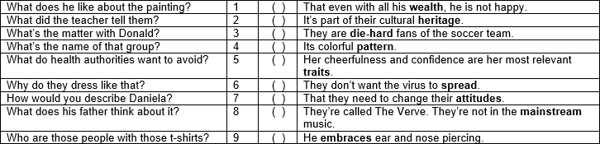

APPENDIX 5

Pop Culture, Subculture, and Cultural Change

It may seem obvious that there are a multitude of cultural differences between societies in the world. After all, we can easily see that people vary from one society to the next. It’s natural that a young woman from rural Kenya would have a very different view of the world from an elderly man in Mumbai—one of the most populated cities in the world. Additionally, each culture has its own internal variations. Sometimes the differences between cultures are not nearly as large as the differences inside cultures.

High Culture and Popular Culture

Sociologists use the term high culture to describe the pattern of cultural experiences and attitudes that exist in the highest class segments of a society. People often associate high culture with intellectualism, political power, and prestige. In America, high culture also tends to be associated with wealth. Events considered high culture can be expensive and formal—attending a ballet, seeing a play, or listening to a live symphony performance.

The term popular culture refers to the pattern of cultural experiences and attitudes that exist in mainstream society. Popular culture events might include a parade, a baseball game, or the season finale of a television show. Rock and pop music—“pop” is short for “popular”—are part of popular culture. Popular culture is often expressed and spread via commercial media such as radio, television, movies, the music industry, publishers, and corporate-run websites. Unlike high culture, popular culture is known and accessible to most people. You can share a discussion of favorite football teams with a new coworker or comment on American Idol when making small talk in line at the grocery store.

Subculture and Counterculture

A subculture is just what it sounds like—a smaller cultural group within a larger culture; people of a subculture are part of the larger culture but also share a specific identity within a smaller group.

Thousands of subcultures exist within the United States. Ethnic and racial groups share the language, food, and customs of their heritage. Other subcultures are united by shared experiences. Biker culture revolves around a dedication to motorcycles. Some subcultures are formed by members who possess traits or preferences that differ from the majority of a society’s population. The body modification community embraces aesthetic additions to the human body, such as tattoos, piercings, and certain forms of plastic surgery. In the United States, adolescents often form

subcultures to develop a shared youth identity. But even as members of a subculture band together, they still identify with and participate in the larger society.

https://courses.lumenlearning.com/sociology/chapter/pop-culture-subculture-and-cultural-change/

Examples of Subcultures in the USA

Fandom is characterized by people who are somewhat obsessed or closely identify with certain characters or fictional worlds, though a “fandom” can be built around any shared interest. Fans have Conventions (cons), dress up as said characters (called cosplaying), and form little individual communities around a particular fandom, such as Doctor Who, Harry Potter, or any Anime ever.

Gamer culture in America represents the more devoted fans and players of what has become one of the largest entertainment industries in the US. Many people in the US play video games of some form (when you realize Candy Crush and The Sims count), and in 2014, more people watched the live League of Legends World Championships than the deciding game of the NBA finals.

Sports – from watching games as a die hard fan to being the soccer mom who drives to all the games – are an important and defining part of American society. For people who consider sports a large part of their lives, well, they just operate on different seasons and speak a different language than those who don’t. Even non-sports fans tune into the Superbowl in the US every year as it’s become such a pervasive part of the entertainment industry.

https://list25.com/25-subcultures-within-the-united-states-that-are-truly-fascinating/

APPENDIX 6

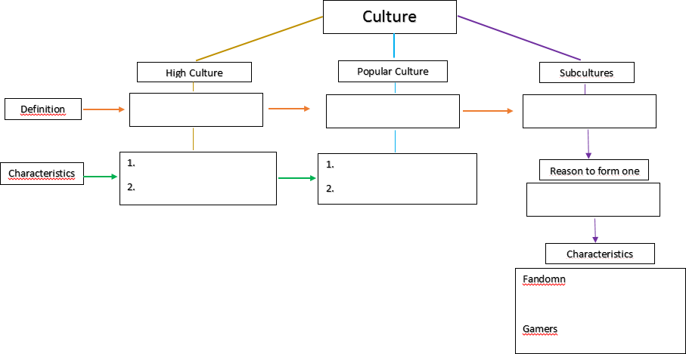

Possible Answers

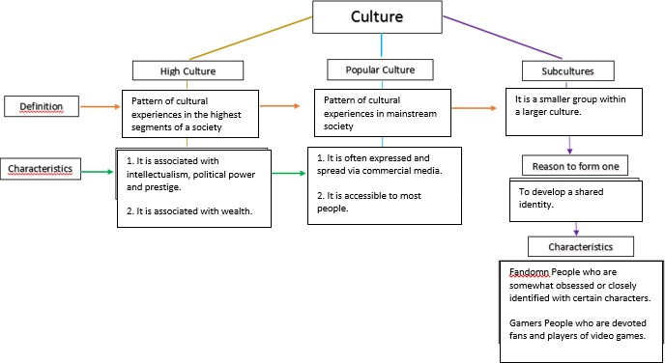

APPENDIX 7

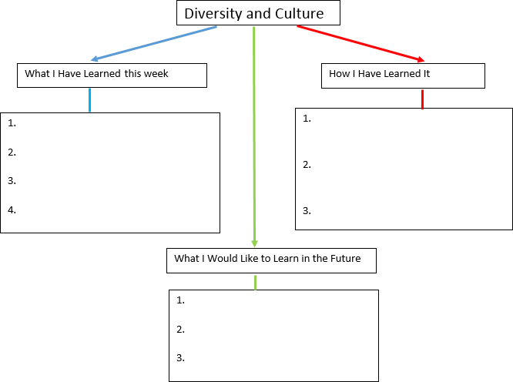

Didactic Planning Week # 3
Level: 10th |  | Unit: 3
Domain: Psycho-social & Sociocultural | Scenario: A World of Differences |  | Theme: Cultural Norms and Cultural Storms
Enduring Understanding: The world is made up of diverse groups of people who nurture one another.
Essential Question: How does understanding people’s differences help us all become better human beings?
General Competences

Responsible Citizenship ( )
Life Competences ( )
Competences for Employability ( )

Learn to Know | Learn to Do |  | Learn to Be and Live in Community
Grammar & Sentence Frames  Contrasting opinions  - On the one hand, different cultures are very interesting. On the other hand, different cultures can cause misunderstandings.  - Mind you, he is still very much a citizen of Costa Rica.  - All societies have cultural norms. Even though norms influence our values, attitudes and how we behave, we are often unaware that we are influenced at all.  Continuing  - Anyway… | Function  - Expressing opinions, agreement, or disagreement.  - Managing interaction (resuming or continuing)  Discourse Markers  Connecting words expressing cause and effect, contrast:  - On the other hand, we could go to the clinic.  - However, this depends on the number of passengers.  Resuming a conversation |  | Psychosocial  - Appreciating and celebrating own diversity (cultural, gender, sexual orientation, religion, disability, ethnic, and age).  - Valuing and preserving own personal/country’s cultural identity  Sociocultural  - Valuing open-minded communication as a strategy for future understanding.  - Showing empathy: putting oneself in the shoes of others and listening to their needs.  - Adopting a non-judgmental attitude towards others’ cultural diversity.  Social Language Samples  - Crossing cultures

- So, as I was saying…  - Okay  Expressing agreement-disagreement  - I think so, too.  - Well, not really.  - I’m sorry, but I think you are wrong.  - I see what you mean but…  - Yes, I agree.  - No, I disagree  Modals  - Cliques are small exclusive groups of people that might choose to separate themselves from others.  - Stereotypes may be positive or negative.  - Subculture is a group having traits they have to follow that are different from others within the same culture.  Vocabulary  Prejudice, racist, cliques, ethnic, form, peace, insensitive, misunderstandings, culture, subculture, citizen, cultural norms, influence, society, positive, negative, typical | - Anyway…,  - Anyway, what was I saying?  - What were we talking about?  - To get back to what I was saying, ...  Continuing  - Anyway, …  - So, as I was saying, …  - Well, ... | - People groups  - Ethnic (or cultural) bias  Idioms  - Seek first to understand, then to be understood.  - Walk a mile in someone else’s shoes  - To see eye to eye  - All walks of life  Proverbs/Quotes  - Diversity is the one true thing we all have in common. Celebrate it every day.  - Unknown author  - All the human beings were born wonderfully different.  - Dr. José Angel Livraga

Assessment Strategies & indicators of learning  (Diagnostic, formative,  summative) | Learner can | Didactic Sequence Mediation | Time Total: 120 min  (3  lessons)
Pre-teaching
Routine: Checking attendance, checking in with Ls, T posts the Essential Question on the board, Can Do’s, and class agenda, etc.

Participating: Warm-up
Before class, the teacher prints and cuts out at least two identical sets of pictures from APPENDIX 1. The pictures show a wide variety of diverse people. The class divides into 2-4 groups and each group receives one identical set of pictures. Each group’s goal is to sort their set of pictures into 4 groups of similar people. This could be done by placing the pictures on four corners of a piece of poster paper and writing a title next to each group. While sorting the pictures, students can practice using modal verbs (e.g. This picture should go here because… This group might be people who...).

Although each group of students has the same pictures as the other group, they will probably sort the pictures in different ways. For example, one group of students might sort the pictures by gender and age. Another group might sort the pictures by race or ethnicity. Once the students have had time to sort their pictures, the teacher should help the students compare their work. How did they sort people differently? Why did they do it that way? The objective of the reflection is to help students see that each person has more than one identity (gender, race, age, nationality, religion, etc.) that makes them both similar to and different from other people.

Engaging: Activation of prior knowledge
Teacher instructs students to list the identities of a person they admire (i.e. that person’s nationality, race, gender, language, ethnicity, sexual orientation, profession, disability, clique, religion, subculture, etc.). Then, the Teacher hands out a blank Venn Diagram (APPENDIX 2.1). Students should write the person’s name in the middle section, then label each of the circles in the diagram with one of the person’s identities. Students then get in partners and try to fill all of the other sections of the diagrams with other people’s names (See APPENDIX 2.2 for an example of a completed diagram).

SI.2 expresses opinions about  cultural identity  and cultural diversity | SI.2 express opinions about  cultural identity  and cultural diversity | Introducing  Teacher introduces the idiom “Seek first to understand, then to be understood.” They then ask students what they think it means. They clarify any misunderstandings. The idiom means that you should listen to other people first and try to understand them before trying to tell them about yourself. Teacher asks students why it is better to listen first, before speaking about themselves.  The teacher explains to students that today they are going to practice listening to other people and “seeking to understand” how they are the same and different, compared to us.  Planning/Organizing  The teacher instructs students to list some of the aspects of their own identity (for example, gender: male). (See APPENDIX 3 for an illustration of aspects of identity.) Students do not need to list every single part of their identity, but they should write as many as they feel comfortable talking about. Once they have a list of several parts of their identity, students should note down some benefits and challenges of having that identity.  Rehearsing  Students get into partner pairs. One student tells the other about one of their identities (e.g. I am a girl.) and one benefit and one challenge of having that identity (e.g. On one hand, boys sometimes do nice things for me, like holding doors. On the other hand, some people think that I can’t do everything that a boy can do.). The other student listens carefully, then summarizes or asks questions (e.g. “So even though boys sometimes do things for girls, other people don’t think girls can do what they want?”).  Once the first person has shared part of their identity and the other person has asked questions, the two students switch roles. The listener starts talking about their own identity and the speaker listens carefully and asks questions.  Interacting/Describing  Teacher reminds students that today they are practicing listening for understanding. In this activity, they will show their understanding by summarizing what their partner says to a third person.

SI.1 repeats what has been said and convey this  information to another person  SP.1 expresses opinions on familiar subjects and ask for others’ opinions  SP.2 asks  questions to others if the questions have been prepared beforehand. | SI.1 repeat what has been said and convey this  information to another person  SP.1 express opinions on familiar subjects and ask for others’ opinions  SP.2 derive  interviews from  others, if the  questions have been prepared beforehand.  Sometimes, can pose further question without having to pause  very long to | Students get into groups of three. This time, there is a speaker, a listener, and an observer. The speaker tells the listener about their own identity and its benefits/challenges. Then the listener tells the observer about the speaker. If the listener makes doesn’t remember correctly, the speaker can correct her (e.g. Well, not really. Actually, I...). The observer can ask the listener questions to get more information. Finally, the students switch roles--the listener becomes the speaker, the speaker becomes the observer, and the observer becomes the listener. This process is repeated until all three students have had a chance to try all three roles.  Planning  The teacher divides students into small groups and gives each group just one of the three stories about migrants’ experiences living in the US (APPENDIX 4). Each group reads its own story and discusses these three questions with their partners:  - What was the cultural norm in this person’s own country?  - What was the cultural norm in the US?  - How did cultural differences affect this person?  The teacher then chooses certain groups to share their text and what they learned. Ideally, each text should be shared one time with the whole class.  Organizing  The teacher explains that this lesson is about cultural norms and cultural “storms” or conflicts. The teacher asks students to share some of the norms of their own cultures (e.g. In my culture, people almost never wear shorts! In my culture, you have to eat the food you’re given, even if you are not hungry!).  Once the class has discussed a few cultural norms together, the teacher asks students to jot down notes about one time they experienced a cultural “storm,” or conflict--when their subculture or their personality did not fit well with the cultural norms of the community.  Rehearsing  Teacher tells students that today they have an opportunity to show empathy for other people with diverse experiences and use open communication to understand each other better.

SP.3 explains points of view, justifying assumptions and plans briefly.  W.1 writes a simple, short descriptive narrative paragraph based on real or imagined  event related to | formulate the question.  SP.3 explain and justify, briefly, points of view, assumptions, and plans.  W.1 write a simple, short descriptive narrative paragraph of personal experiences on  cultural diversity, | Learners imagine that they are TV journalists, doing interviews for a show called “Seeing Eye to Eye.” Teacher asks students what they think that phrase means. Once students are clear on the meaning of the expression, the teacher explains the subject of the interviews. Students should ask their classmates for their opinions on their own cultures and subcultures. Below are three main questions they should be sure to answer:  - What subculture(s) are you a part of?  - How are the norms of your subculture other than the norms in other cultures?  - What is your point of view (opinion) on these differences?  The best interviewers will ask further questions to understand more about their classmates. The best interviewees will explain and justify their answers. Why do they think that? What assumptions are they making? How do they plan to deal with these differences in the future?  Producing  Certain pairs of students come forward to demonstrate their interviews in front of the class. The class listens, then writes follow up questions in their notes. The teacher selects a few of these follow up questions for students to ask the interviewee.  Pre-writing  So far this week, students have explored their identities and cultural experiences. They have gotten lots of chances to talk and ask questions about those things. Today their task will be to write one of their experiences down in a narrative paragraph. The teacher should explain this at the beginning of the lesson, and display this prompt on the board:

cultural diversity, including characters, plot, and setting. | without using an aid such as a dictionary, and check it to look for mistakes (subject- verb agreement, pronoun and article agreement, capitalization, using commas, sentence sense, word order, text structure, concrete ideas, spelling and basic punctuation, etc.). | “Write a narrative paragraph. The paragraph should tell the story of a time when you experienced a cultural ‘storm' or conflict.”  To prepare for writing, the teacher reviews the prompt and reminds the students what a narrative paragraph is. It is a paragraph that tells a story. Then, the Teacher and students review the “Story Mountain” model of narrative (APPENDIX 5).  The teacher gives students a copy of the “Story Mountain” with blank spaces (APPENDIX 6). Students write a few words next to each part of the mountain, to help plan their stories of cultural conflict. A completed example can be found in APPENDIX 6.1.  Drafting  The teacher now challenges the students. Students write their own narrative paragraph. Students may not use a dictionary or other aid, except for their “story mountain” plans. An example of a student’s completed narrative paragraph can be found in APPENDIX 6.2.  Revising  Students get into pairs to read each other’s stories and give feedback. They may use the feedback guide in APPENDIX 7. Students check that their partner’s story has all of the parts of the story mountain. They can recommend that their partners elaborate (add on) to parts of their stories.  Once they have received feedback from their partners, students take time to make changes to their writing.  Editing  Once revisions have been made, students switch to a new partner. The new partners trade papers and check for mistakes in grammar, spelling, conventions, etc. Students correct their own errors based on their partners’ feedback. During this time, the teacher walks around the room, helping students correct their mistakes.  Publishing  Some students come to the front and read their stories aloud. After each story is read, the other  students in the class turn and talk with their partner. The pairs of students tell each other what the cultural conflict in the story was and how the writer resolved the problem.

Phonology Review
Monotonous vs. natural and interesting tone:
Students can watch the video: https://www.youtube.com/watch?v=tzh3Owutf5Y
Teacher asks students to listen to two audios. They are the same text, but they have different intonation. Students choose the one that is monotonous and the one that sounds more natural and
interesting. Then, they are given the text. They work in pairs and they take turns reading it.
Integrated Mini-Project |  |  |  |  | Time
Allow time for the Mini-Project each week. NOTE: All phases of the Integrated Mini-Project should be opportunities for Ls to practice English, not just those related to presentation.  Participating to negotiate: (5 or 10 minutes in week 1 or 2) |  |  |  |  | Adjust previous times listed above to allow 5 min each week.  Group presentation s can be  week 5 or 6.
Reflective Teaching
What worked well |  |  | What didn’t work well | How to improve
Enduring Understanding Reflection
How well did the learners progress in their understanding of the Enduring Understanding?
Week Plan Self-Assessment
At the end of the week, T guides the learners to check their progress using the checklist below. (Can be translated into Spanish if needed to ensure Ls’ understanding.)

Learner Self-Assessment
I can… | Yes | In progress | No
express opinions about cultural identity and cultural diversity
repeat what has been said and convey this information to another person
express opinions on familiar subjects and ask for others’ opinions
ask questions to others if the questions have been prepared beforehand.
explain points of view, justifying assumptions and plans briefly.
write a simple, short descriptive narrative paragraph based on real or imagined event
related to cultural diversity, including characters, plot, and setting.
show how I have worked with others this week.

APPENDIX 1: Pictures of diverse people. Teacher cuts out pictures for students to sort.

https://tradevistas.org/countries-dont-trade/ | https://tradevistas.org/countries-dont-trade/ | https://tradevistas.org/countries-dont-trade/
https://tradevistas.org/countries-dont-trade/ | https://tradevistas.org/countries-dont-trade/ | https://tradevistas.org/countries-dont-trade/
https://tradevistas.org/countries-dont-trade/ | https://tradevistas.org/countries-dont-trade/ | 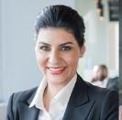  https://tradevistas.org/countries-dont-trade/

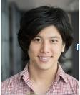  https://tradevistas.org/countries-dont-trade/ | https://tradevistas.org/countries-dont-trade/ | https://tradevistas.org/countries-dont-trade/
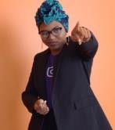  https://diversity.fb.com/initiatives/at-facebook/ | https://diversity.fb.com/initiatives/at-facebook/ | https://www.sparknz.co.nz/sustainability/divers ity-and-inclusion/

APPENDIX 2.1: Blank Venn diagram for students to fill out.
The admired person goes in the middle. Each circle is labeled with one of his/her identities. Try to think of people who fit in the other spaces!
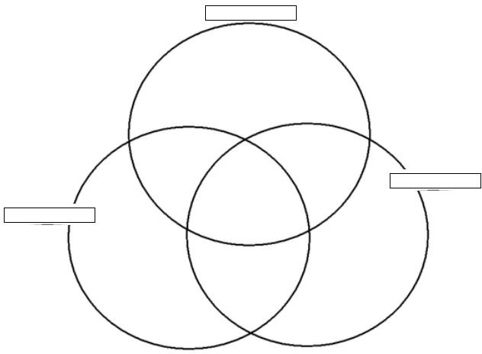

Modified from: https://www.tes.com/teaching-resource/venn-diagram-template-11282239

APPENDIX 2.2: Example of Completed Venn Diagram

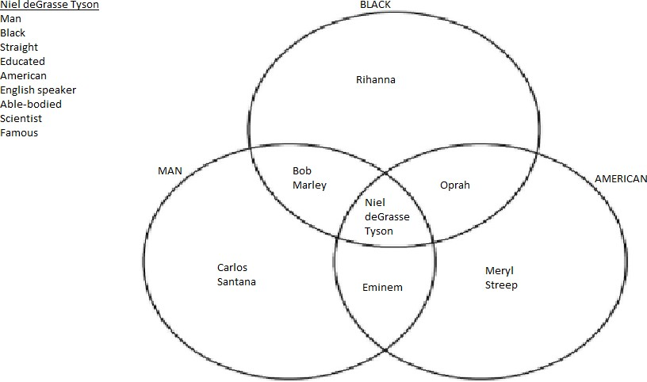

APPENDIX 3: Some aspects of a person´s identities

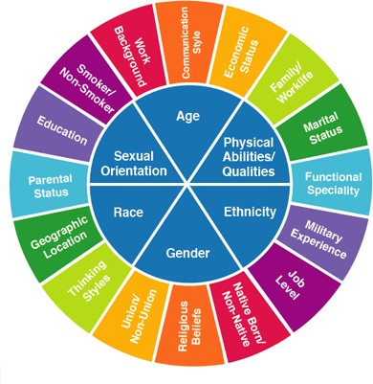
https://www.pinterest.com/pin/351421577147119170/

APPENDIX 4: Stories of immigrants to the US. Only give one story to each group of students.

- When I came to the US, I noticed that our cultures are very different. For example, when I had a party in Mexico, I didn’t really notice if the music bothered our neighbors. In the US, people think that’s insensitive. Today I have learned that I have to respect others so they can
respect me.
-- Alicia, immigrant from Mexico to the US

- One thing that is different for us is the food and the time to eat. Usually we have dinner at noon and a small snack in the evening. Some Americans eat a lot of fast food but we try to keep our customs and eat our ethnic food. It’s hard, though, because we can’t find the ingredients we need, and if we find them, they are expensive. I know that we should enjoy the cultural differences, though, because they will help us grow.
-- Yolanda, immigrant from Cuba to the US

- In American society, people welcome you to a new neighborhood and say hello even though they don’t know you. In Chile when you don’t know the person very well, they look at you in a funny way. I remembered a time when I said hello to several people in Chile, just to see if they would say it back. Only a few responded.
-- Carla, immigrant from Chile to the US

APPENDIX 5: “Story Mountain” model of narrative. Review to help students think through the parts of their story.

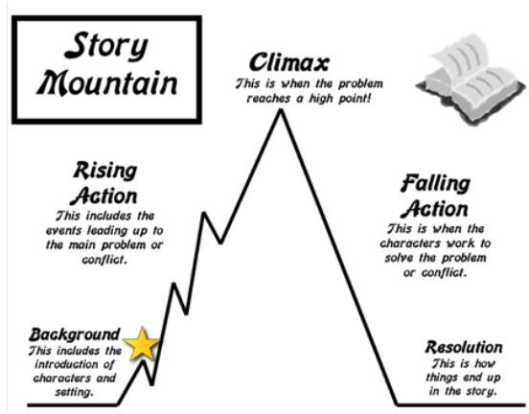

https://www.pinterest.ch/pin/463870830343493637/

APPENDIX 6: “Story Mountain” with blank spaces for students to fill
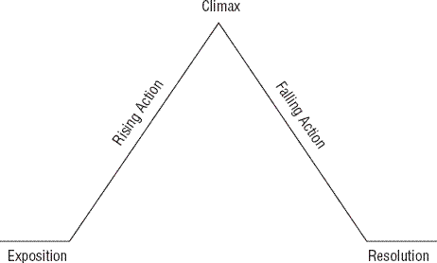

https://www.tes.com/lessons/HGlTQLsI5c6_mw/plot-diagram-practice

APPENDIX 6.1: Example of a story mountain completed by a student
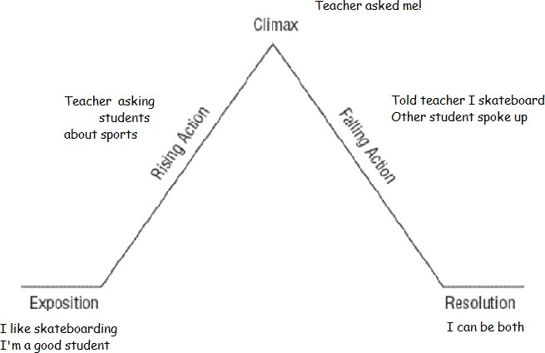

Modified from: https://www.tes.com/lessons/HGlTQLsI5c6_mw/plot-diagram-practice

APPENDIX 6.2: An example of a narrative paragraph completed by a student

I am a really good skateboarder. Ever since I was a kid, I was really into it. But I am also a good student at school. People don’t think that skateboarders are very smart. One day, I heard my teacher asking some other students about sports. I didn’t want him to ask me, because I knew he thought I was a great student. And then he asked me! I had to tell him that I skateboard. I was surprised, because the teacher said it was very creative and good exercise. Some of the other students thought so, too. Now I know that I can be a good student and a skateboarder!

APPENDIX 7: Feedback guide for narrative paragraph

1. What is one good thing about your partner’s story?

2.
Does your partner’s story have... | Yes | No
...background / introduction?
...rising action?
...a climax?
...falling action?
...a resolution?

3. What part of your partner’s story needs more detail?

Didactic Planning Week # 4
Level: 10th |  | Unit: 3
Domain: Psycho-social & Sociocultural | Scenario: A World of Differences |  | Theme: I Am Not My Hair
Enduring Understanding: The world is made up of diverse groups of people who nurture one another.
Essential Question: How does understanding people’s differences help us all become better human beings?
General Competences

Responsible Citizenship ( )
Life Competences ( )
Competences for Employability ( )

Learn to Know | Learn to Do |  | Learn to Be and Live in Community
Grammar & Sentence Frames  Broader range of intensifiers such as too, enough  - Jocks spend too much time in the gym.  - I have heard enough racist comments.  Conditionals, 2nd and 3rd  - If we had more understanding, we would get along with other people.  - If I had been born somewhere else, I would have acted differently than I do now.  - If we could make people listen to each other, we might see peace in the world.  Phrasal verbs | Function Expressing opinions, agreement, and disagreement.  Discourse Markers Connecting words expressing cause and effect, contrast  - On the other hand, we could go to the clinic.  - However, this depends on the number of passengers.  Managing interaction: interrupting  - Sorry to interrupt you, but…  - I have a question. |  | Psychosocial  - Appreciating and celebrating own diversity (cultural, gender, sexual orientation, religion, disability, ethnicity, and age).  Sociocultural  - Showing empathy: putting oneself in the shoes of others and listening to their needs.  - Adopting a non-judgemental attitude towards others’ cultural diversity.  Idioms  - You can’t judge a book by its cover.  - To walk a mile in someone else’s shoes

- When I hang out with people like me, we often talk down to people not like us.  - We don’t put up with bullying.  - I speak up when I hear someone putting  another person down.  Expressing agreement/disagreement  - I think so too…  - Well, not really.  - I’m sorry, but I think you are wrong.  - I see what you mean, but…  - Yes, I agree.  - No, I disagree.  Vocabulary  education level, school or college attended, married or single, introverted or extroverted, language, complexion, hair or skin color, clothing, body art, political party, favorite sports, favorite teams, stereotype |  |  | - Could I interrupt here?  Resuming a conversation  - Anyway, …  - Anyway, what was I saying?  - What were we talking about?  - To get back to what I was saying, …  Continuing  - Anyway, …  - So, as I was saying, …  - Well, ...
Assessment Strategies & indicators of learning  (Diagnostic, formative,  summative) | Learner can | Didactic Sequence Mediation |  |  | Time Total: 120 min  (3  lessons)
Pre-teaching
Routine: Checking attendance, checking in with Ls, T posts the Essential Question on the board, Can Do’s, and class agenda, etc.

Participating: Warm- up
The Teacher provides students with a list of vocabulary words and definitions associated with this week’s theme (See APPENDIX 1 for list of words with explanations and examples). Students look through the

. |  | list briefly (this can be done in partners or individually), and the Teacher clarifies any questions the students may have.  Next, the students get into small groups (no larger than 4), and each group has a piece of paper and a marker. Students divide the paper into 6 equal sized sections by drawing horizontal lines, or by folding the paper, and then unfolding it to make 6 horizontal sections. (See images below for help folding.) These sections are labeled 1-6 on the front of the paper, and then 7-12 on the back.  https://spaceforlivingos.com/2012/02/quick-and-easy-steps-to-creating-your-cleaning-schedule.html  Once students’ papers are prepared, with 6 horizontal sections on each side, the teacher presents the clue for the first vocab word (See APPENDIX 2 for clues). The students’ goal is to listen to the clue, then guess the correct word, and write it on their paper with a marker in section 1. Students should not let other groups see the word they wrote. Once all the students have had time to write an answer, the teacher says “Papers up in 3, 2, 1!” Students hold up their papers and the teacher can see their answers from the front of the room. The teacher tells students what the correct word was, and students draw a check next to the word in section 1 if they got it right.  This process is repeated with up to 12 vocabulary words. Students write each word in the next section of their paper, so that the teacher can easily read the answers from the front of the room.  Engaging: Activation of prior knowledge  For the beginning of this exercise, students work silently and independently. Students receive copies of Likert Agreement Scales (See APPENDIX 3), asking for their opinion on topics related to appearance and prejudice. For each statement, students must select an option on the scale that  reflects how much they agree or disagree with the statement. Then students answer written questions about their opinions (also in APPENDIX 3).

SI.2 expresses opinions about  cultural identity  and cultural diversity  R.3 interprets  many subject  specific words when encountered in text | SI.2 express opinions about  cultural identity  and cultural diversity  R.3 understand  many subject  specific words when encountered in text (e.g. diversity, culture, cultural norms, stereotypes) support reading comprehension by key words, diagrams, and  illustrations. | Once students have had time to fill out the forms giving their own, personal opinions, the teacher reviews the questions with the class, allowing students to express their opinions, as well as explain and justify why they see things that way.  Introducing  The Teacher introduces the idiom “You can’t judge a book by its cover.” The students discuss what it might mean. The teacher makes sure that by the end of the discussion, students know that the phrase means that you can’t judge what is inside of people based only on the way they look on the outside.  The Teacher explains to students that this week they will consider appearances and their effect on how we see ourselves and others.  Planning/prereading  The teacher shows students pictures of Representative Ayanna Pressley (APPENDIX 4). The teacher can ask students what they can tell about Pressley from the pictures.  Next, the teacher reads Pressley’s biography (APPENDIX 5) out loud, while students follow along in the text. The teacher checks that students understand who Pressley is (a Representative in the US House of Representatives), and what she has done (become the first black woman in that position, fight for women’s rights, etc.).  Reading for the first time  Teacher distributes the Newsela.com article on Representative Pressley’s hair-loss announcement (APPENDIX 6). Students skim the title and subtitles, read the picture captions, and tell their partners  what they think the article will be about.

Then students read the article. They can read out loud, taking turns with their partners to practice their pronunciation. Alternatively, the teacher can ask students to read silently to emphasize deep understanding of the text.

After reading, students work in partner pairs to answer the questions from APPENDIX 7. Some of these questions are on subject specific words (R.3), and others check students’ comprehension of the text.

Pair/group feedback
When students have finished filling out the questions, the teacher displays the correct answers on the board. The students check themselves and either draw a check next to their answer if it is right, or change their answer if it is wrong. The teacher can also choose 1 or 2 of the most important questions to review with the class, saying “Why did you pick that answer? How did you know? What did you see in the text that told you…?”.

Reading for the second time
Students read the text again. This time, they underline parts of the text that show how/why Ayanna’s hair was important to her.

Post reading
The Teacher then shows students the reflection questions (APPENDIX 8) one at a time. For each question, students first share their answer with the person sitting next to them, then raise their hands to take turns sharing their ideas with the class.

Finally, students should write down a 1-2 sentence summary of what they have taken away from reading this article. (Examples: Appearance means different things to different people. OR Sometimes people who look different are really amazing. OR You shouldn’t judge people just by the way they look.)

SP.3 explains points of view, justifying assumptions and plans briefly.  W.1 writes completing specific graphic organizers and sentence frames aimed at monitoring comprehension. | SP.3 explain and justify, briefly, points of view, assumptions, and plans.  W.1 express what has been learned, how it has been learned, and learning goals for the future, related to cultural diversity. | Planning  The teacher explains that today students will be creating a public service message for middle-school (grade 6-8) children on the subject of appearances and prejudice. (For example, the message of their announcement might be “You can’t judge a book by its cover.”)  To start planning, students receive a graphic organizer (APPENDIX 9) to complete, organizing their thoughts on the subject. The students fill out their own organizer independently.  Organizing  Students get into small groups (2-3 people) and share their responses to the graphic organizer. Together, they agree on what the most important lesson is and what reasons they should give. Students write a short script with parts for each student to say. The Teacher should circulate around the room, helping students develop their scripts and checking the quality of each script.  Rehearsing  Once their script is written, students rehearse presenting their public service announcements in the same groups.  Producing  Students perform their public service announcement for the class,or record them to show to actual middle school students.  Pre-writing  The teacher tells students that their objective today is to write a well - developed paragraph expressing what they have learned this month about cultural diversity, how they learned it, and what their learning goals are for the future.  To get started, the teacher shows students pictures from each of the last four weeks’ lessons (APPENDIX 10) and asks them to recall things they learned. For example, when students see a picture of an indigenous mask, they might recall “Indigenous people are our people--they are Costa Rican!”.

Then students can fill out a “Knew, Learned, Want to Know” organizer (APPENDIX 11), summarizing their thoughts and knowledge.

Drafting
Students’ job now is to write a well-developed paragraph that answers the prompt “Express what has been learned, how it has been learned, and learning goals for the future related to cultural diversity” (W.2). The teacher can give them a rubric to check for themselves whether they have answered all parts of the prompt (APPENDIX 12). To help the teacher, APPENDIX 13 is an example of a paragraph that a student might write, that answers all parts of the prompt.

Revising
Once students have had time to write and check themselves, they trade papers with their partners. Each student reads their partner’s paragraph, then fills out a peer feedback rubric (APPENDIX 14). Then students trade back and make changes to their writing based on their partners’ feedback.

Editing
Once students have had time to revise their writing, they trade papers with their partners again. This time, students check for grammatical and spelling errors. Students work together to fix these mistakes, while the Teacher circulates to help.

Publishing
Some students read their papers to the class. Listening students can raise their hands, after the paragraph has been read, to add on other things that they have learned or want to learn.

Phonology

Activity: Pronunciation of inflectional –(e)d Instructions:
Students work in pairs. Each player rolls the die twice. The first time they roll the die is to know the row that they will use and the second one is to know the column. They have to identify the word that they will
use in their corresponding turn. Once they identify the word, they have to say the word in past tense.

They have to say the inflectional –(e)d correctly to get a point. At the end, the player that has more points wins the game.

For example,

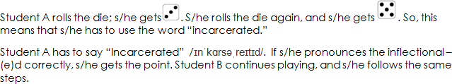

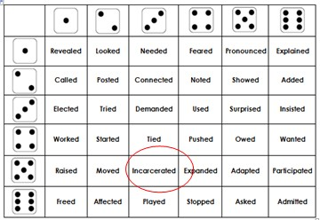

 |  | See appendix 15
Integrated Mini-Project |  |  |  |  | Time
Allow time for the Mini-Project each week. NOTE: All phases of the Integrated Mini-Project should be opportunities for Ls to practice English, not just those related to presentation.  Participating to negotiate: (5 or 10 minutes in week 1 or 2) |  |  |  |  | Adjust previous times listed above to allow 5 min each week.  Group presentation  s can be week 5 or 6.
Reflective Teaching
What worked well |  |  | What didn’t work well | How to improve
Enduring Understanding Reflection
How well did the learners progress in their understanding of the Enduring Understanding?
Week Plan Self-Assessment
At the end of the week, T guides the learners to check their progress using the checklist below. (Can be translated into Spanish if needed to ensure Ls’ understanding.)

Learner Self-Assessment
I can… | Yes | In progress | No
express opinions about cultural identity and cultural diversity
interpret many subject specific words when encountered in text
explain points of view, justifying assumptions and plans briefly.
write completing specific graphic organizers and sentence frames aimed at monitoring
comprehension.
show how I have worked with others this week.

APPENDIX 1: List of vocabulary with explanations and examples
education level - the highest level of school or college that a person has attended. examples: elementary school, middle school, high school, college, masters, doctorate

school or college attended - the college or university where a person studied examples: a community college, Yale University, University of Georgia

married or single - whether someone has a life partner

introverted or extroverted - whether a person likes to speak up, meet new people, and spend time with others (extroverted), or likes to listen, and does not necessarily enjoy meeting new people (introverted)

language - the language that a person speaks, or grew up speaking

complexion - the brightness of someone’s skin color examples: a dark complexion, a light complexion

hair or skin color - the natural color of someone’s hair or skin

clothing - clothes that people like to wear

body art - tattoos
political party - the group of people that someone associates with for elections and other political activities

favorite sport - the sport that someone likes the most

favorite team - the sports team that someone likes the most

stereotype - an assumption that all members of a certain group of people are the same in some way examples: Old people are boring. Young people are disrespectful.

APPENDIX 2: Clues to vocabulary words. The teacher can choose between these clues--they do not all have to be used.

education level:  - I was the first person in my family to get a college degree.  - My mother only got a 6th grade education.  school or college attended:  - I went to the University of Costa Rica.  - She graduated from Harvard.  married or single:  - My wife’s name is Katie.  - He had a divorce.  - My brother is still a bachelor.  introverted or extroverted:  - Sometimes I just need a little time to myself.  - Emma is the life of the party.  language:  - English is not my mother tongue.  - Mark is still learning Spanish.  complexion:  - My skin is a little darker than my brother’s.  hair or skin color:  - He is blond.  - The baby had beautiful, mahogany skin. | clothing:  - Eddy was wearing orange shorts and clogs.  - Mary preferred to wear fuzzy sweaters.  body art:  - Our instructor had a full sleeve of tattoos on his arm.  - Johanna has a picture of a dove on her ankle.  political party:  - Harry’s whole family are Republicans.  - Elsa’s opinions are moderately liberal.  favorite sports:  - Lisa is a football fanatic.  - Niel plays rugby.  favorite teams:  - Jim is a Philadelphia Eagles fan.  - Sarah likes Manchester United.  stereotype:  - It is not actually true that all young people are lazy.  - People think old people are boring, but my grandma is so funny!

APPENDIX 3: Likert agreement scales and questions related to appearances and prejudice.

On each scale, circle the option that represents how much you agree or disagree.
- I think people pay attention to my appearance.

- I pay attention to other people’s appearance.

- You can tell a lot about a person based on how they look.

- You should look the way you want to, no matter what other people think.

- Compare your answers to questions 1 and 2. Do you pay as much attention to others as you think they pay to you?
Yes. No.

- Choose one of your answers above and explain your opinion and feelings about it.

APPENDIX 4: Pictures of Representative Ayanna Pressley

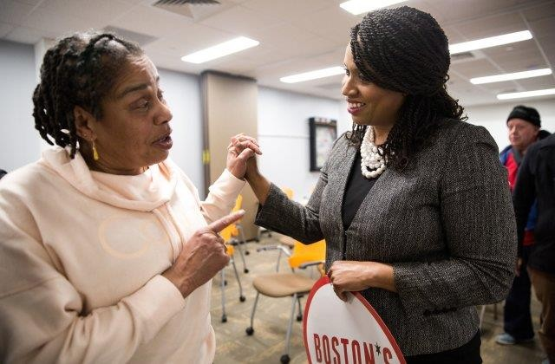  https://www.usnews.com/news/the-report/articles/2018-08-10/ayanna- pressleys-fierce-urgency-of-now | 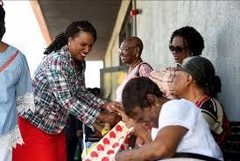  https://www.npr.org/2018/09/05/644716048/nothing-was-off-limits- intimate-photos-from-ayanna-pressley-s-campaign
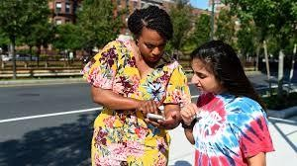  https://www.npr.org/2018/09/05/644716048/nothing-was-off-limits- intimate-photos-from-ayanna-pressley-s-campaign | 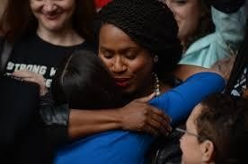  https://www.opensecrets.org/news/2018/11/in-historic-midterms- women-elected/boston-city-hall-plaza-protest-calls-on-senator-jeff- flake-to-reject-brett-kavanaugh-for-supreme-court/

APPENDIX 5: Biography of Representative Ayanna Presley
Modified from wikipedia.org article

Ayanna Pressley was raised in Illinois. Her mother worked multiple jobs, while her father was incarcerated (in prison) for drug abuse. Ayanna attended Boston University, but left school before graduating to take care of her mother. Later, she moved to Boston. She became the first black woman to ever be elected to the Boston City Council. In 2018, Pressley was elected as the first woman of color to represent Massachusetts in Congress. There, she has fought for expanded medical benefits, lowering the voting age, and protections for victims of sexual violence.

APPENDIX 6: Newsela.com article on Representative Pressley’s hair loss announcement.

Representative Ayanna Pressley shows her loss of hair from alopecia
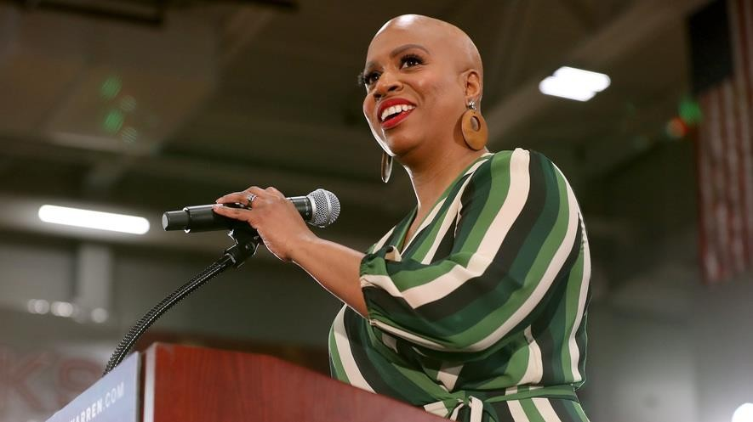
Representative Ayanna Pressley, a Democrat from Massachusetts, introduces Democratic presidential candidate Senator Elizabeth Warren during a campaign rally. Pressley has alopecia, a common skin disease that causes hair loss. Photo: Getty Images

By USA Today, adapted by Newsela.com.

- Ayanna Pressley is a U.S. Democratic Representative of Massachusetts. On January 16, she revealed that she is bald. She has a
condition called alopecia (pronounced: “al-oh-pee-shuh”), which causes hair loss. She explained why her "black hair story is both personal and political."

- In a video posted online, Pressley noted how little girls connected with her braids. She said her hair is part of her image as a black woman. When her hair fell out, she felt like she participated in a "cultural betrayal."

Going Public
- "I'm trying to find my way here, and I do believe going public will help," Pressley said. She showed her bald head. "This is my official public revealing. I am ready now because I want to be freed from the secret and the shame that that secret carries with it."

- She added, "I am making peace with having alopecia. [...] I'm very early in my journey. But I'm making progress every day, and that's why I'm doing this today."

- Pressley, who is 45 years old, represents parts of Boston and other communities in Massachusetts. In 2018, she became the state's first black woman elected to the U.S. House of Representatives.

- While someone was working on her braids in fall 2019, she found out that she had some bald patches. It got worse quickly from there.

Fighting The Hair Loss
- She said she started waking up to sink-fulls of hair. Pressley said she tried to fight the hair loss because she thought she could stop it. She tried wrapping her hair and wearing a bonnet at night, but nothing worked.

- "I did not want the morning to come," she said. She feared that she would take off the wrap and "be met with more hair in the sink," Pressley said. She did not want to see in the mirror "a person who increasingly felt like a stranger" to her, she said.
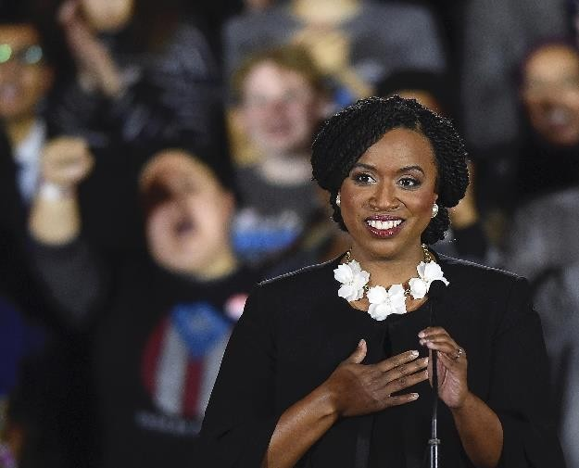
Representative Ayanna Pressley speaks during an event in Boston, Massachusetts. Pressley said that when she got Senegalese twists in her hair, she felt like she met herself "fully for the first time." Photo: Getty Images

- She said her last pieces of hair fell out the night before a big vote in December. Within hours, she needed to appear to cast her vote.

- To her, losing her hair felt like losing an arm or leg, she said. However, she did not have time to think about it. “I knew the moment demanded that I stand in it," she said.

- She left as soon as she could and hid in a bathroom stall. She felt ashamed.

Common Skin Disease
- Alopecia is a common skin disease. It affects nearly 7 million people in the United States.

- Pressley used to be a councilwoman for Boston. She has announced that she will run for a second term in Congress.

- After she became an elected leader, Pressley said at first she wore wigs and hair extensions. Then she got long Senegalese twists about four or five years ago. The twists went down to her waist.

- "I felt like I met myself fully for the first time. I sort of looked myself in the mirror and said, 'Oh, there I am.' And it felt good," she said.

Community Acceptance
- She said she knew that her braid hairstyle would be seen by some as a statement. She said she was surprised by the acceptance of her community, especially from young girls and women.

- Pressley said her twists had become a part of who she is and how she shows up in the world. They are also closely tied to her "political brand." This was why she wanted to be so open about her alopecia.

- Pressley said she felt like she owed "all those little girls an explanation." Her husband insisted she did not owe an explanation. Pressley pushed back.

- "The reality is I'm black and I'm a black woman and I'm a black woman in politics, and everything I do is political," she said.

APPENDIX 7: Vocabulary and comprehension questions for “Representative Ayanna” article

Subject specific word questions:

- In paragraph 1, “bald” means…
  - sick
  - without hair
  - hairy

- In paragraph 2, “braids” are probably…
  - a kind of political club
  - assistants
  - a kind of hairstyle

- In paragraph 8, “stranger” probably means…
  - an unknown person
  - a foreign person
  - a bad person

- In paragraph 14, “Senegalese twists” are probably…
  - a kind of clothing
  - a kind of political advisor
  - a kind of hairstyle

- In paragraph 18, what does “owe an explanation” mean?

Comprehension questions:

- What did Representative Pressley announce?
  - that she was running for congress again
  - that she was very sick
  - that she had lost her hair

- How did it feel for Ayanna to lose her hair?
  - terrified and afraid
  - embarrassed and ashamed
  - tired and sick

- Why were her “Senegalese twists” important to Ayanna?
  - they made her feel like her true self and they were part of the image she had with other people
  - she had gotten them from her mother and they represented her culture
  - they represented a time in her life before she got sick

- Why did Ayanna feel like she “owed” people an explanation?

APPENDIX 8: Reflection questions about “Representative Ayanna” article

- Why does her hair mean so much to Ayanna?

- Will Ayanna’s hair-loss affect how people think of her? How so?

- Should Ayanna’s hair loss affect how people think of her? Why or why not?

APPENDIX 9: Graphic organizer for students’ public service announcements

Brainstorm: What are some words you might use to talk about appearances and prejudice?

Write lessons you have learned about appearances and prejudice:  ● | List reasons these lessons are important:  ●

APPENDIX 10: Images from Unit 3.
https://images.app.goo.gl/jByumBncGQ6LQYY67  Week 1: These Are My People | 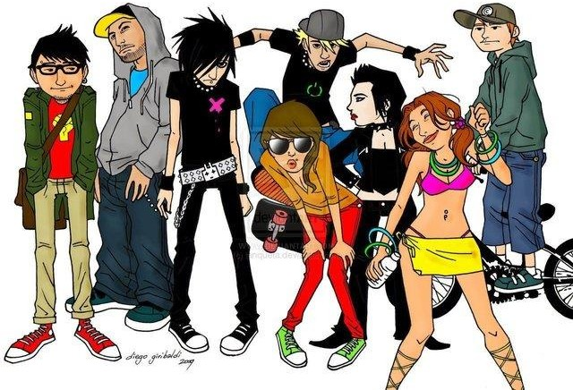  https://steemit.com/life/@reiny/subcultures-8-subcultures  Week 2: Cultures, Subcultures, and Cliques
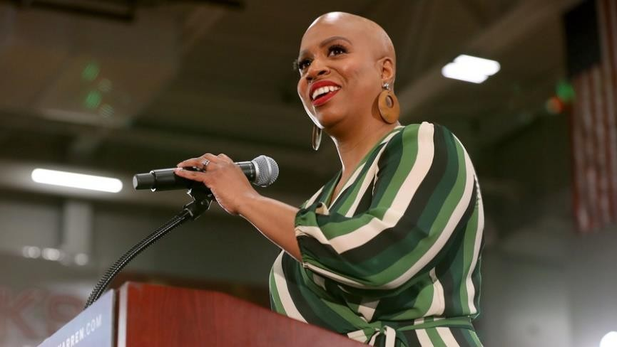
https://newsela.com/

https://www.pinterest.com/pin/351421577147119170/  Week 3: Cultural Norms, Cultural Storms | Week 4: I Am Not My Hair

APPENDIX 11: “Knew, Learned, Want to Know” Organizer
Students fill out the table to organize their thoughts and knowledge about cultural diversity.

I already knew... | I learned... | I still want to know...

APPENDIX 12: Self-check rubric to help students answer all parts of the writing prompt

Directions: Check if you have completed each goal in your writing. Then circle Yes, Partly, or No, depending on whether you have done it. If there are any objectives that are done partly, or not done, correct your essay, then change your answer to Yes.

Prompt: Express what has been learned, how it has been learned, and learning goals for the future related to cultural diversity
My paragraph has a topic sentence. | Yes | Partly | No
I expressed several things that I learned about cultural diversity. | Yes | Partly | No
I described how I learned these things. | Yes | Partly | No
I explained what I still want to learn about cultural diversity. | Yes | Partly | No

APPENDIX 13: Example, for the teacher, of a paragraph that a student might write.

Prompt: Express what has been learned, how it has been learned, and learning goals for the future related to cultural diversity

Student Response:

In this unit, I have learned a lot about cultural diversity and understanding. First, I learned about the cultures of indigenous

people in Costa Rica.
I watched a video about a Boruca festival, and learned the meanings of their masks and performances.
Next,

I learned that every culture has its norms, and the differences between those norms sometimes cause “storms,” or conflicts. I discussed my culture’s norms and other people’s norms with my classmates. Finally, I learned that “you should not judge a book by its cover.” That means that you can’t tell what is inside someone based only on how they look on the outside. I read an article about a congresswoman in the US who lost all her hair. Her hair had been a big part of her identity, and it was important to her, but she was still the same amazing person after her hair fell out. I still don’t know very much about what people’s appearances mean to them. In the future, I want to learn more about why people decide to look the way they do. I also always want to learn more about people who look different from me and see what is on the inside of them--not what is on the outside.

Color coding:

Topic sentence Things learned
How things were learned Goals for learning in the future

APPENDIX 14: Peer feedback rubric for writing.

1)
Prompt: Express what has been learned, how it has been learned, and learning goals for the future related to cultural diversity
My partner’s paragraph has a topic sentence. | Yes | Partly | No
My partner expressed several things that they learned about cultural diversity. | Yes | Partly | No
My partner described how they learned these things. | Yes | Partly | No
My partner explained what they still want to learn about cultural diversity. | Yes | Partly | No

- What is one thing your partner did well?

- What part of the prompt can your partner explain more?

APPENDIX 15:

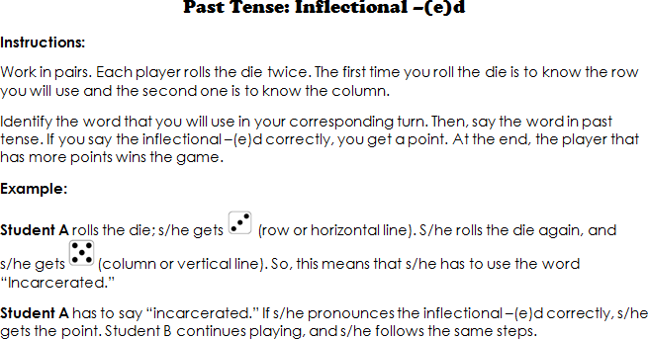

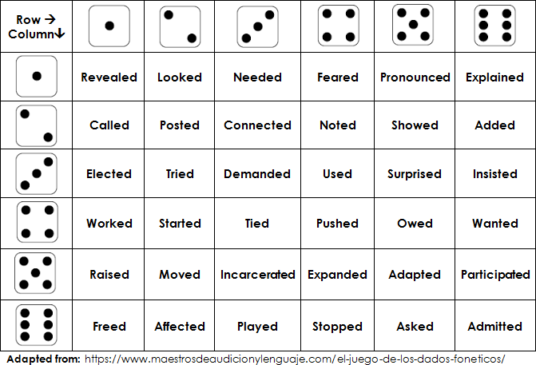

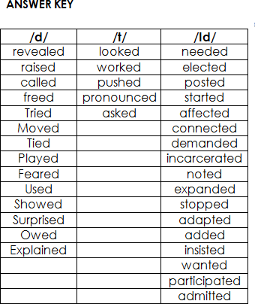

Weeks 5 and 6
Review and Integrated Mini-Project

Level: 10th
Enduring Understanding: The world is made up of diverse groups of people who nurture one another.
Essential Question: How does understanding people’s differences help us all become better human beings?

Unit: 3

General Competences

Responsible Citizenship ( )
Life Competences ( )
Competences for Employability ( )

Learn to Know Learn to Do Learn to Be and Live in Community

Grammar & Sentence Frame
- Did Ls use all sentence frames?

Vocabulary
- Did Ls say aloud and write all vocabulary?

Phonology
- Did Ls recognize, articulate and produce phonological sounds?

Function
- Did Ls use all functions?

Discourse Markers
- Did Ls practice connecting words: and, but, because?

Psychosocial
- Did Ls show evidence of …
- Being aware and committed to protecting the environment
- Appreciating natural wonders

Sociocultural
- Did Ls practice idioms and quotes?

Assessment Strategies & indicators of learning  (Diagnostic, formative,  summative) | Learner can | Didactic Sequence Mediation | Time Total: 120 min  (3  lessons)
- Did Ls achieve all learning outcomes? | - Can Ls do all tasks? | Referencing notes from formative assessments throughout the weeks, repeat activities to strengthen Ls in weaker areas or select from Optional Activities that follow these plans. | All of week 5 or 6
Options |  | Integrated Mini-Project | Time
− |  | By allowing time for the Mini-Project each week for participating, thinking, and acting out, learners should now have a chosen project and determined content and strategies. In the presentation week Ls focus on:  Responding and sharing: Participating in individual and peer assessment of the integrated mini-project.  Teachers monitor ….  - Did Ls use English during all aspects of Integrated Mini-Project?  - How did project presentations reflect understanding and/or mastery of Can - Do Statements?  - Did Ls put into practice the focus of Learn to Be and Live in Community?  - Did the Integrated Mini-Project provide answers to the Essential Question? | All of week 5 or 6 of unit

